Graded Assignment on Networking and Servers

# Assignment – 3

Table of Contents

Assignment – 3 1

Installation of virtual box 1

Choosing the correct package 2

Install VirtualBox 2

For Windows: 2

For macOS: 3

For Linux: 3

Post-installation Configuration 3

Task 1: Install Nginx inside the Ubuntu machine and host a website. 5

Task 2: Come back to your host machine (windows/Linux/mac) and scan the virtual machine using Nmap. 6

## Installation of virtual box

Go to the official VirtualBox website: [https://www.virtualbox.org/](http://www.virtualbox.org/) click on the [Download](https://www.virtualbox.org/wiki/Downloads).

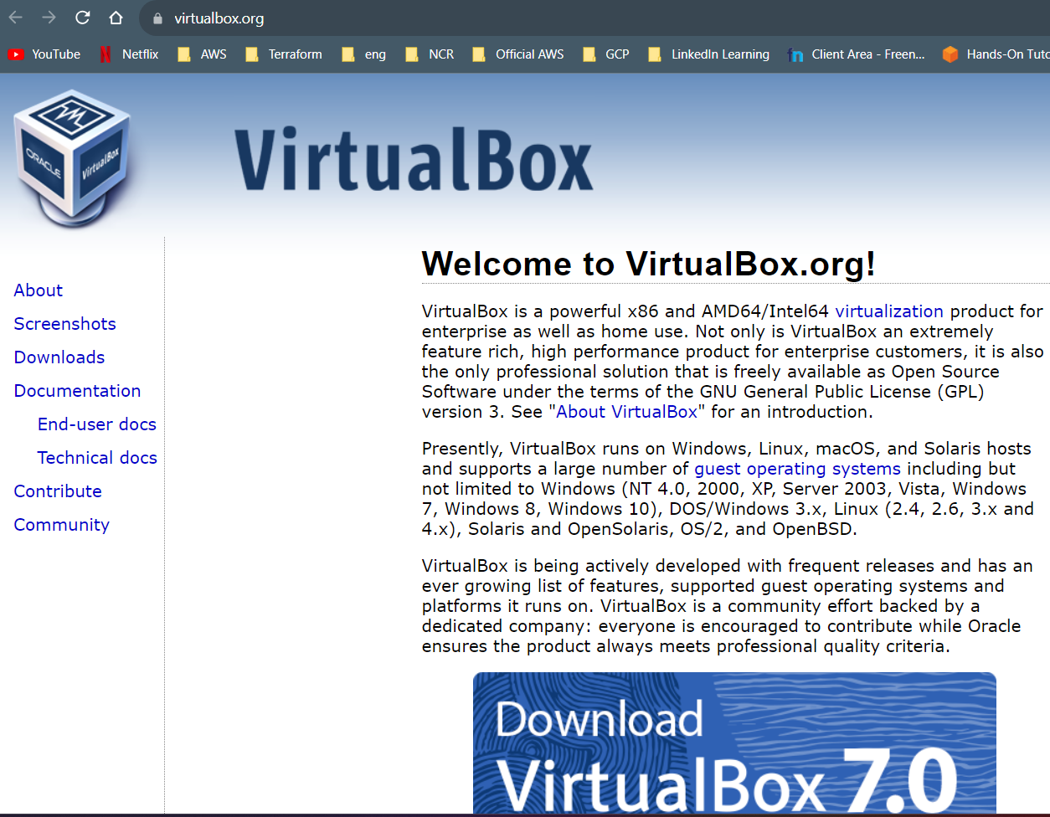

## Choosing the correct package

Click on the Windows hosts, you will be able to download the file and save it in the desired path.

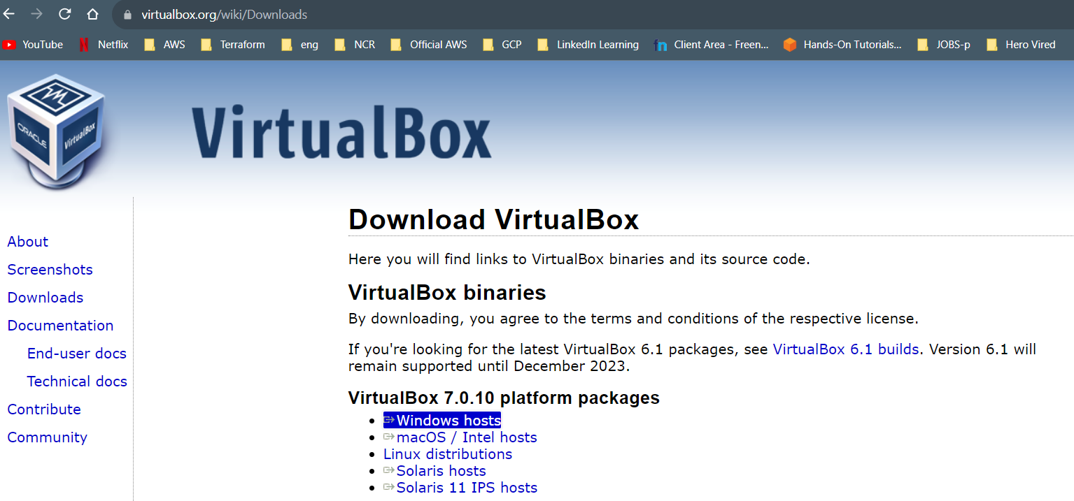

## Install VirtualBox

### For Windows:

●       Download the installer for Windows and double-click on the downloaded file to start the installation.

●       Follow the on-screen instructions and accept the license agreement.

●       Choose the components you want to install and the installation path.

●       Complete the installation process.

### For macOS:

●       Download the macOS version of VirtualBox.

●       Double-click on the downloaded DMG file to open it.

●       Double-click on the VirtualBox package icon to start the installation.

●       Follow the on-screen instructions to complete the installation.

### For Linux:

●       Download the appropriate package for your Linux distribution (e.g., .deb for Debian/Ubuntu-based systems, .rpm for Red Hat/Fedora-based systems).

●       Install VirtualBox using the package manager of your Linux distribution. For example, for Ubuntu, use the following command in the terminal:

○       *sudo dpkg -i <VirtualBox_package_name>.deb*

●       You may need to install additional dependencies if prompted by the package manager.

## Post-installation Configuration

* Post installation, virtual box will appear like below.



* After that we need to click on new button and a pop will open to enter the details in the Name, Folder and the ISO image.
* 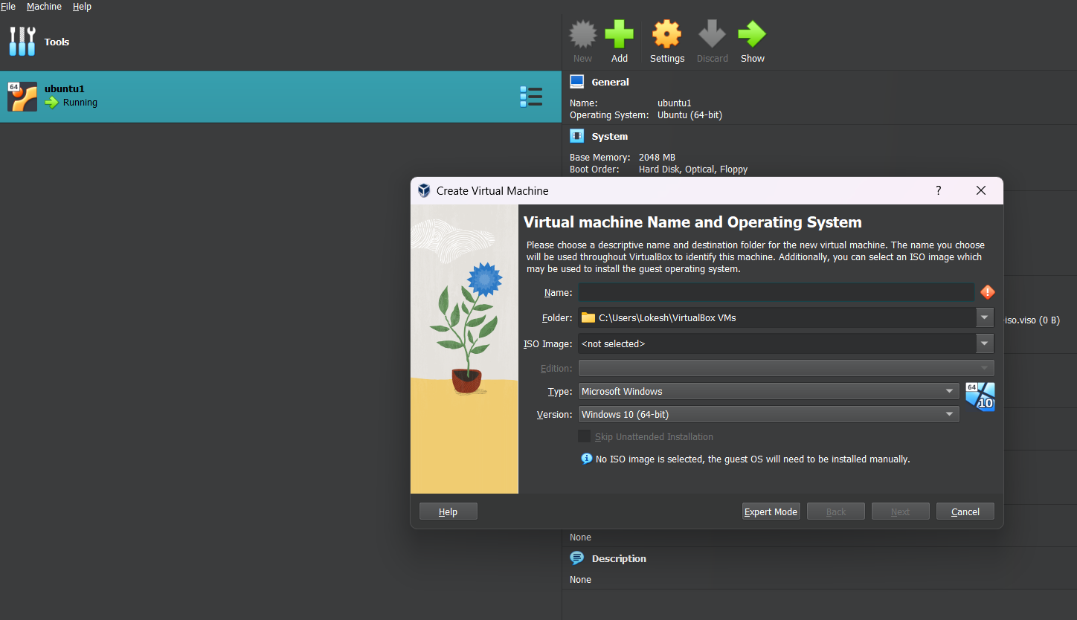
* We need to download the ISO image from [here](https://www.osboxes.org/).
* 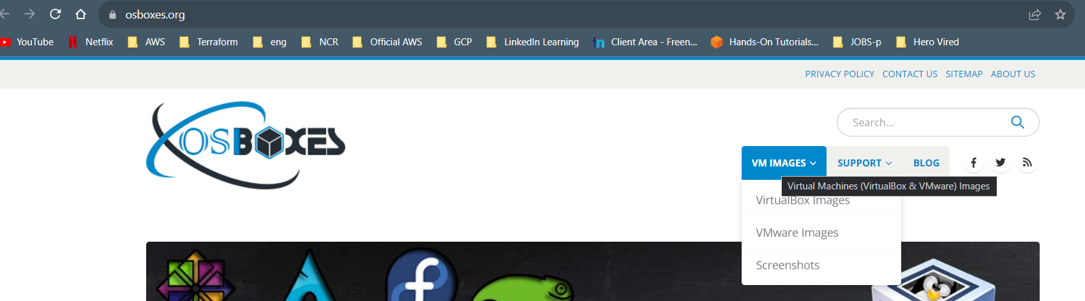
* Need to select [virtual box images](https://www.osboxes.org/virtualbox-images/).
* After that we will need to download the desired OS. In this case, I’ve downloaded [Ubuntu](https://www.osboxes.org/ubuntu/).
* 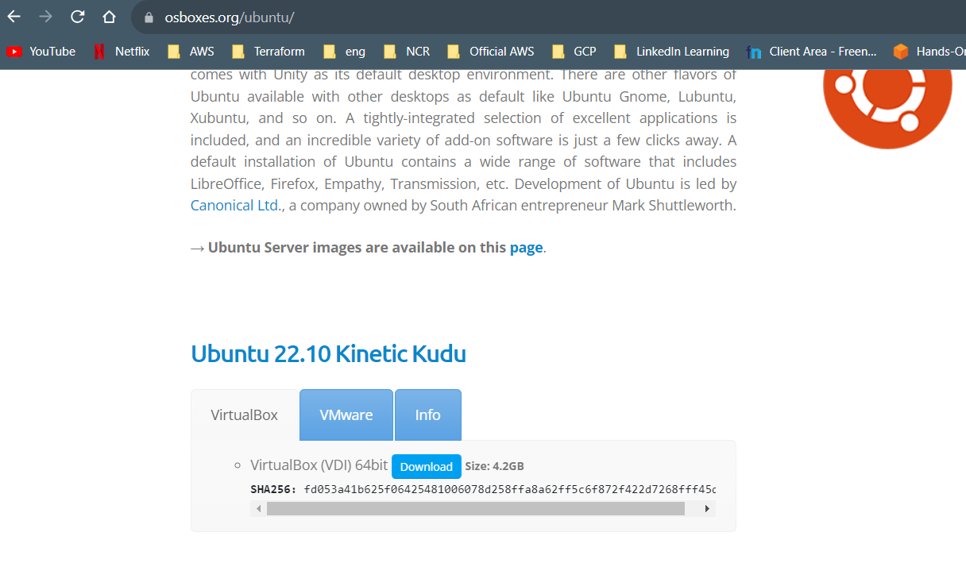
* We need to save in the desired folder and select the same file in ISO path.
* We need to click on next button and make changes if necessary. Recommended method is not to edit and leave as it is. The installation will be done.
* We will need to enter few details like email address and password to link to Ubuntu account.
* Some basic details need to be entered and our Ubuntu machine will be ready to use.

## Task 1: Install Nginx inside the Ubuntu machine and host a website.

1. Open a terminal and need to run the following commands
   1. sudo apt update
   2. sudo apt install nginx
   3. 
   4. It will download all the dependencies.
   5. Need to check whether the Nginx is running or not
   6. 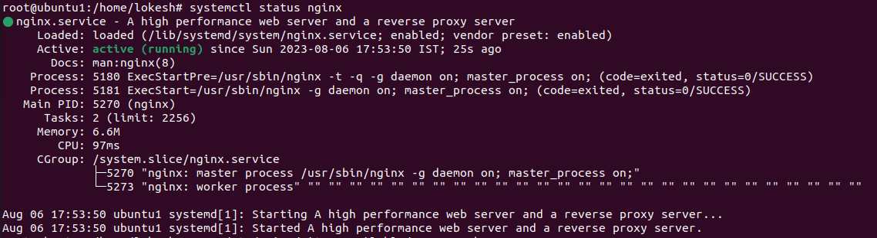
2. Need to create a directory to store your website files
   1. sudo mkdir /var/www/awesomeweb
3. Need to create a simple HTML file in the website directory:
   1. sudo nano /var/www/awesomeweb/index.html
4. Create a simple HTML file in the website directory:
   1. sudo nano /var/www/awesomeweb/index.html
5. Create a server block configuration file:
   1. sudo nano /etc/nginx/sites-available/awesomeweb
   2. an editor will open and need to paste the below content
      1. server {
      2. listen 80;
      3. server_name awesomeweb;
      4. root /var/www/awesomeweb;
      5. index index.html;
      6. location / {
      7. try_files $uri $uri/ =404;
      8. }
      9. }
   3. Once we add the code, we need to save it and exit by saving the file. Command is below.
      1. Ctl+x
      2. Y – enter
6. We need to enable the server block and reload Nginx
   1. sudo ln -s /etc/nginx/sites-available/awesomeweb /etc/nginx/sites-enabled/
   2. sudo systemctl reload nginx
7. Once we perform all the tasks, we also need to update the hosts file
   1. sudo nano /etc/hosts
   2. add the following line
   3. 127.0.0.1 awesomeweb
8. We have successfully performed all the tasks and we are ready to test the file.
9. Open a web browser and visit http://awesomeweb. You should see the sample website you created.
10. 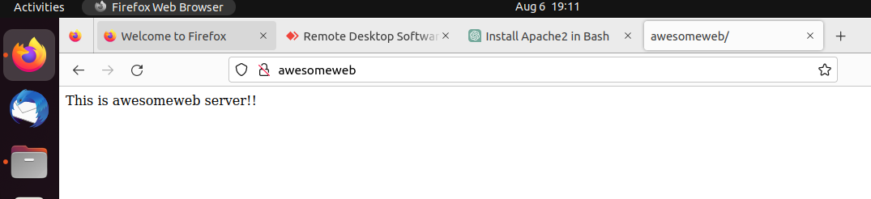

## Task 2: Come back to your host machine (windows/Linux/mac) and scan the virtual machine using Nmap.

We need to copy the ip address and need to select Intense scan, all TCP ports to know the open ports. We can also check in the host machine as well as in the Ubuntu VM. Below are the screenshots for the reference.