***Online pizza ordering system***

**Date**: 17/02/2019

**Guide**:Ankitha philip

**UML DIAGRAM**

1.**STRUCTURAL DIAGRAMS**

**A. Class diagram**

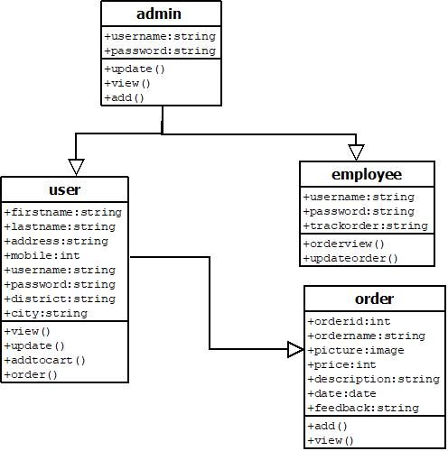

**B**.**Object Diagram**

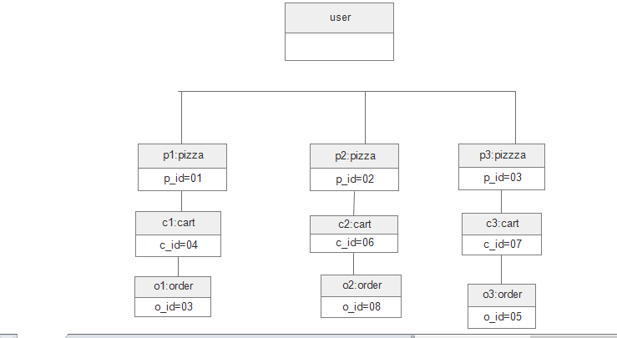

**C. Deployment Diagram**

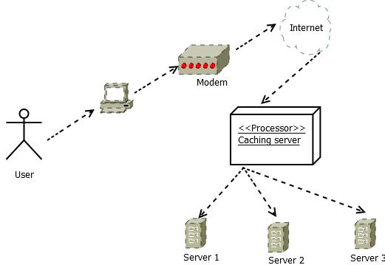

2.**BEHAVIORAL DIAGRAMS**

**A. Use case diagram**

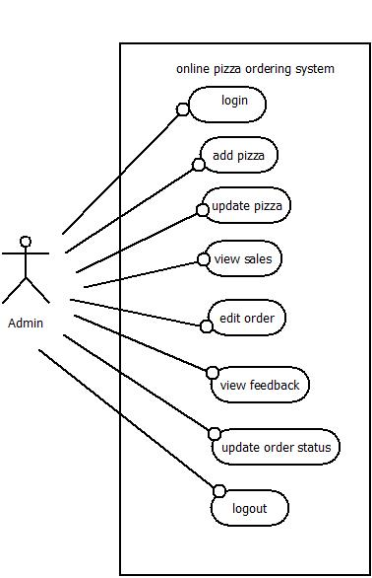

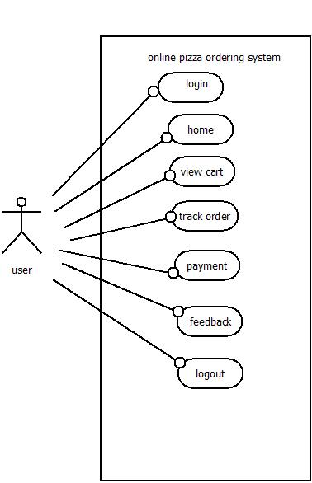

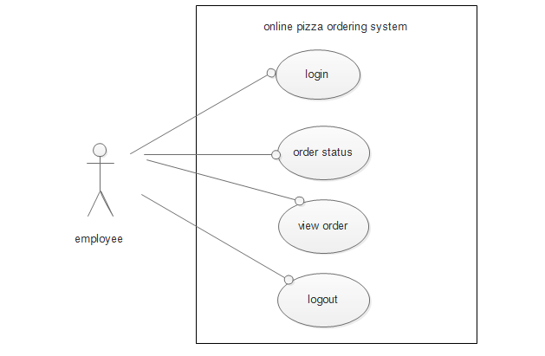

**B.sequence diagram**

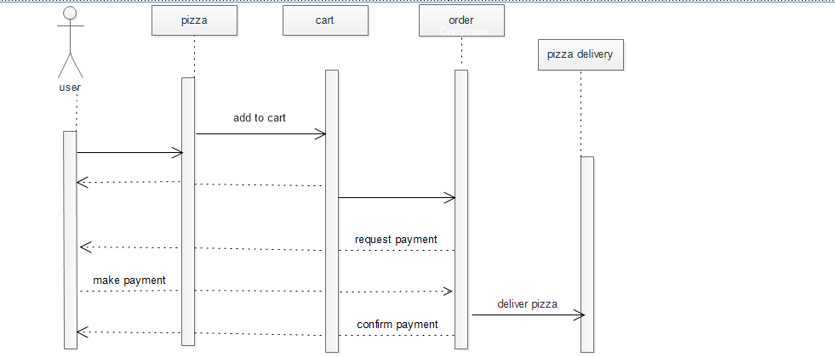

**C.collaboration diagram**

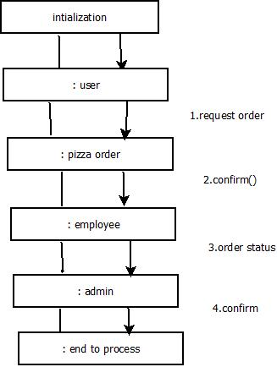

**D.statechart diagram**

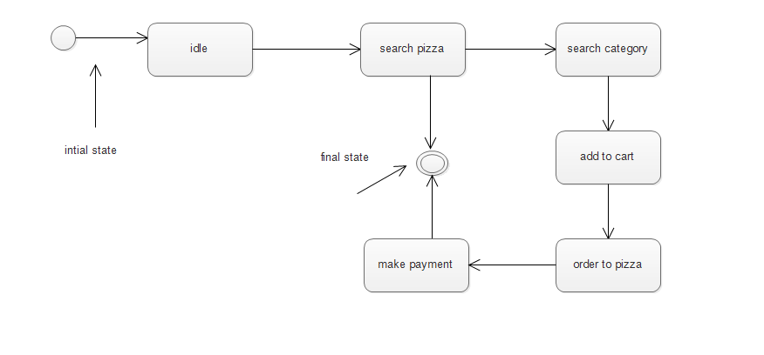

**E.Activity Diagram** 