**1. ReactJS hands-on:**

**import React from 'react';**

**function App() {**

**return (**

**<div>**

**<h1>Welcome to the first session of React</h1>**

**</div>**

**);**

**}**

**export default App;**

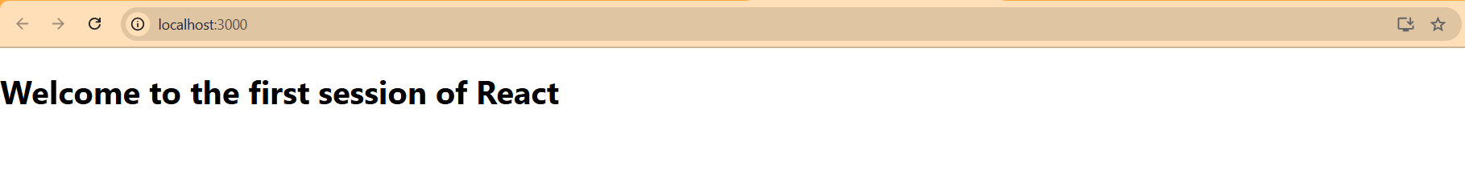

**2. ReactJS hands-on:**

**import React from 'react';**

**function Home() {**

**return (**

**<div>**

**<h2>Welcome to the Home page of Student Management Portal</h2>**

**</div>**

**);**

**}**

**export default Home;**

**import React from 'react';**

**function About() {**

**return (**

**<div>**

**<h2>Welcome to the About page of the Student Management Portal</h2>**

**</div>**

**);**

**}**

**export default About;**

**import React from 'react';**

**function Contact() {**

**return (**

**<div>**

**<h2>Welcome to the Contact page of the Student Management Portal</h2>**

**</div>**

**);**

**}**

**export default Contact;**

**import React from 'react';**

**import Home from './Components/Home';**

**import About from './Components/About';**

**import Contact from './Components/Contact';**

**function App() {**

**return (**

**<div>**

**<h1>Student Management Portal</h1>**

**<Home />**

**<About />**

**<Contact />**

**</div>**

**);**

**}**

**export default App;**

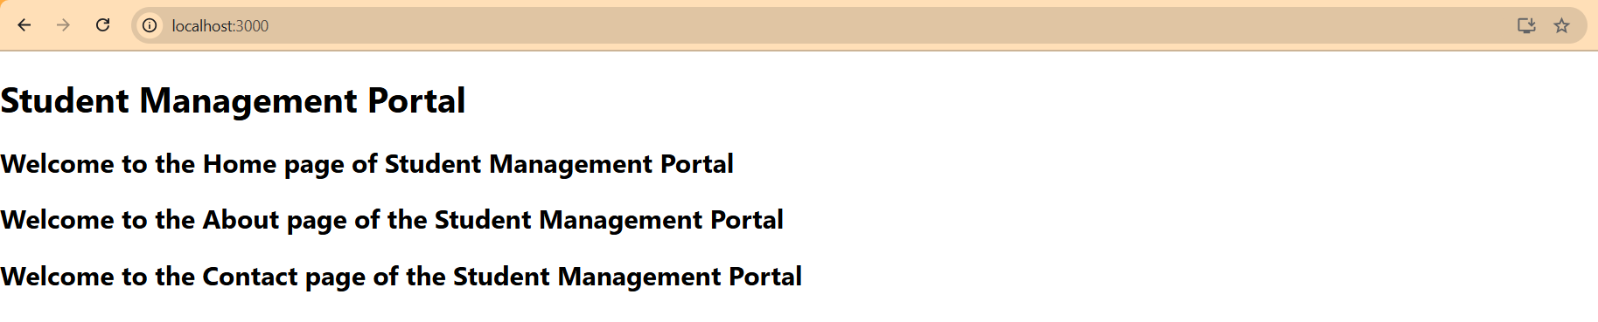

**3. ReactJS hands-on:**

**import React from 'react';**

**import '../Stylesheets/mystyle.css';**

**function CalculateScore() {**

**const name = "Steeve";**

**const school = "DNV Public School";**

**const total = 284;**

**const goal = 300;**

**const score = ((total / goal) * 100).toFixed(2);**

**return (**

**<div className="student-details">**

**<h1>Student Details:</h1>**

**<p><strong className="label name">Name:</strong> <span className="value blue">{name}</span></p>**

**<p><strong className="label school">School:</strong> <span className="value violet">{school}</span></p>**

**<p><strong className="label total">Total:</strong> <span className="value">{total}Marks</span></p>**

**<p><strong className="label score">Score:</strong><span className="value green">{score}%</span></p>**

**</div>**

**);**

**}**

**export default CalculateScore;**

**.student-details {**

**text-align: center;**

**margin-top: 50px;**

**font-family: Arial, sans-serif;**

**}**

**.student-details h1 {**

**color: brown;**

**font-size: 30px;**

**}**

**.label.name {**

**color: blue;**

**font-weight: bold;**

**}**

**.label.school {**

**color: red;**

**font-weight: bold;**

**}**

**.label.total {**

**color: crimson;**

**font-weight: bold;**

**}**

**.label.score {**

**color: green;**

**font-weight: bold;**

**}**

**.value.blue {**

**color: blueviolet;**

**}**

**.value.violet {**

**color: mediumvioletred;**

**}**

**.value.green {**

**color: #4CAF50;**

**}**

**import React from 'react';**

**import CalculateScore from './Components/CalculateScore';**

**function App() {**

**return (**

**<div className="App">**

**<CalculateScore />**

**</div>**

**);**

**}**

**export default App;**

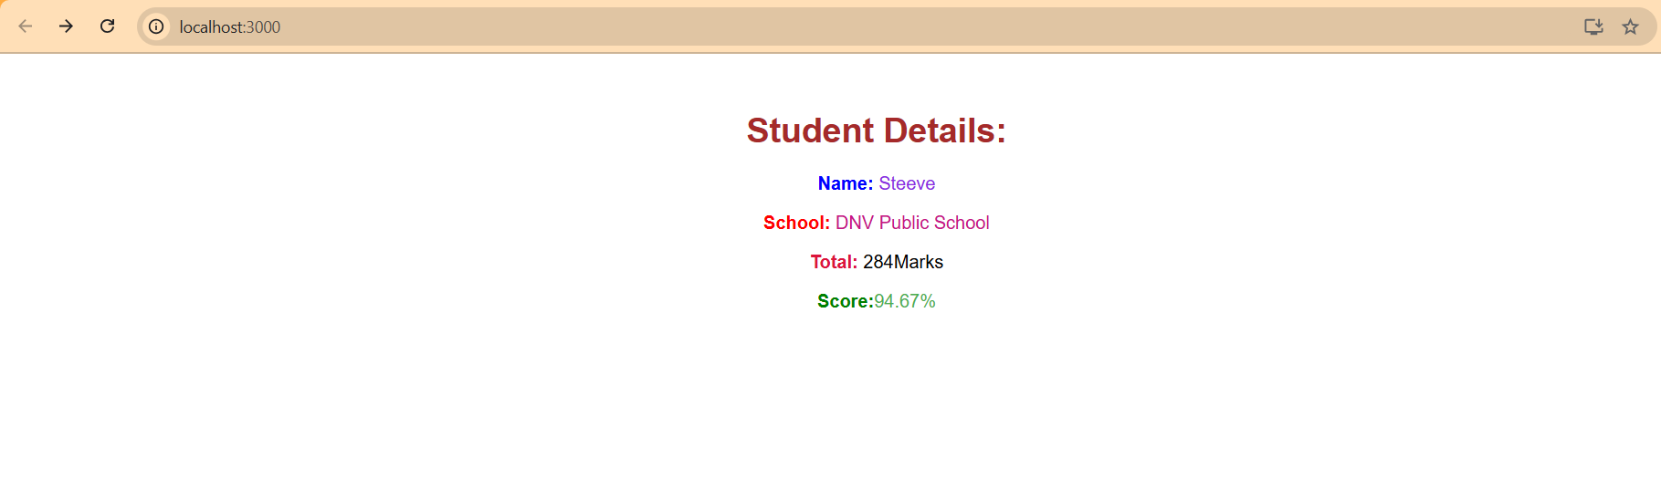

**4. ReactJS hands-on:**

**// src/Post.js**

**import React from 'react';**

**export default class Post extends React.Component {**

**render() {**

**return (**

**<div style={{ border: '1px solid gray', padding: '15px', margin: '10px' }}>**

**<h3>{this.props.title}</h3>**

**<p>{this.props.body}</p>**

**</div>**

**);**

**}**

**}**

**// src/Posts.js**

**import React, { Component } from 'react';**

**import Post from './Post';**

**export default class Posts extends Component {**

**constructor(props) {**

**super(props);**

**this.state = {**

**posts: [],**

**hasError: false**

**};**

**}**

**// Step 6 - Load Posts using Fetch API**

**loadPosts = () => {**

**fetch('https://jsonplaceholder.typicode.com/posts')**

**.then((res) => res.json())**

**.then((data) => this.setState({ posts: data.slice(0, 5) })) // limiting to 5 for brevity**

**.catch((error) => {**

**console.error('Error loading posts:', error);**

**this.setState({ hasError: true });**

**});**

**};**

**// Step 7 - componentDidMount**

**componentDidMount() {**

**this.loadPosts();**

**}**

**// Step 9 - componentDidCatch**

**componentDidCatch(error, info) {**

**alert('Something went wrong while rendering the posts.');**

**console.error('Error Boundary Caught:', error, info);**

**}**

**// Step 8 - Render**

**render() {**

**return (**

**<div style={{ padding: '20px' }}>**

**<h2>Latest Blog Posts</h2>**

**{this.state.posts.map((post) => (**

**<Post key={post.id} title={post.title} body={post.body} />**

**))}**

**</div>**

**);**

**}**

**}**

**import React from 'react';**

**import './App.css';**

**import Posts from './Posts';**

**function App() {**

**return (**

**<div className="App">**

**<Posts />**

**</div>**

**);**

**}**

**export default App;**

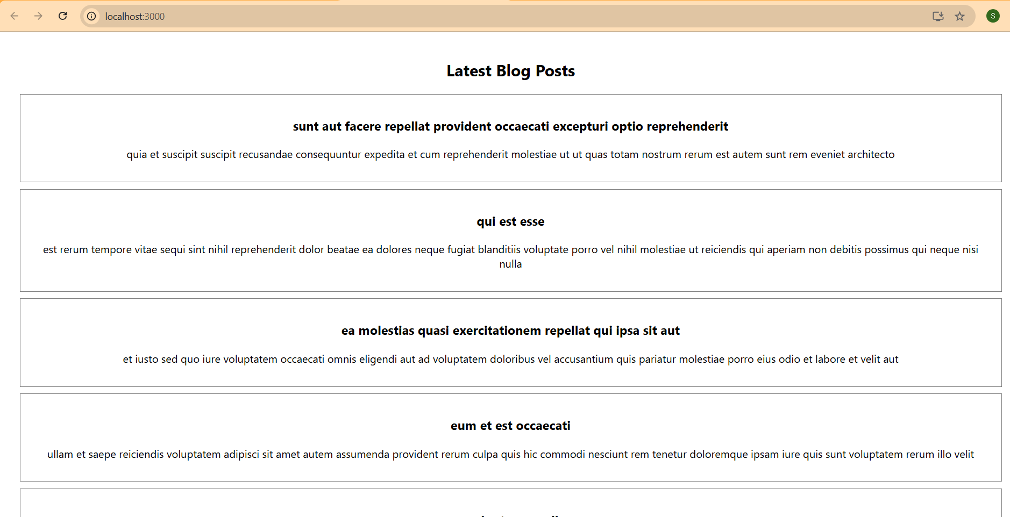

**5. ReactJS hands-on:**

**import React from 'react';**

**import styles from './CohortDetails.module.css';**

**const CohortDetails = ({ cohort }) => {**

**// Dynamic color for title based on status**

**const titleStyle = {**

**color: cohort.status.toLowerCase() === 'ongoing' ? 'green' :**

**cohort.status.toLowerCase() === 'scheduled' ? 'blue' : 'black',**

**fontWeight: 'bold'**

**};**

**return (**

**<div className={styles.card}>**

**<h3 style={titleStyle}>{cohort.title}</h3>**

**<p><strong>Started On</strong><br />{cohort.startDate}</p>**

**<p><strong>Current Status</strong><br />{cohort.status}</p>**

**<p><strong>Coach</strong><br />{cohort.coach}</p>**

**<p><strong>Trainer</strong><br />{cohort.trainer}</p>**

**</div>**

**);**

**};**

**export default CohortDetails;**

**.card {**

**width: 300px;**

**padding: 15px 20px;**

**border: 1px solid lightgray;**

**border-radius: 10px;**

**margin: 10px;**

**box-shadow: 0px 1px 3px rgba(0, 0, 0, 0.1);**

**display: inline-block;**

**vertical-align: top;**

**}**

**.card p {**

**margin: 10px 0;**

**font-size: 14px;**

**}**

**import React from 'react';**

**import CohortDetails from './components/CohortDetails';**

**function App() {**

**const cohorts = [**

**{**

**title: 'INTADMDF10 - .NET FSD',**

**status: 'Scheduled',**

**startDate: '22-Feb-2022',**

**coach: 'Aathma',**

**trainer: 'Jojo Jose'**

**},**

**{**

**title: 'ADM21JF014 - Java FSD',**

**status: 'Ongoing',**

**startDate: '10-Sep-2021',**

**coach: 'Apoorv',**

**trainer: 'Elisa Smith'**

**},**

**{**

**title: 'CDBJF21025 - Java FSD',**

**status: 'Ongoing',**

**startDate: '24-Dec-2021',**

**coach: 'Aathma',**

**trainer: 'John Doe'**

**}**

**];**

**return (**

**<div style={{ padding: '30px' }}>**

**<h2 style={{ marginBottom: '20px' }}>Cohorts Details</h2>**

**{cohorts.map((cohort, index) => (**

**<CohortDetails key={index} cohort={cohort} />**

**))}**

**</div>**

**);**

**}**

**export default App;**

