import React from 'react';

const ListofPlayers = () => {

const players = [

{ name: 'Virat', score: 95 },

{ name: 'Rohit', score: 88 },

{ name: 'Dhoni', score: 78 },

{ name: 'Pant', score: 65 },

{ name: 'Hardik', score: 55 },

{ name: 'Jadeja', score: 72 },

{ name: 'Shami', score: 40 },

{ name: 'Bumrah', score: 90 },

{ name: 'Gill', score: 75 },

{ name: 'Surya', score: 60 },

{ name: 'Ashwin', score: 82 },

];

const lowScorers = players.filter(player => player.score < 70);

return (

<div>

<h2>All Players (Using map)</h2>

<ul>

{players.map((player, index) => (

<li key={index}>{player.name} - {player.score}</li>

))}

</ul>

<h2>Players with score below 70 (Arrow + Filter)</h2>

<ul>

{lowScorers.map((player, index) => (

<li key={index}>{player.name} - {player.score}</li>

))}

</ul>

</div>

);

};

export default ListofPlayers;

import React from 'react';

const IndianPlayers = () => {

const T20Players = ['Virat', 'Rohit', 'Hardik', 'Surya'];

const RanjiTrophyPlayers = ['Rahane', 'Pujara', 'Jadeja'];

// Merging arrays using ES6 Spread

const allPlayers = [...T20Players, ...RanjiTrophyPlayers];

// Destructuring odd and even players

const oddTeam = allPlayers.filter((_, i) => i % 2 !== 0);

const evenTeam = allPlayers.filter((_, i) => i % 2 === 0);

return (

<div>

<h2>Merged Players</h2>

<ul>

{allPlayers.map((player, i) => (

<li key={i}>{player}</li>

))}

</ul>

<h2>Even Team Players (Destructured)</h2>

<ul>

{evenTeam.map((player, i) => (

<li key={i}>{player}</li>

))}

</ul>

<h2>Odd Team Players (Destructured)</h2>

<ul>

{oddTeam.map((player, i) => (

<li key={i}>{player}</li>

))}

</ul>

</div>

);

};

export default IndianPlayers;

import React from 'react';

import ListofPlayers from './ListofPlayers';

import IndianPlayers from './IndianPlayers';

function App() {

const flag = true; // Change this to false to toggle

return (

<div className="App">

<h1>🏏 Cricket App</h1>

{flag ? <ListofPlayers /> : <IndianPlayers />}

</div>

);

}

export default App;

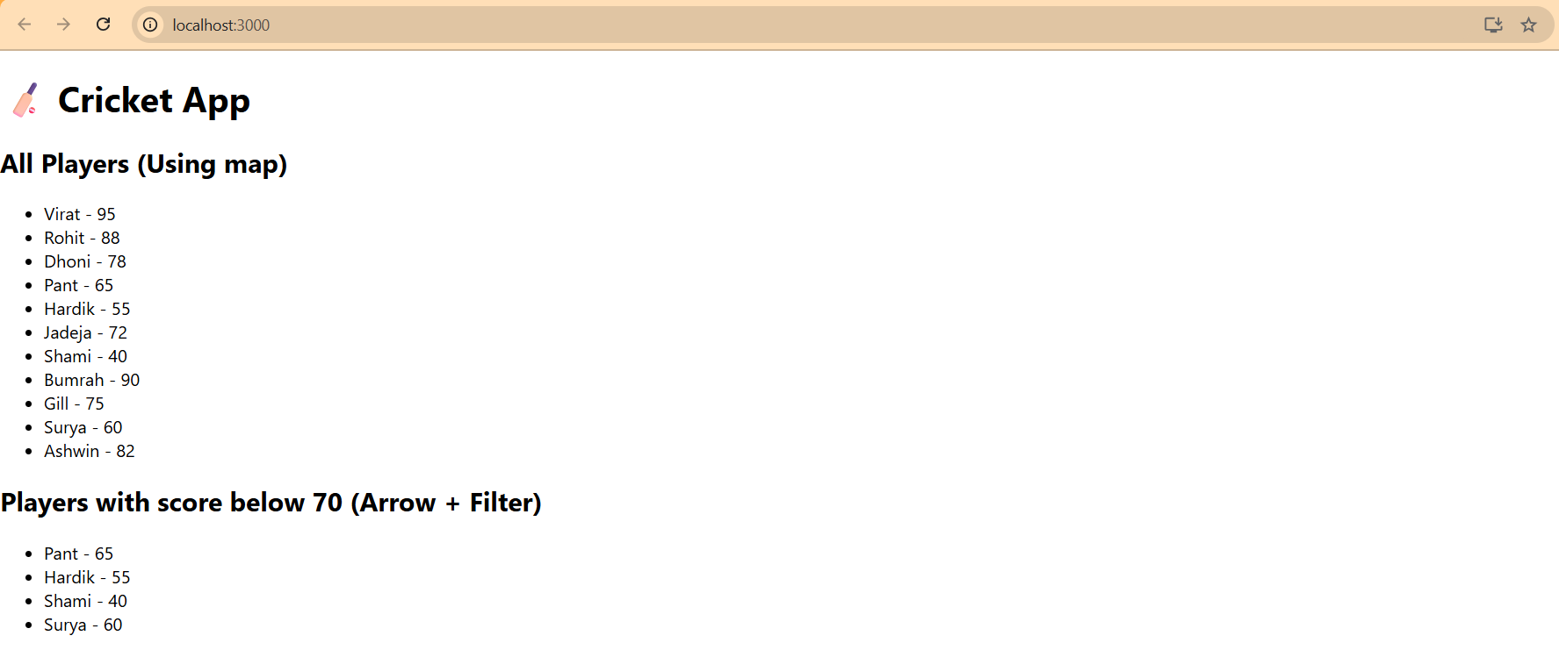

import React from 'react';

import ListofPlayers from './ListofPlayers';

import IndianPlayers from './IndianPlayers';

function App() {

const flag = false; // Change this to false to toggle

return (

<div className="App">

<h1>🏏 Cricket App</h1>

{flag ? <ListofPlayers /> : <IndianPlayers />}

</div>

);

}

export default App;

