Survey on Smart Glasses

Nitish Kumar Maurya¹, Sayan De¹, Shilanjan Ghosh¹ and M Bhattacharya²
¹Student of Information Technology, Haldia Institute of Technology,
West Bengal, India
²Faculty of Information Technology, Haldia Institute of Technology,
West Bengal, India

Abstract:
Currently, the smart glass is being widely used in various fields, from manufacturing to healthcare. In healthcare, smart glasses have the potential to improve patient outcomes by providing real-time feedback to clinicians, enabling remote consultations and collaborations, and enhancing the accuracy and efficiency of medical procedures. In manufacturing and other industries, smart glasses are used for improving worker safety and productivity by providing real-time data and instructions, thereby reducing the need for manual input and increasing the speed and accuracy of tasks. In logistics, smart glasses are used in warehouse workers to locate and pick items more efficiently, thus improving inventory management and reducing costs. Smart glasses are also being used in the education sector to provide an immersive experience to, and also gather feedback from the students. In the realm of entertainment, smart glasses are providing an immersive AR (Augmented Reality) or VR (Virtual Reality) experience for gaming and entertainment applications. Since it is a new & emerging technology, the user base is currently increasing at a rate of over 1.5 million per year [1] and the number of users is expected to increase even more in the upcoming years . Smart glasses with sensors and cameras are being used in various fields such as agriculture, healthcare, and accessibility. They enable real-time data collection for crop management, object recognition for the visually impaired, and observation of medical procedures. However, smart glasses also have limitations, including battery life, input methods, wireless communication issues, device weight, and data privacy concerns. Efforts are ongoing to address these challenges.

1. Introduction:
Smart glasses are wearable computing devices that look like regular eyeglasses but have a built-in display and computer processing capabilities. It is an innovative and interesting technology that is changing the way we interact with our physical surroundings. Smart glasses were first brought into reality in the 1980s by Steve Mann, a researcher at the University of Toronto. Mann created a wearable computer system that included a head-mounted display, camera, and other sensors, which he wore as a sort of personal assistant. It can be used for a variety of functions, like displaying information, providing augmented reality experiences, taking photos or videos, and even performing hands-free computing tasks. It typically uses wireless connectivity, such as Bluetooth, Wi-Fi or 5G, to connect to smartphones, tablets, or other devices, allowing users to access apps, receive notifications, or control other devices with voice commands or gestures. Smart glasses are equipped with cameras, sensors, and other technologies in order to provide real-time feedback, such as environmental monitoring or object recognition, which makes them useful for a variety of applications, from healthcare to industrial and commercial settings. The underlying technology of smart glasses can vary depending on it’s intended use case, but there are some common components that many smart glasses share. The following are some key technologies that are contributing in the development and functioning of smart glasses: Display, which is typically a small screen positioned in front of the wearer's eye, and can be transparent or opaque; Sensors, such as accelerometers, gyroscopes, and magnetometers, which can assist in tracking the wearer's head and eye movements, responding to user input such as gestures or voice commands, and also for object recognition; Wireless connectivity allows the glasses to connect to other devices such as smartphones or computers, while also enabling features such as internet access, app usage, and remote collaboration; Microprocessors allow the glasses to run software applications and perform tasks such as image processing, voice recognition, or artificial intelligence computations, etc.
In this survey, we have taken our references approximately from 2019 to 2022. Here, our objective was to find out how smart glasses are being used in various fields or workplaces, and also how they are impacting the efficiency of work. First, we studied the various methodologies related to the use of smart glasses in respective fields. For example, field workers performing soil contamination used a smart glass-based app which supports them in conducting preliminary investigations of heavy metal soil contamination using a handheld PXRF analyzer; Also, blind people, whose life is always in darkness, are using this technology to detect and identify objects around them using various sensors, visual and audio cues, to overcome the limitations of their lack of vision; This technology is even being used to improve the efficiency of training in the field of healthcare, like vascular surgery, where the students can study the structure of biological organisms using VR & AR models, and analyse the minute details in an extensive manner; Nowadays, tourism is the fastest-growing sectors in the world, and this technology is used by tourists to overcome the language barriers and gather more information about particular places, like their culture, ideology, history, etc. Since nothing is perfect in this world, everything has it’s own set of pros and cons, so do smart glasses. Hence, we studied their impact on the workspace, like how it is helping blind people come from dark to light. We have also discussed about the previous surveys done and the measurement of impact. With the growing demand and versatility of smart glasses in recent times, extensive research is being conducted in this field. This research aims to not only enhance the existing technology, but also overcome its current limitations.
2. Findings:

Field  &  Applications | Aim | Methodology | Results | Author  &  References
Application of Smart Glasses for Field Workers Performing Soil  Contamination Surveys with Portable Equipment | - Smart glass can be used to precisely control and monitor agricultural machinery and equipment, such as irrigation systems and crop-dusting drones. This can lead to more efficient and precise farming practices, resulting in higher yields and reduced costs.  - Smart glass can be used to monitor crop conditions in real-time, providing farmers with data about soil moisture, temperature, and other critical factors that can inform decision-making and improve crop yields.  - Smart glass can be used to improve worker safety by providing workers with real-time information about potential hazards and risks, such as hazardous chemicals or dangerous machinery.  - Smart glass can be used to provide on-the-job training and support, allowing experienced workers to remotely guide and assist less experienced workers.  - Smart glass can collect and analyse data about crop conditions, yield, and other factors, providing farmers with insights that can inform decision-making and improve farm operations. | - In this study, a smart glasses-based app, named the Mine Field Worker Support  (MFWS) system, was developed to support field workers in conducting preliminary investigations of heavy metal soil contamination using a handheld PXRF analyzer.  - A field worker wearing smart glasses moves to the survey point with the help of the app, and inputs the analysis result of the type and content of PTE in the soil measured using the PXRF analyzer into the app. As a result, it is possible to immediately check the evaluation results of each element according to the standards for heavy metal soil contamination and countermeasures prescribed by the Korean Soil Environment Conservation Act and the results of the heavy metal pollution index (PI) evaluation.  - In addition, it enables efficient collaboration with other workers through a cloud that allows real-time data sharing.  - The developed smart glasses-based apps were tested at the Ilgwang mine Korea.  - The workload of field workers wearing smart glasses was evaluated according to the NASA-TLX evaluation method. | Advantages:  - All data gathered from the smart glass can be seen using the glasses themselves, and are also synced with a mobile/PC app for future reference & further analysis.  - Data points can be linked with each other to create meaningful graphs and charts.  - The smart glasses is connected to the Internet / another base station using wireless technologies like WiFi, Bluetooth, 5G, etc. so it can outsource all of the data processing overhead to external servers.  - The calculated data is stored and processed through a real-time database cloud (accessible via the Internet), like Google Firebase. This makes it possible to store and analyse huge volumes of data at once.  - One can check the worker’s current location, current data & time, etc. It can also be used to keep tabs on whether the worker is doing his/her job properly or not.  - Country-wise soil pollution standards and analysis methods are already made available to the analysis software, so the smart glasses can make an accurate analysis based on the data.  - Smart glasses also increase work efficiency by freeing up both the hands of the worker.  Limitations:  - Workers were not familiar with wearing smart glasses, so in the initial days they felt like their work was delayed a bit. This, however, can be overcome by practice.  - Battery life is a major concern, since the smart glasses are equipped with cameras, GPS sensors, accelerometers, gyroscopes, etc. and there’s very little space to accommodate a long-lasting battery without increasing the dimensions & weight of the device.  - Sometimes, in order to take input from the worker, wearable keyboards were needed. However, carrying the wearable keyboard at all times was uncomfortable for some workers.  - An alternative to using wearable keyboards would be to use voice control in order to provide the inputs. This, however, can be a problem in noisy environments.  Improvements:  - Smart glasses equipped with sensors and cameras can help farmers collect real-time data on crop health, soil moisture, and other important factors. This data can be used to make more informed decisions about crop management and improve yields.  - Smart glasses allow farmers to work hands-free, which is especially useful when they need to use both hands to operate machinery or perform other tasks. This can increase efficiency and productivity.  - With smart glasses, farmers can receive remote assistance from experts in real-time. This can be especially helpful when dealing with complex issues or when working in remote locations.  - Smart glasses can also be used to provide farmers with training and educational materials. This can help them learn about new farming techniques, technologies, and practices. | Kim, D.; Choi, Y.  Application of Smart Glasses for  Field Workers Performing Soil  Contamination Surveys with Portable  Equipment.  Sustainability 2022, 14,  12370.  https://doi.org/10.3390/  su141912370
From the Lab to People’s Home: Lessons from Accessing Blind Participants’ Interactions via Smart Glasses in Remote Studies. | - Smart glass can be used to provide turn-by-turn directions and other navigation information to help blind people navigate unfamiliar places.  - Smart glass can be used to identify and describe objects in the environment, such as doors, stairs, and furniture, to help blind people better understand their surroundings.  - Smart glass can be used to recognize and identify the faces of people in the environment, helping blind people to better interact with others.  - Smart glass can be used to read text, such as signs and labels, aloud to help blind people understand written information.  - Smart glass can be used to provide audio descriptions of visual information, such as artwork and scenery, to help blind people better appreciate their surroundings. | - The team, including four sighted researchers and one blind researcher, used an iterative design process to devise a remote user study approach for the evaluation of a  smartphone testbed employing two different camera form factors:  a laptop camera and a camera embedded in smart glasses.  - They explored the potential and limitations of this approach in a remote  study with 12 blind participants, serving as a case study.  - Among them, two sighted researchers had extensive experience with employing this technology for in-person studies with blind participants. Specif-  ically, in collaboration with other sighted and blind collaborators,  they used a pair of Vuzix Blade smart glasses to explore blind people’s camera aiming behaviors for pedestrian detection and understand its social acceptability.  - In this initial investigation, blind participants were walking or standing, and the goal was for the smart glasses to capture any nearby pedestrians. | Advantages:  - During the remote study session, the experimenters could communicate in real time with the participants using dual video conferencing, using the Internet. This allowed the experimenters  It was easier to provide camera aiming guidance to the participants for smart glasses, compared to using a laptop camera.  - The smart glass can provide audio cues if the item is partially visible or fully visible, assisting the participant to aim the smart glass properly at the object.  - The participants quickly got used to wearing the smart glasses and using them to identify objects around them.  Limitations:  - There was variable latency even though the hotspot device used for the remote study session supported upto 5G nation-wide network. This sometimes made it difficult for participants to communicate with the experimenter and the experimenter to check on the participants in real time.  - Overusing the hotspot device sometimes resulted in the device overheating and malfunctioning, especially when the participants were taking a lot of photos and sending them back to the remote server. Sometimes, the hotspot completely stopped functioning and needed a restart.  - Since the participants are handling and interacting with unfamiliar devices, troubleshooting is unavoidable. Local troubleshooting was necessary for some devices which were being used alongwith the smart glasses, to assist it’s functionality. Devices like laptops, smartphones, etc. needed a bit of remote troubleshooting.  - Since participants were not used to the software, there was an instance when one of them had accidentally muted themselves on Zoom (a video conferencing software), and an experimenter had to go and fix the issue locally.  - When anyone encountered a hardware issue, the hardware had to be shipped back to the experimenter and then sent back to the participant.  - 2 types of experimenters were needed. One would be near the participants house to fix issues locally, and another would be conducting the study remotely.  Improvements:  - Smart glasses can provide blind people with real-time audio feedback on their surroundings, using cameras and sensors to detect obstacles, people, and other features of the environment. This can help them navigate safely and independently in unfamiliar places.  - Smart glasses equipped with object recognition technology can help blind people identify objects and read text, labels, and signs. This can be particularly useful for tasks like grocery shopping, finding items in a store, or reading medication labels.  - Smart glasses can facilitate communication between blind and sighted individuals, using features like speech-to-text and text-to-speech translation, as well as audio and video calls. This can help reduce social isolation and improve access to information and resources.  - Smart glasses can also provide access to information and services that may be difficult to obtain for blind people, such as visual descriptions of art, architecture, and other visual media.  - Smart glass can help blind people navigate unfamiliar places and complete tasks independently, enhancing their sense of independence and self-confidence. | Kyungjun Lee; Jonggi Hong; Ebrima Jarjue; Ernest Essuah Mensah;  Hernisa Kacorri.  2022.  In 19th Web for All Conference (W4A’22), April 25–26, 2022, Lyon, France. ACM, New York, NY, USA, 11 pages.  Version of Record:  https://doi.org/10.1145/3493612.3520448
Peripheral Vision: A New Killer App for Smart Glasses. | - Smart glasses can enhance the user's visual field by providing real-time information. They can improve situational awareness and help users to better understand their surroundings. They can also assist users with visual impairments or conditions such as tunnel vision, by expanding their field of vision and providing additional visual cues.  - Smart glasses can use cameras and sensors to capture images of the user's surroundings and display relevant information in their peripheral vision.  - This can be particularly useful in tasks that require a high level of awareness, such as driving, sports, and military operations.  - By improving peripheral vision, smart glasses can help users make more informed decisions and react more quickly to changing situations. | - In the paper, an MPV Model using color and motion to display visual cues in the peripheral vision of the user.  - The MPV Model is implemented within a navigation application. This application is then compared to a  standard navigation application on smartglasses, as  well as the same application on smartphone. The researchers were then able to isolate both the impact of peripheral  vision and use of smartglasses.  - Thanks to the model,  users spent on average 50% less time looking at the screen of the smartglasses.  - Furthermore, 90% agreed that the smartphone application was beneficial.  - Two specific cases were further discussed, namely strabis-mus and color-blindness, for which the MPV model  does not apply.  - Color-blindness changes the  color sensitivity of the eye, while strabismus impacts the eye mobility.  - Modifications were proposed to the  model to account for these specific cases. | Advantages:  - Navigating using peripheral vision on smart glasses was found to be less mentally taxing than navigating using central vision (by looking at a smartphone). This is especially true for car drivers, because it allows the driver to look at the screen of the smart glass while keeping their eyes on the road at all times. Also, users found it easier to walk up and down stairs using the smart glass navigation system, compared to a smartphone.  - Smart glasses do not really need any muscle activation for holding, i.e. the user does not need to hold it while using it. Compared to a smartphone, this results in less physical demand for the user. Also, the user can look at the screen of the smart glass through a shorter eye movement, compared to a smartphone screen.  - The users in general spent less time looking at the screen than in the case of a smartphone. This meant that they were less distracted by the smart glass and more focused towards their path.  Limitations:  - Color blindness is a condition where a person has difficulty distinguishing between certain colors, particularly red and green or blue and yellow. It’s most common form is red-green color blindness. Since the application was dependent on red & green visual cues, participants who suffered from color blindness found it difficult to use the devices. This also resulted in elevated mental stress & frustation levels.  - The smart glasses fail to serve their purpose for people suffering from complete color blindness (Achromatopsia). However, for the partially color blind, the visual cues can be re-adjusted to fit their needs.  - Strabismus is a vision condition where the eyes do not align properly, meaning that they do not point in the same direction at the same time, resulting in double vision. Participants suffering from this condition found it difficult to focus on the screen in front of their eyes. The short distance between their eyes & the screen on the smart glass, caused a slight eye strain to activate the eye. On the other hand, looking at a smartphone was a bit less strain.  Improvements:  - Smart glasses can improve peripheral vision by using cameras and sensors to capture images of the user's environment, then displaying that information in the user's field of view. The real-time feedback provided by smart glasses can help users detect objects or people that they may not have otherwise noticed, allowing them to navigate their environment more safely and confidently.  - Smart glasses can also be programmed to provide alerts or warnings when they detect potential hazards or obstacles in the user's path, further improving safety and reducing the risk of accidents. This can be particularly useful for people with visual impairments, who may have difficulty seeing objects or obstacles in their peripheral vision.  - Overall, the use of smart glasses in peripheral vision can improve mobility and independence for people with visual impairments, allowing them to navigate their environment more effectively and safely. Smart glasses can also be customized to meet the specific needs of individual users, with different settings and features to accommodate different levels and types of visual impairment. | Isha Chaturvedi; Farshid Hassani Bijarbooneh;  Tristan Braud;  Pan Hui.  2019.  In 24th International Conference on Intelligent User Interfaces (IUI ’19), March 17–20, 2019, Marina del Ray, CA, USA. ACM, New York, NY, USA, 14 pages.  Version of Record:  https://doi.org/10.1145/3301275.3302263
Applications of head-mounted displays and smart glasses in vascular surgery | - Smart glass can be used to provide real-time imaging of blood vessels and other structures, allowing surgeons to better visualize the surgical site and make more informed decisions during the procedure.  - Smart glass can be used to connect surgeons with remote experts and colleagues, allowing for real-time consultation and collaboration during the procedure.  - Smart glass can be used to provide trainees with an immersive, hands-on learning experience during surgeries, improving their skills and reducing the need for traditional training methods.  - Smart glass can provide surgeons with real-time information about the location and position of surgical instruments, improving their accuracy and reducing the risk of complications.  - Smart glass can be used to communicate important information to the surgical team, such as patient vital signs and medication information, enhancing communication and reducing the risk of errors. | - A comprehensive literature review was performed to introduce the fundamental concepts and provide an overview of applications of HMD and smart glasses in surgery.  - A study aimed to explore whether VR and AR could enhance student learning, engagement and performance. A total of 59 participants were allocated 3 learning modes: VR, AR or tablet-based applications and they underwent an anatomical knowledge assessment after a lesson of skull anatomy.  - While VR and AR offer an alternative to anatomical teaching on cadavers, the methods did not demonstrate a significant difference on the mean assessment score compared to tablet-based application. The users reported increased immersion and engagement with enjoyment in using new technology, but participants using VR experienced more frequently headaches, blurred vision or dizziness. They also highlighted the need of time to get used to the technology during the first utilization.  - Other investigators aimed to investigate if smart glasses could potentially improve surgical teaching by allowing the instructor to visualize “blind areas”. The use of the wearable surgical visualization system with Google Glass was tested by 11 surgery residents in a simulated operative field, in which the video was streamed from the leaner to the trainer in real time. The system allowed an efficient simultaneous visualization by the mentor and the resident of the operative field, with an improvement of the mean composite error, without a significant impact on task completion. Most of the users found the device unobtrusive, easy to operate and useful for communication and instruction.  - Liu et al. Investigated the interest of AR navigation system based on HoloLens for surgical training and telementoring. The study was conducted in a lab setting and the system used a stereo camera to track the 3D position of a scalpel and transfer its coordinates wirelessly to the HoloLens device. A scenario of surgical training was tested in which a virtual surgical scene with pre-recorded surgical annotations was superimposed with the physical surgical scene and the trainee had to operate following the virtual instructions. A scenario for telementoring was also evaluated in which the virtual surgical scene was co-registered with the physical scene and an experienced surgeon guided a virtual scalpel to provide the AR guidance to the inexperienced on-site operator. The performances of the system during the benchtop experiments demonstrated a tracking accuracy less than 2 mm.  - While this pilot study showed potentially encouraging results for the use of HMD for telementoring, disappointing findings were reported for the application of smart glasses in this setting.  - In a single-study institution involving 34 surgeons, 50% rated Google Glass video as fair and 50% as bad to poor for telementoring, mainly due to inadequate image quality. | Advantages:  - Students could learn about the various aspects of the surgery by communicating in real time with their trainer surgeons. This resulted in a better learning experience overall.  - Smart glasses can display images of the patient's blood vessels, allowing the surgeon to see the anatomy in real-time without having to look away from the surgical site. This can improve accuracy and reduce the risk of complications.  - Smart glasses can spot mistakes in the procedure done by the surgeon, and they can then be rectified by the surgeon in real time.  - Smart glasses help improve precision during surgical procedures.  Limitations:  - A technical assistant is still needed in order to help with the pre-operative data preparation, device initialisation, etc. before the surgeon takes over.  - Various aspects like weight of the device, comfort of use especially during long surgical procedures, battery life, etc. still have room for improvement.  - Since we’re talking about sensitive data of various patients, maintaining data privacy becomes a major concerns. Since wireless technologies are used to transmit the data, it is prone to man-in-the-middle attacks.  Improvements:  - Smart glasses can provide surgeons with real-time visual information during the procedure, allowing them to see the patient's blood vessels without having to look away from the surgical site. This can improve accuracy and reduce the risk of complications.  - Smart glass can provide surgeons with real-time information about the location and position of surgical instruments, improving their accuracy and reducing the risk of complications.  - Smart glasses can provide navigation and guidance during the procedure, helping the surgeon to identify and navigate complex blood vessels with greater precision.  - Smart glasses can enable remote collaboration and communication between the surgeon and other members of the surgical team, such as anesthesiologists or technicians.  - Smart glasses can be used for education and training purposes, allowing students or other surgeons to observe the procedure in real-time from the perspective of the surgeon.  - Smart glasses can enable surgeons to perform procedures without having to look away from the surgical site, reducing the need for assistance and improving the efficiency of the procedure. | Fabien Lareyre;  Arindam Chaudhuri;  Cédric Adam;  Marion Carrier;  Claude Mialhe;  Juliette Raffort.  Department of Vascular Surgery, Hospital of Antibes-Juan-les-Pins, France.  Université Côte d’Azur, CHU, Inserm U1065, C3M, Nice, France  Bedfordshire-Milton Keynes Vascular Centre, Bedfordshire Hospitals NHS Foundation  Trust, Bedford, UK.  Laboratory of Applied Mathematics and Computer Science (MICS), CentraleSupélec,  Université Paris-Saclay, France.  Cardiovascular Surgery Unit, Cardio Thoracic Centre of Monaco, Monaco.  Clinical Chemistry Laboratory, University Hospital of Nice, France.  Version of Record:  https://www.sciencedirect.com/science/article/pii/S0890509621002521
TouristicAR: A Smart Glass Augmented Reality  Application for UNESCO World Heritage Sites in  Malaysia | - Smart glass can be used to provide visitors with immersive, interactive tours of museums, historical sites, and other tourist attractions, enhancing the visitor experience and providing additional context and information.  - Smart glass can be used to provide real-time translation of signs, menus, and other written materials in foreign languages, helping visitors to navigate and understand their surroundings.  - Smart glass can be used to provide turn-by-turn directions and other navigation information to help visitors navigate unfamiliar places.  - Smart glass can be used to provide audio guides and commentary for tourist attractions, enhancing the visitor experience and providing additional context and information.  - Smart glass can be used to provide personalized recommendations for restaurants, activities, and other tourist attractions based on the visitor's preferences and interests. | - It was suggested that smart monocular glasses  were most suitable for consumer-related applications  compared to smart binocular glasses, which were suitable only for specific industrial applications.  - 2 smart glasses, namely "Google Glass Explorer Edition" by Google and "Vuzix M100" by Vuzix, were chosen.  - A survey was conducted to compare the features of both  the products side by side to find a better option in the context  of this work. Various online review blogs were also used to select the best option for this area of work.  - A number of  programming and design software along with coding libraries  were used to develop the Smart glass app.  - The smart glass  prototype application is built on the Android platform, and therefore the coding is done primarily using Java.  - Other software like Adobe Photoshop, Adobe Illustrator, Glassware flow  designer, etc. were also used for designing the  prototype.  - This prototype application was used in the UNESCO World Heritage site in the city of Malacca. | Advantages:  - Smart glasses can provide tourists with a more immersive experience by overlaying useful information on top of the real-world environment.  - They can detect various objects and provide information about them, in real time.  - They can also help tourists navigate unfamiliar environments more safely by providing real-time information on potential hazards or obstacles.  - They are helpful in overcome language barriers by providing real-time language translation services.  Limitations:  - If the smart glass is heavy, it will be too uncomfortable and painful for the wearer to last an entire day of sightseeing.  - Smart glasses require a significant amount of power to operate, and their battery life may not last an entire day of sightseeing.  - The range of applications available for smart glasses in tourism is still relatively limited compared to other devices, such as smartphones.  - Smart glasses can raise privacy concerns if they are used to capture images or collect personal data without the user's knowledge or consent.  - Smart glasses are still a relatively new technology, and they may be subject to technical issues orglitches that could impact the user experience, and they may not be able to use the device to it’s fullest potential.  Improvements:  - Smart glass can provide visitors with real-time information and personalized recommendations, enhancing their overall experience and making their trip more enjoyable.  - Smart glass can provide turn-by-turn directions and other navigation information, making it easier for visitors to navigate unfamiliar places and find their way around.  - Smart glass can provide immersive and interactive tours of museums, historical sites, and other tourist attractions, increasing visitor engagement and providing additional context and information.  - Smart glass can provide personalized recommendations for restaurants, activities, and other tourist attractions based on the visitor's preferences and interests, making their trip more tailored to their individual needs.  - Smart glass can help visitors avoid hazards and navigate potentially dangerous environments, improving their safety and reducing the risk of accidents.  - Smart glass can help reduce the cost of providing tours and other tourist services, as it eliminates the need for traditional audio guides and other equipment. | Waqas Khalid Obeidy;  Haslina Arshad;  Jiung Yao Huang.  Center for Artificial Intelligence Technology, Faculty of Information Science and Technology,  Universiti Kebangsaan Malaysia.  Maxpower System Co. Ltd. Taipei, Taiwan.  waqas@siswa.ukm.edu.my

3. Discussion:
A number of survey related to smart glasses have already been conducted in the past, and the impacts of the technology in various fields, were recorded.

3.1 Soil Contamination:

Heavy metal | Cu | Cd | Pb | Zn | Ni | As | Cr
Possible limit | 100 | 3 | 100 | 300 | 50 | 20 | 100
Table 1: Heavy metal contamination tolerance level (mg/kg). [2]

Case | Total Measurement Time of Heavy Metal Content  (Including Soil Sample Preparation)  (min) | Total Data Sharing Time (min)
Previous study without smart  glasses-based application | 57.5 | 26.8
This study with smart  glasses-based application | 37.0 | 2.4
Table 2: Comparison of heavy metal content measurement and data sharing time without and with smart glasses-based application. [3]

3.2 Accessibility (Blindness):
After the outbreak of COVID-19, many accessibility researchers switched to a remote format for their user studies and shared best practices with the community. With a focus on remote studies that involve people with visual impairments over the past two years, we observe that common approaches employed by researchers spanned online surveys, audio calls, and video conferencing. The majority conducted either an online survey or an interview via a call few did both.[4]

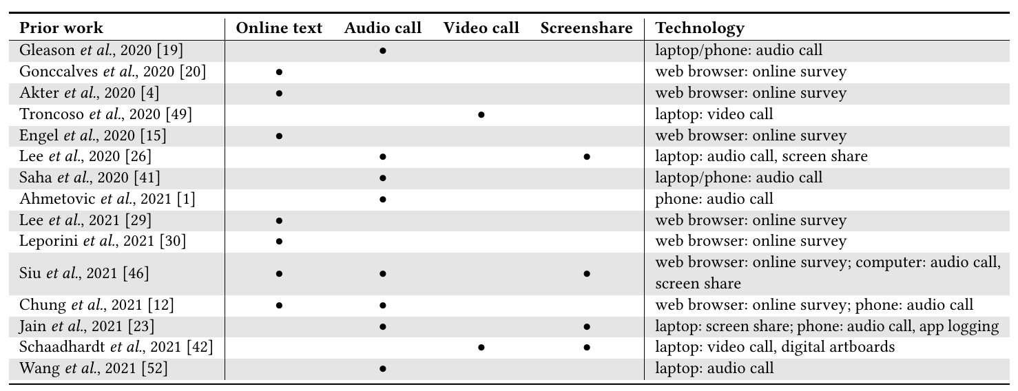
Table 3: Approaches in remote studies with blind and low vision participants during the pandemic (2020-2021). [5]

3.3 Peripheral Vision:
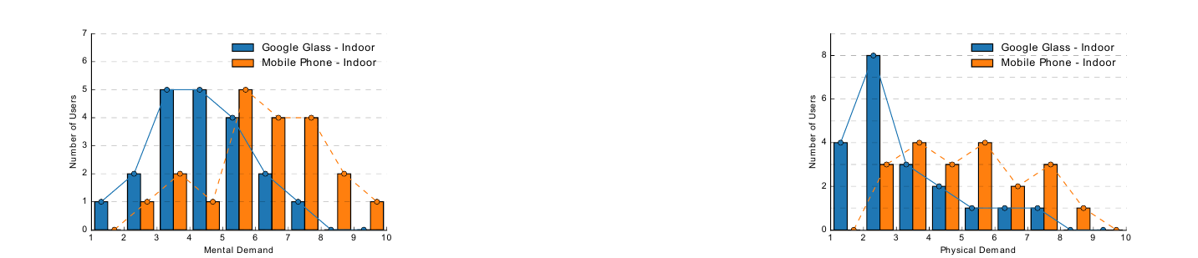
Fig. 1: Mental demand of 20 users (indoors) [6] Fig. 2: Physical demand of 20 users (indoors) [7]
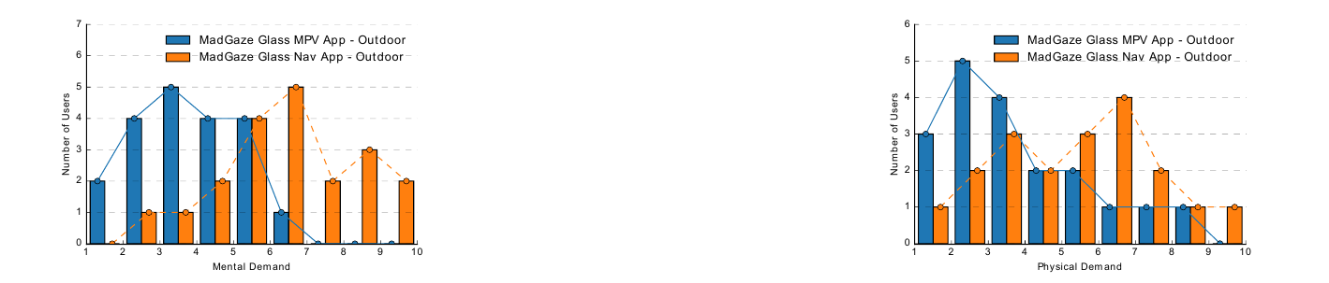
Fig. 3: Mental demand of 20 users (outdoors) [8] Fig. 4: Physical demand of 20 users (outdoors) [9]

3.4 General Study:
This study analyzed the number of research papers published on smart glasses from January 2014 to October 2020 to determine research trends. The number of papers related to smart glasses had been increasing since 2014 but declined in 2017 due to the release of Google Glass. However, the number of published papers has skyrocketed since then and has been steadily increasing up to 2020. Out of 57 papers, 43 were published after 2017. The study found that 74% of the papers were published during the last 3 years. [10]
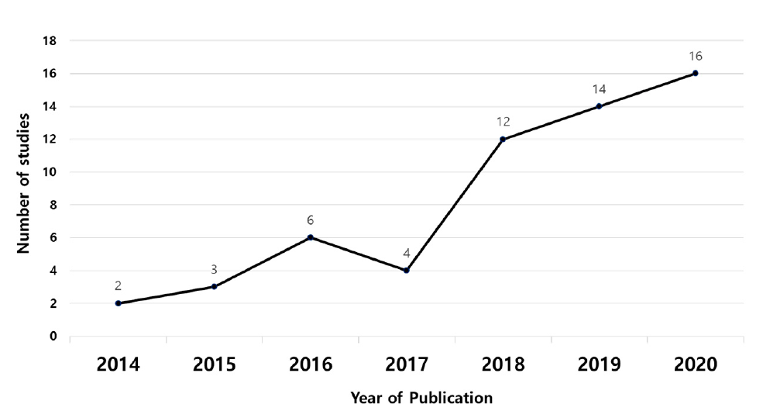
Fig. 5: The number of articles published each year between January 2014 and October 2020 [11]

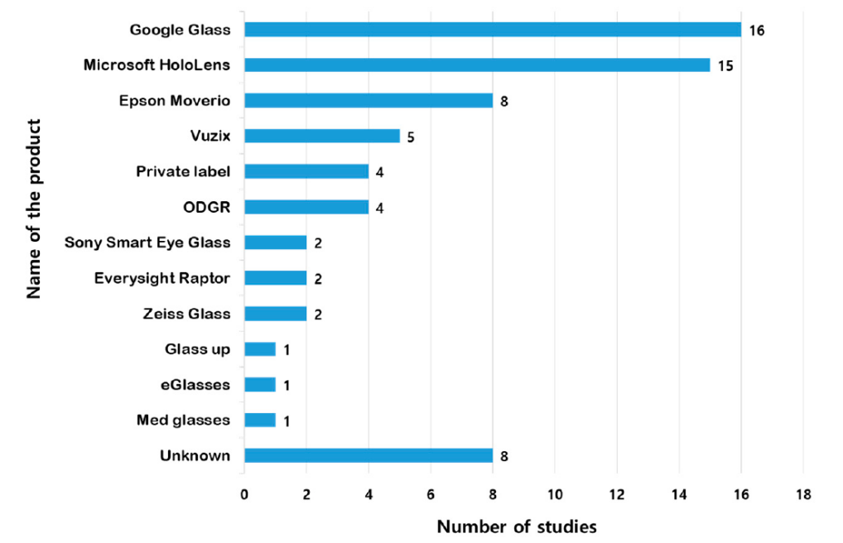
Of the 57 studies in the first category, 21 were healthcare-related studies, with 36% of the 7 areas being the most active. Computer science was included in 11 cases and social science in 7 cases. Industry had six studies, and service had four, which was the smallest number. In the second stage, the subfields in which smart glasses were employed and the corresponding ratios were analyzed. [12]
Fig 6: Frequency of use based on model of smart glasses. [13]

In this study, smart glasses were found to be used in various fields, although the purpose of their application may be different. Smart glasses have been used for one or more purposes. Therefore, the research was categorized based on the purpose of using the smart glasses, excluding the fields of use. Because smart glasses play the most visual role, most research aims to convey other information to the user’s line of sight. Therefore, 32 studies were performed to convey the information obtained from smart glasses and then to visualize such information. Visualization and information transmission corresponded to 32 and 29 studies, respectively, accounting for 65% of the total utilization purpose. In addition, nine studies were aimed at notifying users of dangers using acquired data and eight studies
were aimed at sharing information. [14]
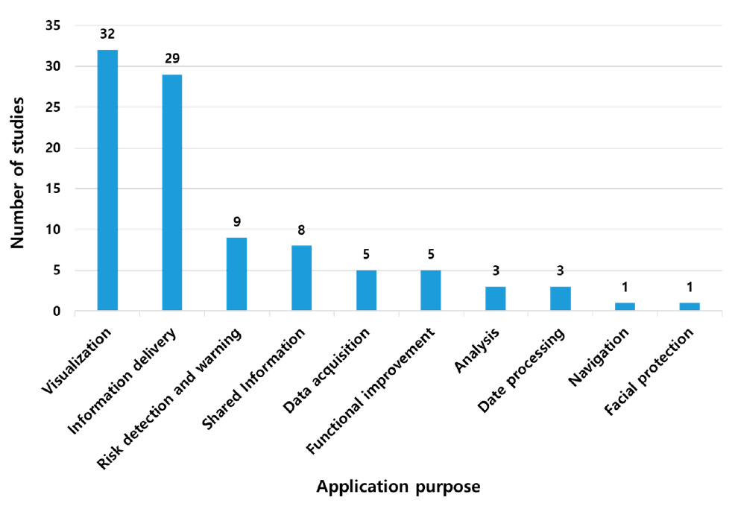
Fig. 7: Number of studies based on research purpose. [15]

4. Conclusion:
As we have seen, smart glasses are proving to be a very useful and versatile piece of technology. It is being used in various fields with numerous advantages as well as limitations. It is a growing area of technology with exponential market growth being observed in recent times. Recently conducted surveys have proved it’s usefulness and efficiency in various real life scenario. In addition, it’s also saving the users a lot of time and resources, and making their lives easier. Also, extensive research & groundwork is being done to resolve it’s current limitations.

5. References:
[1] Laricchia, F. U.S. workforce: smart glasses users 2016-2025. 2022, 14, 02.
[2,3] Kim, D.; Choi, Y. Application of Smart Glasses for Field Workers Performing Soil Contamination Surveys with Portable Equipment. Sustainability 2022, 14, 12370. https://doi.org/10.3390/su141912370
[4,5] Kyungjun Lee, Jonggi Hong, Ebrima Jarjue, Ernest Essuah Mensah, and Hernisa Kacorri. 2022. From the Lab to People’s Home: Lessons from Accessing Blind Participants’ Interactions via Smart Glasses in Remote Studies. In 19th Web for All Conference (W4A’22), April 25–26, 2022, Lyon, France. ACM, New York, NY, USA, 11 pages. https://doi.org/10.1145/3493612.3520448
[6,7,8,9] Isha Chaturvedi, Farshid Hassani Bijarbooneh, Tristan Braud, and Pan Hui. 2019. Peripheral Vision: A New Killer App for Smart Glasses. In 24th International Conference on Intelligent User Interfaces (IUI ’19), March 17–20, 2019, Marina del Ray, CA, USA. ACM, New York, NY, USA, 14 pages. https://doi.org/10.1145/3301275.3302263
[10,11,12,13,14,15] Kim, D.; Choi, Y. Applications of Smart Glasses in Applied Sciences: A Systematic Review. Appl. Sci. 2021, 11, 4956. https://doi.org/10.3390/app11114956

