**Survey on Smart Glasses**

1Nitish Kumar Maurya, 1Sayan De, 1Shilanjan Ghoshand 2Manasija Bhattacharya

*1Student of Information Technology, Haldia Institute of Technology,*

*West Bengal, India*

*2Faculty of Information Technology, Haldia Institute of Technology,*

*West Bengal, India*

**Abstract:**

Currently, the smart glass is being widely used in various fields, from manufacturing to healthcare. In healthcare, smart glasses have the potential to improve patient outcomes by providing real-time feedback to clinicians, enabling remote consultations and collaborations, and enhancing the accuracy and efficiency of medical procedures. In manufacturing and other industries, smart glasses are used for improving worker safety and productivity by providing real-time data and instructions, thereby reducing the need for manual input and increasing the speed and accuracy of tasks. In logistics, smart glasses are used in warehouse workers to locate and pick items more efficiently, thus improving inventory management and reducing costs. Smart glasses are also being used in the education sector to provide an immersive experience to, and also gather feedback from the students. In the realm of entertainment, smart glasses are providing an immersive AR (Augmented Reality) or VR (Virtual Reality) experience for gaming and entertainment applications. Since it is a new & emerging technology, the user base is currently increasing at a rate of over 1.5 million per year [1] and the number of users is expected to increase even more in the upcoming years. Smart glasses with sensors and cameras are being used in various fields such as agriculture, healthcare, and accessibility. They enable real-time data collection for crop management, object recognition for the visually impaired, and observation of medical procedures. However, smart glasses also have limitations, including battery life, input methods, wireless communication issues, device weight, and data privacy concerns. Efforts are ongoing to address these challenges.

**1. Introduction:**

Smart glasses are wearable computing devices that look like regular eyeglasses but have a built-in display and computer processing capabilities. It is an innovative and interesting technology that is changing the way we interact with our physical surroundings. Smart glasses were first brought into reality in the 1980s by Steve Mann, a researcher at the University of Toronto. Mann created a wearable computer system that included a head-mounted display, camera, and other sensors, which he wore as a sort of personal assistant. It can be used for a variety of functions, like displaying information, providing augmented reality experiences, taking photos or videos, and even performing hands-free computing tasks. It typically uses wireless connectivity, such as Bluetooth, Wi-Fi or 5G, to connect to smartphones, tablets, or other devices, allowing users to access apps, receive notifications, or control other devices with voice commands or gestures. Smart glasses are equipped with cameras, sensors, and other technologies in order to provide real-time feedback, such as environmental monitoring or object recognition, which makes them useful for a variety of applications, from healthcare to industrial and commercial settings. The underlying technology of smart glasses can vary depending on it’s intended use case, but there are some common components that many smart glasses share. The following are some key technologies that are contributing in the development and functioning of smart glasses: **Display**, which is typically a small screen positioned in front of the wearer's eye, and can be transparent or opaque; **Sensors**, such as accelerometers, gyroscopes, and magnetometers, which can assist in tracking the wearer's head and eye movements, responding to user input such as gestures or voice commands, and also for object recognition; **Wireless connectivity** allows the glasses to connect to other devices such as smartphones or computers, while also enabling features such as internet access, app usage, and remote collaboration; **Microprocessors** allow the glasses to run software applications and perform tasks such as image processing, voice recognition, or artificial intelligence computations, etc.

In this survey, we have taken our references approximately from 2019 to 2022. Here, our objective was to find out how smart glasses are being used in various fields or workplaces, and also how they are impacting the efficiency of work. First, we studied the various methodologies related to the use of smart glasses in respective fields. For example, field workers performing soil contamination used a smart glass-based app which supports them in conducting preliminary investigations of heavy metal soil contamination using a handheld PXRF analyzer; Also, blind people, whose life is always in darkness, are using this technology to detect and identify objects around them using various sensors, visual and audio cues, to overcome the limitations of their lack of vision; This technology is even being used to improve the efficiency of training in the field of healthcare, like vascular surgery, where the students can study the structure of biological organisms using VR & AR models, and analyse the minute details in an extensive manner; Nowadays, tourism is the fastest-growing sectors in the world, and this technology is used by tourists to overcome the language barriers and gather more information about particular places, like their culture, ideology, history, etc. Since nothing is perfect in this world, everything has it’s own set of pros and cons, so do smart glasses. Hence, we studied their impact on the workspace, like how it is helping blind people come from dark to light. We have also discussed about the previous surveys done and the measurement of impact. With the growing demand and versatility of smart glasses in recent times, extensive research is being conducted in this field. This research aims to not only enhance the existing technology, but also overcome its current limitations.

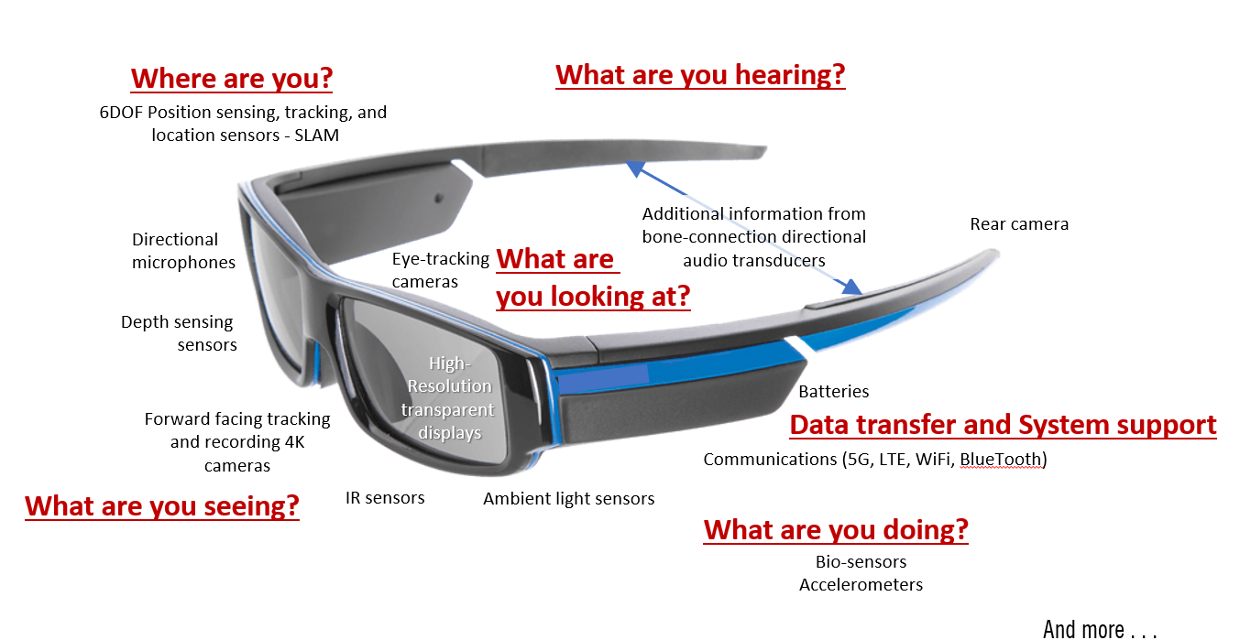2. **Features of Smart Glasses:**

**Fig. 1: Smart Glass** [1+1]

Smart glasses are wearable computing devices that look like regular eyeglasses but have a built-in display and computer processing capabilities. It is an innovative and interesting technology that is changing the way we interact with our physical surroundings. It can be used for a variety of functions, like displaying information, providing augmented reality experiences, taking photos or videos, and even performing hands-free computing tasks.

Here are the main features of smart glasses:

a) **Display**: Smart glasses typically have a small screen, which is positioned in front of the wearer's eye. The screen is used to display information or provide Augmented Reality (AR) / Virtual Reality (VR) experiences. It can be either transparent or opaque.

b) **Sensors**: Smart glasses are equipped with multiple sensors such as accelerometers, gyroscopes, and magnetometers. These sensors track the wearer's head and eye movements, which helps the smart glass respond to gestures or voice commands, and provide features like object & face recognition and environmental monitoring.

c) **Wireless** **Connectivity**: Smart glasses use wireless connectivity, like Bluetooth, Wi-Fi, or 5G, to transmit/receive data to/from other devices such as smartphones or computers. Thus, functions like data analysis, app usage, and remote collaboration can be performed externally, thus reducing the amount of on-board processing power required.

d) **Camera**: Smart glasses have built-in cameras, thus enabling features such as image recognition or video conferencing.

e) **Microphone**: Smart glasses are equipped with microphones, which the user can use to provide input.

2. **Findings**:

|  |  |  |  |  |
| --- | --- | --- | --- | --- |
| **Author**  **&**  **References** | **Methodology** | **Advantages** | **Disadvantages** | **Improvements** |
| **Application of Smart Glasses for Field Workers Performing Soil Contamination Surveys with Portable Equipment.**  Kim, D.; Choi, Y.  Sustainability 2022, 14,  12370.  [https://doi.org/10.3390/](https://doi.org/10.3390/su141912370)  [su141912370](https://doi.org/10.3390/su141912370) | - An app-based Mine Field Worker Support (MFWS) system developed for use by workers with a handheld PXRF analyzer.  - Test location: Ilgwang mine, Korea.  - The workload of field workers evaluated according to the NASA-TLX evaluation method. | a) All gathered data can be synced with an app for future reference & further analysis.  b) Meaningful data analysis is possible.  c) The data processing can be outsourced through a real-time database cloud, since the smart glasses is connected to the Internet.  d) Smart glasses also increase work efficiency by freeing up both the hands of the worker. | 1. Workers were not familiar with wearing smart glasses, so in the initial days they felt like their work was delayed a bit. 2. Battery life was a major concern, since the smart glasses have a lot of sensors, and there’s very little space to accommodate a long-lasting battery in that limited space.   c) Voice control was used as an input method, but it was not feasable in noisy environments. | a) The collected real-time data can be analysed to take meaningful decisions and improve yields.  b) Hands-free operation of the workers can increase efficiency and productivity.  c) Farmers can receive remote assistance from experts in real-time, which helps deal with complex issues. |
| **From the Lab to People’s Home: Lessons from Accessing Blind Participants’ Interactions via Smart Glasses in Remote Studies.**  Kyungjun Lee; Jonggi Hong; Ebrima Jarjue; Ernest Essuah Mensah;  Hernisa Kacorri.  2022.  In 19th Web for All Conference (W4A’22), April 25–26, 2022, Lyon, France. ACM, New York, NY, USA, 11 pages.  Version of Record:  <https://doi.org/10.1145/3493612.3520448> | - Research team comprised of four sighted researchers and one blind researcher.  - 12 blind participants participated in the case study.  - A pair of Vuzix Blade smart glasses were used.  - Two different camera form factors were evaluated, a laptop camera and a camera embedded in smart glasses.  Parameters evaluated:  - The ability of the smart glasses to capture any nearby pedestrians.  - The camera aiming behaviors of the blind participants.  - Social acceptability. | a) Experimenters could communicate in real time with the participants using dual video conferencing, using the Internet.  b) Providing camera aiming guidance to the participants was easier in case of smart glasses.  c) The smart glass can provide audio cues if the item is partially visible or fully visible.  d) The participants quickly got used to wearing the smart glasses and using them to identify objects around them. | a) There was variable latency when using the Internet, which sometimes made the 2-way communication difficult.  b) Overusing the hotspot device sometimes resulted in the device overheating and malfunctioning. Often times, it needed a restart.  c) 2 types of experimenters were needed. One would be near the participants house to fix issues locally, and another would be conducting the study remotely. | a) Smart glasses can detect obstacles, people, and other features of the environment. This helps blind people navigate safely and independently in unfamiliar places.  b) They can also read text, labels, and signs, for tasks like grocery shopping, finding items in a store, or reading medication labels.  c) Features like speech-to-text and text-to-speech translation, audio and video calls help them to stay in touch with the world around them.  d) They can complete tasks independently, thus enhancing their sense of independence and self-confidence. |
| **Peripheral Vision: A New Killer App for Smart Glasses.**  Isha Chaturvedi; Farshid Hassani Bijarbooneh;  Tristan Braud;  Pan Hui.  2019.  In 24th International Conference on Intelligent User Interfaces (IUI ’19), March 17–20, 2019, Marina del Ray, CA, USA. ACM, New York, NY, USA, 14 pages.  Version of Record:  https://doi.org/10.1145/3301275.3302263 | - An MPV Model using color and motion to display visual cues in the peripheral vision of the user. It is implemented within a navigation application.  - The researchers were able to isolate both the impact of peripheral  vision and use of smartglasses, by comparing the MPV model with standard applications.  - Two specific cases were further discussed, namely strabis-mus and color-blindness, for which the MPV model  does not apply. | a) Navigating using peripheral vision on smart glasses was found to be less mentally taxing than navigating using central vision (by looking at a smartphone), because they can be more focused towards their path.  b) The users in general spent less time looking at the screen than in the case of a smartphone.  c) Smart glasses did not really need any muscle activation for holding, which resulted in less physical demand for the user. | a) Since the application was dependent on red & green visual cues, participants who suffered from color blindness found it difficult to use the devices, resulting in elevated mental stress & frustation levels.  b) For the partially color blind, the visual cues can be re-adjusted to fit their needs.  c) Participants suffering from complete colour blindness (Achromatopsia) did not benefit from using this model. | a) The real-time feedback provided by smart glasses can help users detect objects or people around them, thus allowing them to navigate their environment more safely and confidently.  b) They can provide alerts or warnings when they detect potential hazards or obstacles in the user's path.  c) It can improve mobility and independence for people with visual impairments.  d) Smart glasses can also be customized to meet the specific needs of individual users, like those with specific health conditions. |
| **Applications of head-mounted displays and smart glasses in vascular surgery.**  Fabien Lareyre;  Arindam Chaudhuri;  Cédric Adam;  Marion Carrier;  Claude Mialhe;  Juliette Raffort.  Department of Vascular Surgery, Hospital of Antibes-Juan-les-Pins, France.  Université Côte d’Azur, CHU, Inserm U1065, C3M, Nice, France  Bedfordshire-Milton Keynes Vascular Centre, Bedfordshire Hospitals NHS Foundation  Trust, Bedford, UK.  Laboratory of Applied Mathematics and Computer Science (MICS), CentraleSupélec,  Université Paris-Saclay, France.  Cardiovascular Surgery Unit, Cardio Thoracic Centre of Monaco, Monaco.  Clinical Chemistry Laboratory, University Hospital of Nice, France.  Version of Record:  <https://www.sciencedirect.com/science/article/pii/S0890509621002521> | - A comprehensive literature review was performed to provide an overview of applications of HMD and smart glasses in surgery. The study aimed to explore whether VR and AR could enhance student learning, engagement and performance.  - A total of 59 participants were allocated 3 learning modes: VR, AR or tablet-based applications.  - Most of the users found the device unobtrusive, easy to operate and useful for communication and instruction.  - The performances of the system during the benchtop experiments demonstrated a tracking accuracy less than 2 mm. | a) Students could learn about the various aspects of the surgery by communicating in real time with their trainer surgeons, leading to improved accuracy and reduced risk of complications.  b) Smart glasses can display images of the patient's blood vessels, allowing the surgeon to see the anatomy in real-time without having to look away from the surgical site.  c) Smart glasses can spot mistakes in the procedure done by the surgeon, which can then be rectified by the surgeon.  d) They also improve precision during surgical procedures. | a) A technical assistant is still needed to assist with the device initialisation before the surgeon can begin using it.  b) Comfort of use, especially during long surgical procedures, can still be improved.  c) Since we’re talking about sensitive data of various patients, maintaining  d) Data privacy is a major concern since we’re talking about sensitive patient data. | a) Smart glasses allow surgeons & students to see the patient's blood vessels without having to look away from the surgical site, which improves accuracy and reduce the risk of complications.  b) Smart glasses can provide navigation and guidance during the procedure, helping the surgeon to identify and navigate complex blood vessels with greater precision.  c) They can provide opportunities collaboration and communication.  d) They can be used for education and training purposes. |
| **TouristicAR: A Smart Glass Augmented Reality Application for UNESCO World Heritage Sites in Malaysia.**  Waqas Khalid Obeidy;  Haslina Arshad;  Jiung Yao Huang.  Center for Artificial Intelligence Technology, Faculty of Information Science and Technology,  Universiti Kebangsaan Malaysia.  Maxpower System Co. Ltd. Taipei, Taiwan.  waqas@siswa.ukm.edu.my | - It was suggested that smart monocular glasses  were most suitable for consumer-related applications.  - 2 smart glasses, "Google Glass Explorer Edition" by Google and "Vuzix M100" by Vuzix, were chosen.  - A survey was conducted to compare the features of both the products side by side to find the better choice out of these two.  - A number of  programming and design software along with coding libraries  were used to develop app.  - A prototype application, build on the Android platform, was used in the UNESCO World Heritage site in the city of Malacca. | a) Smart glasses can provide tourists with a more immersive experience by overlaying useful information on top of the real-world environment.  b) They can detect various objects and provide information about them, in real time.  c) They can also help tourists navigate unfamiliar environments safely by identifying potential hazards or obstacles.  d) They are helpful in overcome language barriers, by providing language translation services. | a) Smart glasses require a significant amount of power to operate, and their battery life may not last an entire day of sightseeing.  b) If they’re too heavy, wearing them for a full day may be uncomfortable for the user.  c) application support for smart glasses, is limited.  d) Privacy concerns can occur if they accidentally capture images or collect personal data without the user's consent.  e) Smart glasses are still a relatively new technology, so technical issues and glitches that could impact the user experience, are expected. | a) Smart glass can provide visitors with real-time information and, thus enhancing their overall experience.  b) Personalized recommendations, which are tailored to the individual’s needs, can be provided.  c) Smart glass can provide turn-by-turn directions, helping tourists find their way around. They can also help identify hazards and potentially dangerous environments.  d) Smart glass can provide immersive and interactive tours of tourist attractions, increasing visitor engagement.  e) They can help reduce the cost of providing tours and other tourist services. |

**Table 1: Methodology, Advantages, Disadvantages & Improvements of smart glasses in different fields.**

|  |  |
| --- | --- |
| **Field**  **&**  **Applications** | **Aim** |
| Application of Smart Glasses for Field Workers Performing Soil  Contamination Surveys with Portable Equipment | - To develop a smart glasses-based app, named the Mine Field Worker Support (MFWS) system, to support field workers in conducting preliminary investigations of heavy metal soil contamination using a handheld PXRF analyzer.  - To check the evaluation results of each element according to the standards for heavy metal soil contamination and countermeasures prescribed by the Korean Soil Environment Conservation Act. |
| From the Lab to People’s Home: Lessons from Accessing Blind Participants’ Interactions via Smart Glasses in Remote Studies. | - To use an iterative design process to devise a remote user study approach for the evaluation of a smartphone testbed employing two different camera form factors: a laptop camera and a camera embedded in smart glasses.  - To explore the potential and limitations of this approach in a remote study with 12 blind participants, serving as a case study. |
| Peripheral Vision: A New Killer App for Smart Glasses. | - To design an MPV Model using color and motion to display visual cues in the peripheral vision of the user.  - To implement the MPV Model within a navigation application.  - To compare this application to a standard navigation application on smartglasses, as well as the same application on smartphone.  - To isolate both the impact of peripheral vision and use of smartglasses. |
| Applications of head-mounted displays and smart glasses in vascular surgery. | - To perform a comprehensive literature review to introduce the fundamental concepts and provide an overview of applications of HMD and smart glasses in surgery.  - To explore whether VR and AR can enhance student learning, engagement and performance.  - To investigate if smart glasses could potentially improve surgical teaching by allowing the instructor to visualize “blind areas”. |
| TouristicAR: A Smart Glass Augmented Reality  Application for UNESCO World Heritage Sites in  Malaysia. | - To provide visitors with immersive, interactive tours of museums, historical sites, and other tourist attractions, enhancing the visitor experience and providing additional context and information.  - To provide real-time translation of signs, menus, and other written materials, in a foreign language.  - To provide turn-by-turn directions and other navigation information, and help avoid hazardous environments and obstacles. |

**Table 2: Application & Aim of smart glasses in different fields.**

**3. Discussion**:

A number of survey related to smart glasses have already been conducted in the past, and the impacts of the technology in various fields, were recorded.

**3.1 Soil Contamination:**

|  |  |  |  |  |  |  |  |
| --- | --- | --- | --- | --- | --- | --- | --- |
| Heavy metal | **Cu** | **Cd** | **Pb** | **Zn** | **Ni** | **As** | **Cr** |
| Possible limit | 100 | 3 | 100 | 300 | 50 | 20 | 100 |

**Table 3: Heavy metal contamination tolerance level (mg/kg).** [2]

In the preliminary survey of soil pollution, the soil pollution standards prescribed by the Korea Soil Environment Conservation Act and pollution index (PI) were used. First, the degree of soil pollution was evaluated by applying the PI using the data acquired via PXRF for the soil in the evaluation area. Next, according to the soil pollution conservation standards in Korea, it was judged whether the soil pollution standard value of each element was exceeded. The PI is based on the tolerance level proposed by Kloke (**Table 3**). A PI value of 1.0, or higher, not only indicates that the heavy metal content in the soil is above the permissible limit value on average, but also that an area is contaminated by artificial or natural factors. Additionally, a PI of less than 1.0 indicates an uncontaminated soil area. The contamination status of each element was divided into three stages according to the Korean soil environment conservation method. [3]

|  |  |  |
| --- | --- | --- |
| **Case** | **Total Measurement Time of Heavy Metal Content**  **(Including Soil Sample Preparation)**  **(min)** | **Total Data Sharing Time (min)** |
| Previous study without smart  glasses-based application | 57.5 | 26.8 |
| This study with smart  glasses-based application | 37.0 | 2.4 |

**Table 4: Comparison of heavy metal content measurement and data sharing time without and with smart glasses-based application.** [4]

**Table 4** presents the total measurement time of heavy metal content using the PXRF analyzer and the total data sharing time with other field workers at 10 points for both studies. Based on the comparison results, we can confirm that the smart glasses-based app has the following advantages for field workers performing soil contamination surveys with a PXRF analyzer. First, the smart glasses worn on the face can simplify the equipment and allow the worker to freely use both hands. Therefore, the total measurement time for heavy metal content (including soil sample preparation) at sampling points could be reduced compared to the previous study using a notebook PC. Second, the smart glasses-based app can process and share data with other field workers in real-time. Therefore, the evaluation results and PI values for each heavy metal element could be obtained immediately, and the data sharing time with others could be shortened compared to the previous study. The real-time data sharing enables several field workers to collaborate effectively and facilitates communication between field workers and managers, thereby managing the work plan flexibly according to the situation. [5]

**3.2 Accessibility (Blindness):**

After the outbreak of COVID-19, many accessibility researchers switched to a remote format for their user studies and shared best practices with the community. With a focus on remote studies that involve people with visual impairments over the past two years, we observe that common approaches employed by researchers spanned online surveys, audio calls, and video conferencing. The majority conducted either an online survey or an interview via a call few did both. [6]

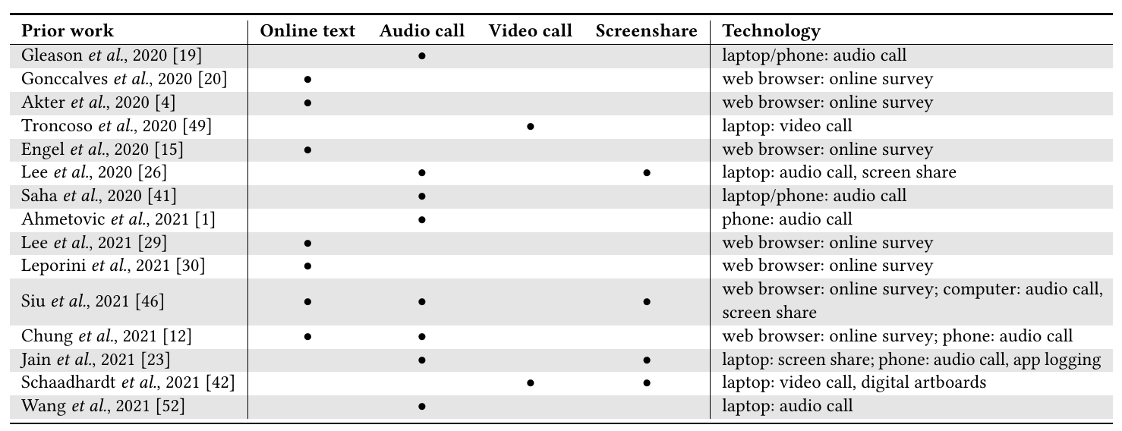**Table 5: Approaches in remote studies with blind and low vision participants during the pandemic (2020-2021).** [7]

**3.3 Peripheral Vision:**

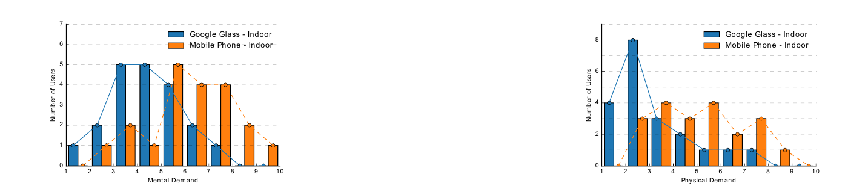**Fig. 2: Mental demand of 20 users (indoors)** [8] **Fig. 3: Physical demand of 20 users (indoors)** [9]

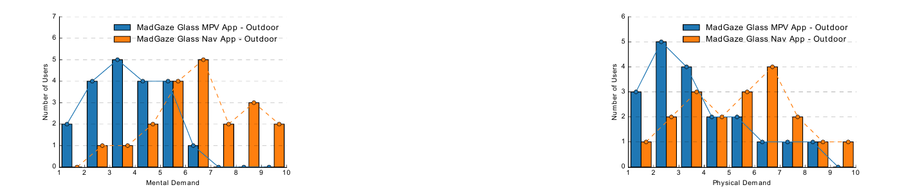**Fig. 4: Mental demand of 20 users (outdoors)** [10] **Fig. 5: Physical demand of 20 users (outdoors)** [11]

**Figures 2 and 4** show the mental demand reported by users while performing the experiment respectively indoors and outdoors. The average mental demand required by 20 users in performing the experiment using Google Glass is 3.8. When using the smartphone, participants show a much higher mental demand, with much more variance in the results. If the first and third quartile are relatively close (respectively 5 and 7), we observe disparities, with 25% of users experiencing a mental demand between 2 and 5, and 25% between 7 and 9. Although the curve clearly tends towards the right, a non-negligible amount of them reports a low mental demand. When looking at the individual results, most users report a lower mental demand for the smartglass application, confirming the superiority of navigating using peripheral vision compared to a similar application using central vision. [12]

**Figures 3 and 5** show the physical demand required by the users while performing the experiment indoor and outdoor. The graph curve for the physical demand using Google Glass (Figure 9) is highly skewed towards the left, and the physical demand of 50% users falls below the curve at 2.00 or lower. Further, the physical demand of 75% users falls under 3.00. This indicates that peripheral vision approach significantly reduced the physical demand on the users. The average physical demand in conducting the experiment using Google Glass is 2.65. [13]

**3.4 General Study**:

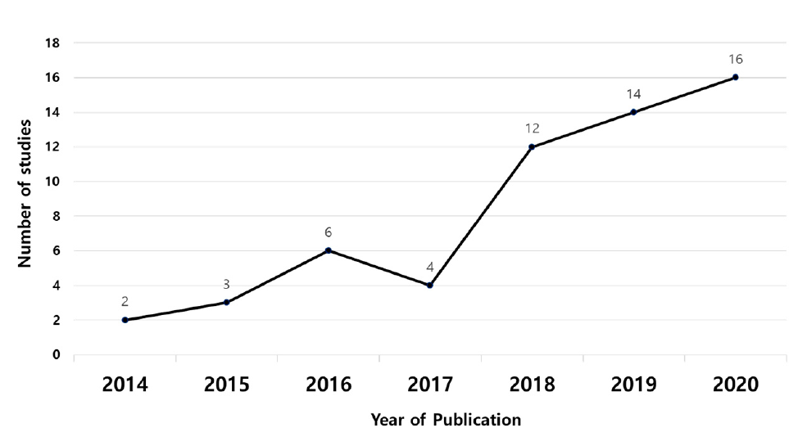**Fig. 6: The number of articles published each year between January 2014 and October 2020** [14]

In **Figure 6**, the study analyzed the number of research papers published on smart glasses from January 2014 to October 2020 to determine research trends. The number of papers related to smart glasses had been increasing since 2014 but declined in 2017 due to the release of Google Glass. However, the number of published papers has skyrocketed since then and has been steadily increasing up to 2020. Out of 57 papers, 43 were published after 2017. The study found that 74% of the papers were published during the last 3 years. [15]

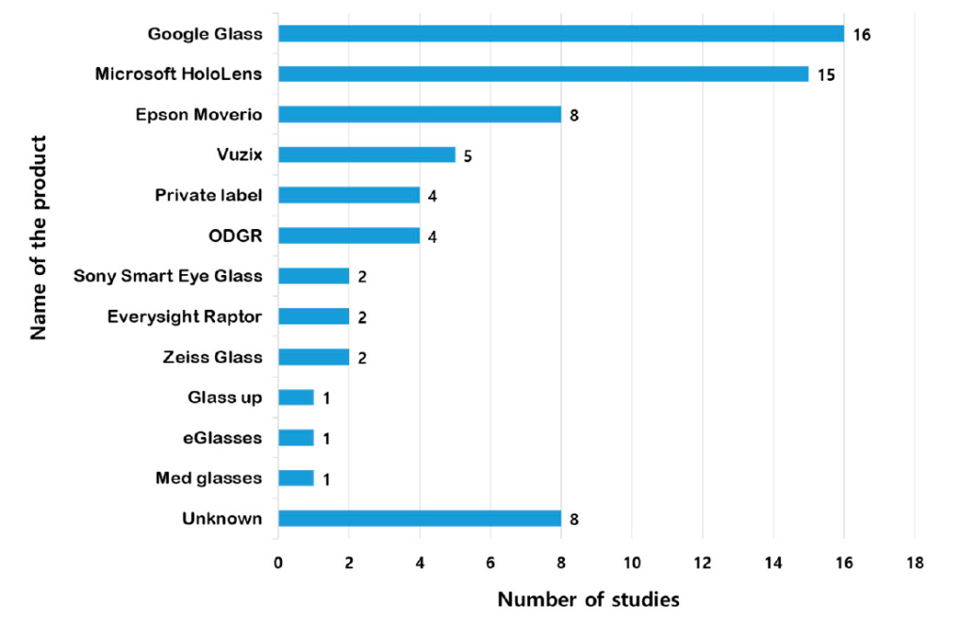**Fig 7: Frequency of use based on model of smart glasses.** [16]

A wide variety of smart glasses have been used in the 57 studies. The smart glasses used in the research were categorized to understand the most used products among multiple smart glass products (**Figure 7**). In one study, a single product was used; however, in other studies, multiple products were compared and used. As for the smart glasses used in the research, Google Glass was used the most, in 16 studies, followed by Microsoft HoloLens in 15 studies. Epson’s Movie series was used in eight studies, making it the third most popular among the commercialized products. Beyond commercially available smart glasses, there were four cases in which we made our own smart glasses to suit the research purpose. In addition, although smart glasses were used in this study, eight papers did not include specific product information. [17]

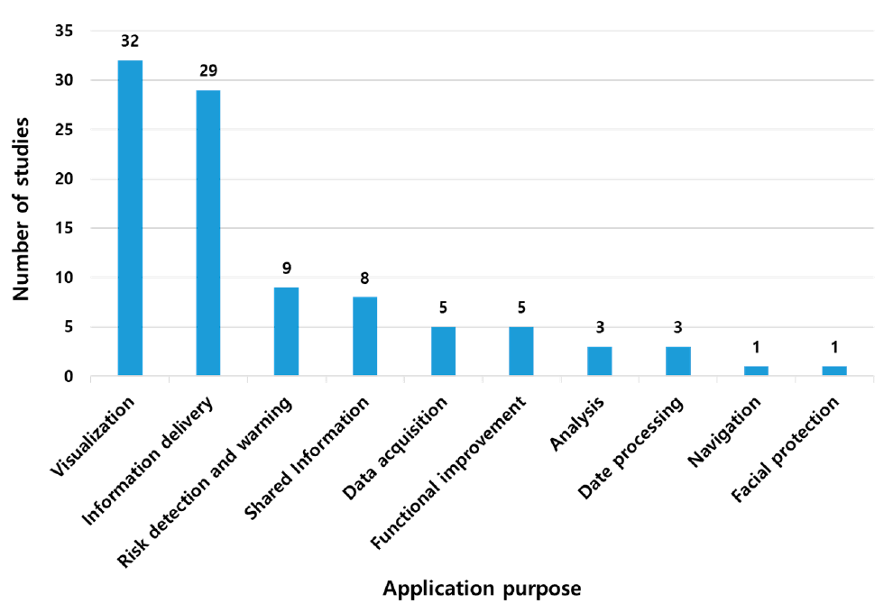**Fig. 8: Number of studies based on research purpose.** [18]

In **Figure 8**, smart glasses were found to be used in various fields, although the purpose of their application may be different. Smart glasses have been used for one or more purposes. Therefore, the research was categorized based on the purpose of using the smart glasses, excluding the fields of use. Because smart glasses play the most visual role, most research aims to convey other information to the user’s line of sight. Therefore, 32 studies were performed to convey the information obtained from smart glasses and then to visualize such information. Visualization and information transmission corresponded to 32 and 29 studies, respectively, accounting for 65% of the total utilization purpose. In addition, nine studies were aimed at notifying users of dangers using acquired data and eight studies

were aimed at sharing information. [19]

**4. Conclusion:**

As we have seen, smart glasses are proving to be a very useful and versatile piece of technology. It is being used in various fields with numerous advantages as well as limitations. It is a growing area of technology with exponential market growth being observed in recent times. Recently conducted surveys have proved it’s usefulness and efficiency in various real life scenario. In addition, it’s also saving the users a lot of time and resources, and making their lives easier. Also, extensive research & groundwork is being done to resolve it’s current limitations.

**5. Future Scope**:

These are some potential areas where smart glasses could have a significant impact:

* **Healthcare**: Smart glasses can be used for remote medical consultations, telemedicine, and real-time monitoring of patients. They can aid in surgical procedures, provide hands-free access to medical records, and facilitate training for medical professionals.
* **Education** **and** **Training**: Smart glasses can be used for remote learning, virtual classrooms, and interactive training in various fields, such as vocational training, technical skills development, and professional development.
* **Augmented Reality (AR) and Virtual Reality (VR)**: Smart glasses can provide immersive AR and VR experiences, allowing users to interact with virtual objects and environments, opening up opportunities in gaming, entertainment, and simulation training.
* **Field Service and Maintenance**: Smart glasses can be used for remote assistance and guidance in field service and maintenance tasks, reducing downtime, and improving efficiency.
* **Accessibility and Inclusion**: Smart glasses can assist individuals with visual impairments, hearing impairments, and other disabilities, providing real-time information, navigation, and communication support.

Overall, the future scope of smart glasses is promising, with potential applications in diverse fields, offering improved efficiency, convenience, and experiences in various aspects of life.

**6. References**:

**[1+1]** Emily Drake. Smart-glasses. 2019, 04.

<https://blog.siggraph.org/2019/04/seeing-things-that-arent-there-how-augmented-reality-will-change-our-lives.html/smart-glasses/>

**[1]** Laricchia, F. U.S. workforce: smart glasses users 2016-2025. 2022, 14, 02.

**[2,3,4,5]** Kim, D.; Choi, Y. Application of Smart Glasses for Field Workers Performing Soil Contamination Surveys with Portable Equipment. Sustainability 2022, 14, 12370. <https://doi.org/10.3390/su141912370>

**[6,7]** Kyungjun Lee, Jonggi Hong, Ebrima Jarjue, Ernest Essuah Mensah, and Hernisa Kacorri. 2022. From the Lab to People’s Home: Lessons from Accessing Blind Participants’ Interactions via Smart Glasses in Remote Studies. In 19th Web for All Conference (W4A’22), April 25–26, 2022, Lyon, France. ACM, New York, NY, USA, 11 pages. <https://doi.org/10.1145/3493612.3520448>

**[8,9,10,11,12,13]** Isha Chaturvedi, Farshid Hassani Bijarbooneh, Tristan Braud, and Pan Hui. 2019. Peripheral Vision: A New Killer App for Smart Glasses. In 24th International Conference on Intelligent User Interfaces (IUI ’19), March 17–20, 2019, Marina del Ray, CA, USA. ACM, New York, NY, USA, 14 pages. https://doi.org/10.1145/3301275.3302263

**[14,15,16,17,18,19]** Kim, D.; Choi, Y. Applications of Smart Glasses in Applied Sciences: A Systematic Review. Appl. Sci. 2021, 11, 4956. <https://doi.org/10.3390/app11114956>