DFD AND SEQUENCE DIAGRAMS
E-Commerce Product Catalog System
PHP with MySQL Mini Project (PCA2) | BCA 5th Semester
Group Members | Sayan Debnath | Adrija Majumdar
Based On | SRS – E-Commerce Product Catalog System, Version 1.0 (12 October 2026)

1. Data Flow Diagrams (DFD)
The DFDs show the two external entities in the SRS (Visitor and Administrator), the processes derived from the functional requirements, and the three data stores that correspond to the database tables.

1.1 DFD Level 0 (Context Diagram)
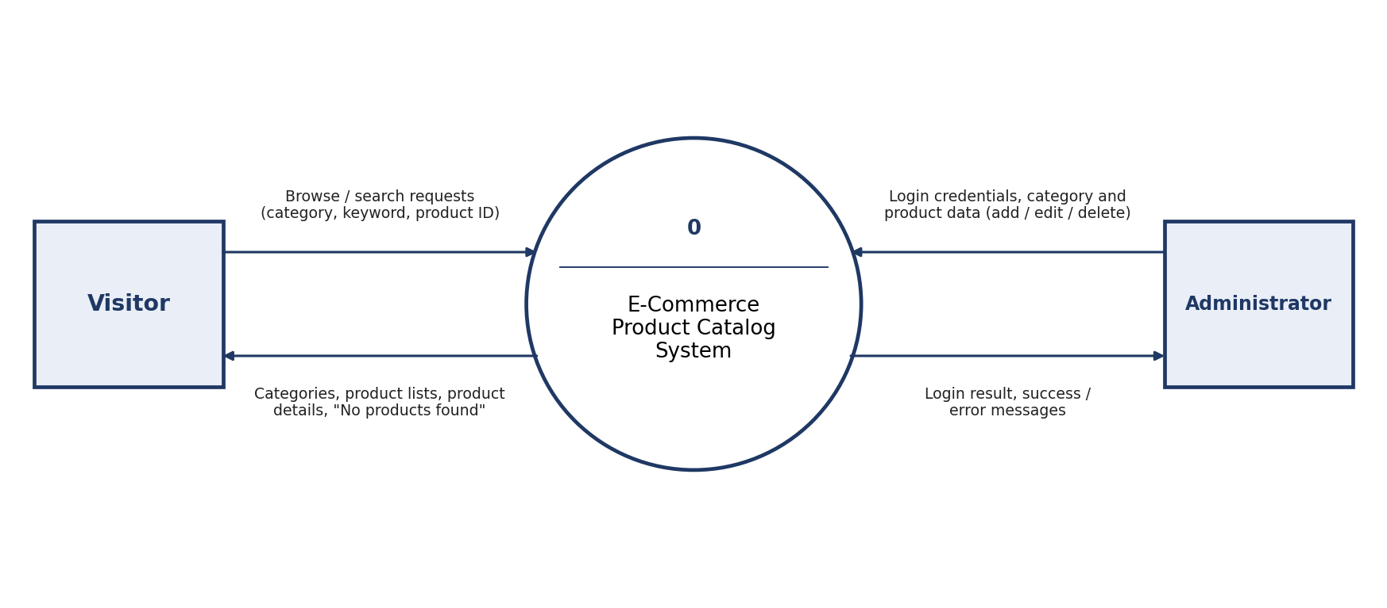

1.2 DFD Level 1 – Visitor Module
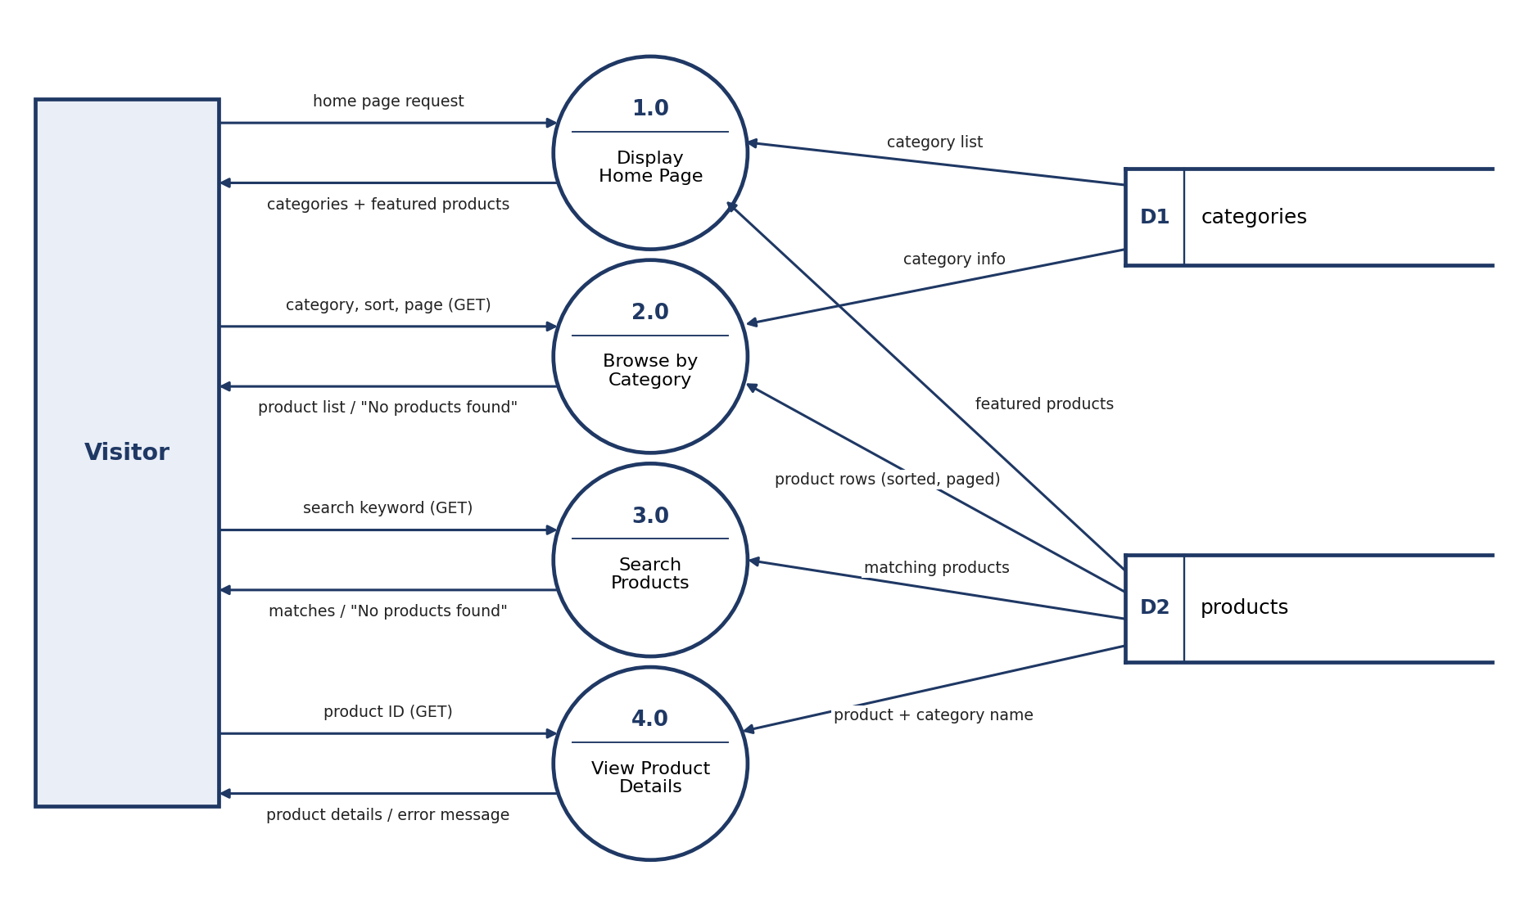

1.3 DFD Level 1 – Administrator Module
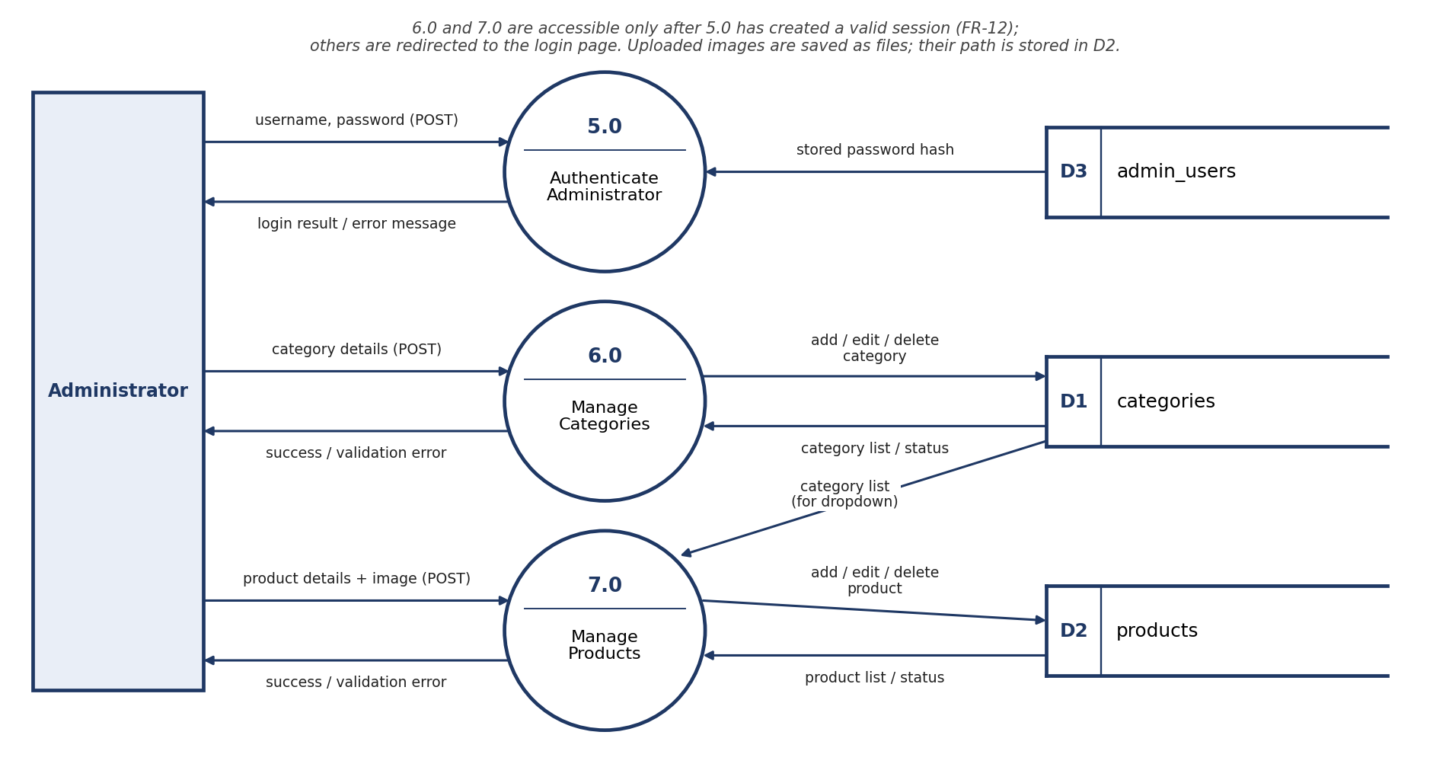

1.4 Processes and SRS Requirements
Process | SRS Requirements
1.0 Display Home Page | FR-01
2.0 Browse by Category | FR-02, FR-05, FR-06, FR-07
3.0 Search Products | FR-03, FR-07
4.0 View Product Details | FR-04
5.0 Authenticate Administrator | FR-08, FR-12
6.0 Manage Categories | FR-09, FR-11, FR-12
7.0 Manage Products | FR-10, FR-11, FR-12
Data stores: D1 = categories, D2 = products, D3 = admin_users.

2. Sequence Diagrams
Each diagram shows one module of the application. Requests use GET for search and filter data and POST for admin forms, as stated in the SRS communication interface.

2.1 Browse by Category (Home Page and Category Listing)
Covers: FR-01, FR-02, FR-05, FR-06, FR-07
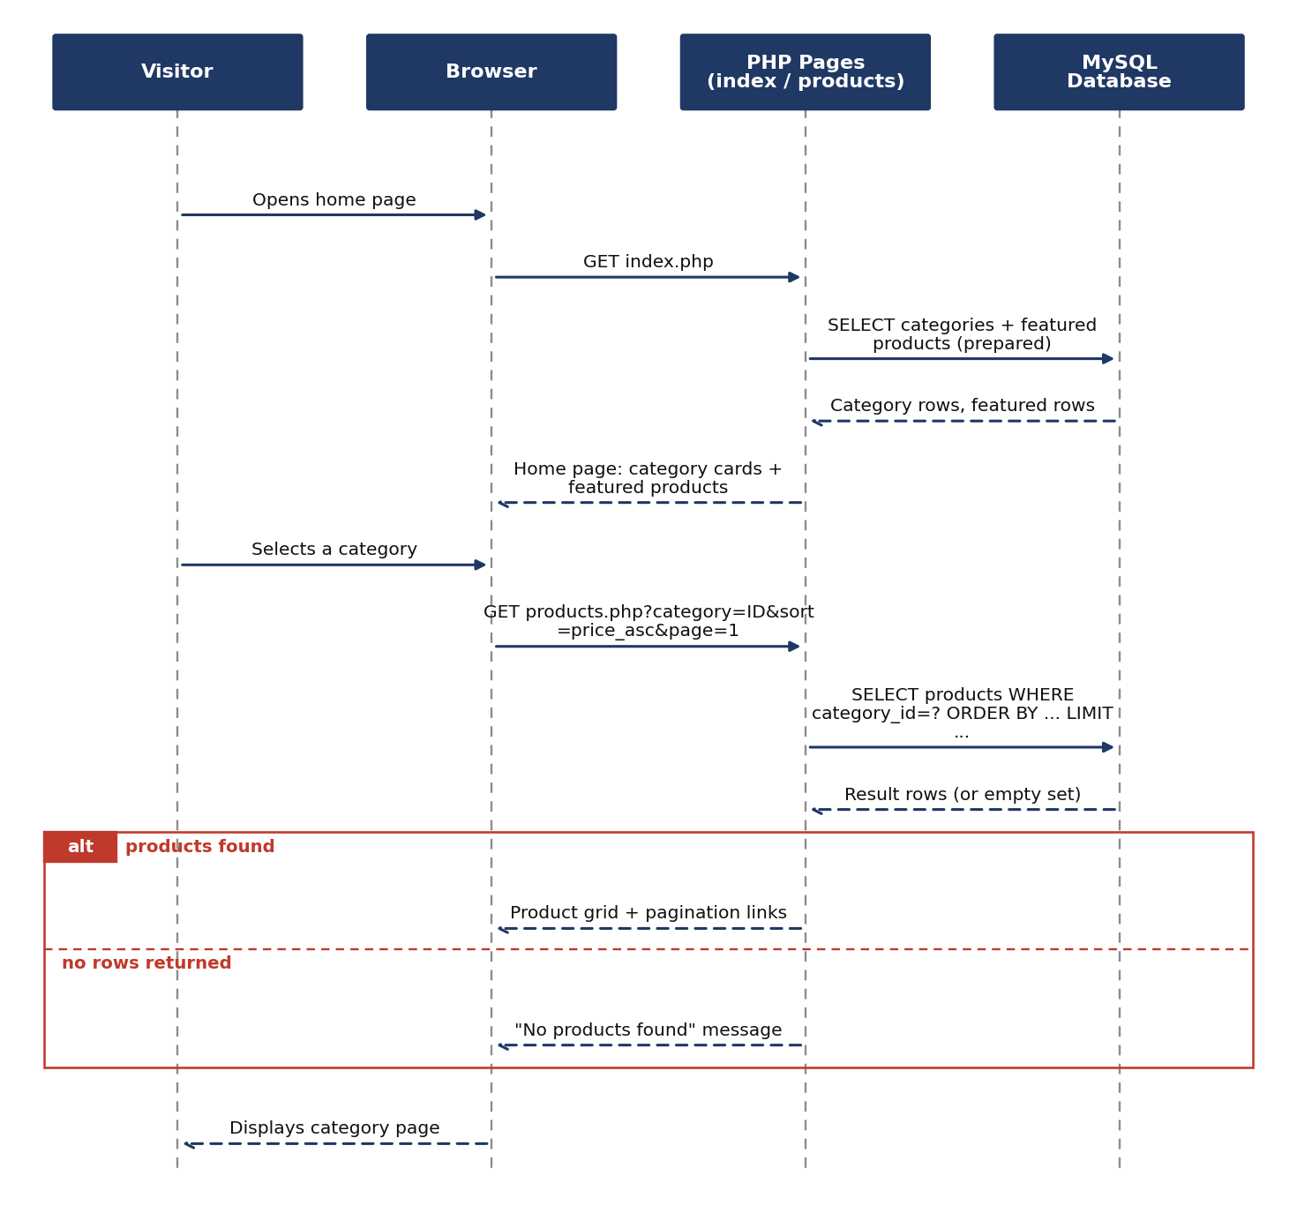

2.2 Search Products
Covers: FR-03, FR-07
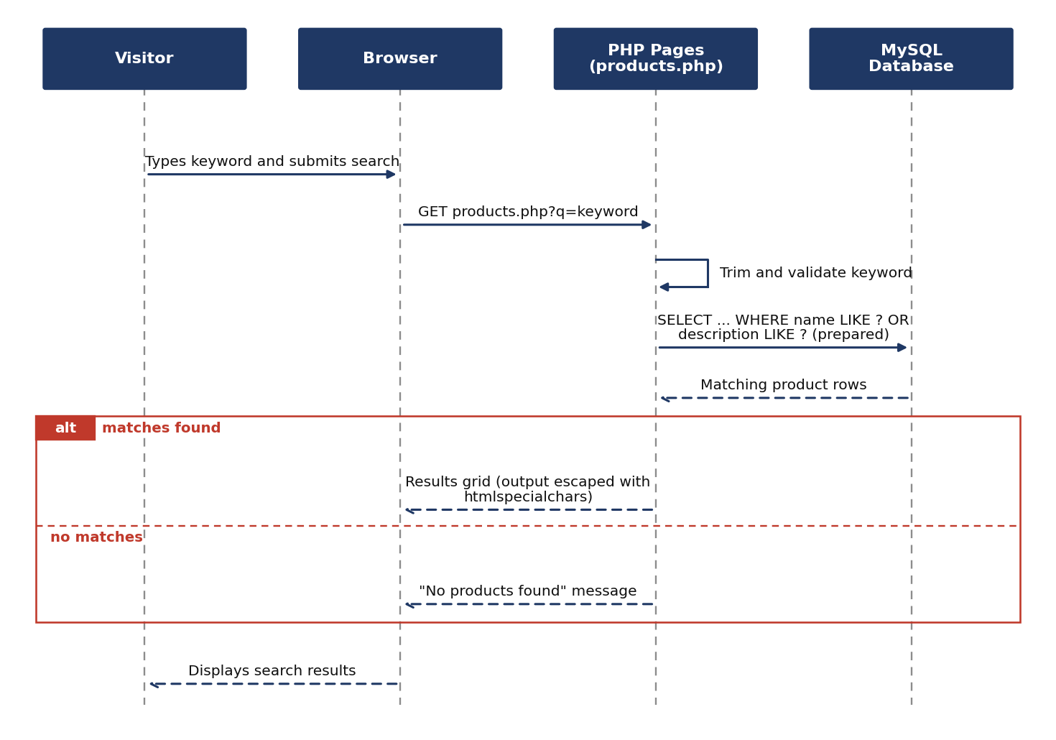

2.3 View Product Details
Covers: FR-04, with invalid IDs handled gracefully (Reliability requirement)
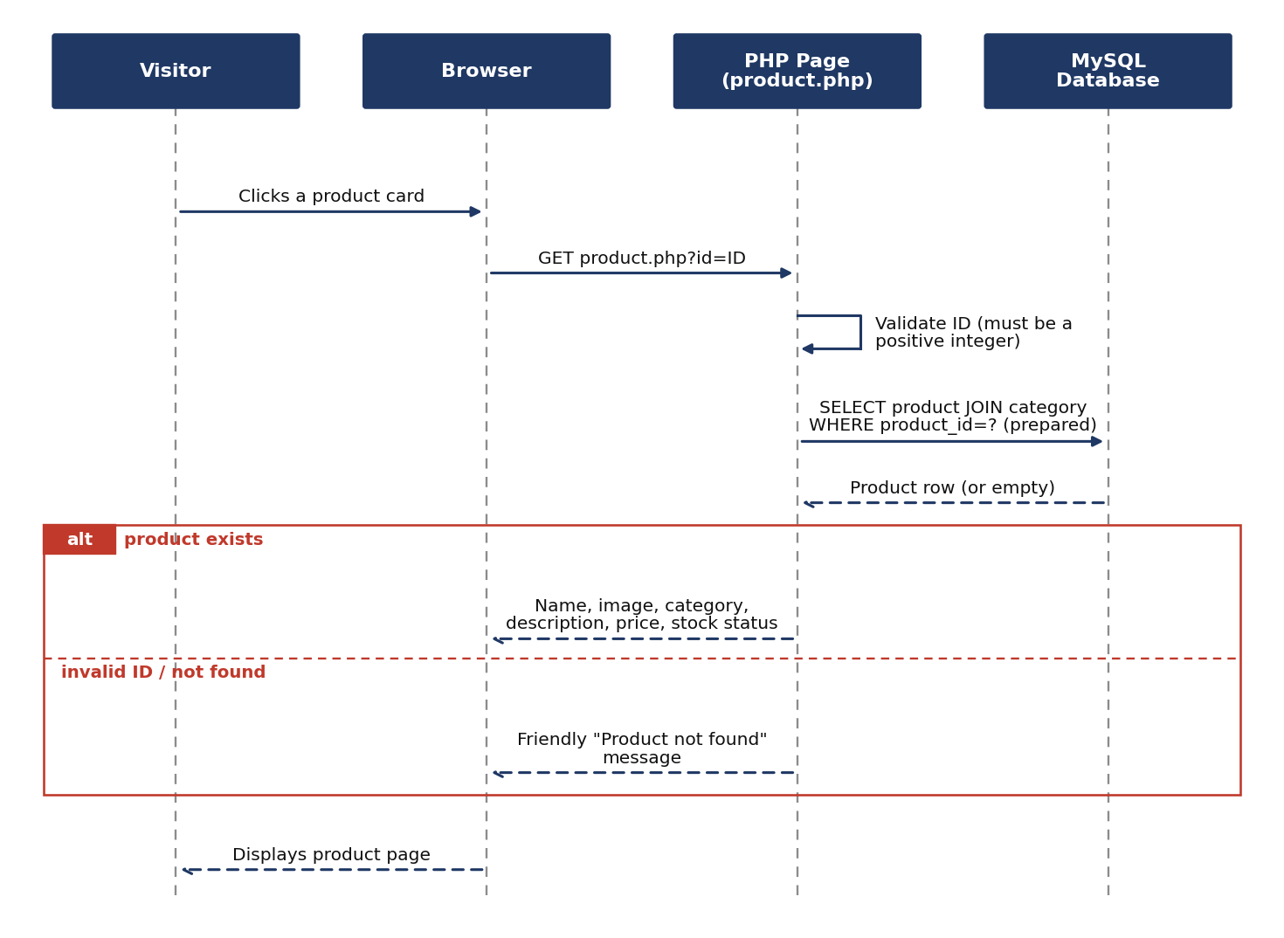

2.4 Admin Login and Logout
Covers: FR-08
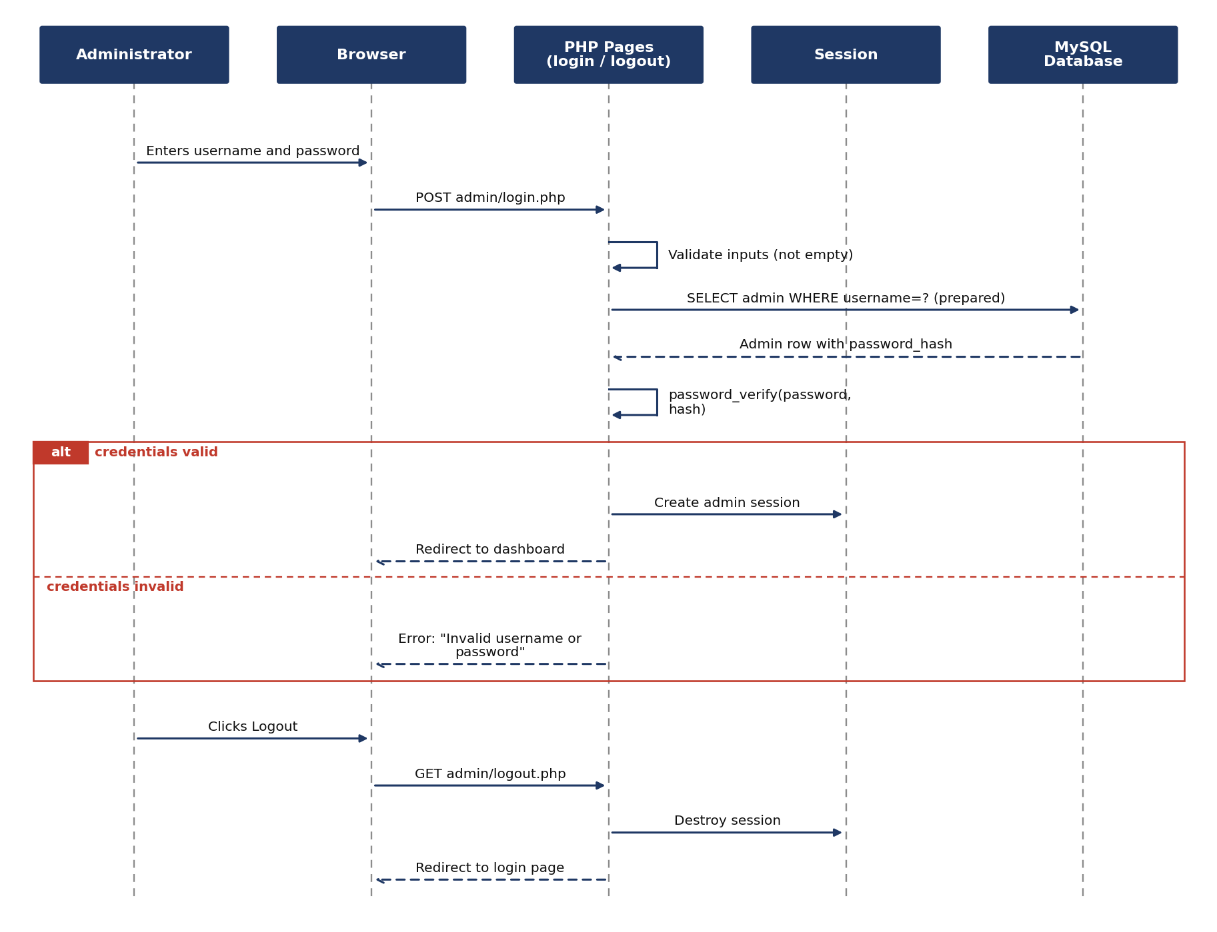

2.5 Admin Add Product
Covers: FR-10, FR-11, FR-12. Editing and deleting a product follow the same flow (session check, validation, prepared statement, result).
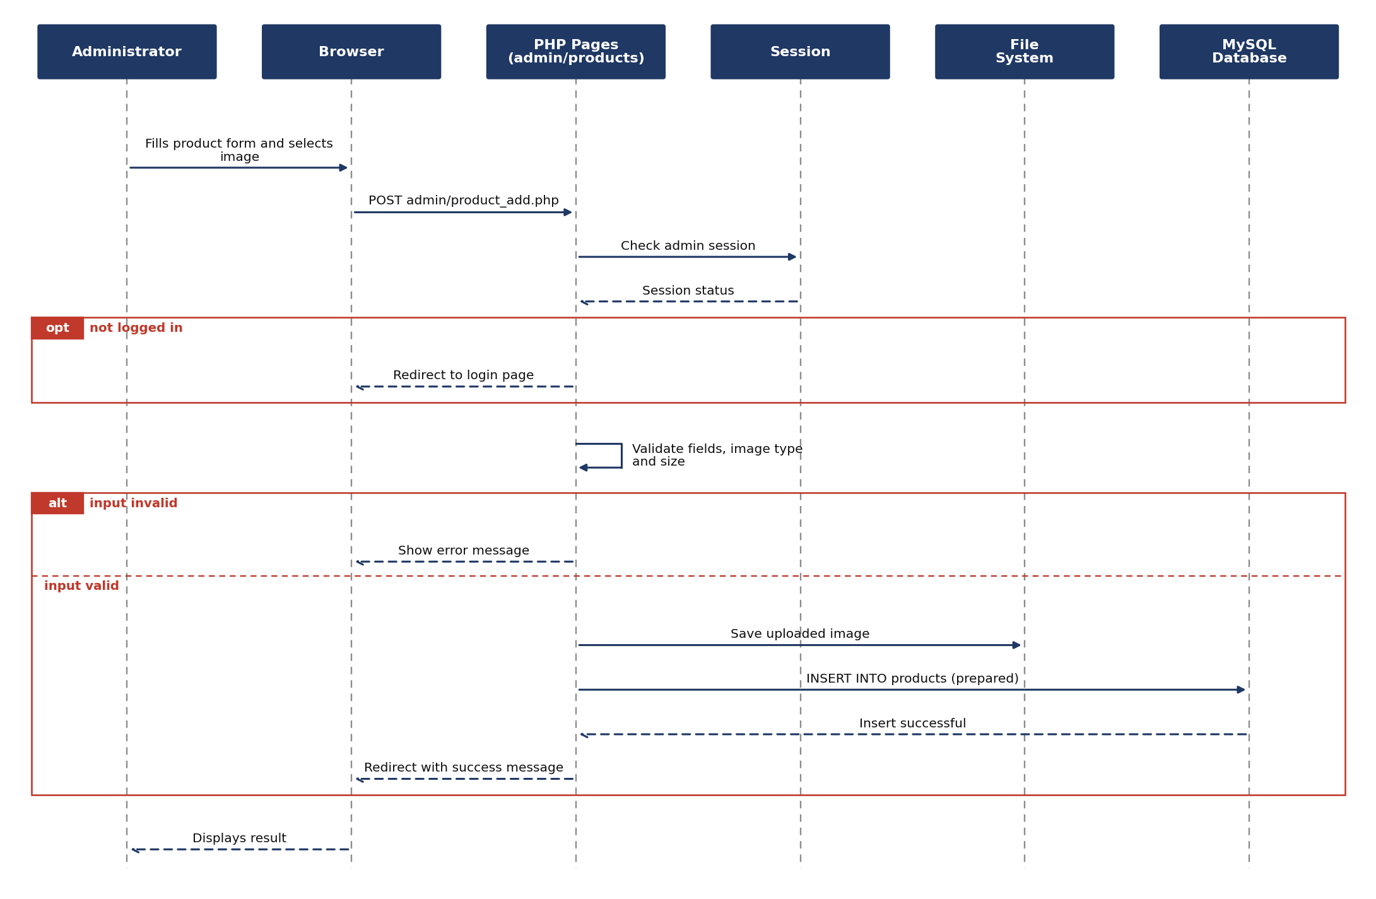

2.6 Admin Delete Category
Covers: FR-09, FR-12. Adding and editing a category follow the same flow as 2.5. A category that still has products cannot be deleted, because of the foreign key rule.


