A
PROJECT REPORT
On

LokVeda — Your E-Gram Panchayat

Submitted In partial fulfillment of the requirement for the award of the degree

of
BACHELOR OF TECHNOLOGY
IN
Computer Science & Engineering
(Maulana Abul Kalam Azad University of Technology)
Submitted by:
Sayan Goswami (33200122070)
Other Members:
Smritilata Sarkar (33200122121)
Ayushman Saha (33200122040)
Dipsana Roy (33200122047)
Ananya Saha (33200122029)
Under the Guidance of:
Prof. Indrajit Chakraborty


DEPARTMENT OF COMPUTER SCIENCE & ENGINEERING
TECHNO INTERNATIONAL BATANAGAR
Maheshtala, Kolklata-700141, West Bengal, India
2025
TECHNO INTERNATIONAL BATANAGAR
MAHESHTALA, KOLKATA, PIN: 700141, WEST BENGAL
2025-2026
DEPARTMENT OF COMPUTER SCIENCE AND ENGINEERING

CERTIFICATE

Certified that the project work entitled LokVeda – Digital E-Gram Panchayat System is a bona fide work carried out by
NAME | ROLL NO
Dipsana Roy | 33200122047
Ananya Saha | 33200122029
Ayushman Saha | 33200122040
Sayan Goswami | 33200122070
Smritilata Sarkar | 33200122121

In partial fulfilment for the award for degree of BACHELOR OF TECHNOLOGY in COMPUTER SCIENCE AND ENGINEERING of the MAULANA ABUL KALAM AZAD UNIVERSITY OF TECHNOLOGY, formerly known as WEST BENGAL UNIVERSITY OF TECHNOLOGY, KOLKATA during the year 2025-2026. It is certified that all corrections / suggestions indicated for Internal Assessment has been incorporated in the report deposited in the Department. The project report has been approved as it satisfies the academic requirements in respect of Project Work prescribed for Bachelor of Technology Degree.

Mr. Indrajit Chakraborty Mr. Subhankar Guha Prof (Dr.) Ashok Kr. Naskar
Project Guide HOD, CSE Principal-in-charge

Name of the Student: Sayan Goswami
University Roll No.: 33200122070

Name of Examiner: Signature with Date
1.
2.

ACKNOWLEDGEMENT
I am greatly indebted to my project Guide Prof. Indrajit Chakraborty of the Computer Science and Engineering Department for providing us all possible help and support throughout the design and development of this project. Without his guidance the project would not have reached this level of completion.

I also express my sincere thanks to Mr. Subhankar Guha, Head of the Department, Computer Science and Engineering, whose ceaseless cooperation made it possible to complete this project by extending all possible help.

Finally, I would like to thank Prof. (Dr.) Ashok Kumar Naskar, Principal-in-charge, Techno International Batanagar, for his colossal support and encouragement.

Lastly, I would like to extend my thanks to all respected Faculty Members and friends, directly or indirectly associated with our project, who contributed their personal level best, which enabled us to bring this project to a successful completion.

ABSTRACT
Gram Panchayats, the foundational unit of rural local self-governance in India, continue to rely heavily on manual, paper-based administrative processes. This dependence leads to delayed service delivery, weak identity verification, limited transparency, and difficulty in tracking citizen applications across their lifecycle. This project presents LokVeda, a secure, web-based Digital E-Gram Panchayat System designed to modernize village-level governance through Aadhaar-based authentication, OTP verification, geographic access control, and a structured, role-based approval workflow.
LokVeda follows a pre-registration model in which citizens, staff, and administrators are enrolled by the Panchayat administration rather than self-registering. Authentication combines Aadhaar number verification, geographic access validation (state-level for citizens, a 10 km radius for staff, and a 250 km radius for administrators), and a cryptographically generated, bcrypt-hashed One-Time Password delivered by e-mail, after which a JWT-secured session is issued. Citizens can submit service applications, track their status through Pending, Reviewed, Approved, and Rejected states, and re-submit rejected applications; staff members verify and forward applications; and administrators hold final approval authority while also managing service activation across Panchayat areas. Every OTP dispatch and application status change triggers an automated e-mail notification.
Beyond its core workflow, LokVeda includes usability features such as time-aware greetings, light/dark theme support, and a mobile-responsive interface designed for non-technical, rural users. The platform is engineered with security, maintainability, and scalability as first-class concerns, and offers a strong foundation for future enhancements including document generation, multi-language support, SMS notifications, and advanced analytics.

Tech Stack Used
This web application is built with Node.js and Express.js on the backend, using Mongoose ODM over a MongoDB database for persistence of User, Service, Area, and Polygon data. The frontend is rendered using EJS templates with HTML5, CSS3, and JavaScript. Security is enforced through JWT-based session management, bcrypt password/OTP hashing, the Crypto module for secure OTP generation, and the Validator library for input sanitisation, supported by cookie-parser and dotenv for session and configuration handling. Nodemailer powers the centralized e-mail notification service, and the application is deployed on Render, with Cloudflare integration planned for future performance and security hardening.

Table Of Contents

Contents
ACKNOWLEDGEMENT 3
ABSTRACT 4
Tech Stack Used 4
Table Of Contents 5
Overview of Project 7
1.1 Purpose 7
1.2 Scope 7
1.3 Intended Audience 7
1.4 Definitions, Acronyms and Abbreviations 7
1.5 Objectives 8
1.6 Target Users 8
1.7 Conclusion of Chapter 8
Literature Review 9
System Block Diagram 10
3.1 System Block Diagram 10
3.2 Database Design Overview 10
3.3 Database Model Summary 11
3.4 Application Workflow Logic 11
Project Methodology 12
4.1 Requirement Analysis 12
4.2 System Design 12
4.3 Development 12
4.4 Testing 13
4.5 Deployment 13
4.6 Methodology Summary 13
Technical Platform 14
5.1 Frontend Layer 14
5.2 Backend Layer 14
5.3 Database Layer 14
5.4 Security Layer 14
5.5 Communication & Utility Libraries 14
5.6 Deployment Layer 14
5.7 Development Tools and Version Control 14
5.8 Operating Environment 15
5.9 Conclusion 15
Expected Result 16
6.1 Authentication & Geographic Verification 16
6.2 Citizen Workflow 16
6.3 Staff & Administrator Workflow 16
6.4 Notification System 16
6.5 Non-Functional Targets 16
6.6 Merits 16
6.7 Limitations 17
Scope of Further Improvements 18
7.1 Service Enhancements 18
7.2 Document Enhancements 18
7.3 Workflow & Notification Enhancements 18
7.4 Administrative Enhancements 18
7.5 Security Enhancements 18
7.6 User Experience Enhancements 18
Conclusion 19
References 20
Appendix – Default Setup Commands 20

Overview of Project

1.1 Purpose
LokVeda is a web-based governance platform developed to modernize village-level administrative processes through secure digital service delivery, workflow management, and citizen-centric interactions. The system provides Aadhaar-based authentication, OTP verification, location-aware access control, role-based authorization, service application management, administrative approval workflows, and Panchayat-level service management. This report serves as a reference for the system’s development, testing, deployment, maintenance, and academic evaluation.

1.2 Scope
LokVeda is designed as a secure digital governance solution for Gram Panchayats, reducing manual administrative processes by providing a centralized system through which citizens, staff members, and administrators interact digitally. The current implementation covers citizen services (secure login, application submission, tracking, re-submission of rejected applications, profile viewing), staff operations (application review, rejection, verification workflow management), administrative operations (service activation/deactivation, application approval, rejected-application review, approved-application management), and security features (OTP authentication, JWT session management, geographic access verification, account protection, and suspicious-activity detection). The platform is intended for educational, demonstration, and future deployment purposes.

1.3 Intended Audience
- Academic Evaluators – to understand the system’s objectives, architecture and implementation.
- Developers – to understand requirements, workflows and system design.
- Maintainers – to support future enhancement and maintenance activities.
- Project Stakeholders – to understand the capabilities and limitations of the system.

1.4 Definitions, Acronyms and Abbreviations
Term | Description
Aadhaar | Government-issued identification number
OTP | One Time Password
JWT | JSON Web Token
MVC | Model View Controller
UI | User Interface
UX | User Experience
SRS | Software Requirements Specification
Admin | Panchayat Administrator
Staff | Panchayat Employee
Citizen | Registered User
API | Application Programming Interface
DB | Database
RBAC | Role Based Access Control

1.5 Objectives
- To design and implement a secure, role-based web application for village-level E-Governance.
- To authenticate citizens using Aadhaar verification combined with OTP and geographic validation.
- To restrict access geographically — by state for citizens, a 10 km radius for staff, and a 250 km radius for administrators.
- To model a multi-level approval workflow spanning citizen submission, staff review and admin approval.
- To give citizens a transparent, real-time view of their application status, including re-submission of rejected applications.
- To automate stakeholder communication via a centralized e-mail notification service.
- To build a maintainable, scalable foundation supporting future document management and multilingual access.

1.6 Target Users
Role | Description | Primary Activities
Citizen | Village resident and registered service applicant | Log in via Aadhaar + OTP, submit applications, track status, re-submit rejected applications, view profile
Staff | Panchayat employee with verification authority | Review pending applications, reject incomplete ones, forward verified applications to administrators
Administrator | Panchayat decision maker | Approve or reject reviewed applications, activate/deactivate services, review rejected applications, monitor availability

1.7 Conclusion of Chapter
LokVeda’s overall purpose and scope establish it as a focused, security-first digital governance solution for Gram Panchayats. By combining strong identity verification with a structured, role-based workflow, the platform lays the groundwork for a transparent and accountable rural administrative system, addressed in detail throughout the remainder of this report.

Literature Review
Traditional village administration systems largely depend on paper-based workflows, physical visits to Panchayat offices, and manual record-keeping. These approaches commonly result in delayed service delivery, data redundancy across registers, a lack of transparency for citizens, difficulty in tracking the state of a submitted application, and general administrative inefficiency. Citizens frequently have no way to independently verify who reviewed their application, when it was reviewed, or why it may have been rejected, which weakens accountability at the village level.
Several E-Governance initiatives introduced by the Government of India have demonstrated the effectiveness of digital platforms in improving public service delivery at larger administrative scales, from state-level portals to national identity and welfare-delivery systems built around Aadhaar-based verification. These systems consistently highlight a common set of design principles: secure user authentication tied to a trusted identity source, strict role-based access control across different classes of government staff, digitization of previously manual services, automation of multi-step approval workflows, and mechanisms that keep citizens informed of the outcome of their requests.
Most existing citizen-facing appointment or application portals, however, rely on relatively weak authentication — typically a username/password or a single OTP step — without any geographic dimension to verify that a login attempt originates from a plausible location for the claimed role. LokVeda extends the standard OTP-based verification model by layering Aadhaar-based identity lookup with role-specific geographic verification, restricting citizens to their registered state, staff to a tight 10 km operational radius, and administrators to a wider 250 km jurisdictional radius. This additional layer directly addresses a gap identified in typical E-Governance literature: verifying not just who is logging in, but whether their claimed physical context is consistent with their role.
LokVeda incorporates these established E-Governance principles — secure authentication, role-based access control, service digitization, workflow automation, and citizen transparency — and adapts them specifically for a Panchayat-level governance model, where the user base is predominantly non-technical, rural, and dependent on mobile or shared-computer access rather than dedicated government kiosks.

System Block Diagram

3.1 System Block Diagram
The diagram below illustrates the end-to-end authentication and workflow sequence in LokVeda. A citizen, staff member, or administrator first enters their Aadhaar number, which the system looks up against the User Model and checks for account approval. The system then performs geographic verification appropriate to the user’s role — state-level for citizens, a 10 km radius for staff, and a 250 km radius for administrators — before a cryptographically generated, bcrypt-hashed OTP is dispatched by e-mail through Nodemailer. Once the OTP is verified, a JWT-secured session is created and the user is routed to a role-specific dashboard. From there, citizens submit and track applications, staff review and forward them, and administrators approve or reject them, with every status transition triggering an e-mail notification and an update to the MongoDB Atlas database.
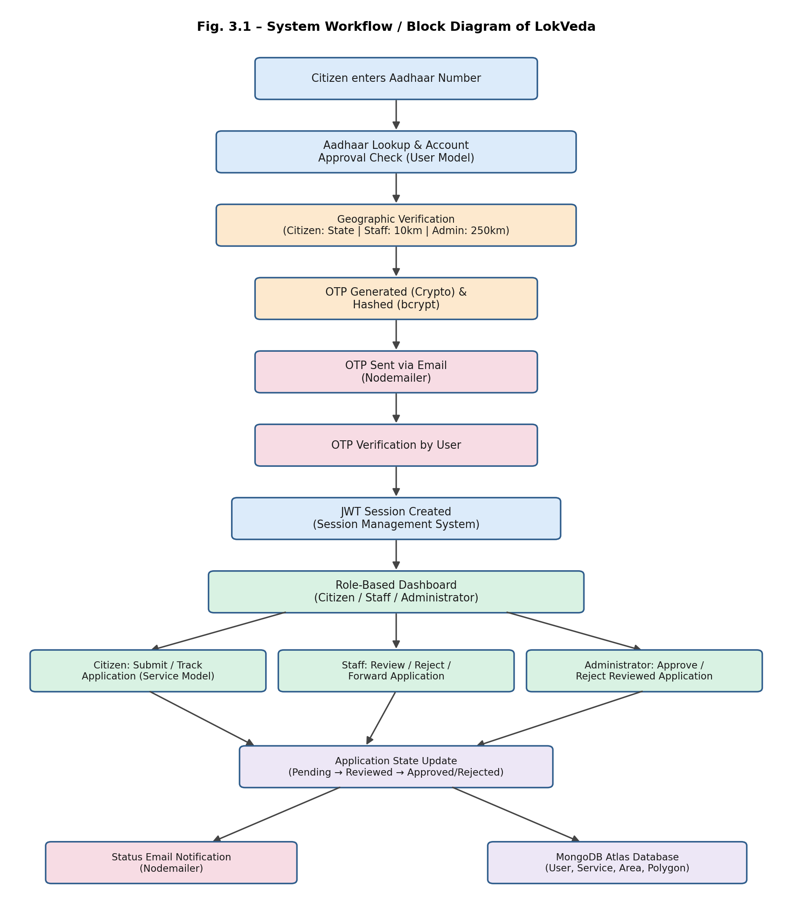

3.2 Database Design Overview
LokVeda’s persistence layer is organised around four core Mongoose models. The User Model stores identity, authentication, profile, session, and access-restriction information for citizens, staff, and administrators alike. The Service Model stores each service application and its full workflow history — applicant information, current status, form data, and review/approval/rejection metadata with timestamps. The Area Model holds Panchayat-level administrative information, including which services are available in a given area, while the Polygon Model stores the geographic boundary data used to validate a user’s location against their permitted area during authentication.
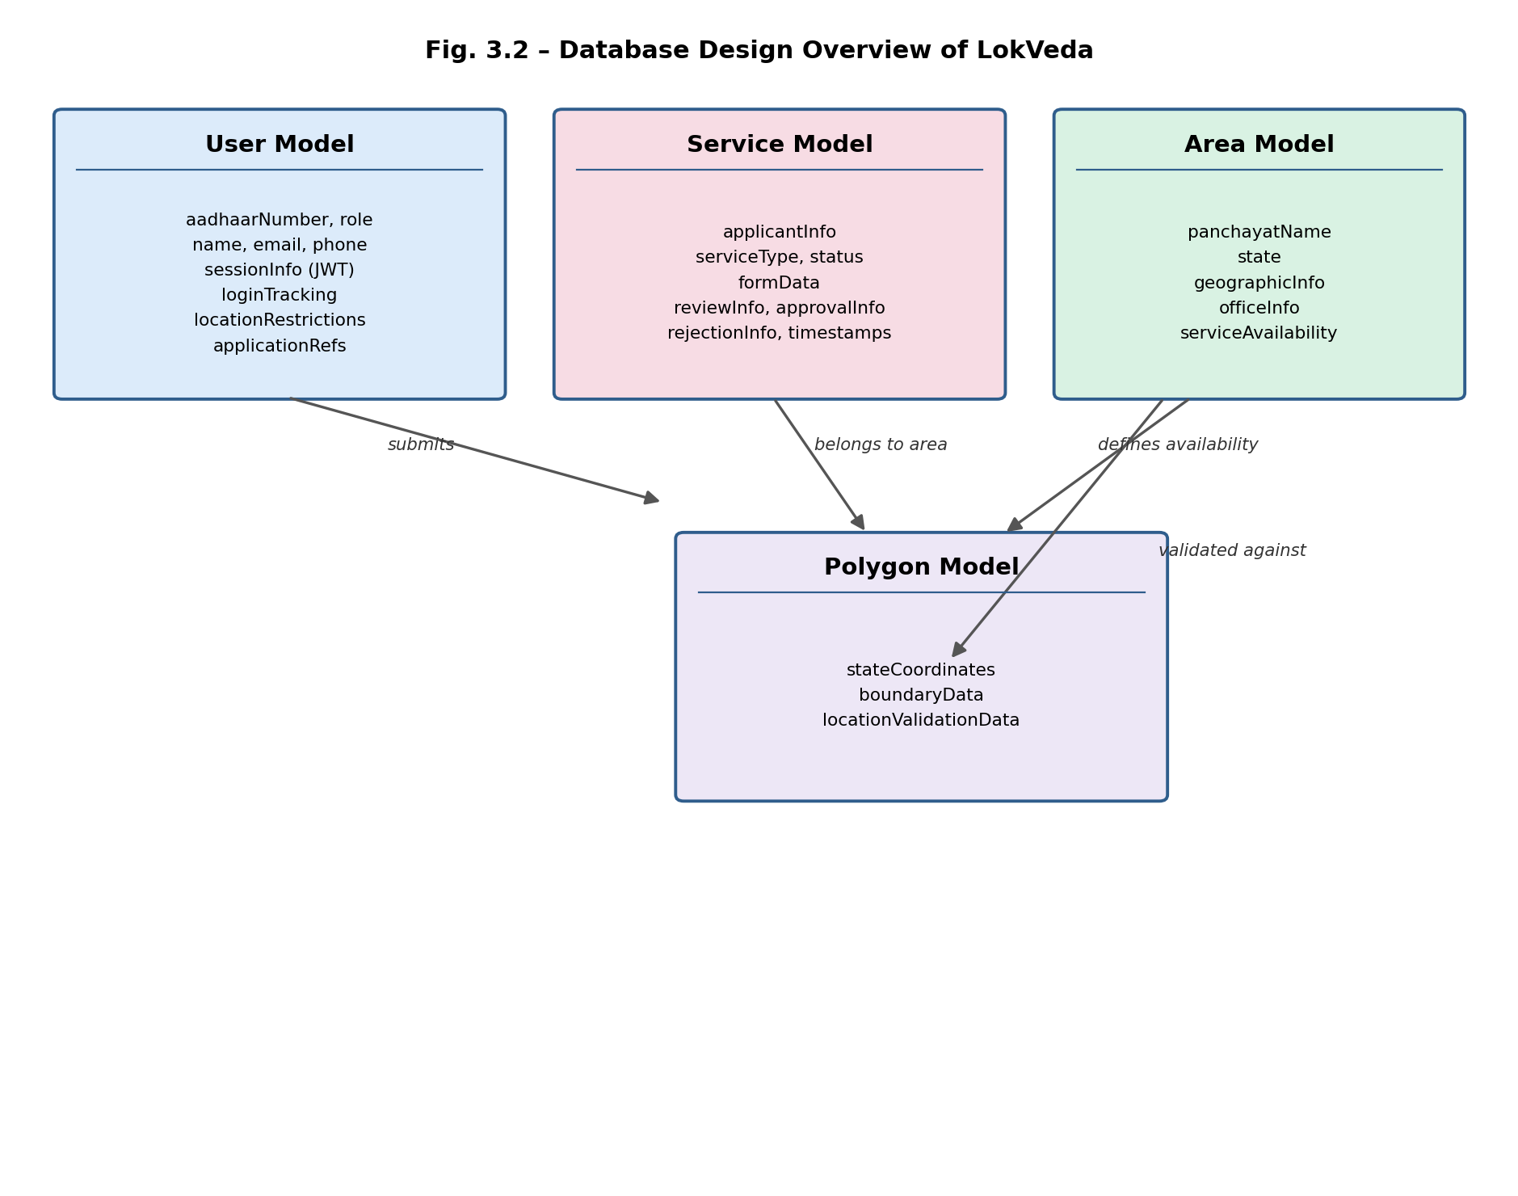

3.3 Database Model Summary
Model | Key Information Stored | Relationships
User Model | aadhaarNumber, role, name, email, phone, sessionInfo, loginTracking, locationRestrictions, applicationRefs | Has many Service (application) records
Service Model | applicantInfo, serviceType, status, formData, reviewInfo, approvalInfo, rejectionInfo, timestamps | Belongs to User; belongs to Area
Area Model | panchayatName, state, geographicInfo, officeInfo, serviceAvailability | Has many Service records; linked to Polygon
Polygon Model | stateCoordinates, boundaryData, locationValidationData | Referenced by Area for geographic validation

3.4 Application Workflow Logic
Every service application progresses through four supported states: Pending, Reviewed, Approved, and Rejected. A citizen’s submission is created as Pending and immediately visible on their dashboard. A staff member reviews the application, records review information and a timestamp, and either forwards it (moving it toward Reviewed/Approved) or rejects it with a documented reason — staff members are explicitly restricted from approving applications themselves. Administrators then perform the final approval or rejection of reviewed applications, and retain the ability to revisit previously rejected applications. The system enforces valid state transitions only, preventing duplicate approvals, duplicate reviews, or any workflow shortcut that would bypass the staff review stage.

Project Methodology
LokVeda was developed using an iterative, feature-driven approach aligned with agile principles — beginning with the Software Requirements Specification, followed by core Aadhaar/OTP authentication, geographic verification, the citizen application workflow, staff/admin review stages, and subsequent refinements to notifications and UX features. The project progressed through the following phases.

4.1 Requirement Analysis
The first phase involved formalising the system’s requirements into the SRS, covering functional requirement groups for authentication, OTP handling, geographic verification, session management, role-specific workflows, service management, application tracking, and supporting UX/notification features, summarised below.
Group | Focus Area | Representative Requirements
AUTH | Aadhaar-based authentication | AUTH-01 to AUTH-10: Aadhaar lookup, account approval check, geo-gated OTP issuance, session creation and dashboard redirection
OTP | OTP generation & verification | OTP-01 to OTP-08: Crypto-based generation, bcrypt hashing/comparison, invalidation after use, resend cooldown, failed-attempt tracking
GEO | Geographic verification | GEO-01 to GEO-08: Location permission, coordinate capture, distance calculation, role-specific radius checks, violation feedback
SES | Session management | SES-01 to SES-08: Token issuance, secure storage, logout invalidation, single active session, protected-route validation
CIT / STF / ADM | Role-specific workflows | CIT-01–10, STF-01–09, ADM-01–09: Citizen submission/tracking, staff review/forwarding, admin approval/rejection
SRV / APP | Service & application tracking | SRV-01–06, APP-01–08: Service activation per area, application state storage, reviewer/approver tracking, transition validation
GRT / THM / MAIL | UX & notification features | GRT-01–04, THM-01–05, MAIL-01–06: Time-aware greetings, light/dark theme persistence, OTP and status-change e-mails

4.2 System Design
This phase focused on designing the overall MVC architecture, the four-model MongoDB schema (User, Service, Area, Polygon), the Aadhaar + Geo + OTP authentication sequence, and role-specific dashboard layouts — the block diagram and database design presented in Chapter 3 were produced during this phase.

4.3 Development
Development proceeded in iterative sprints covering: the Aadhaar-based authentication module with geographic verification; the OTP generation, hashing and validation pipeline; JWT-based session management; role-based dashboards for citizens, staff and administrators; the multi-stage application workflow; the centralized Nodemailer-based e-mail service; and supporting UX features such as time-aware greetings and light/dark theming.

4.4 Testing
Testing covered authentication and geographic-verification edge cases (denied locations, boundary radius values), OTP expiry and resend-cooldown behaviour, session integrity and unauthorized-route redirection, end-to-end workflow testing across all three roles, UI/UX testing across desktop and mobile, and dedicated testing of e-mail template rendering and delivery reliability.

4.5 Deployment
Standard deployment practice was followed: environment configuration through dotenv for database, JWT-secret and SMTP credentials, dependency installation, and deployment of the Node.js/Express server to Render, with Cloudflare integration planned as a future hardening step for DNS management, caching, and protection against automated and malicious traffic.

4.6 Methodology Summary
The agile, iterative methodology ensured the development process remained flexible and responsive to the security and usability demands of a rural, non-technical user base. By progressing through requirement analysis, system design, focused development sprints, and structured testing, the project delivers a secure, transparent E-Gram Panchayat platform ready for academic evaluation and future production hardening.

Technical Platform
This chapter details the technologies and tools used at every layer of the LokVeda application, following the layered architecture defined in its Software Requirements Specification.

5.1 Frontend Layer
Responsible for user interaction, form rendering, navigation, and visual presentation. Built using HTML5, CSS3, JavaScript, and EJS templates, with light/dark theme support and a mobile-responsive layout suited to non-technical, rural users.

5.2 Backend Layer
Responsible for authentication, authorization, business logic, workflow management, and validation. Implemented using Node.js and Express.js following an MVC architectural pattern.

5.3 Database Layer
Responsible for user management, service management, area information, and application storage, using MongoDB with the Mongoose ODM across the User, Service, Area, and Polygon models described in Chapter 3.

5.4 Security Layer
- JWT (JSON Web Token) for stateless, role-aware session validation.
- bcrypt for hashing OTPs and any stored sensitive verification data.
- Crypto module for cryptographically secure OTP generation.
- Validator for input sanitisation and format validation.
- Geographic verification logic enforcing state, 10 km, and 250 km access radii for citizens, staff, and administrators respectively.

5.5 Communication & Utility Libraries
- Nodemailer – centralized e-mail service for OTP delivery and application status notifications.
- cookie-parser – secure handling of session cookies.
- dotenv – environment-based configuration management.

5.6 Deployment Layer
Render provides application hosting and deployment for the Node.js and Express.js server in a cloud environment. Cloudflare integration is planned for future releases to provide DNS management, performance optimisation, SSL enhancement, caching, and protection against automated bots and malicious traffic.

5.7 Development Tools and Version Control
- Visual Studio Code as the primary development environment.
- Git for version control and change management.
- GitHub for repository hosting and collaborative development across the five-member team.

5.8 Operating Environment
On the client side, LokVeda supports Google Chrome, Mozilla Firefox, Microsoft Edge, and mobile browsers. On the server side, it runs on the Node.js runtime with a MongoDB database, communicating over HTTPS and depending on an active internet connection for both application access and location-based services.

5.9 Conclusion
The selected technology stack — Node.js, Express.js, MongoDB and EJS, secured with Aadhaar verification, geographic access control, JWT and bcrypt — provides a robust, layered foundation for a village-level E-Governance platform that remains scalable, secure, and accessible to citizens, staff, and administrators alike.

Expected Result
This chapter presents the expected functional outcomes of the LokVeda platform, demonstrating that the objectives outlined in Chapter 1 are achieved through the design described in the preceding chapters.

6.1 Authentication & Geographic Verification
Citizens, staff, and administrators are expected to authenticate using their Aadhaar number, pass a role-appropriate geographic verification check, and complete a cryptographically secure OTP challenge before a JWT session is issued. Users attempting access from outside their permitted radius receive clear, user-friendly feedback explaining the restriction rather than a generic failure message.

6.2 Citizen Workflow
Citizens are expected to view only the services active in their area, submit applications against those services, track each application through Pending, Reviewed, Approved, and Rejected states on a personal dashboard, and re-submit any rejected application without needing to contact the Panchayat office directly.

6.3 Staff & Administrator Workflow
Staff members are expected to review pending applications, verify applicant profiles, and either forward or reject applications with recorded remarks and timestamps, without the ability to grant final approval themselves. Administrators are expected to hold final approval authority over reviewed applications, manage service activation and deactivation per area, and revisit rejected applications when necessary.

6.4 Notification System
The system is expected to dispatch an OTP e-mail during every authentication attempt and a status e-mail whenever an application is submitted, approved, or rejected, using HTML-formatted, reusable templates that clearly state the application name and its current status.

6.5 Non-Functional Targets
Metric | Target
Authentication Operations | < 5 seconds
Dashboard Rendering | < 2 seconds
Service Loading | < 2 seconds
Planned Availability | 99%+

6.6 Merits
- Strong identity assurance: Aadhaar verification combined with role-specific geographic checks and OTP goes beyond typical single-factor citizen portals.
- Transparent multi-level workflow: citizen submission, staff review, and admin approval are clearly separated and independently auditable.
- Centralized, reusable communication layer: a single e-mail-service module drives both OTP delivery and status notifications.
- Good citizen experience: real-time status tracking, time-aware greetings, dark-mode support, and a responsive interface suited to rural, non-technical users.
- Maintainable, layered architecture: Node.js, Express and MongoDB’s ecosystems keep authentication, workflow, and communication concerns cleanly separated.

6.7 Limitations
- Pre-registration only — citizens cannot self-register; onboarding depends on Panchayat administration.
- No document upload or verification module yet — supporting documents are not currently stored or validated within the system.
- Profile images currently use local demonstration avatars rather than user-uploaded photos.
- No SMS channel yet — all notifications currently depend on e-mail delivery.
- Single-language interface — no multilingual (Hindi/Bengali/regional) support yet.
- No analytics dashboard for administrative insight into approval trends or service utilisation.

Scope of Further Improvements
While LokVeda successfully meets its primary objectives, several enhancements are planned for future development to further enrich functionality, security, and scalability.

7.1 Service Enhancements
- Custom service creation by administrators without code changes.
- A dynamic form builder for new service types.
- A dedicated service search system.

7.2 Document Enhancements
- PDF and DOCX generation for approved applications.
- Downloadable certificates.
- Digital signatures on generated documents.

7.3 Workflow & Notification Enhancements
- Login-success notifications and password-recovery e-mails.
- Scheduled reminder e-mails for pending applications.
- SMS-based status updates.
- Escalation workflows for delayed reviews or approvals.

7.4 Administrative Enhancements
- An analytics dashboard covering approvals, rejections, and service utilisation.
- Dedicated audit reports and activity-monitoring views.

7.5 Security Enhancements
- Multi-Factor Authentication beyond OTP.
- Advanced audit logging and a security-monitoring dashboard.
- User-uploaded profile images with cloud-based media storage, replacing current demonstration avatars.
- Cloudflare integration for DNS management, performance optimisation, SSL enhancement, caching, and bot/DDoS protection.

7.6 User Experience Enhancements
- Multi-language support for Hindi, Bengali, and other regional languages.
- A Progressive Web Application (PWA) with offline functionality.
- Enhanced accessibility features for a wider range of users.

Conclusion
LokVeda demonstrates the practical implementation of a secure digital governance platform tailored for Gram Panchayat operations, combining Aadhaar-based authentication, geographic verification, workflow management, role-based authorization, service administration, and e-mail notification services within a single, unified platform designed to remain accessible to non-technical users. The project successfully transforms traditional, paper-based administrative workflows into a structured digital system while maintaining usability, accountability, and security. Its modular architecture, layered security mechanisms, and clearly defined workflow provide a strong foundation for future growth from an academic MVP into a production-grade rural governance platform.

References
[1] IEEE Software Requirements Specification Standards. https://www.ieee.org
Reference standard followed for structuring LokVeda’s Software Requirements Specification.
[2] MongoDB Documentation. https://www.mongodb.com/docs
Reference for MongoDB, used as the primary data store for the User, Service, Area and Polygon models.
[3] Mongoose Documentation. https://mongoosejs.com/docs
Documentation for the Mongoose ODM used to define and query LokVeda’s MongoDB schemas.
[4] Express.js Documentation. https://expressjs.com
Documentation for the Express.js framework used for routing and middleware.
[5] Node.js Documentation. https://nodejs.org/docs
Official documentation for the Node.js runtime used to build LokVeda’s backend server.
[6] MDN Web Docs. https://developer.mozilla.org
Reference for HTML, CSS and JavaScript used in the EJS-rendered citizen, staff and admin interfaces.
[7] JSON Web Token Documentation. https://jwt.io/introduction
Reference for JWT-based stateless session management used across all user roles.
[8] bcrypt Documentation. https://www.npmjs.com/package/bcrypt
Reference for password and OTP hashing used to secure citizen, staff and admin credentials.
[9] Nodemailer Documentation. https://nodemailer.com
Documentation for the e-mail-sending library powering LokVeda’s OTP and status-notification service.
[10] Government E-Governance Service Models. https://www.digitalindia.gov.in
Background reference on national E-Governance efforts that informed LokVeda’s Panchayat-level workflow design.

Appendix – Default Setup Commands
npm run start git clone https://github.com/dipsana/lokveda.git
cd lokveda
npm install
cp .env.example .env
# Configure the following variables in .env:
# ODB_URI=<your_mongodb_connection_string>
# JWT_SECRET=<your_jwt_secret>
# SMTP_EMAIL=<your_email>
# SMTP_PASS=<your_email_password>
# NODE_ENV=<development_or_production>
# OTP_EXPIRY=<in_milliseconds>
# MAX_AGE=<in_milliseconds>
#PORT=<your_localhost_port_no>
npm run start

