**Excel Assignment - 9**

**1. What are the different margins options and do we adjust the margins of the excel worksheet?**

There are four margins you can specify: top, bottom, left, and right. Each margin refers to the distance from the edge of the paper to where the information in your worksheet can be printed

**On the Page Layout tab, in the Page Setup group, click Margins**. Do one of the following: To use predefined margins, click Normal, Wide, or Narrow. Tip: If you previously used a custom margin setting, that setting is available as the Last Custom Setting option.

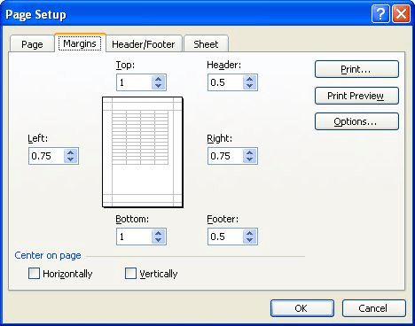

**2. Set a background for your table created.**

Click the worksheet that you want to display with a sheet background. Make sure that only one worksheet is selected. On the Page Layout tab, in the Page Setup group, click Background. Select the picture that you want to use for the sheet background, and then click Insert.

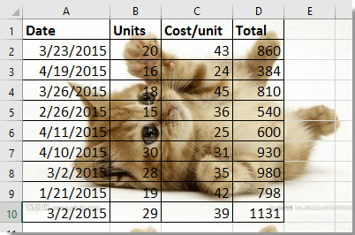

**3. What is freeze panes and why do we use freeze panes? Give examples.**

The Excel Freeze Panes option allows you to lock your columns and/or rows so that when you scroll down or over to view the rest of your sheet, the column and/or row will remain on the screen.

**In the image the entire first row (row 1) is frozen. A horizontal gray line appears right below row 1. This line indicates that the row immediately above is frozen.**



**4. What are the different features available within the Freeze Panes command?**

**The different features available within the freeze panes command are Freeze Panes, Freeze Top Row, Freeze First column**

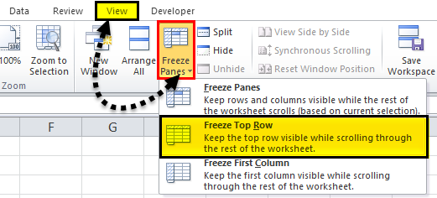

5**. Explain what the different sheet options present in excel are and what they do?**

**MS Excel provides various sheet options for printing purpose like generally cell gridlines aren’t printed. If you want your printout to include the gridlines, Choose Page Layout » Sheet Options group » Gridlines » Check Print.**

**Options in Sheet Options Dialogue**

* **Print Area −** You can set the print area with this option**.**
* **Print Titles**− You can set titles to appear at the top for rows and at the left for columns.
* **Print −**
  + **Gridlines −** Gridlines to appear while printing worksheet**.**
  + **Black & White −** Select this check box to have your color printer print the chart in black and white.
  + **Draft quality − Select** this check box to print the chart using your printer’s draft-quality setting.
  + **Rows & Column Heading**− Select this check box to have rows and column heading to print.
* **Page Order −**
  + **Down, then Over −** It prints the down pages first and then the right pages.
  + **Over, then Down −** It prints right pages first and then comes to print the down pages