**SQL_DAY_3_ASSIGNMENTS**

**Question No 1-🡪23 from “**[**https://sql-ex.ru/**](https://sql-ex.ru/)”

Q1. Find the model number, speed and hard drive capacity for all the PCs with prices below $500.  
Result set: model, speed, hd.

select model, speed, hd

from pc

where price <500;

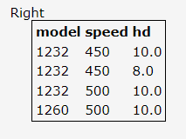

Q2. List all printer makers. Result set: maker.

select distinct maker

from product

where type = 'printer'

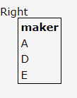

Q3. Find the model number, RAM and screen size of the laptops with prices over $1000.

Select model, ram, screen

from laptop

where price>1000;

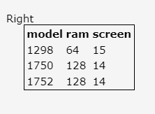

Q4. Find all records from the Printer table containing data about color printers.

Select code, model, color, type, price

from printer

where color = 'y'

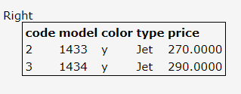

Q5. Find the model number, speed and hard drive capacity of PCs cheaper than $600 having a 12x or a 24x CD drive.

Code: select model, speed, hd

from pc

where price < 600 and cd in ('12x','24x');

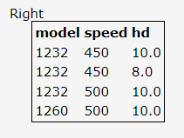

Q6. For each maker producing laptops with a hard drive capacity of 10 Gb or higher, find the speed of such laptops. Result set: maker, speed.

select p.maker, l.speed

from product p

join laptop l

on p.model = l.model

where l.hd >=10;

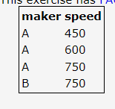

Q7. Get the models and prices for all commercially available products (of any type) produced by maker B.

select p.model,c.price

from product p

join pc c

on p.model = c.model

where p.maker = 'B'

union

select p.model,l.price

from product p

join laptop l

on p.model = l.model

where p.maker = 'B'

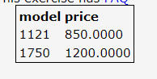

Q8. Find the makers producing PCs but not laptops.

Select distinct maker

From product where type = ‘pc’

And maker not in (select maker from product where type = ‘laptop’

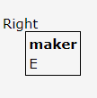

Q9. Find the makers of PCs with a processor speed of 450 MHz or more. Result set: maker

select distinct p.maker

from product p

inner join pc c

on p.model = c.model

where c.speed >=450;

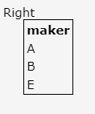

Q10. Find the printer models having the highest price. Result set: model, price.

select model,price

from printer

where price in (select max(price) from printer);

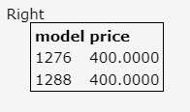

Q11. Find out the average speed of PCs.

select avg(speed) from pc;

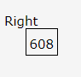

Q12. Find out the average speed of the laptops priced over $1000.

select avg(speed)

from laptop

where price>1000

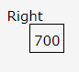

Q13. Find out the average speed of the PCs produced by maker A.

select avg(c.speed)

from product p

inner join pc c

on p.model = c.model

where p.maker = 'A';

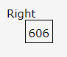

Q14. For the ships in the Ships table that have at least 10 guns, get the class, name, and country

select c.class,s.name,c.country

from classes c

join ships s

on c.class = s.class

where c.numguns >=10;

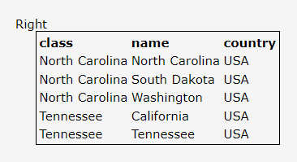

Q15. Get hard drive capacities that are identical for two or more PCs

select hd

from pc

group by hd

having count(code)>=2

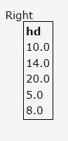

Q16. Get pairs of PC models with identical speeds and the same RAM capacity. Each resulting pair should be displayed only once, i.e. (i, j) but not (j, i).  
Result set: model with the bigger number, model with the smaller number, speed, and RAM.

select distinct pc1.model as model_bigger_num, pc2.model as model_smaller_num, pc1.speed, pc1.ram

from pc pc1

join pc pc2

on (pc1.speed = pc2.speed

and pc1.ram = pc2.ram

and pc1.model > pc2.model)

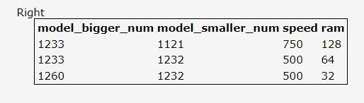

Q17. Get the laptop models that have a speed smaller than the speed of any PC.  
Result set: type, model, speed.

select p.type,l.model,l.speed from laptop l

join product p

on p.model = l.model

where l.speed < all (select speed from pc);

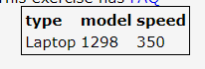

Q18. Find the makers of the cheapest color printers.  
Result set: maker, price.

select p.maker,pr.price

from product p join printer pr

on p.model = pr.model

where pr.color = 'y' and pr.price in (select min(price) from printer where color = 'y');

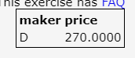

Q19. For each maker having models in the Laptop table, find out the average screen size of the laptops he produces.  
Result set: maker, average screen size.

select p.maker,avg(l.screen)

from product p

join laptop l

on p.model = l.model

group by p.maker;

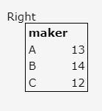

Q20. Find the makers producing at least three distinct models of PCs.  
Result set: maker, number of PC models.

select maker,count(maker) as count_of_model

from product

where type = 'pc'

group by maker

having count(maker)>=3;

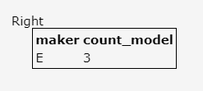

Q21. Find out the maximum PC price for each maker having models in the PC table. Result set: maker, maximum price.

Select p.maker,max(c.price)

from product p join pc c

on p.model = c.model

group by p.maker

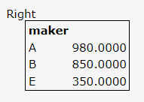

Q22. For each value of PC speed that exceeds 600 MHz, find out the average price of PCs with identical speeds.  
Result set: speed, average price.

select speed,avg(price) as avg_price

from pc

where speed > 600

group by speed;

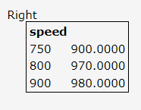

Q23. Get the makers producing both PCs having a speed of 750 MHz or higher and laptops with a speed of 750 MHz or higher.  
Result set: maker

select p.maker

from product p join pc c

on p.model = c.model

where c.speed >= 750

intersect

select p.maker

from product p join laptop l

on p.model = l.model

where l.speed >= 750;

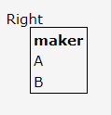

Task:2

1. Which is the department having greater than or equal to 5 employees and display the department names in ascending order.

select d.department_id,d.name

from employee e join department d

on e.department_id = d.department_id

group by d.department_id,d.name

having count(e.employee_id) >=5

order by d.department_name ;



3. How many employees working in “New York”.

select count(e.employee_id)

from location l left join department d on l.location_id = d.location_id

join employee e on d.department_id = e.department_id

where l.regional_group = 'NEW YORK';

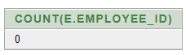

Q4. Show the no. of employees working under every manager.

select manager_id,count(employee_id) as "emp under manager"

from employee

group by manager_id;

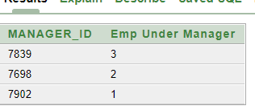

Q5. Display employee details with all departments.

select d.*,e.*

from department d left join employee e

on d.department_id = e.department_id

order by d.department_id;

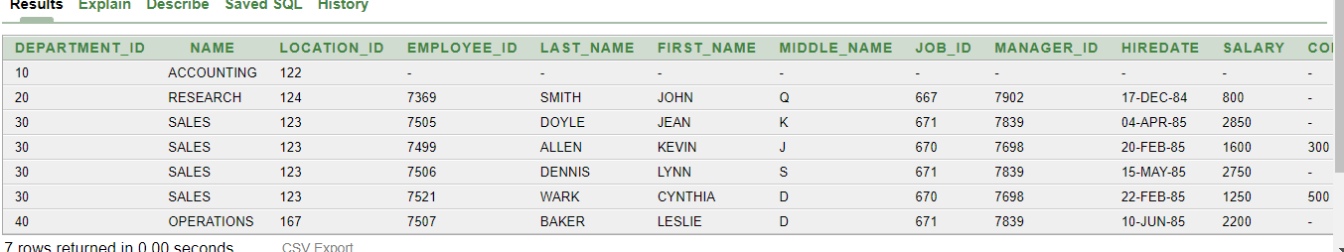

Q6. Display all employees in sales or operation departments

select e.* from employee e

join department d on e.department_id = d.department_id

where d.name in('SALES','OPERATIONS');

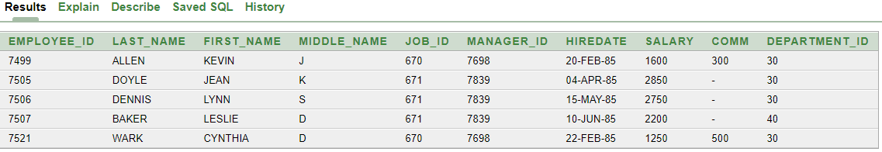

Q7. How many employees who are working in different departments and display with department name.

SELECT d.name,count(e.employee_id)

from department d join employee e

on d.department_id = e.department_id

group by d.name;

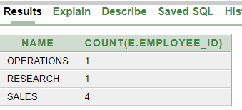

Q8. Display the employees with their department name and regional groups.

select e.*,d.name as "Department_name",l.regional_group

from location l left join department d

on l.location_id = d.location_id

join employee e on d.department_id = e.department_id;

