**SQL_DAY4_ASSIGNMENTS:**

Q1. Display the employee who got the maximum salary.

select * from employee

where salary = (select max(salary) from employee);



Q2. Display the employees who are working in Sales department

select e.* from employee e

join department d

on e.department_id = d.department_id

where d.name = 'SALES';

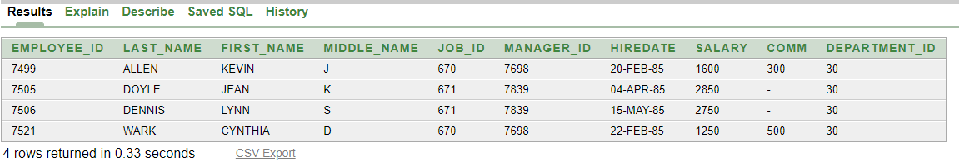

Q3. Display the employees who are working as “Clerk”.

select * from employee

where JOB_ID = (select JOB_ID from job where function = 'CLERK')



Q4. Display the employees who are working in “New York”

select x.*

from

(select e.* from location l

join department d on l.location_id = d.location_id

join employee e on d.department_id = e.department_id

where l.Regional_group = 'NEW YORK') x

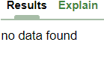

Q5. Find out no of employees working in “Sales” department.

select count(employee_id)

from employee

where department_id = (select department_id from department where name = 'SALES');

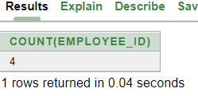

Q6. Update the employees salaries, who are working as Clerk on the basis of 10%.

update employee

set salary = salary*1.10

where job_id = (select job_id from job where function = 'CLERK');

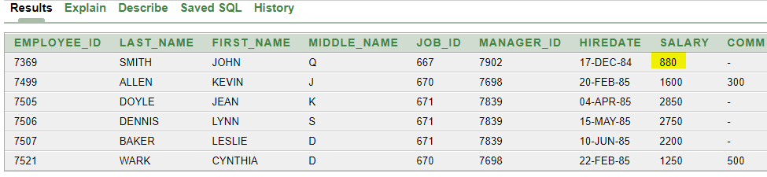

Q7. Delete the employees who are working in the accounting department.

delete from employee

where department_id =(

select department_id from department where name = 'ACCOUNTING');

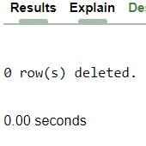

Q8. Display the second highest salary drawing employee details.

Select top 1* from

(select distinct top 2 *

from employee

order by salary desc)a

order by salary;



Q9. Display first 3 highest salaries

select * from

(select salary

from employee

order by salary desc)

where rownum <=3

order by salary desc;

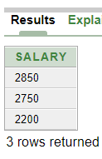

Q10. Display the record of employee who belongs to “Bostan” regional group

select * from employee

where department_id in (

select d.department_id from department d join location l on d.location_id = l.location_id

where l.Regional_group = 'BOSTON');

