**SQL_DAY5_ASSIGNMENTS:**

Q1. Write a SQL query using the analytic function to find the total sales(QUANTITY) of each product?

select distinct product_id , sum(price) over(partition by product_id) as "Total_sales_by_product"

from sales

order by product_id;

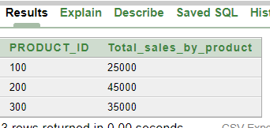

Q2. Write a SQL query to find the minimum sales of a product without using the group by clause.

select distinct product_id, min(quantity) over (partition by product_id) as "Min_quantity_sales"

from sales

order by product_id;

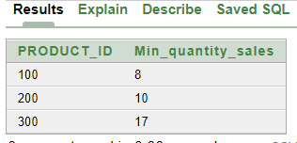

Q3. Create index on sale_id

create index idx_sale_id on sales(sale_id)

Q5. Create a view on given table which can display sale_id product_id and price.

create view sales_vw

as

select sale_id,product_id,price

from sales;

select * from sales_vw;

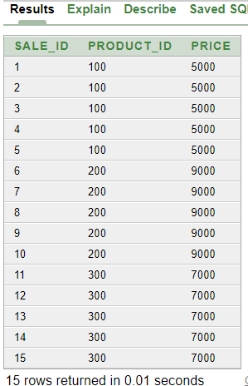

Q6. Create a sequence on table Student given in Q.8 ER diagaram

create table student(

stu_id int primary key,

stu_name varchar(50) not null,

stu_addr varchar(50) not null);

create sequence seq_stu_id

start with 1

increment by 1

minvalue 1

cache 10;

insert into student values(seq_stu_id.nextval,'sayanik','Kolkata');

insert into student values(seq_stu_id.nextval,'soham','London');

insert into student values(seq_stu_id.nextval,'arjun','Paris');

select * from student;

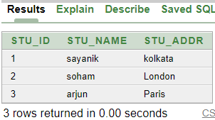

Q7. Create table emp having eid,ename,salary update its eid from 101 to 105 for 5 employee by using sequence generate its eid and insert it into table

create table emp(

eid int primary key,

ename varchar(50),

salary int);

create sequence seq_emp_id

start with 101

increment by 1

minvalue 101

maxvalue 105

cache 2;

insert into emp values(seq_emp_id.nextval,'john',50000);

insert into emp values(seq_emp_id.nextval,'james',60000);

insert into emp values(seq_emp_id.nextval,'joseph',45000);

insert into emp values(seq_emp_id.nextval,'king',35000);

insert into emp values(seq_emp_id.nextval,'jack',90000);

select * from emp;

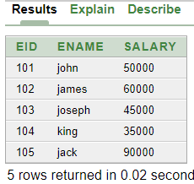

Q8.

create table student(

stu_id int primary key,

stu_name varchar(50) not null,

stu_addr varchar(50) not null);

create table college(

col_id int primary key,

col_num varchar(100) not null);

Q9. use unique constraint on stu_name and col_name and display the data

create table stud(

stu_id int primary key,

stu_name varchar(50) unique,

stu_addr varchar(50) not null);

create table col (

col_id int primary key,

col_num varchar(100) unique);

10. update stu_addr as default value is “Pune” if address is not given.

alter table student modify stu_addr default 'Pune';

insert into student (STU_ID, STU_NAME) values (seq_stu_id.nextval,'anik');

select * from student;

