**SQL_DAY6_ASSIGNMENTS:**

1. **Write a program to find out whether number is positive or negative**

Begin

declare @a int;

set @a = 100;

if @a<0

Begin

print 'the number is negative';

End

else

print 'the number is positive';

End;

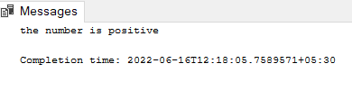

**2) Compare three numbers. Then print greatest number from them**

create function greatestnumber (@a int,@b int,@c int)

returns varchar(50)

as

begin

declare @result as varchar(50)

select @result = case

when @a>@b and @a>@c then cast(@a as varchar(10)) + 'is greatest'

when @b>@a and @b>@c then cast(@b as varchar(10)) + 'is greatest'

when @c>@a and @c>@b then cast(@c as varchar(10)) + 'is greatest'

End

return @result

end;

print(dbo.greatestnumber (25,78,69));

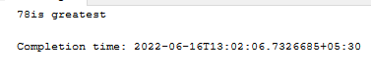

**3) Swap two numbers**

Begin

declare @a int = 100

declare @b int = 200

declare @temp int

print ('original values @a = ' + cast(@a as varchar(5)) + ', @a = ' + cast(@b as varchar(5)))

set @temp = @a

set @a = @b

set @b = @temp

print ('after swapping @a = ' + cast(@a as varchar(5)) + ', @a = ' + cast(@b as varchar(5)))

end;

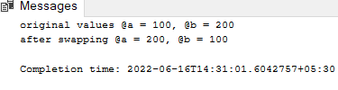

**4) Program to print Fibonacci series upto given number (upto 20)**

begin

declare @num1 int = 0

declare @num2 int = 1

declare @num3 int

declare @start int = 1

print @num1

print @num2

while @start<21

begin

set @num3 = @num1+@num2

print @num3

set @num1 = @num2

set @num2 = @num3

set @start = @start+1

end

end;

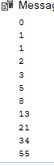

**5) Program to print factorial of given number**

begin

declare @num int = 5

declare @fact int = 1

while @num > 0

begin

set @fact = @fact * @num

set @num = @num - 1

end

print(@fact)

end;

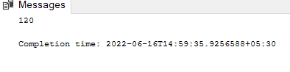

**6) write a program to display the total salary paying to deptno=30 employees assume suitable table data for it**

alter procedure spsalarydeptwise (@depid int)

as

begin

select department_id,sum(salary) as 'total salary' from employee

where DEPARTMENT_ID = @depid

group by DEPARTMENT_ID

end;

exec spsalarydeptwise 30

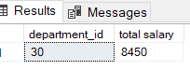

**7) write  a  program to display the "number of male customers" from the given city? assume suitable table data for it**

create procedure spcustgender (@city varchar(25))

as

begin

select count(emp_id) as 'no_of_male_customers',city

from emp_city

where city = @city and gender = 'M'

group by city

end;

exec spcustgender'pune'

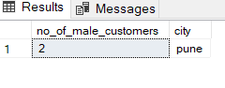

**8) WRITE A program to insert a customer record by taking customer names,city and Gender in customer table. Assume suitable table data**

create function fn_empdetails()

returns @table table (name varchar(50),city varchar(30),gender varchar(7))

as

begin

insert into @table

select name,city,gender from employee

return

end;

select * from fn_empdetails()

9)**Generate an exception if name of employee is 6 characters long**

begin try

select first_name from employee where len(first_name)=6

end try

begin catch

print error_message()

end catch;

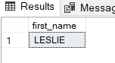

**10) write a procedure to display the commission of a given employee id?  If commission is null, then display any useful message?**

alter procedure spcommission(@empid int)

as

begin

select employee_id,

case when comm is null then 0 else comm end as 'commission'

from employee

where EMPLOYEE_ID = @empid

end;

exec spcommission 7369

