**SQL_DAY_2_ASSIGNMENTS**

CREATE TABLE ORDER_TABLE(

CUSTOMER_ID INT,

CUST_NAME VARCHAR(100),

CITY VARCHAR(50),

SATISFACTION_GRADE INT,

SALESMAN_ID INT,

ORD_NO INT,

PURCH_AMT NUMBER(10,2),

ORD_DATE DATE);

INSERT INTO ORDER_TABLE VALUES (101,'Nick','New York',100,2344,5003,546.6,TO_DATE('2012-11-11','YYYY-MM-DD'));

INSERT INTO ORDER_TABLE VALUES (102,'Brad','Paris',100,2346,5002,7864.7,TO_DATE('2021-11-30','YYYY-MM-DD'));

INSERT INTO ORDER_TABLE VALUES (103,'James','California',200,2349,5005,2344.56,TO_DATE('2021-11-23','YYYY-MM-DD'));

INSERT INTO ORDER_TABLE VALUES (104,'Thomas','New York',300,2333,5007,233.4,TO_DATE('2021-11-02','YYYY-MM-DD'));

INSERT INTO ORDER_TABLE VALUES (105,'Martha','London',200,2323,5009,129.8,TO_DATE('2021-11-23','YYYY-MM-DD'));

INSERT INTO ORDER_TABLE VALUES (106,'Julia','London',100,2365,5001,4566.62,TO_DATE('2021-10-26','YYYY-MM-DD'));

INSERT INTO ORDER_TABLE VALUES (107,'Peterson','Moscow',100,2378,5005,3456.6,TO_DATE('2021-10-05','YYYY-MM-DD'));

INSERT INTO ORDER_TABLE VALUES (108,'Robert','Berlin',300,2359,5006,1233.8,TO_DATE('2021-10-12','YYYY-MM-DD'));

INSERT INTO ORDER_TABLE VALUES (109,'Adam','Italy',200,2393,5011,416.3,TO_DATE('2021-11-23','YYYY-MM-DD'));

INSERT INTO ORDER_TABLE VALUES (110,'Sam','Italy',200,2386,5010,4824.32,TO_DATE('2021-11-11','YYYY-MM-DD'));

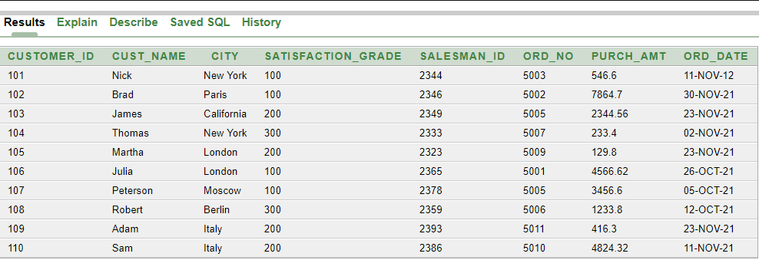

Q1.

SELECT CUSTOMER_ID, CUST_NAME, CITY, SATISFACTION_GRADE,SALESMAN_ID

FROM ORDER_TABLE

WHERE SATISFACTION_GRADE > 100;

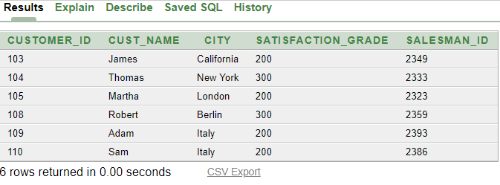

Q2.

SELECT CUSTOMER_ID, CUST_NAME, CITY, SATISFACTION_GRADE,SALESMAN_ID

FROM ORDER_TABLE

WHERE SATISFACTION_GRADE > 100 AND CITY = 'New York' ;

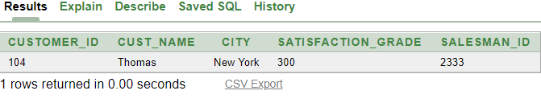

Q3.

SELECT CUSTOMER_ID, CUST_NAME, CITY, SATISFACTION_GRADE,SALESMAN_ID

FROM ORDER_TABLE

WHERE SATISFACTION_GRADE > 100 OR CITY = 'New York' ;

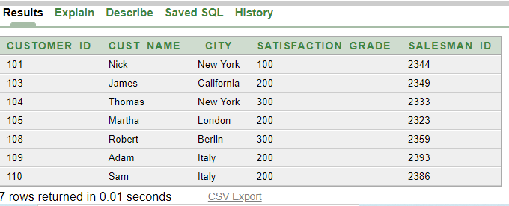

Q4.

SELECT CUSTOMER_ID, CUST_NAME, CITY, SATISFACTION_GRADE,SALESMAN_ID

FROM ORDER_TABLE

WHERE SATISFACTION_GRADE <= 100 AND CITY <> 'New York';

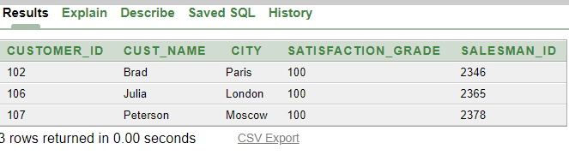

Q5.

SELECT ORD_NO, PURCH_AMT,ORD_DATE,CUSTOMER_ID,SALESMAN_ID

FROM ORDER_TABLE

WHERE ORD_DATE != TO_DATE('2021-11-23','YYYY-MM-DD') AND (SALESMAN_ID <= 5007 OR PURCH_AMT <= 1000);

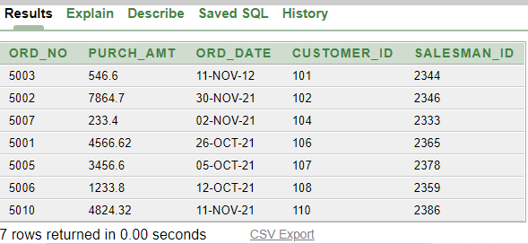

Q6.

SELECT ORD_NO, PURCH_AMT,ORD_DATE,CUSTOMER_ID,SALESMAN_ID

FROM ORDER_TABLE

WHERE PURCH_AMT < 200

OR NOT(ORD_DATE >= TO_DATE('2021-10-10','YYYY-MM-DD') AND CUSTOMER_ID < 107);

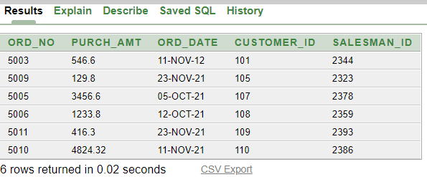

Q7.

SELECT ORD_NO,PURCH_AMT AS "ACHIEVED"

FROM ORDER_TABLE

WHERE PURCH_AMT< 5000*0.5;

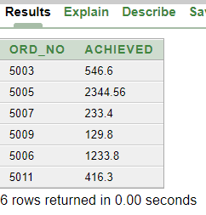

Q8.

SELECT CUSTOMER_ID,CUST_NAME

FROM ORDER_TABLE

ORDER BY ORD_NO,PURCH_AMT DESC;

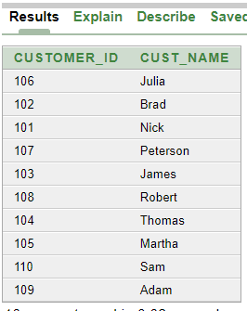

Q9.

SELECT SATISFACTION_GRADE,COUNT(CUSTOMER_ID) AS "TOTAL CUSTOMERS"

FROM ORDER_TABLE

GROUP BY SATISFACTION_GRADE;

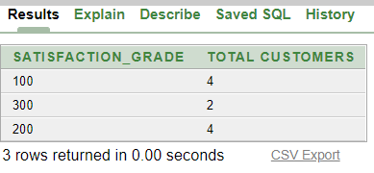

Q10.

SELECT CITY, COUNT(1) AS "NO OF CUSTOMER"

FROM ORDER_TABLE

GROUP BY CITY

HAVING COUNT(1)>1;

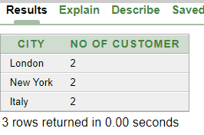

Q11.

---->(MIN_PURCH)

SELECT A.CUSTOMER_ID,A.CUST_NAME AS "MAX PURCH CUST NAME",A.SATISFACTION_GRADE

FROM ORDER_TABLE A

JOIN

(SELECT MAX(PURCH_AMT) AS "MAXP",SATISFACTION_GRADE

FROM ORDER_TABLE

GROUP BY SATISFACTION_GRADE) B

ON A.SATISFACTION_GRADE = B.SATISFACTION_GRADE

WHERE A.PURCH_AMT = B.MAXP;

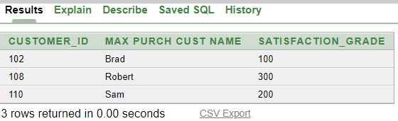

----->(MIN_PURCH)

SELECT A.CUSTOMER_ID,A.CUST_NAME AS "MIN PURCH CUST NAME",A.SATISFACTION_GRADE

FROM ORDER_TABLE A

JOIN

(SELECT MIN(PURCH_AMT) AS "MINP",SATISFACTION_GRADE

FROM ORDER_TABLE

GROUP BY SATISFACTION_GRADE) B

ON A.SATISFACTION_GRADE = B.SATISFACTION_GRADE

WHERE A.PURCH_AMT = B.MINP;

