Employee Attrition Prediction Report
This project focuses on predicting which employees are likely to leave the company using HR analytics and machine learning. The goal is to help organizations take preventive actions, improve retention strategies, and understand key attrition drivers.

Tech Stack
Python, Pandas, Scikit-learn, Matplotlib

Challenges
• Perform feature selection and encoding
• Train Random Forest / Decision Tree classifier
• Handle imbalance if present
• Visualize important features influencing attrition

Dataset Description
The dataset typically includes HR attributes such as Age, Monthly Income, Years at Company, Job Satisfaction, Overtime Status, and Attrition label indicating whether the employee left.

Visualizations
Attrition Count Visualization:
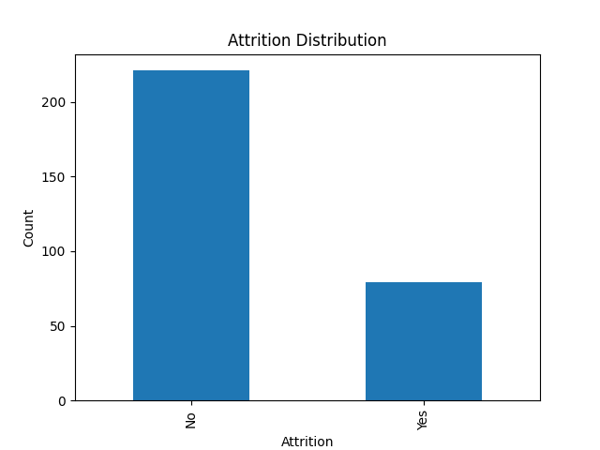

Age vs Attrition:
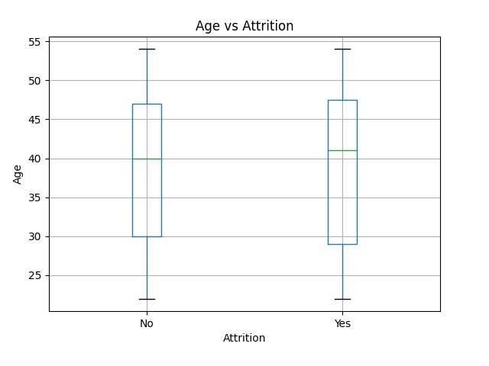
Monthly Income vs Attrition:
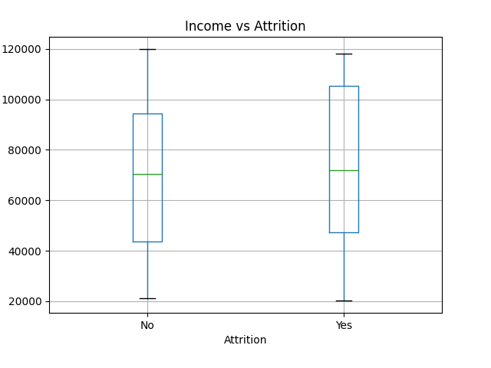

Evaluation Metrics
Accuracy: 0.65
Precision: 0.00
Recall: 0.00
F1-Score: 0.00

Confusion Matrix
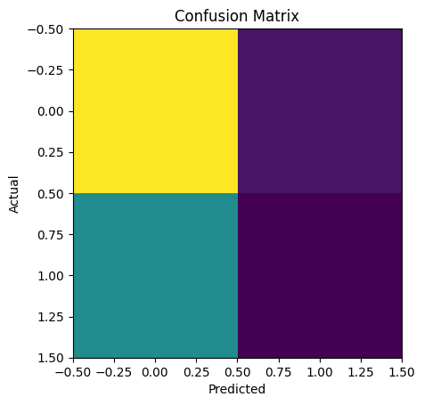

Feature Importance

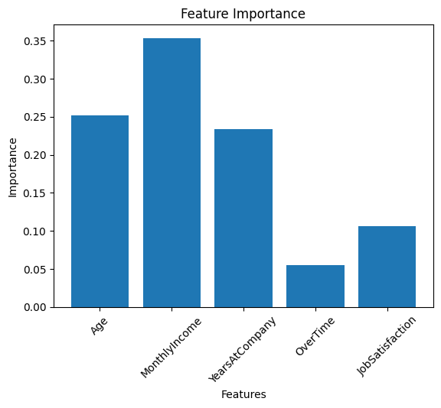

Conclusion
From the visualizations, we can observe how factors such as income, age, and overtime relate to employee attrition. Further machine learning modeling using Random Forest or Decision Trees can help predict attrition more accurately, while feature importance visualization will highlight which HR factors contribute most to employee turnover.

