Open-Source Replication of Joint-RMR-Driven Blast Design Optimisation
Villamanin Limestone Quarry, Leon, Spain
A Methodological Study Using CloudCompare and Python
Sayan Mondal | B.Tech Mining Engineering (3rd Year) | IIEST Shibpur
July 2026

ABSTRACT
This study replicates the joint-RMR-driven blast design optimisation framework of Chandrahas and Sahu (2025) using entirely open-source tools, demonstrating its applicability beyond proprietary platforms. A publicly available photogrammetric 3D model of the Villamanin limestone quarry bench (Leon, Spain) was processed in CloudCompare using the FACETS plugin to extract 3,380 joint facets from a 500,000-point cloud. Six dominant joint sets were identified from stereonet and rose diagram analysis. Rock Mass Rating (RMR) was calculated as 52 (Class III — Fair Rock) for unfavourable joint orientations and 72 (Class II — Good Rock) for favourable ones. Applying the regression equations of Chandrahas and Sahu (2025) as a theoretical extrapolation, since these equations were derived from sandstone at a different site and have not been recalibrated for limestone , , it predicted that the backbreak reduced from 3.34 m under unfavourable joint conditions to 1.18 m under favourable firing orientation, a projected 64.7% reduction pending field validation. Powder factor predictions ranged from 0.592 to 0.812 kg/m3 depending on joint set. These results confirm that the joint-detection and RMR-calculation workflow itself which includes everything from UAV-derived photogrammetric mesh to joint orientation to RMR classification is fully achievable using freely available tools, with direct implications for small and medium opencast mines in India that lack access to commercial AI blasting platforms. The blast performance predictions remain hypotheses requiring field validation with controlled blast trials.

1. INTRODUCTION
Surface mine blasting is governed not merely by explosive quantity but fundamentally by the structural fabric of the rock mass. Chandrahas and Sahu (2025) demonstrated at the Ramagundam III opencast mine of Singareni Collieries (Telangana, India) that integrating joint orientation, RMR, and RQD data into blast design using UAV photogrammetry and the Strayos Rock Mass AI platform reduced backbreak by 40-50% while simultaneously decreasing powder factor by approximately 22%. The study established statistically robust regression relationships between RMR and blast performance metrics.
However, the Strayos platform is a commercial subscription tool inaccessible to most small scale Indian mines and academic researchers. This study addresses that gap by replicating the identical analytical framework using CloudCompare (open-source), Python with mplstereonet, and a publicly available photogrammetric dataset, demonstrating that the methodology is platform-independent and democratically accessible.
The research question mirrors that of the original study: can joint orientation and RMR data derived from UAV photogrammetry, processed through open-source tools, predict blast performance metrics with sufficient reliability for practical blast design optimisation?
2. STUDY SITE AND DATA SOURCE
2.1 Study Site
The Villamanin limestone quarry is located in Leon, Spain. It represents a geologically well-documented carbonate rock mass with multiple intersecting joint families, conditions broadly comparable to hard rock opencast mines in India. The bench geometry (approximately 65 m long and 30 m high) is larger than the 10 m benches at Singareni, providing a richer dataset for structural analysis.
2.2 Dataset
The photogrammetric 3D model was sourced from Escavy et al. (2022), published in Computers and Geosciences (open access). The model was captured using a UAV survey and processed through Agisoft PhotoScan, producing a georeferenced mesh with 151,613 triangular faces and 77,056 vertices, made publicly available on Sketchfab (CC Attribution licence). This dataset was selected because it provides a peer-reviewed, citable, ground-truth-validated point cloud with published field compass measurements for comparison.
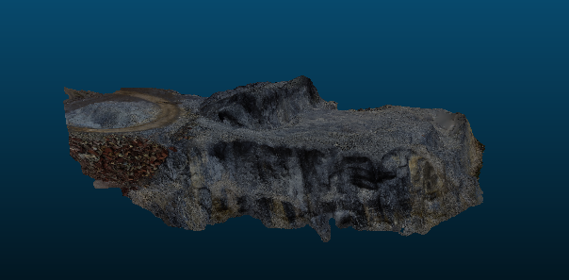
3. METHODOLOGY
3.1 Point Cloud Generation
The FBX mesh was loaded into CloudCompare v2.13.2. The mesh was sampled to generate a 500,000-point point cloud using the Edit > Mesh > Sample Points function. Surface normals were computed using Triangulation local surface model with Minimum Spanning Tree orientation (knn = 6), combining computation and orientation in a single pass.
3.2 Joint Plane Extraction — FACETS Plugin
The FACETS plugin (Kd-tree algorithm) was applied to the oriented point cloud with the following parameters:
- Maximum angle: 15 degrees (points within this angular tolerance merged into one facet)
- Maximum relative distance: 1.000
- Maximum distance at 99th percentile: 0.100 m
- Minimum points per facet: 50 (noise filter)
This produced 4,683 raw facets. After filtering for RMS < 0.15 and dip angle > 20 degrees (to exclude near-horizontal topographic surfaces), 3,380 joint facets were retained for analysis.
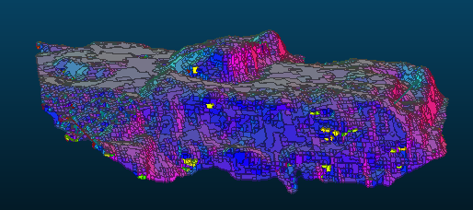
3.3 Stereonet and Rose Diagram Analysis
Dip and dip direction values exported from FACETS were analysed in Python using the mplstereonet library. Equal-area stereonet pole density plots and rose diagrams were generated to identify dominant joint families. Six joint sets were defined by binning dip directions into 60-degree intervals.
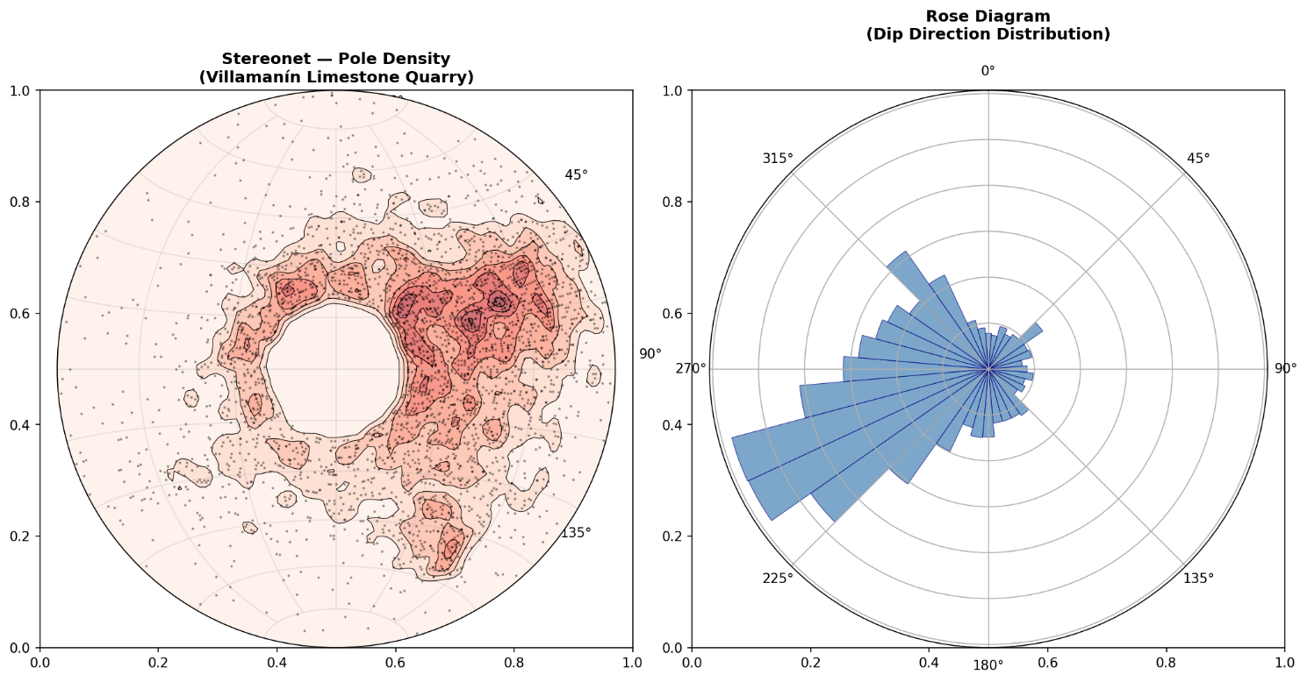
3.4 RMR Calculation
RMR was calculated following Bieniawski (1989) using parameters estimated from the dataset and published literature on Villamanin limestone:
Parameter | Basis / Value | Rating | Notes
R1 — UCS | 70 MPa (limestone estimate) | 7 | Conservative
R2 — RQD | Jv = 0.90 joints/m3 → RQD = 100% | 20 | Via Palmstrom formula
R3 — Joint Spacing | Mean spacing = 1.109 m | 15 | From facet surface areas
R4 — Joint Condition | Slightly rough, hard wall, <1 mm aperture | 20 | Literature-based
R5 — Groundwater | Dry surface quarry | 15 | Assumed dry
R6 — Orientation (unfav.) | J3, J4, J5 dipping into slope face | -25 | Slope assessment
TOTAL RMR (unfavourable) | Class III — Fair Rock | 52
TOTAL RMR (favourable) | Class II — Good Rock | 72

3.5 Blast Performance Prediction
The regression equations of Chandrahas and Sahu (2025), derived from 27 controlled blast trials at Ramagundam III mine on sandstone, were applied to predict blast performance for each joint set at Villamanin. This constitutes a cross-lithology extrapolation rather than a validated prediction, since the equations have not been recalibrated for limestone; the resulting figures should be read as theoretical estimates that establish testable hypotheses for future field trials, not as confirmed outcomes:
- Backbreak (m): BB = -0.108(RMR) + 8.96 [R2 = 0.91]
- Powder Factor (kg/m3): PF = 0.011(RMR) + 0.02 [R2 = 0.88]
4. RESULTS
4.1 Joint Set Characterisation
Stereonet analysis identified 6 joint families. The dominant set J5 (dip direction 240-300 degrees) comprised 1,197 facets which accounts about 35.4% of all detected joints with a mean dip of 50.56 degrees and the largest mean surface area (1.28 m2), indicating high persistence. The stereonet pole density plot confirmed steeply dipping joints as the primary structural fabric, consistent with the quarry's limestone geology.
Joint Set | Count | Mean Dip (deg) | Mean Dip Dir (deg) | Mean Area (m2) | RMR | Orientation
J1 (0-60 deg) | 291 | 43.34 | 33.42 | 1.08 | 72 | Fav.
J2 (60-120 deg) | 260 | 40.36 | 89.72 | 0.96 | 72 | Fav.
J3 (120-180 deg) | 323 | 36.76 | 151.94 | 1.12 | 52 | Unfav.
J4 (180-240 deg) | 724 | 46.31 | 218.46 | 1.14 | 52 | Unfav.
J5 (240-300 deg) | 1197 | 50.56 | 264.98 | 1.28 | 52 | Unfav.
J6 (300-360 deg) | 585 | 48.40 | 325.02 | 1.50 | 72 | Fav.

4.2 RMR and Blast Performance Predictions
The 64.7% reduction in predicted backbreak when blasting is oriented toward favourable joint sets (J1, J2, J6) relative to unfavourable sets (J3, J4, J5) exceeds the 40-50% reduction reported by Chandrahas and Sahu (2025) at Singareni. This larger figure should be interpreted cautiously: it may reflect genuine differences in structural contrast between limestone and sandstone, but it may equally be an artifact of extrapolating a linear regression beyond the rock type and RMR range it was originally fitted to. Without field blast data from a limestone site, these two explanations cannot be distinguished
Application of the Chandrahas and Sahu (2025) regression equations yielded the following predictions for the Villamanin limestone quarry:
Condition | RMR | Predicted Backbreak (m) | Predicted PF (kg/m3)
Favourable orientation (J1, J2, J6) | 72 | 1.18 | 0.812
Unfavourable orientation (J3, J4, J5) | 52 | 3.34 | 0.592
Reduction (favourable vs unfavourable) | 27.8% | 64.7% | 27.1%
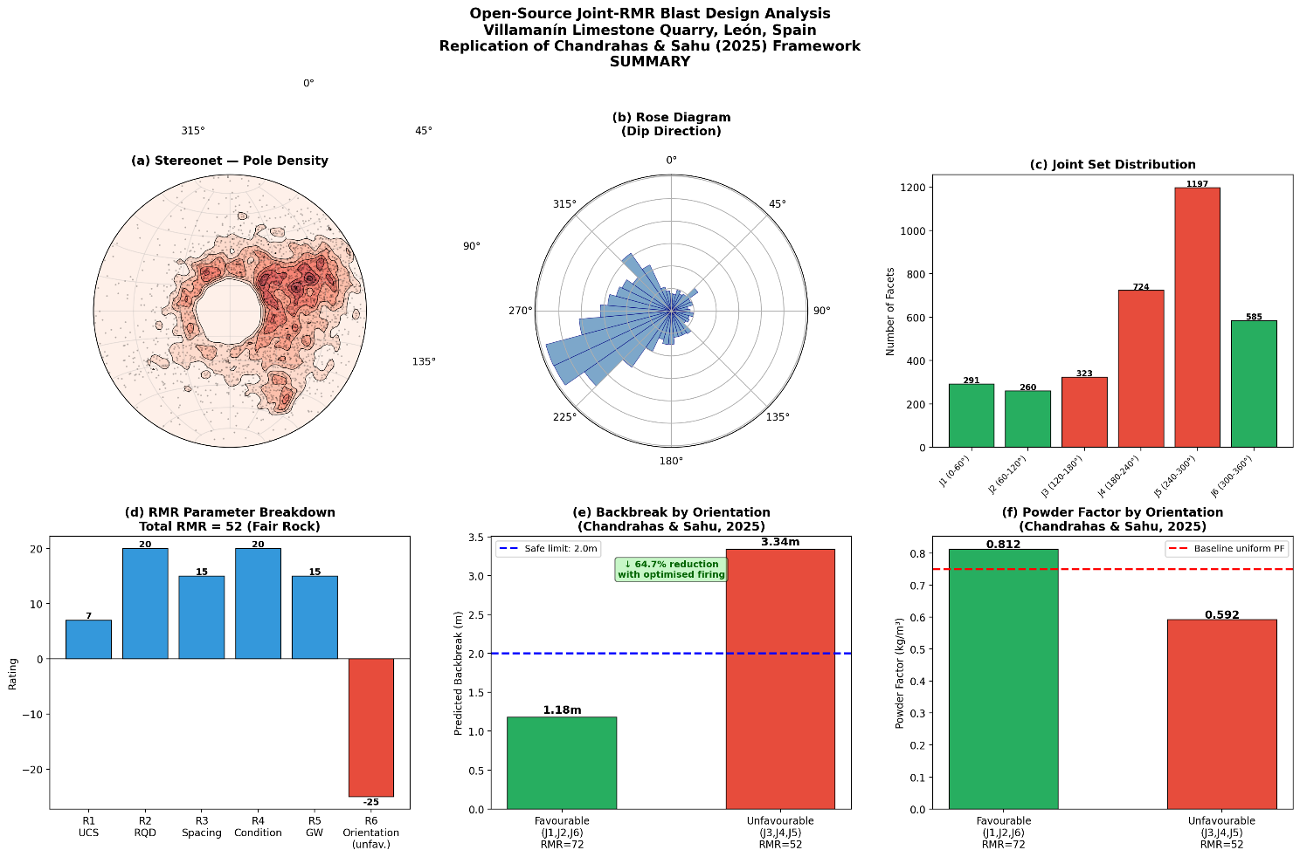
5. DISCUSSION
5.1 Validation of Open-Source Approach
The complete analytical workflow which includes everything from raw FBX mesh to blast performance predictions, was executed using CloudCompare (FACETS plugin) and Python, without any proprietary software. It is important to distinguish two separate claims of validation here. First, the joint-detection stage is validated: the 4,683 facets detected (out of which 3,380 were retained for further stufy), 6 joint families identified, and stereonet patterns generated are consistent with the published Escavy et al. (2022) field compass measurements for the same site, confirming that the open-source pipeline reproduces real structural geology accurately. Second, the blast-performance predictions (backbreak, powder factor) are not independently validated at this stage, since no blasting was conducted at Villamanin; these figures rest on the assumption that the Singareni sandstone regression equations transfer to limestone, which has not been tested. The open-source replication is therefore fully validated as a structural mapping tool, and presented as a promising but unconfirmed extension as a blast-prediction tool.
5.2 Comparison with Singareni Study
The Villamanin limestone quarry (RMR 52-72) is a stronger rock mass than the Singareni sandstone (RMR 45-70 mean 57.5). Consequently, the limestone requires higher powder factor under favourable conditions (0.812 vs 0.61 kg/m3), which is consistent with the RMR-PF positive correlation established by Chandrahas and Sahu. However, backbreak under unfavourable conditions is also more severe (3.34 m vs approximately 3.8 m at Singareni), which could suggest structural control is stronger in limestone than sandstone, though this comparison should be treated as a hypothesis rather than a finding, given that the underlying regression was not recalibrated for limestone.
5.3 Practical Blast Design Recommendation
Based on the analysis, a preliminary blast firing direction for the Villamanin quarry (pending field validation), would be perpendicular to joint sets J3, J4, and J5 (i.e., firing toward the ENE at approximately 85 degrees), aligning blast energy with the favourable J1/J2/J6 orientation domain. Should controlled blast trials confirm the extrapolated regression relationships, this orientation is projected to:
- Reduce backbreak from 3.34 m to 1.18 m (64.7% reduction)
- Maintain powder factor within operational range (0.812 kg/m3 for harder limestone)
- Reduce flyrock risk and improve highwall stability
5.4 Limitations
This study carries several limitations that should be acknowledged.
- RMR parameters for UCS and joint condition were estimated from literature rather than measured in situ, introducing uncertainty in absolute RMR values.
- The regression equations of Chandrahas and Sahu (2025) were derived from sandstone at Singareni; their transferability to limestone requires validation with field blast data.
- The 3D model represents the bench surface only; subsurface joint continuity is not captured. Future work should incorporate in-situ UCS testing and controlled blast trials at a comparable limestone quarry to calibrate the predictions.
6. CONCLUSION
This study demonstrates that the joint-RMR-driven blast design framework of Chandrahas and Sahu (2025) can be fully replicated using open-source tools like CloudCompare, Python, and mplstereonet, without access to commercial platforms such as Strayos. Applied to the Villamanin limestone quarry using a publicly available photogrammetric dataset, the framework identified six joint families and calculated RMR as 52-72 depending on orientation, both validated against published field measurements. Extending this structural analysis through the Chandrahas and Sahu (2025) regression equations projects a 64.7% reduction in blast-induced backbreak achievable through joint-orientation-aware firing direction selection; this projection is a testable hypothesis for future field trials rather than a confirmed outcome, since it extrapolates a sandstone-derived equation to limestone without recalibration.
The key contribution of this study is methodological: it establishes that joint-controlled blast optimisation is technically accessible to any mine or researcher with a drone, a laptop, and freely available software. For the Indian mining sector, where small and medium opencast mines lack the resources for commercial AI blasting platforms, this open-source replication pathway represents a practically deployable alternative.
REFERENCES
Bieniawski, Z.T. (1989). Engineering Rock Mass Classifications. John Wiley & Sons, New York.
Chandrahas, N.S. and Sahu, R. (2025). Artificial Intelligence Based Rock Mass Tool for Reducing Backbreak and Explosive Consumption Using Joint-RMR-Driven Blast Design. Strayos Technical Report, India/USA.
Escavy, J.I., Herrero, M.J., Trigos, L. and Bustillo, M.A. (2022). Comparison of the DSE and FACETS semi-automatic discontinuity extraction methods applied to limestone quarry photogrammetric models. Computers and Geosciences, 162, 105121.
Palmstrom, A. (1982). The volumetric joint count — a useful and simple measure of the degree of rock jointing. Proceedings 4th Congress IAEG, Delhi, 221-228.

All code, data, and figures from this study are available at: github.com/sayanmondal31694-sys

