STRATEGIC ANALYTICS USING THE OLIST BRAZILIAN E-COMMERCE DATASET
Transforming E-Commerce Data into Business Intelligence Using Excel, SQL, and Power BI
Why I Selected This Project

In today's digital economy, e-commerce companies generate massive amounts of transactional data every day. However, raw data alone has limited value unless it is transformed into meaningful insights that support business decision-making. I selected the Olist Brazilian E-Commerce Dataset because it provides a realistic and comprehensive representation of a modern online marketplace, containing interconnected information about customers, orders, products, sellers, payments, deliveries, and customer reviews.

This project offered an excellent opportunity to apply the analytical skills developed throughout the course using industry-standard tools such as Microsoft Excel, SQL, and Power BI. Unlike small or simplified datasets, the Olist dataset reflects real-world business challenges, including data cleaning, integrating multiple related tables, identifying trends, and presenting findings through interactive dashboards.

The project was selected because it allows the practical application of core business analytics concepts, including data preparation, descriptive analysis, performance measurement, and data visualisation. Through this analysis, I was able to explore key business questions such as revenue performance, customer purchasing behaviour, seller effectiveness, product category performance, and operational efficiency. These are common challenges faced by organisations operating in the e-commerce industry.

Furthermore, this project demonstrates how data-driven decision-making can improve business performance. By analysing historical sales and operational data, organisations can identify growth opportunities, improve customer satisfaction, optimise logistics, and enhance overall marketplace performance.

Overall, this project aligns with the learning objectives of the Data Analytics and Artificial Intelligence programme by combining technical analysis with business problem-solving. It has provided valuable hands-on experience in converting raw data into actionable insights, making it both academically meaningful and professionally relevant.
Keywords
Business Intelligence | Data Analytics | Microsoft Excel | SQL | Power BI | Data Visualisation | E-Commerce Analytics | Business Decision Making
Target Audience
The findings of this project are intended for the following audiences:
E-commerce Business Managers – To monitor sales performance, customer behaviour, product demand, and operational efficiency for strategic decision-making.
Sales and Marketing Teams – To identify high-performing products, customer purchasing patterns, and opportunities for targeted marketing campaigns.
Operations and Logistics Managers – To evaluate delivery performance, shipping efficiency, and order fulfilment processes to improve customer satisfaction.
Business Analysts and Data Analysts – To demonstrate how business intelligence tools can be used to transform raw transactional data into actionable insights.
Senior Management and Decision Makers – To support data-driven decisions related to revenue growth, seller performance, customer retention, and overall business strategy.
Students and Academic Evaluators – As a practical demonstration of applying Microsoft Excel, SQL, and Power BI to solve real-world business problems using a large, relational dataset.

Primary Target Audience
The primary target audience is e-commerce business managers and decision-makers, who require data-driven insights to improve business performance, customer satisfaction, and operational efficiency.
Data Cleaning & Preparation
In Excel we first started with the removing of duplicate from our dataset :
- First we open the csv file in excel
- Then we select all using ctrl+A
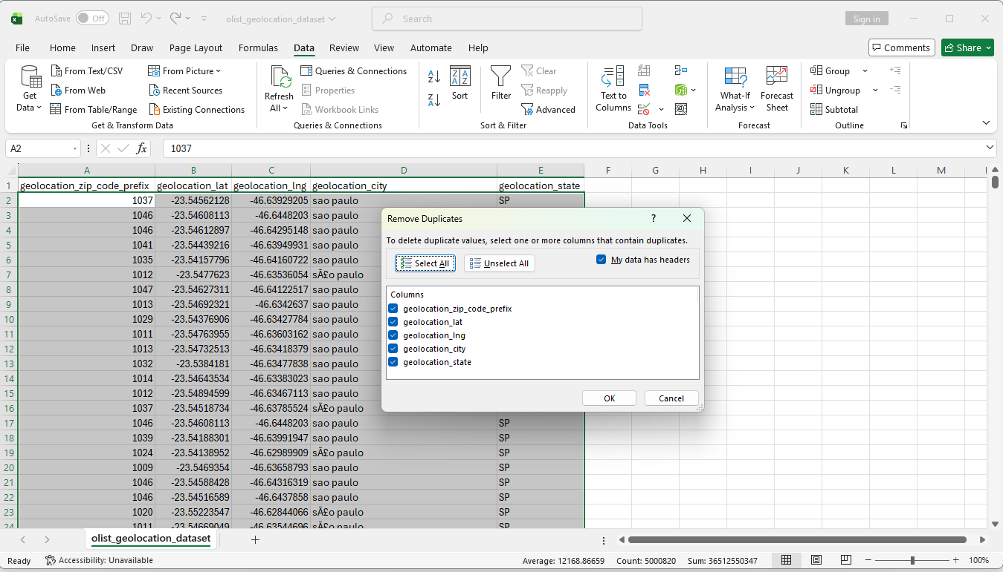
- After selecting we went to Data ->Remove Duplicates->And we click on it to clean the data
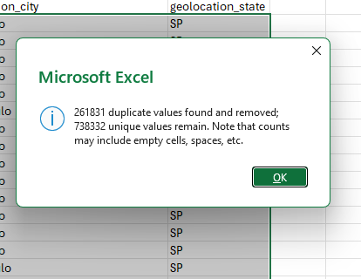

- After removing the duplicates we apply filter which is in same location as remove duplicates
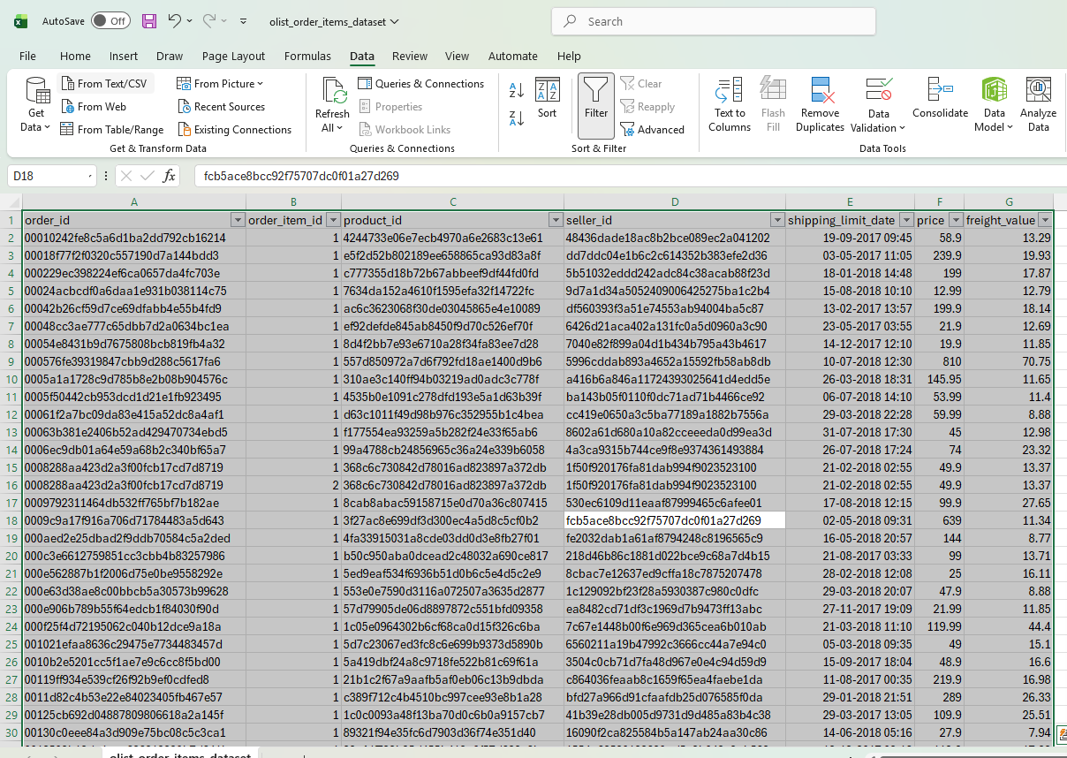
- After that we apply filter to remove null values or blank values

- 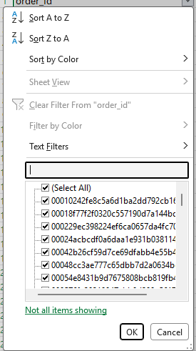
Basic SQL — Understanding the Tables
First u need to download the data set from Kaggle(https://www.kaggle.com/datasets/olistbr/brazilian-ecommerce)
Then we clean the data set from excel
After that we uploaded the the clean dataset inside MySQL run:
into this folder: C:\ProgramData\MySQL\MySQL Server 9.7\Uploads\
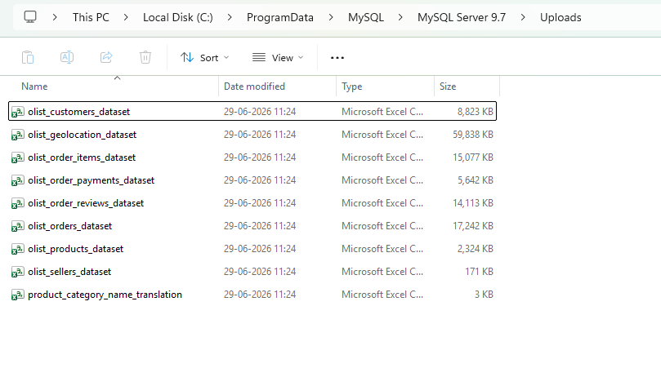
and run the following command in MySQL Workbench:
- Creating Databases
- Create Table( Customer and sellers)
- Load Data from – load data infile
- Then we see if the table Is been imported by – select quary
- Then we use filters , where claws ,join ,order by ,group by

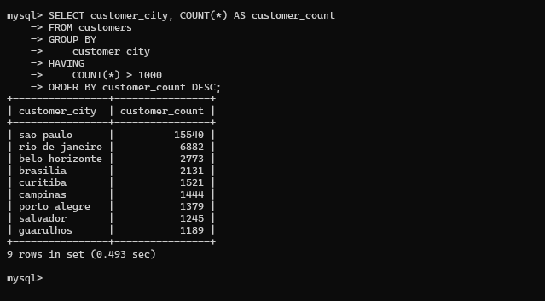

We can also do the same thing by creating a Script File (MYsql_scripts.sql)
And we can joins, filtering, and grouping, not building a production database. Subqueries, stored procedures, and complex schema design are not required.


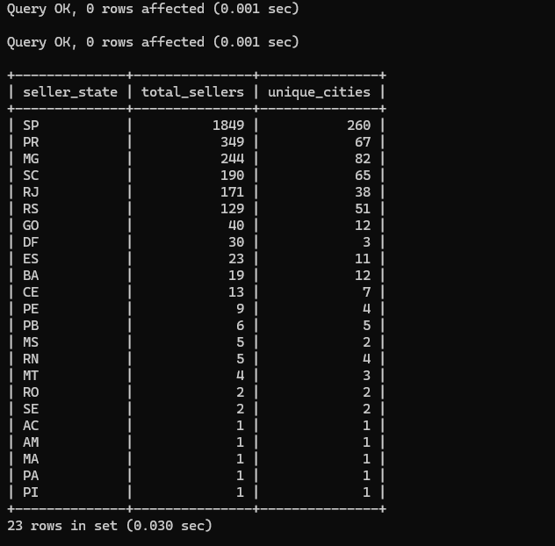

Power BI Dashboard Development
Load your cleaned Excel/CSV tables into Power BI and connect them using relationships
Load your cleaned Excel/CSV tables into Power BI steps are :-
- First open Power BI
- Then go to get data from other sources
- Then click on Excel Workbook
- Then one by one open and load all excel clean data
- 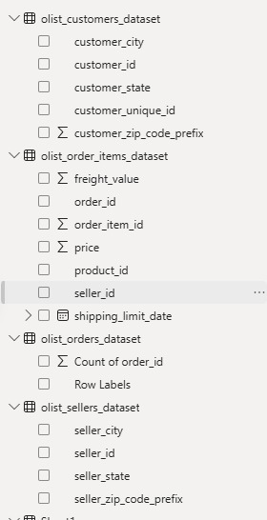

- After that we create the relationship from Modeling->Manage relationship button -> And then we click on Autodetect(which create the relationship automatically )

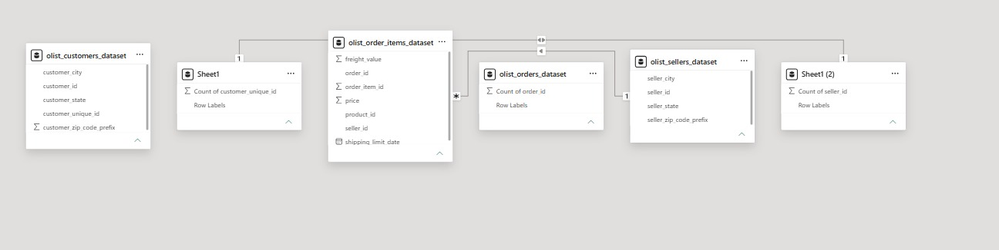

- Build these dashboard pages:
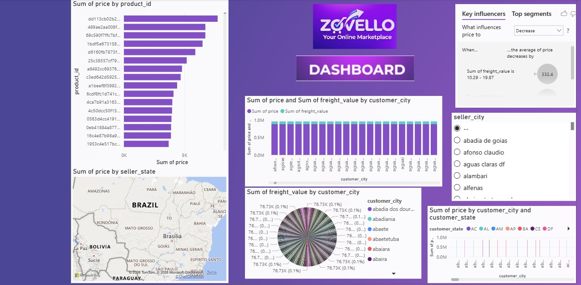
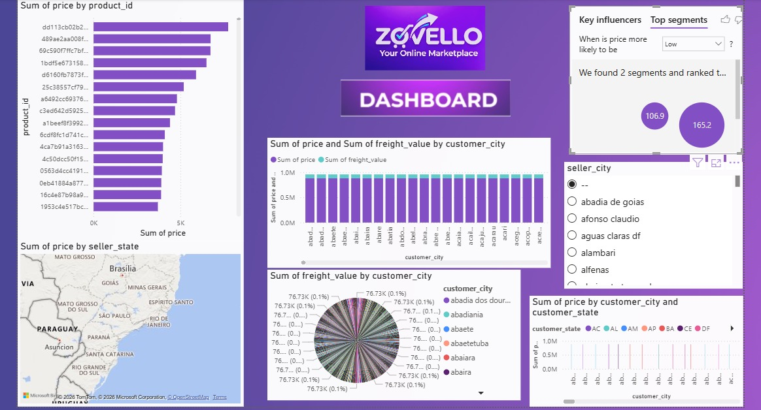
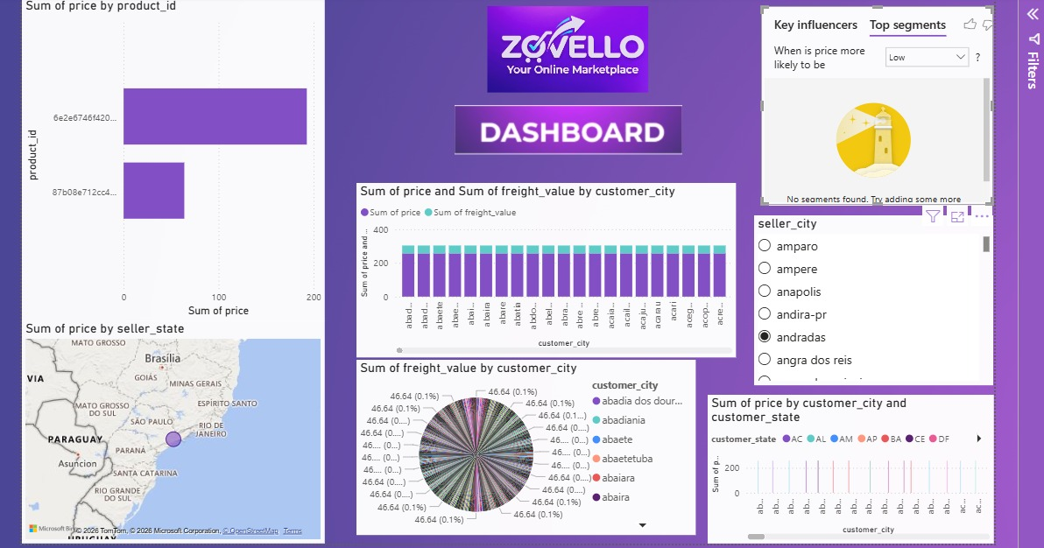

Executive Challenge

If I were presenting this analysis to the CEO, my three highest-priority recommendations would be:

1. Improve Delivery Performance (Highest Priority)
Analysis shows that delayed deliveries are strongly associated with lower customer review scores. Reducing delivery delays by improving logistics partnerships and warehouse operations should be the top priority, as it will increase customer satisfaction, repeat purchases, and brand loyalty.

2. Focus on High-Performing Products and Sellers
Sales data indicates that a small number of product categories and top-performing sellers generate a significant share of total revenue. Increasing investment in these categories and supporting high-performing sellers with promotions and inventory planning can drive revenue growth quickly.

3. Strengthen Customer Retention Through Targeted Marketing
Customer purchase analysis shows that repeat customers contribute substantial long-term value. Implementing personalised offers, loyalty programmes, and targeted email campaigns based on purchase history can increase customer retention at a relatively low implementation cost.
Rank | Strategic Action | Data Point Behind the Recommendation | Impact | Feasibility
1 | Improve delivery performance | Lower review scores are linked to delayed deliveries | Very High | High
2 | Invest in top-performing products and sellers | A small number of categories and sellers generate most revenue | High | High
3 | Increase customer retention through targeted marketing | Repeat customers provide higher long-term business value | High | Medium

