INDIVIDUAL MODULE-WISE LAB WORKBOOK
Wipro Python Automation CoE

1. Module Name and Experiment Title
Module: Tier 1: Core Fundamentals & Locators. Focus: Mastering element identification, synchronization, and basic browser actions.
Experiment: Assignment 1: The Multi-Locator Challenge using By.ID, By.NAME, and By.XPATH locators.

2. Problem Statement
Element identification is the primary foundation of robust web automation. In modern web applications, elements often require different locator strategies depending on available HTML attributes. The task is to navigate to a login page (SauceDemo: https://www.saucedemo.com/), locate and interact with the username field using By.ID, the password field using By.NAME, and the login button using By.XPATH. After logging in, validate that the resulting page URL contains "/inventory.html" and verify that the product inventory dashboard loads successfully.

3. Objective
• Master multi-locator strategies in Selenium WebDriver 4 (By.ID, By.NAME, and By.XPATH).
• Accurately target DOM elements without relying on fragile or brittle selector definitions.
• Utilize WebDriverWait and expected_conditions for reliable page load and element synchronization.
• Validate post-login navigation by asserting URL transformation and dashboard presence.
• Capture execution screenshots at critical verification checkpoints into screenshot_a1/.

4. Tools, Software, and Concepts Used
Item | Detail
Language | Python 3.12+
Library | Selenium WebDriver 4 (selenium.webdriver.common.by, WebDriverWait, EC)
Browser / Driver | Google Chrome with Selenium Manager automatic driver resolution
Execution OS | Linux / Ubuntu x86_64
Application Under Test | SauceDemo E-Commerce portal (https://www.saucedemo.com/)
Locators Applied | By.ID ("user-name"), By.NAME ("password"), By.XPATH ("//input[@id='login-button']")
Core Concepts | Element identification, relative XPath, locator diversity, explicit synchronization, URL assertions, screenshot capture

Concept Summary: Locating elements by ID is usually the fastest and most stable method because IDs are unique in well-structured HTML. Locating by NAME is standard for form data serialization. Locating by XPATH provides flexible querying capable of navigating hierarchical tree relationships, relative element matching, and attribute querying.

5. Source Code or Implementation Steps
Implementation Steps:
Step 1: Launch Google Chrome and navigate to the base URL (https://www.saucedemo.com/).
Step 2: Synchronize on page title "Swag Labs" and capture the initial loaded page.
Step 3: Locate the username field using By.ID ("user-name"), clear it, and type standard_user.
Step 4: Locate the password field using By.NAME ("password"), clear it, and enter secret_sauce.
Step 5: Capture a screenshot of the filled login form credentials.
Step 6: Locate the login submit button using By.XPATH ("//input[@id='login-button']") and execute .click().
Step 7: Synchronize on the URL change using EC.url_contains("/inventory.html") and assert url validity.
Step 8: Verify dashboard inventory heading "Products" and capture the post-login dashboard screenshot.
Source Code (assignment1_multi_locator.py):
"""
Assignment 1: The Multi-Locator Challenge
Site : https://www.saucedemo.com/ (SauceDemo Login Page)
Focus : Mastering element identification, synchronization, and basic browser actions.
Task : Navigate to a login page (SauceDemo).
Find and interact with:
- Username field using By.ID ("user-name")
- Password field using By.NAME ("password")
- Login button using By.XPATH ("//input[@id='login-button']")
Validation : Assert that the resulting page URL contains '/inventory.html' after logging in.
Run : python assignment1_multi_locator.py
"""
from pathlib import Path
from selenium import webdriver
from selenium.webdriver.common.by import By
from selenium.webdriver.support.ui import WebDriverWait
from selenium.webdriver.support import expected_conditions as EC
BASE_URL = "https://www.saucedemo.com/"
VALID_USER = "standard_user"
VALID_PASS = "secret_sauce"
TIMEOUT = 10
SCREENSHOT_DIR = Path(__file__).resolve().parent / "screenshot_a1"
SCREENSHOT_DIR.mkdir(parents=True, exist_ok=True)
def shot(driver, name: str) -> Path:
path = SCREENSHOT_DIR / f"{name}.png"
driver.save_screenshot(str(path))
print(f"[SHOT] saved -> {path}")
return path
def test_multi_locator_login(driver):
wait = WebDriverWait(driver, TIMEOUT)
# Step 1: Navigate to login page
print("\n--- Step 1: Navigating to SauceDemo Login Page ---")
driver.get(BASE_URL)
wait.until(EC.title_contains("Swag Labs"))
print(f"[PASS] Page loaded: {driver.title} ({driver.current_url})")
shot(driver, "01_login_page_loaded")
# Step 2: Locate username field using By.ID
print("\n--- Step 2: Interacting with Username using By.ID ---")
username_field = wait.until(EC.visibility_of_element_located((By.ID, "user-name")))
username_field.clear()
username_field.send_keys(VALID_USER)
assert username_field.get_attribute("value") == VALID_USER
print(f"[PASS] Username entered using By.ID ('user-name'): {VALID_USER}")
# Step 3: Locate password field using By.NAME
print("\n--- Step 3: Interacting with Password using By.NAME ---")
password_field = wait.until(EC.visibility_of_element_located((By.NAME, "password")))
password_field.clear()
password_field.send_keys(VALID_PASS)
assert password_field.get_attribute("value") == VALID_PASS
print("[PASS] Password entered using By.NAME ('password'): [MASKED]")
shot(driver, "02_credentials_entered")
# Step 4: Locate login button using By.XPATH and click
print("\n--- Step 4: Interacting with Login Button using By.XPATH ---")
login_button = wait.until(
EC.element_to_be_clickable((By.XPATH, "//input[@id='login-button']"))
)
print(f"[PASS] Login button located using By.XPATH: {login_button.get_attribute('value')}")
login_button.click()
# Step 5: Validate URL contains /inventory.html
print("\n--- Step 5: Validating Post-Login URL and Inventory Dashboard ---")
wait.until(EC.url_contains("/inventory.html"))
current_url = driver.current_url
assert "/inventory.html" in current_url, f"Expected '/inventory.html' in URL, but got '{current_url}'"
print(f"[PASS] URL validation successful: {current_url} contains '/inventory.html'")
title_elem = wait.until(
EC.visibility_of_element_located((By.CSS_SELECTOR, "[data-test='title']"))
)
assert title_elem.text == "Products"
print(f"[PASS] Dashboard title verified: '{title_elem.text}'")
shot(driver, "03_inventory_logged_in")
def main():
options = webdriver.ChromeOptions()
options.add_argument("--start-maximized")
driver = webdriver.Chrome(options=options)
try:
test_multi_locator_login(driver)
print("\n==========================================")
print("[RESULT] Assignment 1 completed successfully!")
print(f"[RESULT] Screenshots stored in: {SCREENSHOT_DIR}")
print("==========================================\n")
finally:
driver.quit()
if __name__ == "__main__":
main()

6. Output with Clearly Labelled Screenshots
Run command: python assignment1_multi_locator.py
Screenshots are captured automatically and saved into the screenshot_a1 folder.
Screenshot 1: SauceDemo login page loaded with initial state
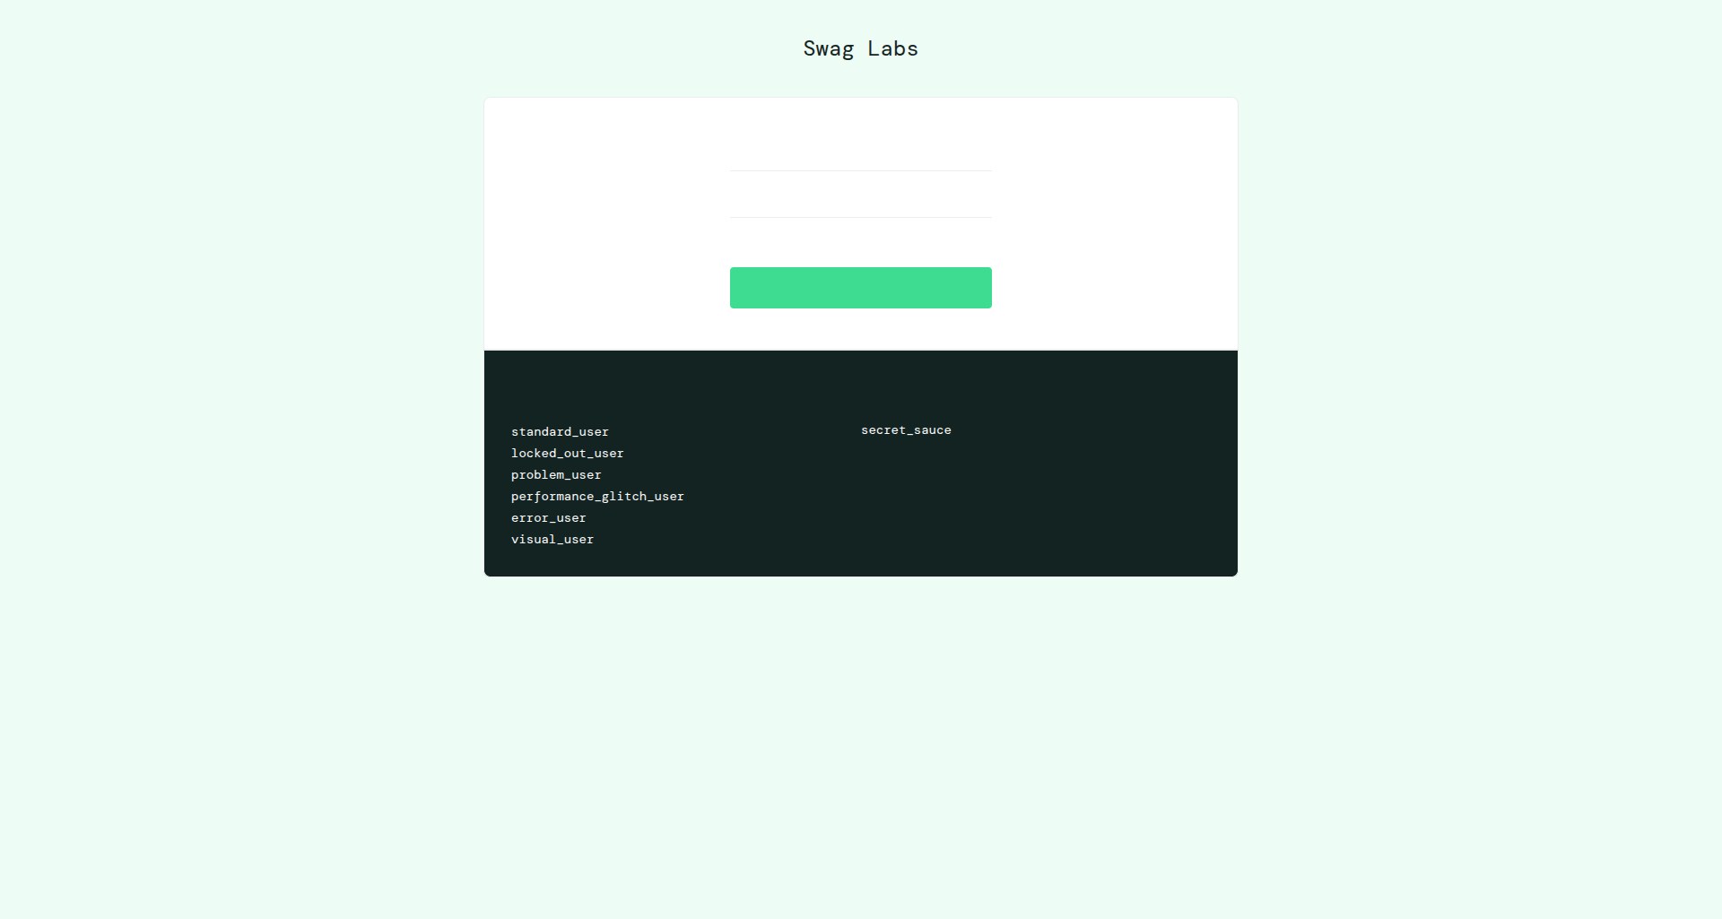

Screenshot 2: Username (By.ID) and Password (By.NAME) entered into input fields
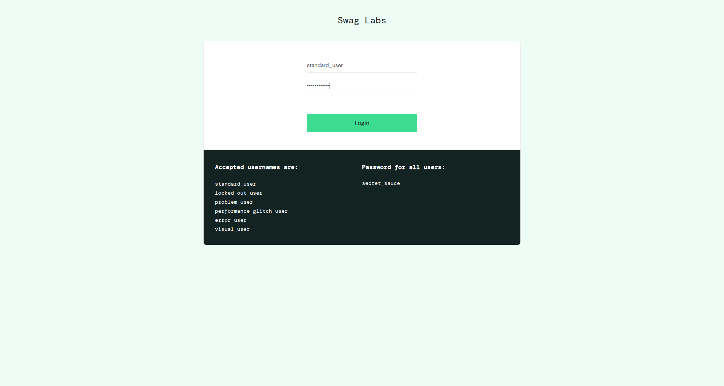

Screenshot 3: Post-login dashboard verified with /inventory.html URL (By.XPATH login click)
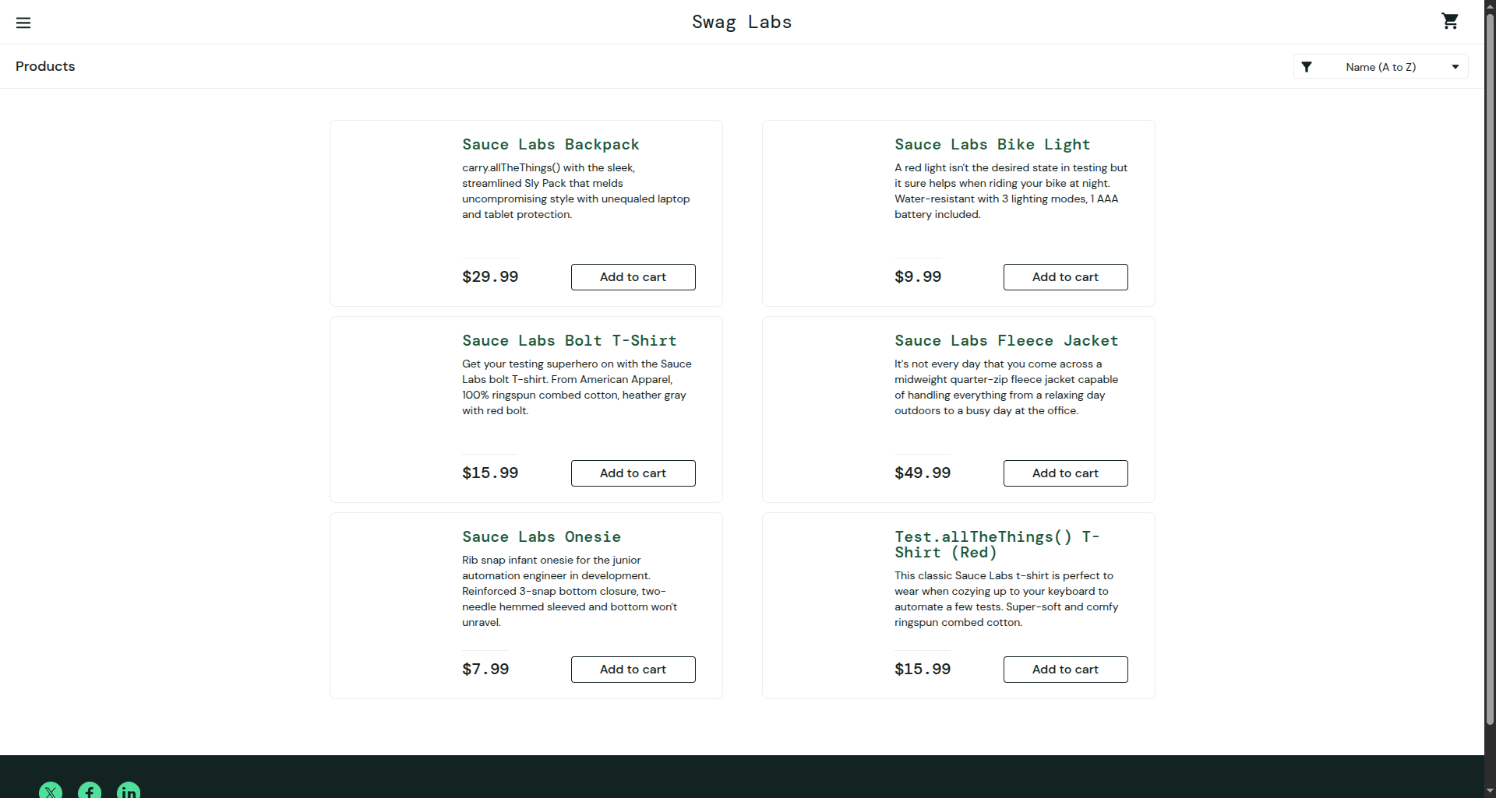

7. Brief Result, Observation, and Conclusion
Result:
All 5 implementation steps executed cleanly without errors. The user was authenticated successfully and the URL was verified to contain "/inventory.html".
Observation:
• By.ID provided instant, unambiguous targeting of the username input field.
• By.NAME successfully targeted the password field, confirming that form input elements without unique IDs can be robustly automated via standard HTML name attributes.
• By.XPATH targeted the submit button precisely using attribute matching (//input[@id='login-button']).
• Post-login synchronization using WebDriverWait prevented race conditions during the React client-side route transition to /inventory.html.
Conclusion:
Assignment 1 demonstrates proficient mastery of multi-locator identification strategies in Selenium WebDriver. By employing ID, NAME, and XPath in a single cohesive test, the automation solution validates best practices in locator selection, synchronization, and assertion.

