INDIVIDUAL MODULE-WISE LAB WORKBOOK
Wipro Python Automation CoE

1. Module Name and Experiment Title
Module: Tier 1: Core Fundamentals & Locators. Focus: Mastering element identification, synchronization, and basic browser actions.
Experiment: Assignment 3: Dynamic Dropdowns & Checkboxes Automation.

2. Problem Statement
Forms in enterprise and consumer applications (e.g. flight booking, registration, or e-commerce checkouts) feature dynamic interactive controls such as multiple checkboxes and search-as-you-type autocomplete dropdowns. Automating these components requires handling element state inspection (.is_selected()), keyboard inputs, dynamic suggestion rendering, and DOM traversal. The task is to open a registration/practice page containing multiple checkboxes and a search-as-you-type autocomplete dropdown, select specific checkboxes, verify their state using .is_selected(), type into the autocomplete dropdown, loop through suggested results dynamically to locate and click a matching option, and verify the outcome.

3. Objective
• Automate multiple checkbox controls and verify boolean state transitions using .is_selected().
• Assert that unselected checkboxes correctly return False while selected checkboxes return True.
• Handle search-as-you-type dynamic autocomplete dropdowns with asynchronous suggestion filtering.
• Iterate dynamically through rendered suggestion elements to locate and select a target item.
• Integrate standard HTML <select> dropdown automation using Selenium Select helper class.
• Save high-resolution verification screenshots for each functional phase into screenshot_a3/.

4. Tools, Software, and Concepts Used
Item | Detail
Language | Python 3.12+
Library | Selenium WebDriver 4 (common.by, support.ui.WebDriverWait, Select, EC)
Browser / Driver | Google Chrome with Selenium Manager automatic driver resolution
Execution OS | Linux / Ubuntu x86_64
Application Under Test | Test Automation Practice portal (https://testautomationpractice.blogspot.com/)
Controls Handled | Checkboxes (Days), Autocomplete Input (#comboBox + #dropdown), Standard Select (#country)
Core Concepts | Element state querying (.is_selected()), DOM scrolling, dynamic suggestion loops, Select class, explicit wait

Concept Summary: Checkboxes represent toggleable states where .is_selected() allows programmatic verification of selection status. Autocomplete dropdowns dynamically render filtered list items in response to keystrokes. Selenium handles them by sending search keys, waiting for the suggestions container to become visible, iterating through the list elements, matching the target text string, and dispatching a click.

5. Source Code or Implementation Steps
Implementation Steps:
Step 1: Navigate to the automation practice page and synchronize on page title.
Step 2: Locate the week day checkboxes (Monday, Wednesday, Friday), scroll them into view, click them, and assert that .is_selected() returns True.
Step 3: Check remaining unselected checkboxes (Sunday, Tuesday, Thursday, Saturday) and assert that .is_selected() returns False.
Step 4: Locate the autocomplete combobox input (#comboBox) and send search query "Item".
Step 5: Wait for the dynamic suggestions popup (#dropdown) to populate.
Step 6: Traverse through the suggestion list elements in a loop, locate "Item 15", and click it.
Step 7: Assert that the input field value updates to "Item 15".
Step 8: Automate standard country select dropdown using Select class and verify selection.
Source Code (assignment3_dropdowns_checkboxes.py):
"""
Assignment 3: Dynamic Dropdowns & Checkboxes
Site : https://testautomationpractice.blogspot.com/ (Automation Practice Page)
Focus : Mastering element identification, synchronization, and basic browser actions.
Task : Open a registration/practice form containing:
1. Multiple checkboxes (Days of the week).
2. Search-as-you-type autocomplete dynamic dropdown (comboBox + dropdown suggestions).
3. Standard select dropdown (Country selection).
Task Steps :
- Select specific checkboxes (e.g., Monday, Wednesday, Friday).
- Verify their state using .is_selected() (assert selected == True and unselected == False).
- Type query into the autocomplete dropdown.
- Loop through the suggested results dynamically to locate and select the matching option.
- Verify the selected value in the combobox input.
Run : python assignment3_dropdowns_checkboxes.py
"""
from pathlib import Path
from selenium import webdriver
from selenium.webdriver.common.by import By
from selenium.webdriver.support.ui import WebDriverWait, Select
from selenium.webdriver.support import expected_conditions as EC
BASE_URL = "https://testautomationpractice.blogspot.com/"
TIMEOUT = 15
SCREENSHOT_DIR = Path(__file__).resolve().parent / "screenshot_a3"
SCREENSHOT_DIR.mkdir(parents=True, exist_ok=True)
DAYS_TO_SELECT = ["monday", "wednesday", "friday"]
DAYS_TO_LEAVE_UNSELECTED = ["sunday", "tuesday", "thursday", "saturday"]
SEARCH_ITEM = "Item 15"
SELECTED_COUNTRY = "canada"
def shot(driver, name: str) -> Path:
path = SCREENSHOT_DIR / f"{name}.png"
driver.save_screenshot(str(path))
print(f"[SHOT] saved -> {path}")
return path
def scroll_to_element(driver, element):
driver.execute_script("arguments[0].scrollIntoView({block: 'center', behavior: 'instant'});", element)
def test_checkboxes(driver, wait):
print("\n--- Part 1: Multiple Checkboxes Selection & Verification ---")
wait.until(EC.presence_of_element_located((By.ID, "monday")))
# Step 1: Select target checkboxes and verify state
for day in DAYS_TO_SELECT:
checkbox = wait.until(EC.presence_of_element_located((By.ID, day)))
scroll_to_element(driver, checkbox)
if not checkbox.is_selected():
wait.until(EC.element_to_be_clickable((By.ID, day))).click()
assert checkbox.is_selected() is True, f"Expected checkbox '{day}' to be selected!"
print(f"[PASS] Checkbox '{day}' successfully selected (.is_selected() == True)")
# Step 2: Verify unselected checkboxes
for day in DAYS_TO_LEAVE_UNSELECTED:
checkbox = driver.find_element(By.ID, day)
assert checkbox.is_selected() is False, f"Expected checkbox '{day}' to be unselected!"
print(f"[PASS] Unselected checkbox '{day}' verified (.is_selected() == False)")
shot(driver, "01_checkboxes_selected")
def test_dynamic_autocomplete_dropdown(driver, wait):
print("\n--- Part 2: Search-as-you-type Autocomplete Dropdown ---")
combobox = wait.until(EC.visibility_of_element_located((By.ID, "comboBox")))
scroll_to_element(driver, combobox)
# Type search term
combobox.clear()
combobox.send_keys("Item")
print(f"[INFO] Typed query 'Item' into autocomplete input #comboBox")
# Wait for suggestions container to become visible
dropdown_container = wait.until(EC.visibility_of_element_located((By.ID, "dropdown")))
shot(driver, "02_autocomplete_suggestions_opened")
# Loop through suggestions dynamically to locate and click matching option
suggestions = wait.until(
lambda d: d.find_elements(By.XPATH, "//div[@id='dropdown']//div | //div[@id='dropdown']/*")
)
print(f"[INFO] Discovered {len(suggestions)} suggestion elements in dynamic dropdown")
matched = False
for option in suggestions:
text = option.text.strip()
if text == SEARCH_ITEM:
scroll_to_element(driver, option)
option.click()
matched = True
print(f"[PASS] Found and clicked matching option: '{SEARCH_ITEM}'")
break
assert matched, f"Could not find matching suggestion '{SEARCH_ITEM}' in dropdown options!"
# Verify input field now displays the selected value
actual_value = combobox.get_attribute("value").strip()
assert actual_value == SEARCH_ITEM, f"Expected '{SEARCH_ITEM}' in #comboBox, got '{actual_value}'"
print(f"[PASS] Autocomplete dropdown value verified: '{actual_value}'")
shot(driver, "03_autocomplete_option_selected")
def test_standard_select_dropdown(driver, wait):
print("\n--- Part 3: Standard Select Dropdown (Country) ---")
country_elem = wait.until(EC.presence_of_element_located((By.ID, "country")))
scroll_to_element(driver, country_elem)
select = Select(country_elem)
select.select_by_value(SELECTED_COUNTRY)
selected_option = select.first_selected_option
assert selected_option.get_attribute("value") == SELECTED_COUNTRY
print(f"[PASS] Country select dropdown verified: '{selected_option.text}' (value={SELECTED_COUNTRY})")
shot(driver, "04_country_dropdown_selected")
def main():
options = webdriver.ChromeOptions()
options.add_argument("--start-maximized")
driver = webdriver.Chrome(options=options)
wait = WebDriverWait(driver, TIMEOUT)
try:
print("\n--- Navigating to Test Automation Practice Page ---")
driver.get(BASE_URL)
wait.until(EC.title_contains("Automation Testing Practice"))
print(f"[PASS] Page loaded: {driver.title}")
test_checkboxes(driver, wait)
test_dynamic_autocomplete_dropdown(driver, wait)
test_standard_select_dropdown(driver, wait)
print("\n==========================================")
print("[RESULT] Assignment 3 completed successfully!")
print(f"[RESULT] Screenshots stored in: {SCREENSHOT_DIR}")
print("==========================================\n")
finally:
driver.quit()
if __name__ == "__main__":
main()

6. Output with Clearly Labelled Screenshots
Run command: python assignment3_dropdowns_checkboxes.py
Screenshots are captured automatically and saved into the screenshot_a3 folder.
Screenshot 1: Multiple checkboxes selected (Monday, Wednesday, Friday) with .is_selected() verified
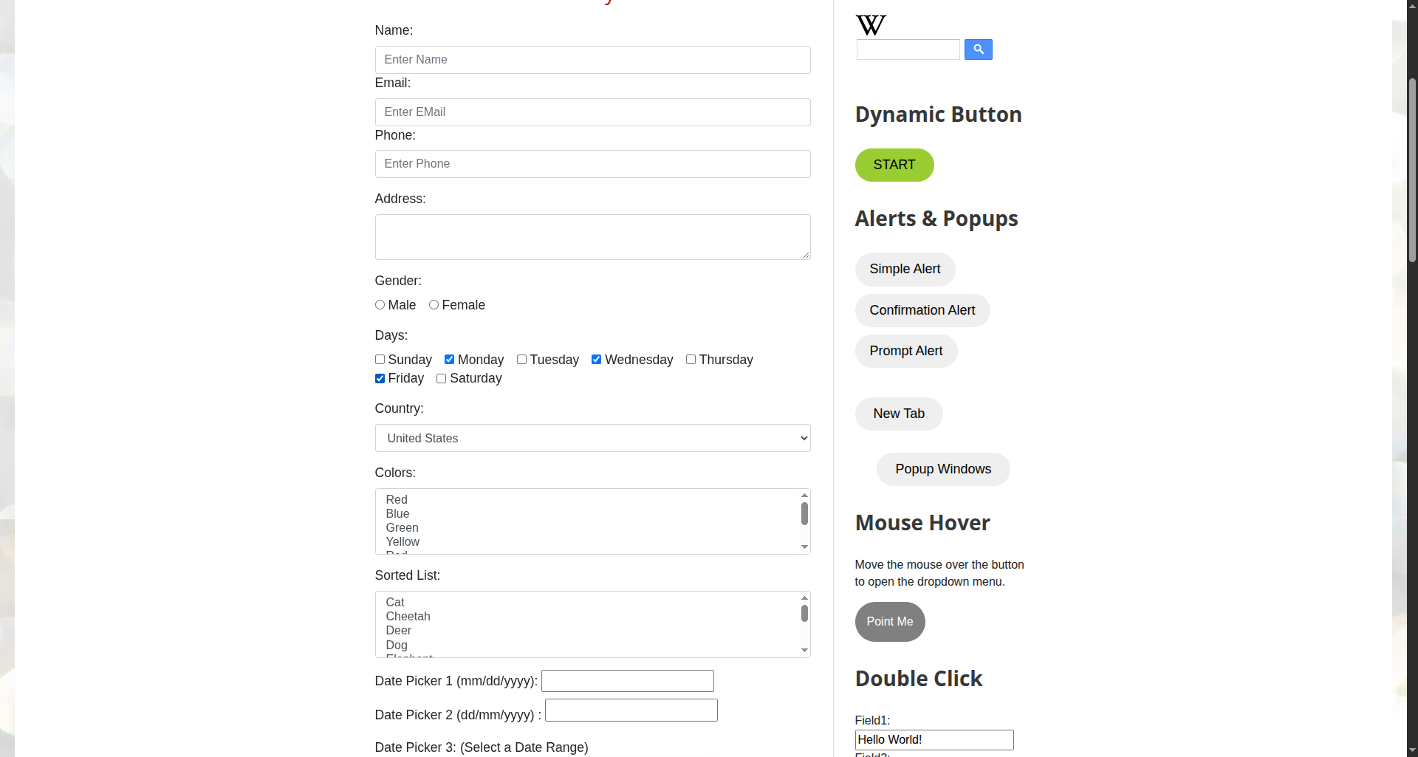

Screenshot 2: Search-as-you-type autocomplete suggestions opened dynamically upon typing "Item"
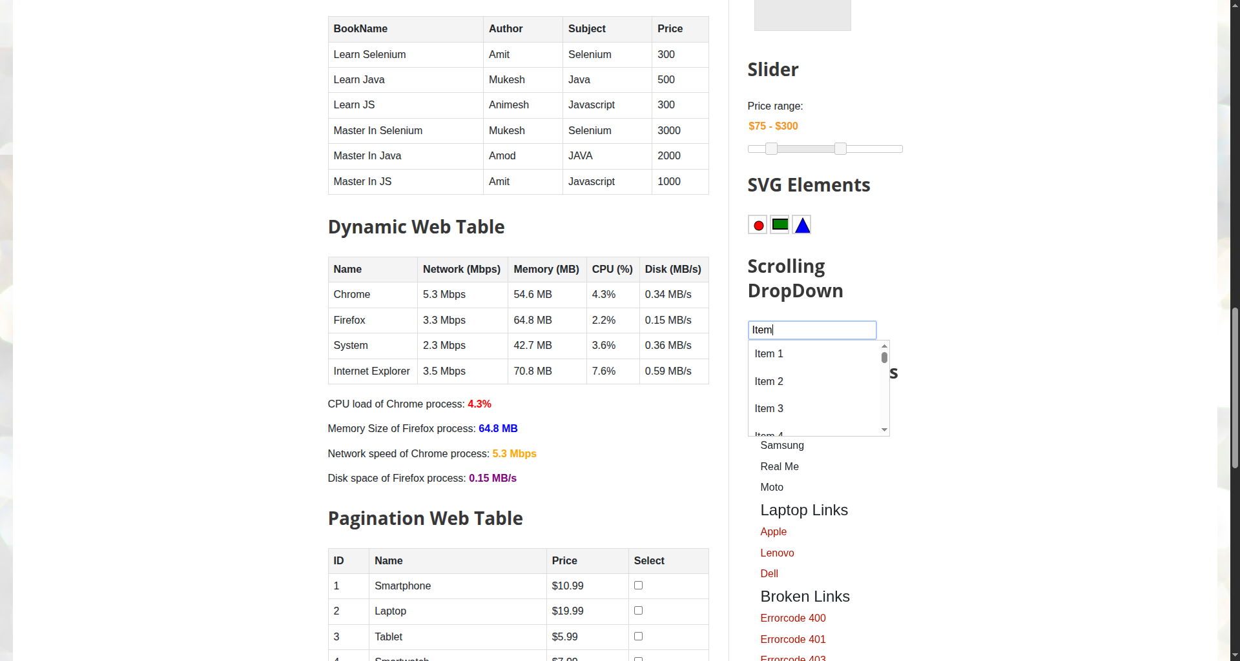

Screenshot 3: Dynamic option "Item 15" matched from loop and selected into the combobox
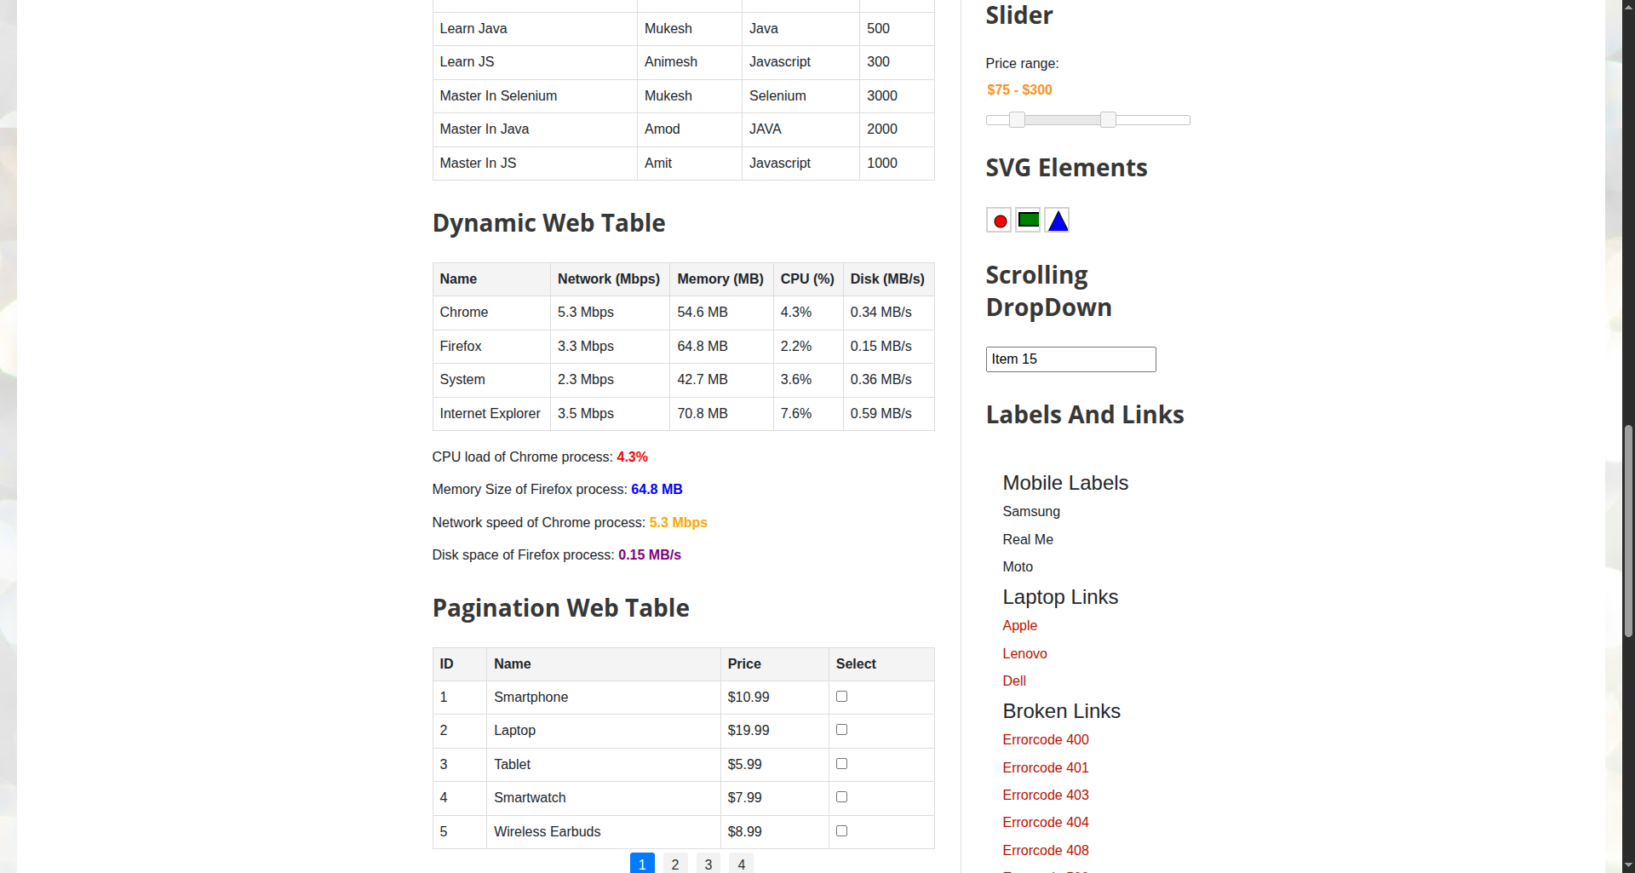

Screenshot 4: Standard HTML select dropdown option (Canada) chosen and verified
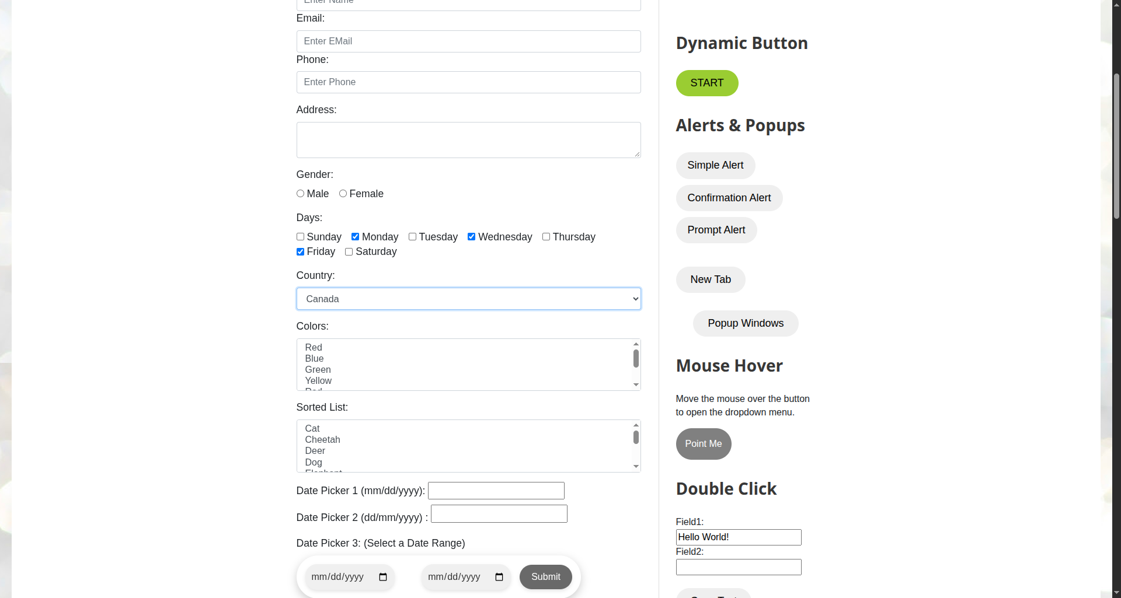

7. Brief Result, Observation, and Conclusion
Result:
All checkbox verifications, dynamic autocomplete suggestions traversal, and select dropdown operations passed without error.
Observation:
• Checkbox verification via .is_selected() correctly confirmed active state for chosen days and inactive state for unselected days.
• Typing into the autocomplete dropdown triggered client-side suggestion generation dynamically. Looping through the suggestions ensured resilient matching regardless of DOM index order.
• The Select helper class simplified standard <select> tag interactions compared to raw XPath clicking.
Conclusion:
Assignment 3 demonstrates comprehensive capability in automating both static form controls (checkboxes, standard selects) and dynamic asynchronous UI components (search-as-you-type autocomplete dropdowns) using Selenium WebDriver 4.

