INDIVIDUAL MODULE-WISE LAB WORKBOOK
Wipro Python Automation CoE

1. Module Name and Experiment Title
Module: Selenium WebDriver with Python: Page Object Model (POM).
Experiment: Assignment 7, Page Object Model (POM) Restructure.

2. Problem Statement
As Selenium suites grow, keeping locators and UI actions directly inside test scripts makes tests harder to maintain when the interface changes. The working login scenarios from the earlier tier are therefore reorganized into a Page Object Model structure. Separate page classes contain locator definitions and UI methods, while the test module retains the actual assertions and expected outcomes.

3. Objective
- Restructure Selenium tests into reusable page-object classes.
- Keep locator definitions and UI interaction methods inside the relevant page classes.
- Keep test assertions and expected business outcomes in the test module.
- Use a PyTest driver fixture to initialize and close the browser cleanly.
- Demonstrate reuse of LoginPage and InventoryPage across multiple test cases.

4. Tools, Software, and Concepts Used
Item | Detail
Language | Python 3
Framework | PyTest
Library | Selenium WebDriver 4
Browser / Driver | Google Chrome with Selenium Manager
Editor / OS | VS Code or PyCharm on Windows
Application | SauceDemo
Concepts | Page Object Model, locators, reusable UI methods, fixtures, explicit waits, assertions, separation of concerns

POM architecture summary. The test module owns the assertions and expected outcomes. LoginPage and InventoryPage own only the locators and UI behavior required to perform actions. The driver fixture owns browser lifecycle management. This separates test intent from UI implementation details.

5. Source Code and Implementation Steps
Implementation steps:
- Step 1: Create a driver fixture in conftest.py that starts Chrome for each test and calls driver.quit() after the test completes.
- Step 2: Create LoginPage with locators for username, password, login button, and login error, plus open(), login(), and get_error_message() methods.
- Step 3: Create InventoryPage with locators for the inventory container, page title, first product, menu, and logout link, plus is_loaded(), get_first_product_name(), and logout() methods.
- Step 4: Rewrite the test cases so they instantiate page objects and call UI methods instead of directly scattering locators through the test flow.
- Step 5: Keep assertions in assignment7.py. The page objects return values or perform UI actions but do not decide whether a test passes or fails.
- Step 6: Save execution screenshots to screenshot_a7 so the same folder schema can be used consistently for later assignments.
Source code (pages/login_page.py):
from selenium.webdriver.common.by import By
from selenium.webdriver.support.ui import WebDriverWait
from selenium.webdriver.support import expected_conditions as EC
class LoginPage:
URL = "https://www.saucedemo.com/"
USERNAME = (By.ID, "user-name")
PASSWORD = (By.ID, "password")
LOGIN_BUTTON = (By.ID, "login-button")
ERROR_MESSAGE = (By.CSS_SELECTOR, "[data-test='error']")
def __init__(self, driver, timeout=10):
self.driver = driver
self.wait = WebDriverWait(driver, timeout)
def open(self):
self.driver.get(self.URL)
self.wait.until(EC.visibility_of_element_located(self.USERNAME))
return self
def login(self, username, password):
self.wait.until(EC.visibility_of_element_located(self.USERNAME)).clear()
self.driver.find_element(*self.USERNAME).send_keys(username)
self.driver.find_element(*self.PASSWORD).clear()
self.driver.find_element(*self.PASSWORD).send_keys(password)
self.wait.until(EC.element_to_be_clickable(self.LOGIN_BUTTON)).click()
def get_error_message(self):
return self.wait.until(
EC.visibility_of_element_located(self.ERROR_MESSAGE)
).text

Source code (pages/inventory_page.py):
from selenium.webdriver.common.by import By
from selenium.webdriver.support.ui import WebDriverWait
from selenium.webdriver.support import expected_conditions as EC
class InventoryPage:
INVENTORY_CONTAINER = (By.ID, "inventory_container")
PAGE_TITLE = (By.CSS_SELECTOR, ".title")
FIRST_PRODUCT = (By.CSS_SELECTOR, ".inventory_item_name")
MENU_BUTTON = (By.ID, "react-burger-menu-btn")
LOGOUT_LINK = (By.ID, "logout_sidebar_link")
def __init__(self, driver, timeout=10):
self.driver = driver
self.wait = WebDriverWait(driver, timeout)
def is_loaded(self):
self.wait.until(EC.visibility_of_element_located(self.INVENTORY_CONTAINER))
return self.driver.find_element(*self.PAGE_TITLE).text == "Products"
def get_first_product_name(self):
return self.wait.until(
EC.visibility_of_element_located(self.FIRST_PRODUCT)
).text
def logout(self):
self.wait.until(EC.element_to_be_clickable(self.MENU_BUTTON)).click()
self.wait.until(EC.element_to_be_clickable(self.LOGOUT_LINK)).click()

Source code (conftest.py):
from pathlib import Path
import pytest
from selenium import webdriver
@pytest.fixture
def driver():
options = webdriver.ChromeOptions()
options.add_argument("--start-maximized")
browser = webdriver.Chrome(options=options)
yield browser
browser.quit()
@pytest.fixture(scope="session")
def screenshot_dir():
path = Path(__file__).resolve().parent / "screenshot_a7"
path.mkdir(parents=True, exist_ok=True)
return path

Source code (assignment7.py):
from pathlib import Path
from selenium.webdriver.common.by import By
from pages.login_page import LoginPage
from pages.inventory_page import InventoryPage
VALID_USERNAME = "standard_user"
VALID_PASSWORD = "secret_sauce"
LOCKED_USERNAME = "locked_out_user"
EXPECTED_LOCKED_ERROR = "Epic sadface: Sorry, this user has been locked out."
def save_screenshot(driver, screenshot_dir, filename):
path = Path(screenshot_dir) / filename
driver.save_screenshot(str(path))
print(f"[SHOT] {path}")
def test_valid_login(driver, screenshot_dir):
login_page = LoginPage(driver).open()
login_page.login(VALID_USERNAME, VALID_PASSWORD)
inventory_page = InventoryPage(driver)
# Assertions stay in the test layer; page objects only expose UI behavior.
assert inventory_page.is_loaded()
assert inventory_page.get_first_product_name() == "Sauce Labs Backpack"
save_screenshot(driver, screenshot_dir, "01_valid_login.png")
def test_locked_user_error(driver, screenshot_dir):
login_page = LoginPage(driver).open()
login_page.login(LOCKED_USERNAME, VALID_PASSWORD)
error_message = login_page.get_error_message()
assert error_message == EXPECTED_LOCKED_ERROR
save_screenshot(driver, screenshot_dir, "02_locked_user_error.png")
def test_logout_flow(driver, screenshot_dir):
login_page = LoginPage(driver).open()
login_page.login(VALID_USERNAME, VALID_PASSWORD)
inventory_page = InventoryPage(driver)
assert inventory_page.is_loaded()
inventory_page.logout()
# Assertion remains in the test class/function, not inside a page object.
assert driver.find_element(By.ID, "login-button").is_displayed()
save_screenshot(driver, screenshot_dir, "03_logout_returned_to_login.png")

6. Output with Labelled Screenshots
Run command: pytest assignment7.py. Screenshots are saved to the screenshot_a7 folder by the script; insert each live execution screenshot into its box below.
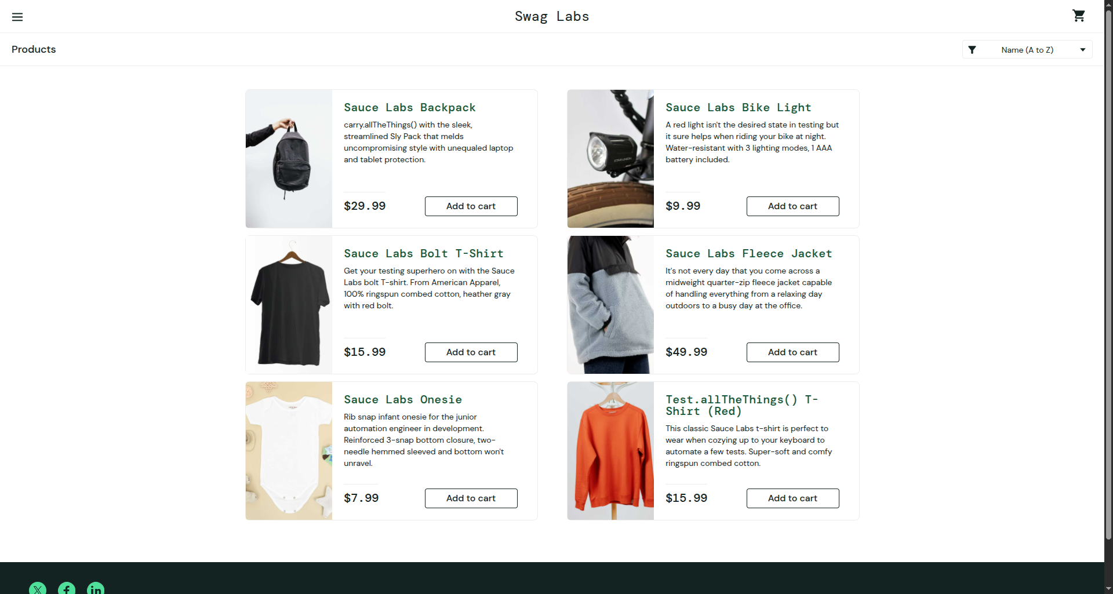

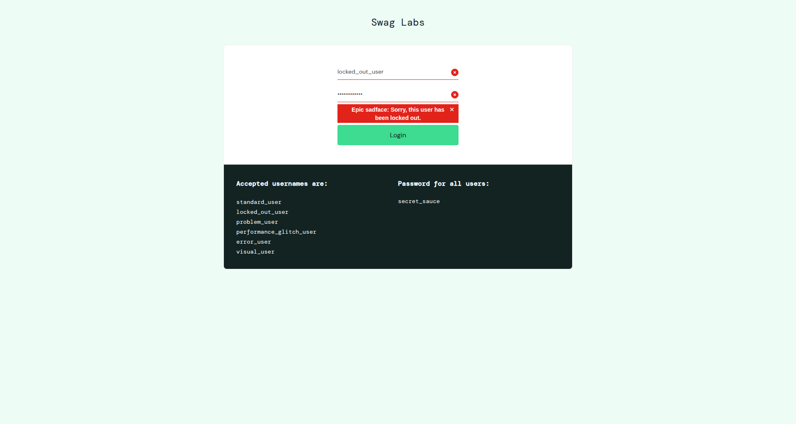

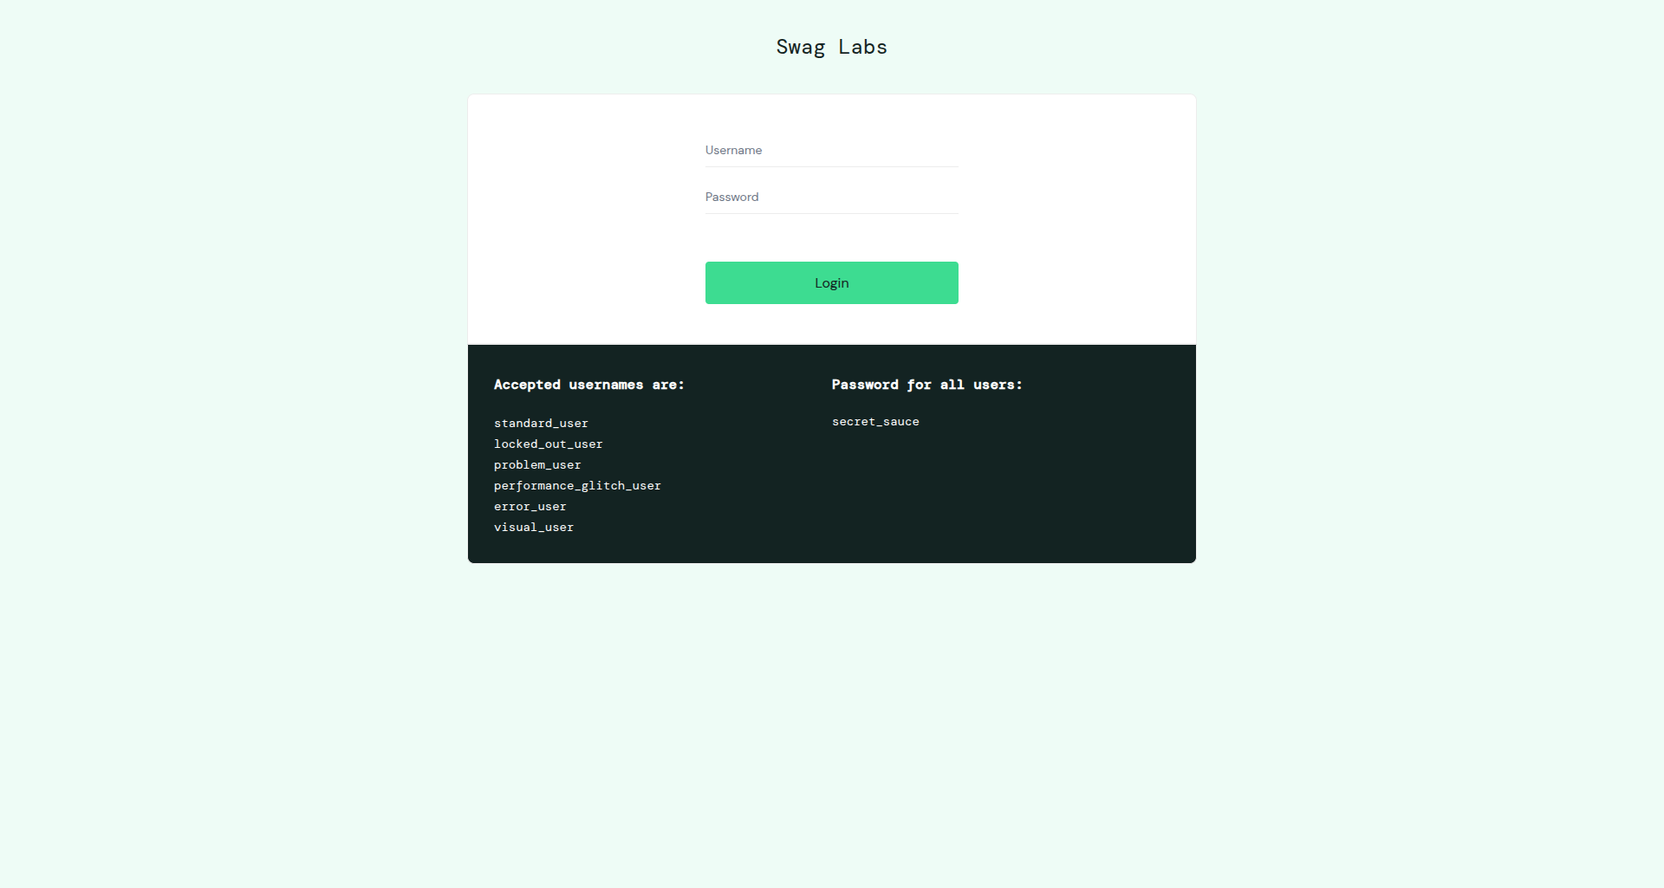

[ Insert console_output.png here ]
Screenshot 4: PyTest terminal output showing the executed POM test cases.

7. Brief Result, Observation, and Conclusion

Result
Test / Step | POM Component Used | Expected Outcome | Status
1. Valid login | LoginPage + InventoryPage | Products page opens and first product is Sauce Labs Backpack | PASS / FAIL
2. Locked user | LoginPage | Exact locked-user error is displayed | PASS / FAIL
3. Logout flow | InventoryPage + LoginPage context | Logout returns to login page | PASS / FAIL
4. Screenshot evidence | screenshot_a7 | Execution images saved using assignment-specific folder | PASS / FAIL

Observation
- The tests no longer contain repeated username, password, login-button, menu, and logout locators.
- When a UI selector changes, the relevant page class can be updated without rewriting the test assertions.
- LoginPage and InventoryPage expose actions and state, while assignment7.py retains the test intent and assertions.
- The browser lifecycle is centralized in the PyTest fixture, so each test receives a clean driver instance and the browser is closed in teardown.

Conclusion
The Tier 1 login scenarios were successfully reorganized into a Page Object Model structure. Locator definitions and UI methods are isolated inside LoginPage and InventoryPage, while assertions remain in the test layer. This separation makes the Selenium suite easier to read, reuse, and maintain when the web UI changes.

