INDIVIDUAL MODULE-WISE LAB WORKBOOK
Wipro Python Automation CoE

1. Module Name and Experiment Title
Module: Selenium WebDriver with Python: Synchronization and Waits.
Experiment: Assignment 2, Synchronization & Explicit Waits.

2. Problem Statement
Web applications load content dynamically through AJAX calls, so an element that a script needs may not exist in the DOM, or may not be visible, at the moment the script looks for it. Fixed delays make scripts slow when the application is fast and flaky when it is slow. Navigate to a page with dynamic content and synchronize the script with the application state without using time.sleep(). Use WebDriverWait together with expected_conditions.

3. Objective
- Synchronize test steps with dynamic page content using WebDriverWait.
- Apply multiple expected_conditions (title, clickability, visibility, presence, text change, invisibility).
- Verify that an AJAX-generated alert and an AJAX-refreshed cart widget are handled without time.sleep().
- Confirm that WebDriverWait raises TimeoutException when a condition is never met.

4. Tools, Software, and Concepts Used
Item | Detail
Language | Python 3
Library | Selenium WebDriver 4 (selenium.webdriver, selenium.webdriver.support)
Browser / Driver | Google Chrome with Selenium Manager (automatic driver resolution)
Editor / OS | VS Code or PyCharm on Windows
Application | TutorialsNinja OpenCart demo store
Concepts | Synchronization, explicit wait, WebDriverWait, expected_conditions, polling interval, TimeoutException, AJAX dynamic content, locators (ID, NAME, CSS, LINK_TEXT)

Concept summary. An explicit wait polls a condition (every 0.5 s by default) until it returns a truthy value or the timeout expires. On expiry it raises TimeoutException. Unlike time.sleep(), it returns as soon as the condition is met, so the wait time equals the real application delay. No implicit wait is set, to avoid the combined-wait timing problem.

5. Source Code and Implementation Steps
Implementation steps:
- Step 1: Open the home page and wait for the title and logo (title_contains, visibility_of_element_located).
- Step 2: Type the product name in the search box and wait for results (element_to_be_clickable, presence_of_all_elements_located, visibility_of_element_located).
- Step 3: Click Add to Cart, which fires an AJAX request, and wait for the success alert (visibility_of_element_located). Measure the wait.
- Step 4: Wait for the cart total to change to "1 item(s)" (text_to_be_present_in_element).
- Step 5: Close the alert and wait until it disappears (invisibility_of_element_located).
- Step 6: Open the cart dropdown and wait for its AJAX-loaded content to list the product (visibility_of_element_located, text_to_be_present_in_element).
- Step 7: Negative test: wait 3 s for a non-existent element and catch TimeoutException.

Source code (assignment2_explicit_waits.py):
"""
Assignment 2: Synchronization & Explicit Waits
Site : https://tutorialsninja.com/demo/ (OpenCart demo store)
Dynamic content used:
1. Search results loaded after a page request
2. AJAX "Add to Cart" success alert (appears only after the server responds)
3. AJAX-refreshed cart total (#cart-total) and cart dropdown (#cart ul.dropdown-menu)
Constraint: no fixed delays and no implicit wait. Only WebDriverWait + expected_conditions.
Run: python assignment2_explicit_waits.py
"""
import os
from time import perf_counter

from selenium import webdriver
from selenium.common.exceptions import TimeoutException
from selenium.webdriver.common.by import By
from selenium.webdriver.support import expected_conditions as EC
from selenium.webdriver.support.ui import WebDriverWait

BASE_URL = "https://tutorialsninja.com/demo/"
PRODUCT = "iMac"
TIMEOUT = 15
SHOT_DIR = "screenshots"

def shot(driver, name):
os.makedirs(SHOT_DIR, exist_ok=True)
path = os.path.join(SHOT_DIR, f"{name}.png")
driver.save_screenshot(path)
print(f"[SHOT] saved -> {path}")

def test_dynamic_content_waits(driver):
wait = WebDriverWait(driver, TIMEOUT)

# Step 1: page load synchronization
driver.get(BASE_URL)
wait.until(EC.title_contains("Your Store"))
wait.until(EC.visibility_of_element_located((By.CSS_SELECTOR, "#logo")))
print("[PASS] Step 1: home page loaded, title and logo visible")
shot(driver, "01_home_loaded")

# Step 2: search and wait for results
search_box = wait.until(EC.element_to_be_clickable((By.NAME, "search")))
search_box.clear()
search_box.send_keys(PRODUCT)
wait.until(EC.element_to_be_clickable((By.CSS_SELECTOR, "#search button"))).click()
wait.until(EC.presence_of_all_elements_located((By.CSS_SELECTOR, ".product-layout")))
wait.until(EC.visibility_of_element_located((By.LINK_TEXT, PRODUCT)))
print(f"[PASS] Step 2: search results for '{PRODUCT}' displayed")
shot(driver, "02_search_results")

# Step 3: trigger AJAX call and wait for the dynamic success alert
add_btn = wait.until(EC.element_to_be_clickable(
(By.CSS_SELECTOR, ".product-layout button[onclick^='cart.add']")))
start = perf_counter()
add_btn.click()
alert = wait.until(EC.visibility_of_element_located(
(By.CSS_SELECTOR, "div.alert-success")))
elapsed = perf_counter() - start
assert "Success: You have added" in alert.text, f"Unexpected alert text: {alert.text}"
print(f"[PASS] Step 3: AJAX alert visible after {elapsed:.2f}s -> {alert.text.splitlines()[0]}")
shot(driver, "03_ajax_alert_visible")

# Step 4: wait for the cart total text to refresh
start = perf_counter()
wait.until(EC.text_to_be_present_in_element((By.ID, "cart-total"), "1 item(s)"))
elapsed = perf_counter() - start
print(f"[PASS] Step 4: cart total updated to '{driver.find_element(By.ID, 'cart-total').text}' "
f"(extra wait {elapsed:.2f}s)")
shot(driver, "04_cart_total_updated")

# Step 5: dismiss alert and wait until it disappears
alert.find_element(By.CSS_SELECTOR, "button.close").click()
wait.until(EC.invisibility_of_element_located((By.CSS_SELECTOR, "div.alert-success")))
print("[PASS] Step 5: alert dismissed, no longer visible")

# Step 6: open cart dropdown and wait for its AJAX-loaded content
wait.until(EC.element_to_be_clickable((By.CSS_SELECTOR, "#cart > button"))).click()
wait.until(EC.visibility_of_element_located((By.CSS_SELECTOR, "#cart ul.dropdown-menu")))
wait.until(EC.text_to_be_present_in_element(
(By.CSS_SELECTOR, "#cart ul.dropdown-menu"), PRODUCT))
print(f"[PASS] Step 6: cart dropdown loaded and lists '{PRODUCT}'")
shot(driver, "05_cart_dropdown_loaded")

def test_timeout_behaviour(driver):
"""Negative test: an element that never appears must raise TimeoutException."""
short_wait = WebDriverWait(driver, 3)
start = perf_counter()
try:
short_wait.until(EC.visibility_of_element_located((By.ID, "non-existent-loader")))
print("[FAIL] Negative test: element unexpectedly found")
except TimeoutException:
elapsed = perf_counter() - start
print(f"[PASS] Negative test: TimeoutException raised after {elapsed:.2f}s (limit 3s)")

def main():
driver = webdriver.Chrome()
driver.maximize_window()
try:
test_dynamic_content_waits(driver)
test_timeout_behaviour(driver)
print("[RESULT] Assignment 2 completed")
finally:
driver.quit()

if __name__ == "__main__":
main()

6. Output with Labelled Screenshots
Run command: python assignment2_explicit_waits.py. Screenshots are saved to the screenshots folder by the script; insert each into its box below.
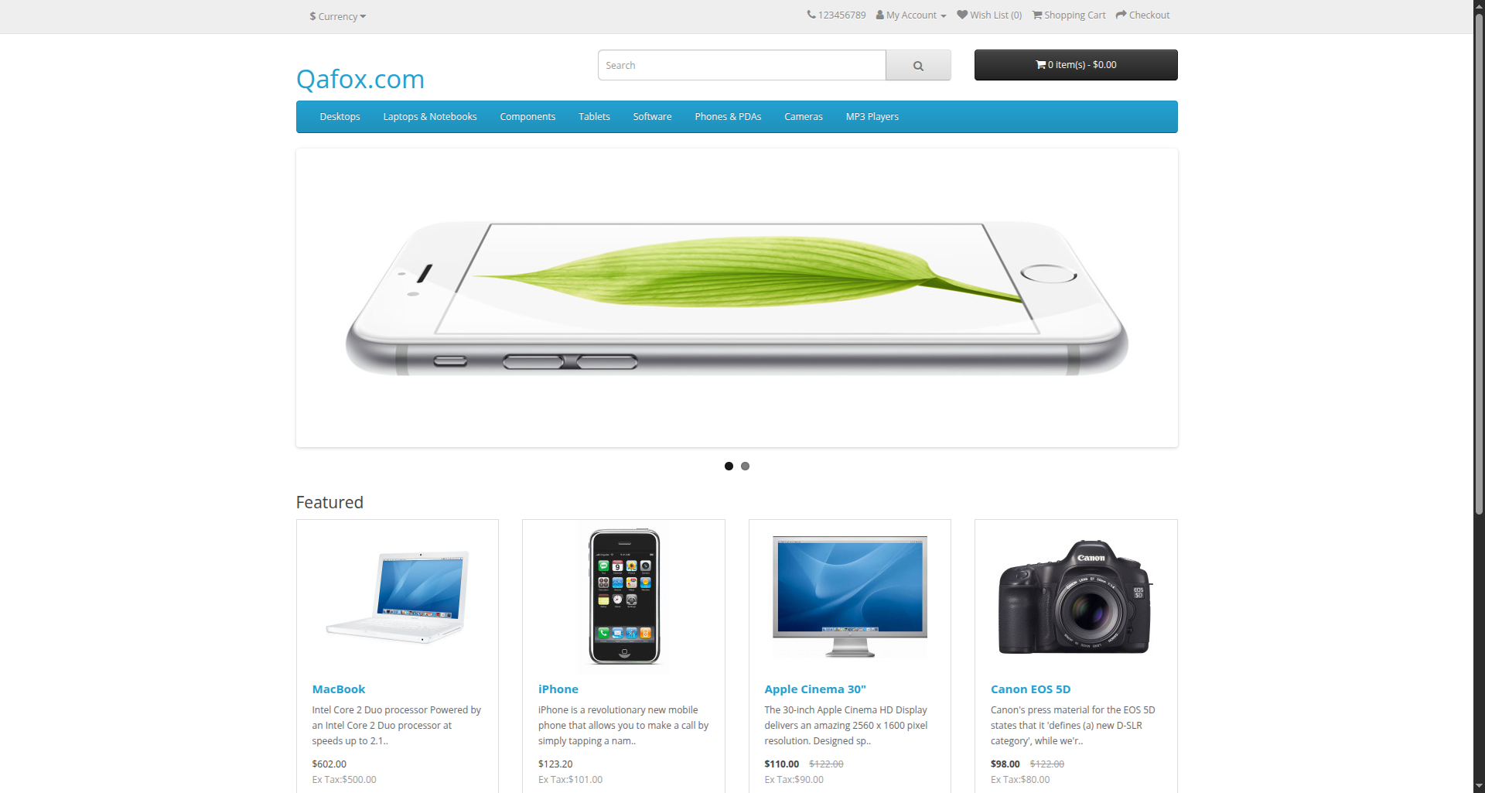
Screenshot 1: Home page loaded (Step 1, title and logo wait satisfied)
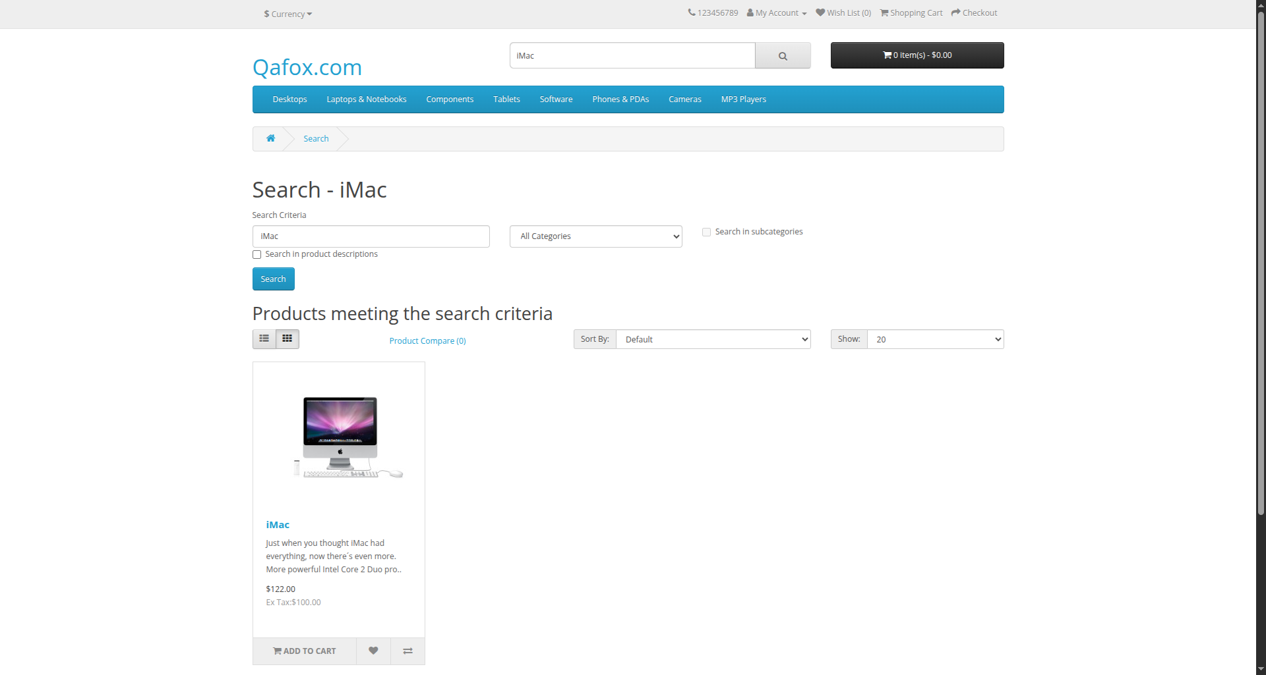
Screenshot 2: Search results for "iMac" displayed (Step 2)
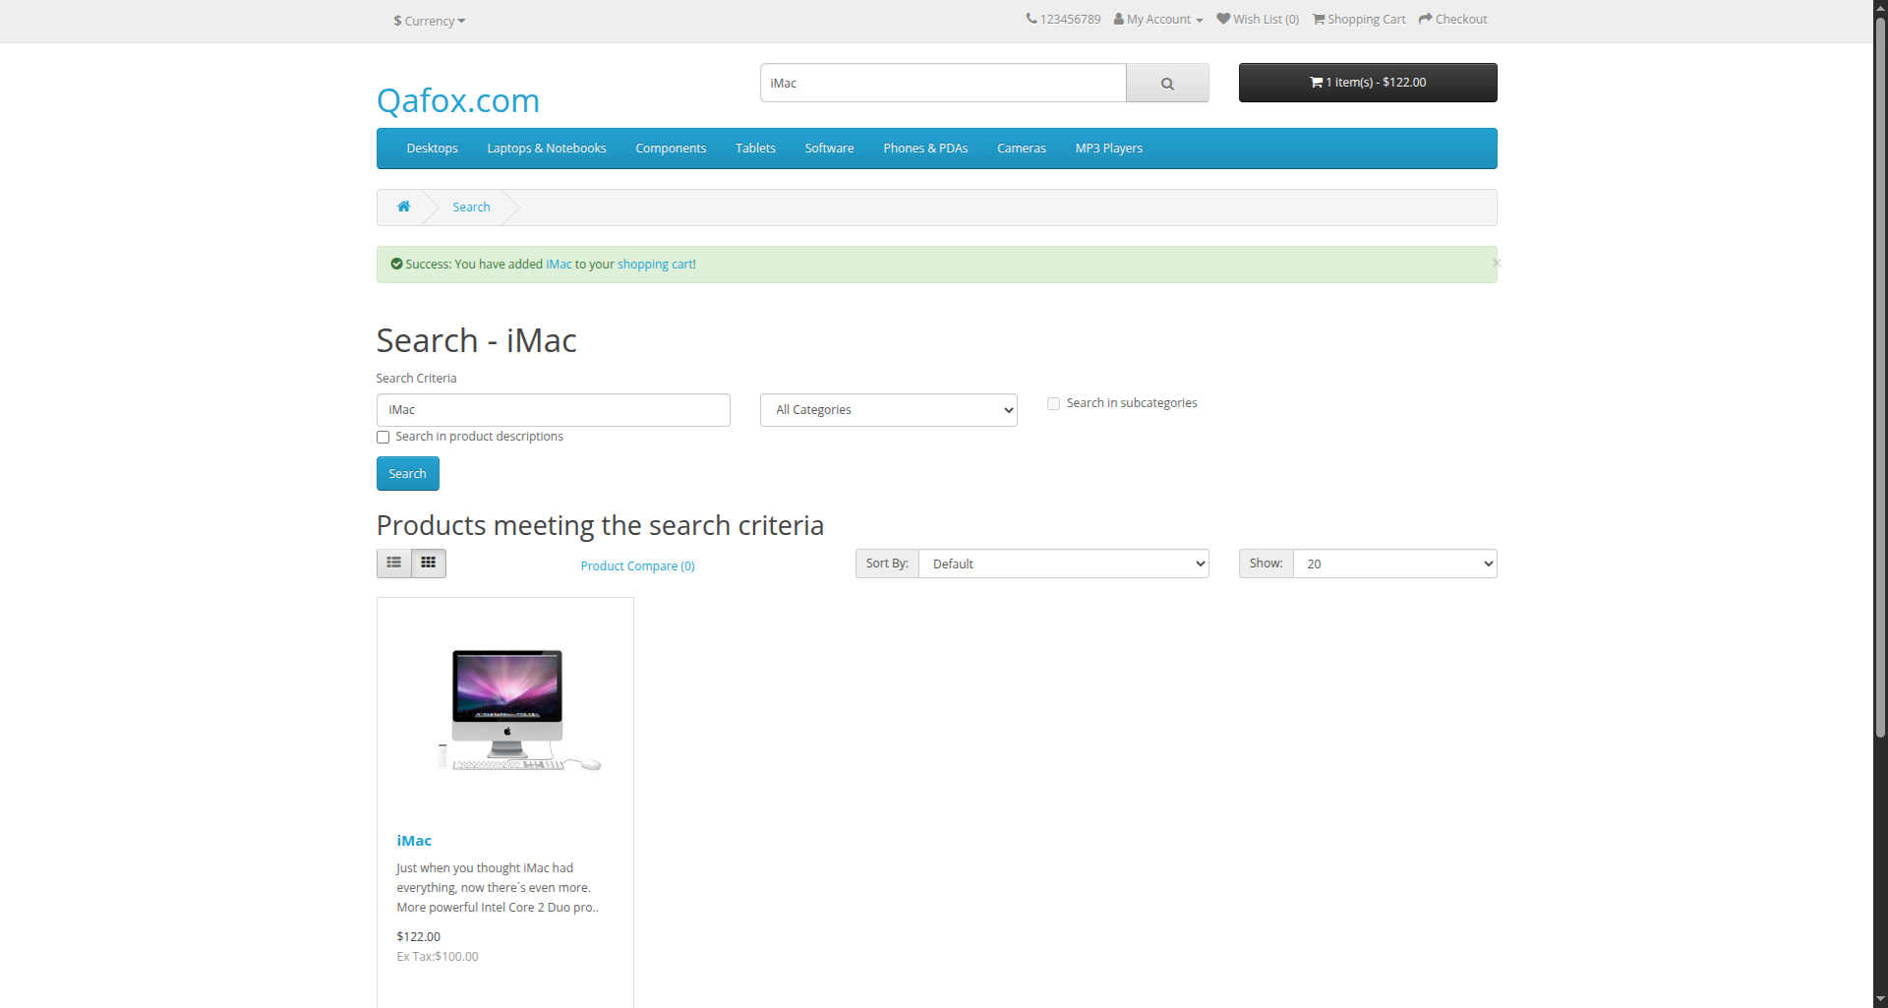
Screenshot 3: AJAX success alert visible after Add to Cart (Step 3)
Screenshot 4: Cart total refreshed to "1 item(s)" (Step 4)
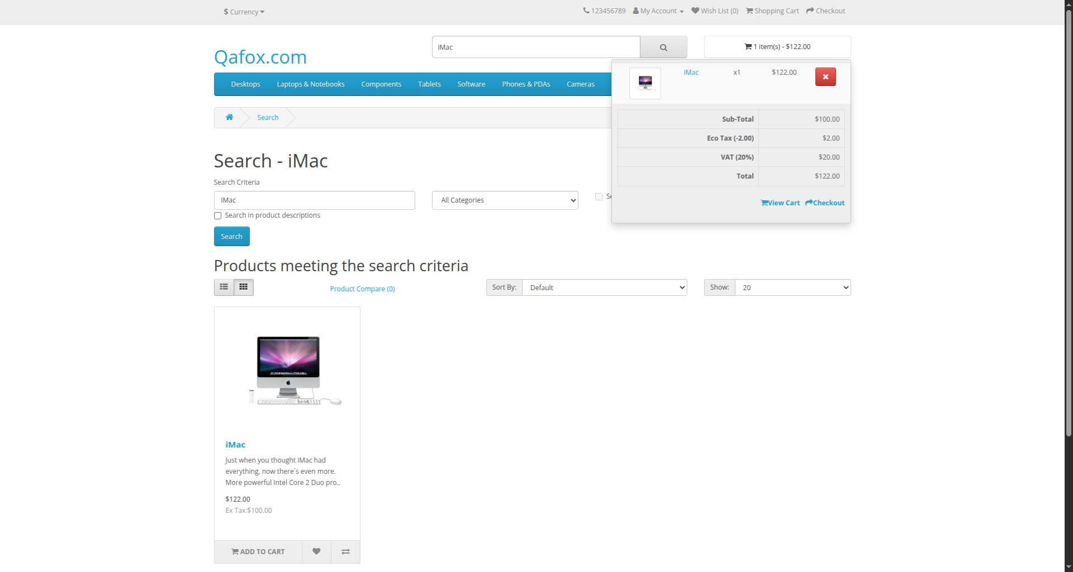
Screenshot 5: Cart dropdown loaded and listing iMac (Step 6)
[ Insert console_output.png here ]
Screenshot 6: Console output showing all [PASS] lines and timings

7. Brief Result, Observation, and Conclusion
Result
Step | Wait / Expected Condition | Expected Outcome | Measured
1 | title_contains, visibility_of_element_located | Home page ready | PASS / FAIL
2 | element_to_be_clickable, presence_of_all_elements_located, visibility_of_element_located | Search results shown | PASS / FAIL
3 | visibility_of_element_located | Success alert appears after AJAX | ____ s
4 | text_to_be_present_in_element | Cart total shows 1 item(s) | ____ s
5 | invisibility_of_element_located | Alert removed | PASS / FAIL
6 | visibility_of_element_located, text_to_be_present_in_element | Dropdown lists iMac | PASS / FAIL
7 | visibility_of_element_located (3 s limit) | TimeoutException raised | ____ s

Observation
- The alert and the cart total are produced by an AJAX response, so each exists only after the server replies. WebDriverWait returned as soon as the condition held.
- Each wait consumed only the real delay, up to the 15 s ceiling. A fixed delay would always consume its full value.
- A single condition is often insufficient: the alert can be visible before the cart total updates, so Step 4 has its own condition.
- The negative test raised TimeoutException at the configured 3 s limit, confirming the failure path is deterministic.
Conclusion
Explicit waits synchronize the script with the application state instead of with elapsed time. Using WebDriverWait with the appropriate expected_conditions, and no time.sleep(), makes the script faster on quick responses and more stable on slow ones, and a missing element fails with a clear TimeoutException.

