INDIVIDUAL MODULE-WISE LAB WORKBOOK
Wipro Python Automation CoE

1. Module Name and Experiment Title
Module: Tier 2, Advanced User Interactions. Focus: handling complex web behaviors such as overlays, pop-ups, and data structures.
Experiment: Assignment 5, The HTML Web Table Extractor.

2. Problem Statement
Web applications present records such as product lists, stock lists, and user directories in multi-column HTML tables. The rows may be rendered by JavaScript and split across several pages. Find a page containing a multi-column dynamic data table. Write a script to iterate through its rows and columns, locate a specific row by matching a name string, and retrieve the corresponding value from the "Price" column next to it.

3. Objective
- Read table headers and data cells and iterate through all rows and columns.
- Locate a row by an exact name match and return the value from the Price column of that row.
- Find the target column by header text so the script does not depend on column position.
- Handle a JavaScript-rendered, paginated table by waiting for rows and moving through every page.
- Verify extracted values against known expected data and export the extracted data to a CSV file.

4. Tools, Software, and Concepts Used
Item | Detail
Language | Python 3, csv module
Library | Selenium WebDriver 4
Browser / Driver | Google Chrome with Selenium Manager (automatic driver resolution)
Editor / OS | VS Code on Windows, virtual environment (venv)
Application | Automation Testing Practice page: Static Web Table (BookName, Author, Subject, Price) and Pagination Web Table (ID, Name, Price, Select)
Concepts | HTML table structure (table, thead, tr, th, td), XPath, find_elements, header-based column lookup, WebDriverWait, staleness_of, pagination, JavaScript execution for highlighting, CSV export

Concept summary. An HTML table is a tree of tr elements, each holding th (header) or td (data) cells. Reading the th texts gives the column names, and the td cells of each tr are matched to them by index. A row is located by comparing the name column of every row with the target string, and the value is then read from the Price key of the same row. The paginated table replaces its rows each time a page link is clicked, so the script waits for the old row to become stale before reading the new page.

5. Source Code and Implementation Steps
Implementation steps:
- Step 1: Open the page and wait for the title.
- Step 2 (Static table): Wait for the table containing the BookName header. Read the headers, then iterate through every row and column into a dictionary per row.
- Step 3: Look up "Master In Selenium" and "Learn Java" by name in the BookName column and read the Price column. Assert 3000 and 500.
- Step 4 (Dynamic table): Wait for the JavaScript-rendered rows of table#productTable and read the headers.
- Step 5: Count the pagination links. For each page, click the page link, wait until the old first row is stale, and read the new rows.
- Step 6: Match the target product name across all pages, read its Price, highlight the row, and take a screenshot.
- Step 7: Print all extracted rows and write them to extracted_tables.csv.

Source code (assignment5_table_extractor.py):
"""
Assignment 5: The HTML Web Table Extractor
Site : https://testautomationpractice.blogspot.com/ (Selenium practice page)
Tables used:
1. Static Web Table -> columns: BookName | Author | Subject | Price
2. Pagination Web Table (table#productTable, rows rendered by JavaScript)
-> columns: ID | Name | Price | Select
Task : Iterate through rows and columns, locate a row by matching a name string,
and return the value from the "Price" column next to it.
Run : python assignment5_table_extractor.py
python assignment5_table_extractor.py --product "Smartwatch"
"""
import csv
import os
import sys

from selenium import webdriver
from selenium.webdriver.common.by import By
from selenium.webdriver.support import expected_conditions as EC
from selenium.webdriver.support.ui import WebDriverWait

URL = "https://testautomationpractice.blogspot.com/"
TIMEOUT = 15
SHOT_DIR = "screenshots_a5"
CSV_FILE = "extracted_tables.csv"

STATIC_TARGET = "Master In Selenium" # expected Price: 3000
STATIC_EXPECTED = {"Master In Selenium": "3000", "Learn Java": "500"}
DYNAMIC_TARGET = sys.argv[sys.argv.index("--product") + 1] if "--product" in sys.argv else "Smartwatch"

STATIC_TABLE_XPATH = "//table[.//th[normalize-space()='BookName']]"
DYNAMIC_TABLE_CSS = "table#productTable"

def shot(driver, name):
os.makedirs(SHOT_DIR, exist_ok=True)
path = os.path.join(SHOT_DIR, f"{name}.png")
driver.save_screenshot(path)
print(f"[SHOT] saved -> {path}")

def highlight(driver, element):
driver.execute_script(
"arguments[0].scrollIntoView({block:'center'});"
"arguments[0].style.backgroundColor='yellow';", element)

def get_headers(table):
"""Column headers taken from the table itself, so lookups do not depend on column order."""
return [th.text.strip() for th in table.find_elements(By.XPATH, ".//tr[1]/th")]

def read_rows(table):
"""Iterate through every data row and every column. Returns [(row_element, {header: value})]."""
headers = get_headers(table)
result = []
for row in table.find_elements(By.XPATH, ".//tr[td]"):
cells = row.find_elements(By.TAG_NAME, "td")
record = {}
for col, cell in enumerate(cells):
key = headers[col] if col < len(headers) and headers[col] else f"col{col + 1}"
record[key] = cell.text.strip()
result.append((row, record))
return result

def find_value(records, name_column, name, value_column):
"""Locate the row whose name_column equals name and return its value_column."""
for record in records:
if record.get(name_column) == name:
return record.get(value_column)
return None

def print_table(title, headers, records):
print(f"\n--- {title} ---")
print(" | ".join(f"{h:<20}" for h in headers))
for record in records:
print(" | ".join(f"{record.get(h, ''):<20}" for h in headers))
print(f"Rows: {len(records)}\n")

def test_static_table(driver, wait, csv_rows):
table = wait.until(EC.visibility_of_element_located((By.XPATH, STATIC_TABLE_XPATH)))
headers = get_headers(table)
pairs = read_rows(table)
records = [rec for _, rec in pairs]
print_table("Static Web Table", headers, records)
csv_rows.extend(["static"] + [rec.get(h, "") for h in headers] for rec in records)

for name, expected in STATIC_EXPECTED.items():
price = find_value(records, "BookName", name, "Price")
assert price == expected, f"{name}: expected {expected}, got {price}"
print(f"[PASS] Static table: Price of '{name}' = {price}")

for row, rec in pairs:
if rec.get("BookName") == STATIC_TARGET:
highlight(driver, row)
shot(driver, "01_static_table_row_highlighted")

def read_current_page(driver, wait):
table = wait.until(EC.visibility_of_element_located((By.CSS_SELECTOR, DYNAMIC_TABLE_CSS)))
wait.until(lambda d: len(table.find_elements(By.CSS_SELECTOR, "tbody tr")) > 0)
return table, read_rows(table)

def test_dynamic_table(driver, wait, csv_rows):
table, pairs = read_current_page(driver, wait)
headers = get_headers(table)
print(f"[INFO] Dynamic table headers: {headers}")
driver.execute_script("arguments[0].scrollIntoView({block:'center'});", table)
shot(driver, "02_dynamic_table_page1")

page_count = len(driver.find_elements(By.CSS_SELECTOR, "#pagination li a"))
print(f"[INFO] Pagination links found: {page_count}")
all_records, found_price, found_on_page = [], None, None

for page in range(1, page_count + 1):
if page > 1:
first_row = table.find_element(By.CSS_SELECTOR, "tbody tr")
link = wait.until(lambda d: next(
(a for a in d.find_elements(By.CSS_SELECTOR, "#pagination li a")
if a.text.strip() == str(page) and a.is_displayed()), None))
link.click()
wait.until(EC.staleness_of(first_row)) # old rows replaced by new rows
table, pairs = read_current_page(driver, wait)

for row, rec in pairs:
all_records.append(rec)
if rec.get("Name") == DYNAMIC_TARGET and found_price is None:
found_price, found_on_page = rec.get("Price"), page
highlight(driver, row)
shot(driver, "03_dynamic_target_row_highlighted")
print(f"[INFO] Page {page}: {len(pairs)} rows read")

print_table("Dynamic (Pagination) Web Table, all pages", ["ID", "Name", "Price"], all_records)
csv_rows.extend(["dynamic", r.get("ID", ""), r.get("Name", ""), r.get("Price", ""), ""]
for r in all_records)

if found_price is None:
names = ", ".join(r.get("Name", "") for r in all_records)
raise LookupError(f"'{DYNAMIC_TARGET}' not found. Available names: {names}. "
f"Re-run with --product \"<name>\".")
print(f"[PASS] Dynamic table: Price of '{DYNAMIC_TARGET}' = {found_price} (found on page {found_on_page})")

def main():
driver = webdriver.Chrome()
driver.maximize_window()
wait = WebDriverWait(driver, TIMEOUT)
csv_rows = []
try:
driver.get(URL)
wait.until(EC.title_contains("Automation Testing Practice"))
print(f"[PASS] Page loaded: {driver.title}")
test_static_table(driver, wait, csv_rows)
test_dynamic_table(driver, wait, csv_rows)

with open(CSV_FILE, "w", newline="", encoding="utf-8") as f:
writer = csv.writer(f)
writer.writerow(["table", "col1", "col2", "col3", "col4"])
writer.writerows(csv_rows)
print(f"[PASS] Extracted data written to {CSV_FILE} ({len(csv_rows)} rows)")
print("[RESULT] Assignment 5 completed")
finally:
driver.quit()

if __name__ == "__main__":
main()

6. Output with Labelled Screenshots
Run command: python assignment5_table_extractor.py. Screenshots 1 to 3 are saved by the script to the screenshots_a5 folder. Screenshots 4 and 5 are taken from the terminal and the generated CSV file.
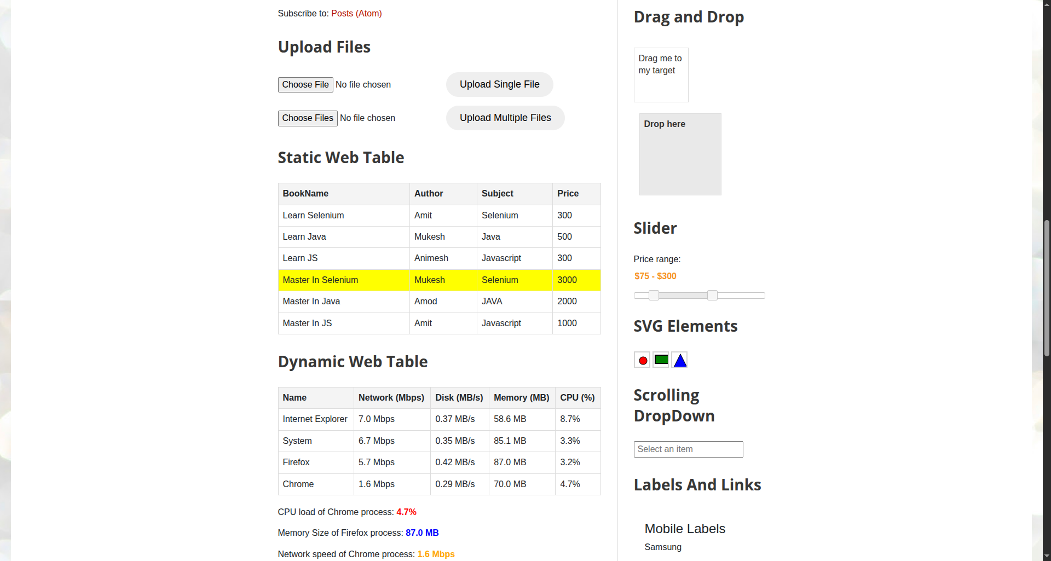
Screenshot 1: Static Web Table with the "Master In Selenium" row highlighted
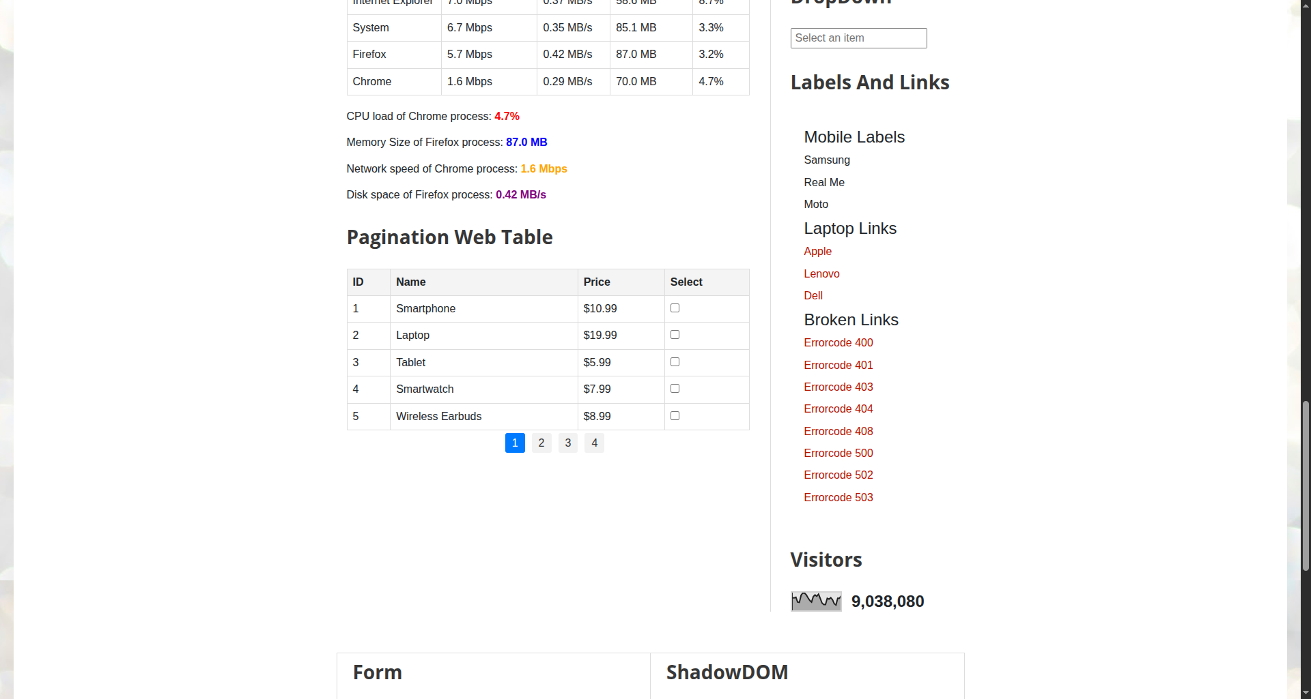
Screenshot 2: Pagination Web Table, page 1 (JavaScript-rendered rows)
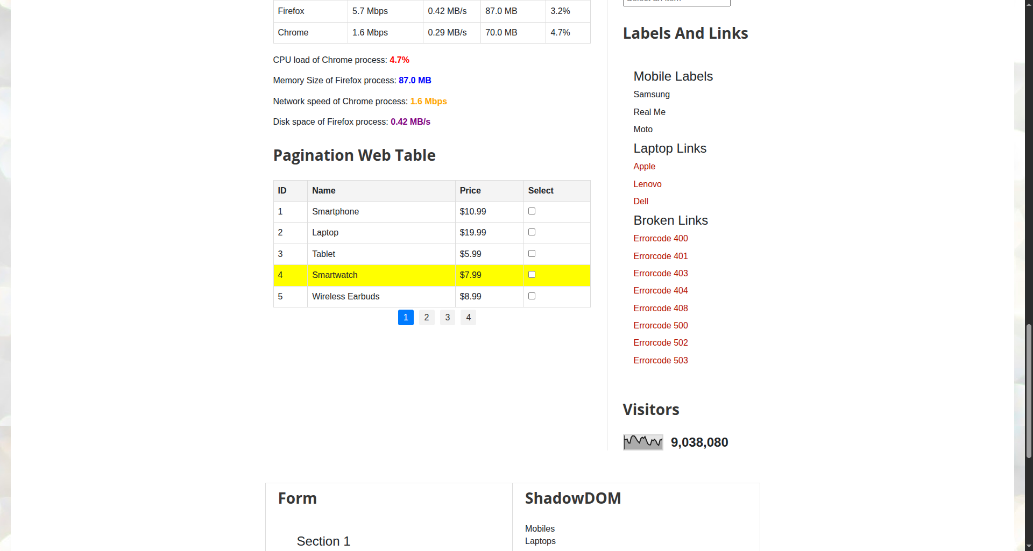
Screenshot 3: Pagination Web Table with the matched product row highlighted

7. Brief Result, Observation, and Conclusion
Result
Step | Lookup | Expected Value | Status
3 | Static table: BookName = "Master In Selenium", column Price | 3000 | PASS / FAIL
3 | Static table: BookName = "Learn Java", column Price | 500 | PASS / FAIL
6 | Dynamic table: Name = target product, column Price | Price shown in the table row (____) | PASS / FAIL
7 | CSV export of all extracted rows | File created with all rows | PASS / FAIL

Observation
- The paginated table body is empty in the page source and is filled by JavaScript, so the rows exist only after the page runs its script. Waiting for at least one row is required before reading.
- Reading the Price column by header name returned the correct cell without a hardcoded column number, so the lookup survives a change in column order.
- Only one page of the paginated table is in the DOM at a time. The target row can be found only by visiting each page.
- Rows are replaced on every page change. Waiting for staleness_of on the old row prevents reading the previous page by mistake.
- Cell values are text: prices such as "$10.99" or "3000" need conversion before numeric comparison.
Conclusion
The script iterated through the rows and columns of a static table and a JavaScript-rendered paginated table, matched rows by name, and returned the corresponding Price value. Header-based column lookup and explicit waits made the extraction independent of column order and page-load timing, and the results were exported to CSV.

