**Assignment 10.2**

Loading Data Into HBase Using PIG Scripts.

Creating and loading the dataset AcadgildStudent.txt

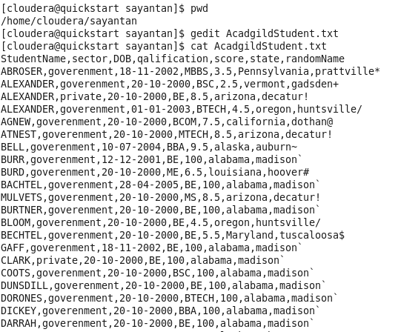

We will be copying the data set in to HDFS which will be further loaded into HBase.



We will be including few jar files of HBase to the Pig classpath.



We will now start HBase shell and create a table.

We only need this table as skeleton so PIG can Store data inside this by referring the table name.

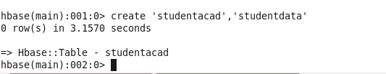

We can come out from HBase by typing exit and switch to PIG grunt shell.

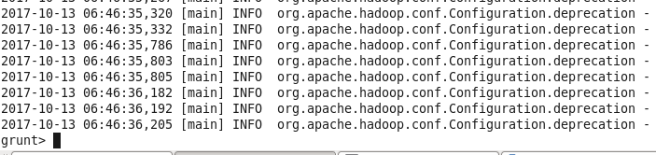

Once we are inside PIG mode we can load data from HDFS to Alias relation.



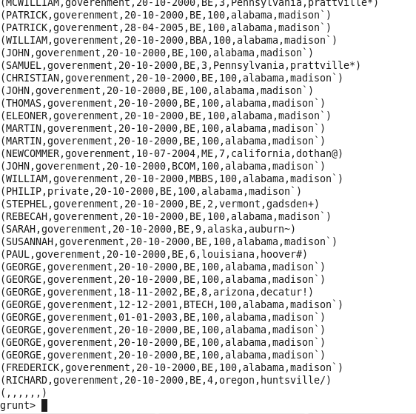

Now we will store the data into hbase using the command

STORE rawD INTO 'hbase://acadstudent' USING org.apache.pig.backend.hadoop.hbase.HBaseStorage('studentdata:sector,studentdata:dob,studentdata:qualification,studentdata:score,studentdata:state,studentdata:randomName');

