Assignment 11.1

Problem Statement:

Transfer data between Mysql and HDFS (Import and Export) using Sqoop.

Creating a table named com

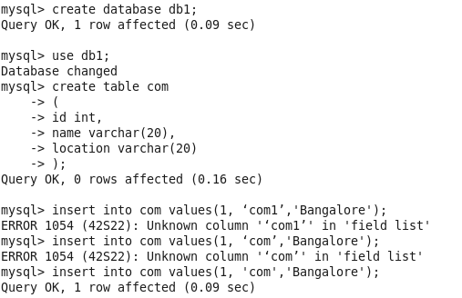

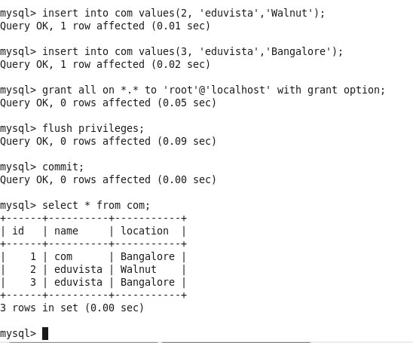

Importing the table into HDFS

Single mapper import

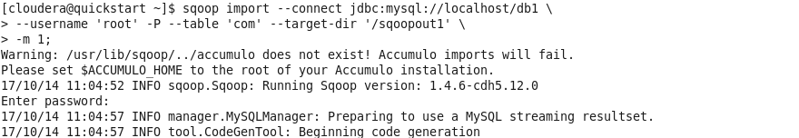

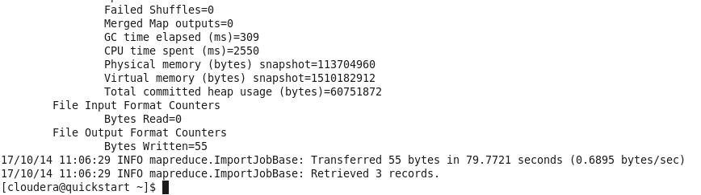

The mapreduce code successfully ran. Now we will check our hdfs output directory to check if the data has been imported

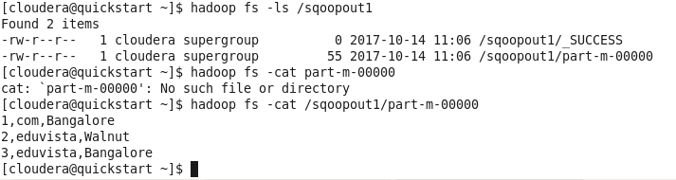

It is successfully imported.

Incremental Import

We will insert some more rows

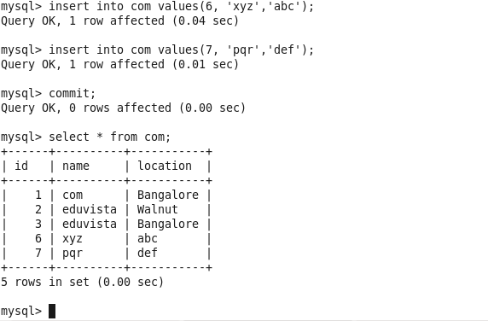

Now we will run the incremental import command

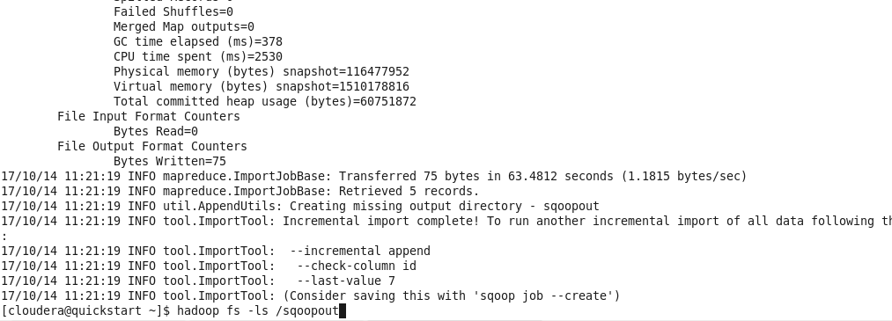

We will check if the updated rows are imported successfully

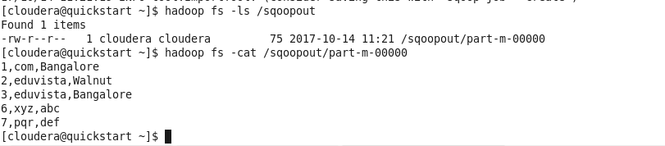

We can see all the updated values from com table now.

Import based on last value

sqoop import --connect jdbc:mysql://localhost/db1 \

--username 'root' -P --table 'com' --target-dir '/sqoopout' \

--incremental append \

--check-column id \

--last-value 3 \

-m 1;

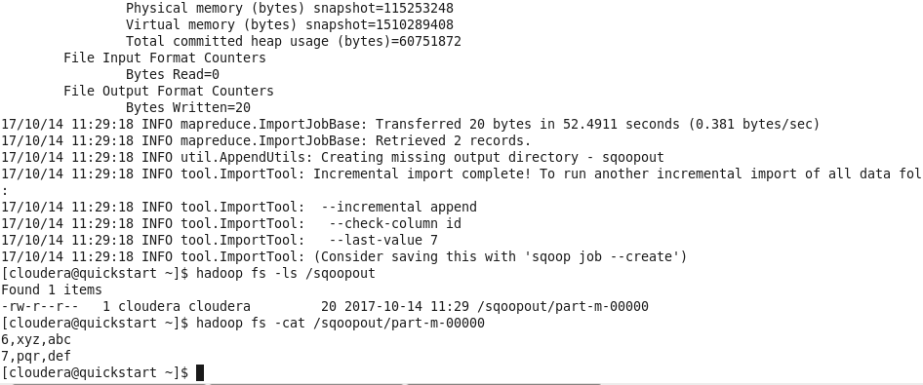

As we can see from the screenshot that we have successfully imported the values after id 3 in a separate file in hdfs.

Multi-mapper import

sqoop import --connect jdbc:mysql://localhost/db1 \

--username 'root' -P --table 'com' --target-dir '/sqoopout' \

--split-by id \

-m 2;

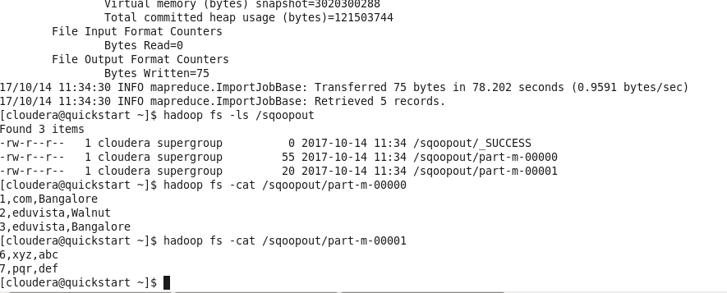

As we can see the records are imported into two separate files in hdfs because we have used two mappers.

Sqoop Export

sqoop export --connect jdbc:mysql://localhost/db1 --username 'root' -P --table 'com' --export-dir '/sqoopout' --input-fields-terminated-by ',' -m 1 --columns id,name,location

we will create a table on RDBMS and then load it from hdfs

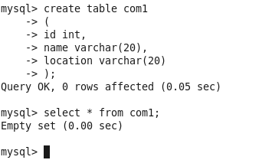

Now we will load data into this table from hdfs

We will take the data from /sqoopout directory and export it to RDBMS again

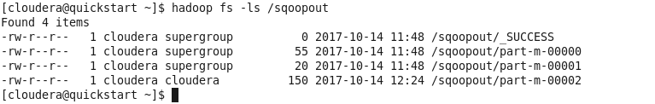

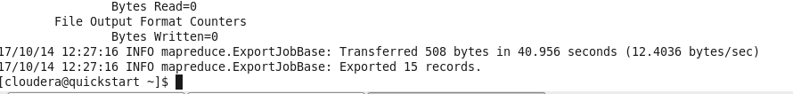

Our export was successful. Now lets check in mysql if we have data in com1

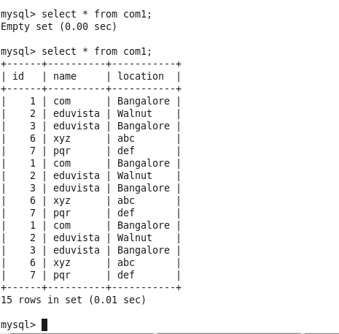

As we can see we now have all the data in the table com1 after export.

We can also configure a sqoop.password file and pass it in the export command as

sqoop export --connect jdbc:mysql://localhost/db1 --username 'root' --table 'company' --export-dir '/sqoopout' --input-fields-terminated-by ',' -m 1 --columns id,name,location --password-file /sqoop.password

Problem Statement:

Transfer data between Mysql and Hive (Import and Export only selected columns) using Sqoop.

sqoop import --connect jdbc:mysql://localhost/db1 \

--username 'root' -P --table 'com' --target-dir '/sqoopout1' \

--hive-import \

-m 1;

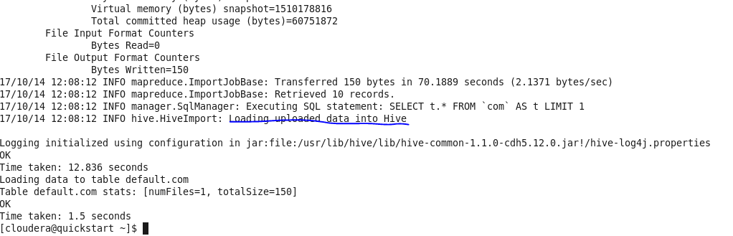

As we can see it has successfully loaded com table into hive. Now lets go into hive shell and check if it shows our com table

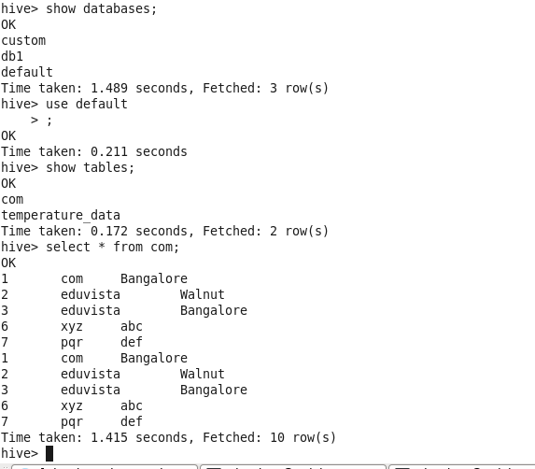

It has loaded table com into default hive database as we can see. Using select \* from com we can see the contents of the table.