Assignment 11.2

Problem Statement:

Perform incremental load in Hive. Read from MySQL Table and load it in Hive table. Create hive table if it does not exist. If it exists, perform the incremental load.

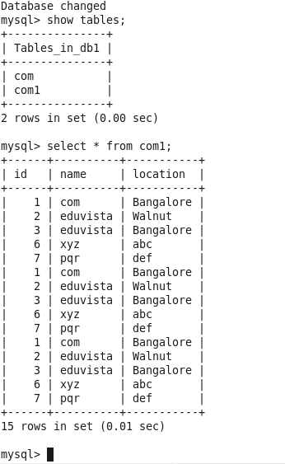

We have a table com1 in RDBMS that we will incremental load into hive

 A Sqoop command is used to transfer selected columns from MySQL to Hive.

We will use the following sqoop command to transfer data from mysql to hive.



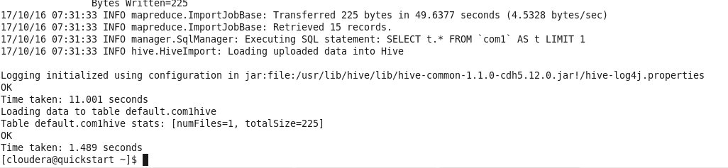

Now we will check in hive shell if our table is created

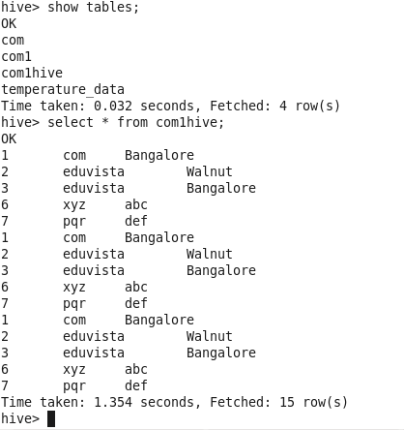

Now we will try to do an incremental import to hive incase there is a achange in mysql table com1,we will store the incremental data in a separate table com1hive_incremental

sqoop import --connect jdbc:mysql://localhost/db1 --username 'root' -P --split-by id --columns id,name,location --table com1 --target-dir /myhive --hive-import --create-hive-table --hive-table default.com1hive_incremental -m 1 --incremental append --check-column id --last-value 1

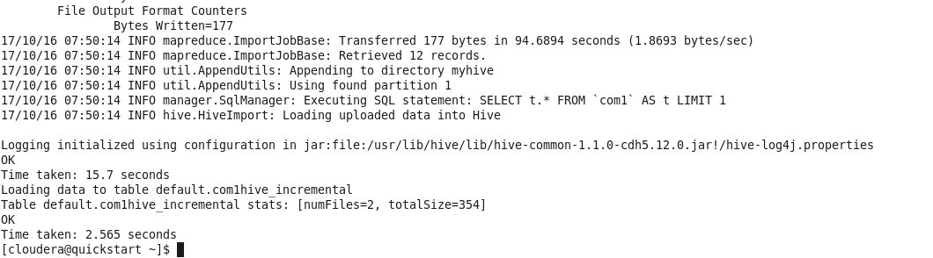

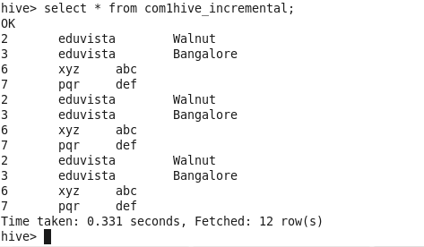

As we can see we have all the values after id 1.

In this case the id is not uniform hence we can see the following 12 records except value 1 which came 3 times in the original table com1.