**Assignment 12.3**

**Problem Statement**

Create a list of tuples, where the 1st element of the tuple is an int and the second

element is a string.

Example - ((1, ‘alpha’), (2, ‘beta’), (3, ‘gamma’), (4, ‘zeta’), (5, ‘omega’))

- for the above list, print the numbers where the corresponding string length is 4

- find the average of all numbers, where the corresponding string contains alphabet ‘m’ or alphabet ‘z’

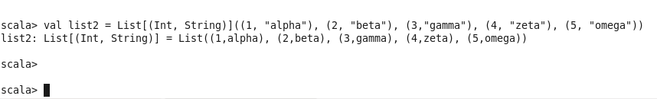

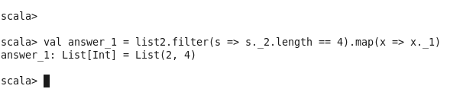

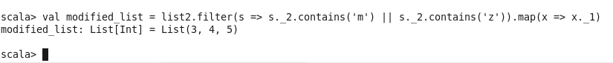

1. Now to get the average

