**Assignment 13.1**

**Problem Statement**

Create a Scala application to find the GCD of two numbers.

The scala application code is as follows:

Using successive division method, the last divisor will be the GCD

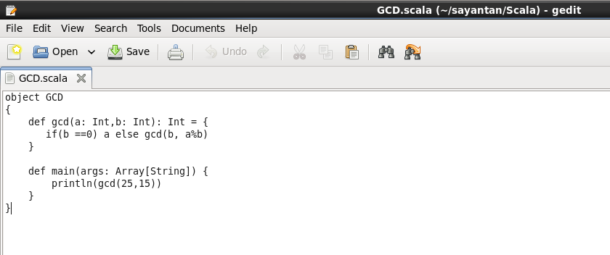

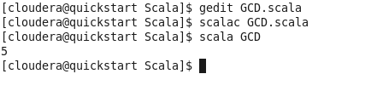

As we can see from above figure the GCD of 25 and 15 is 5.