**Assignment13.2**

Problem Statement

A Fibonacci series (starting from 1) written in order without any spaces in between, thus producing a sequence of digits.

Write a Scala application to find the Nth digit in the sequence.

○ Write the function using standard for loop

○ Write the function using recursion

1) using for loop

The Fibonacci Sequence is characterized by the fact that every number in it is equal to the sum of the preceding ones eg **0, 1, 1, 2, 3, 5, 8, 13, 21…..**

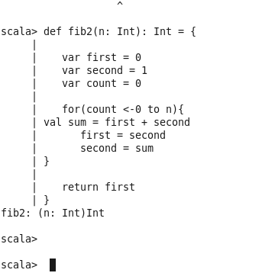

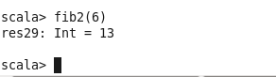

2) using recursion

