**Assignment14.1**

**Problem Statement**

Create a calculator to work with rational numbers.

Requirements:

○ It should provide capability to add, subtract, divide and multiply rational

numbers

○ Create a method to compute GCD (this will come in handy during operations on

rational)

Add option to work with whole numbers which are also rational numbers i.e. (n/1)

- achieve the above using auxiliary constructors

- enable method overloading to enable each function to work with numbers and rational.

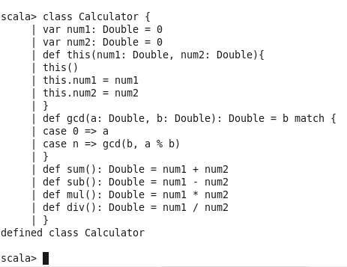

Above is the calculator class.

Auxiliary constructor this is used to initialize the values. It is same as in java where we have the same name as the class name.

The values have to be passed while creating the object using new Calculator(num1,num2)

For the sum,mul,div and sub functions. For the gcd functions you have to pass the values explicitly.

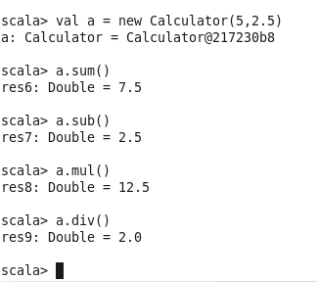

We have to create new object for gcd

