**Assignment15.1**

**Problem Statement**

1.Write a simple program to show inheritance in scala.

2.Write a simple program to show multiple inheritance in scala.

1)

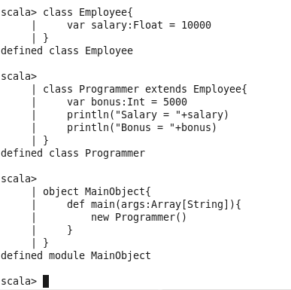

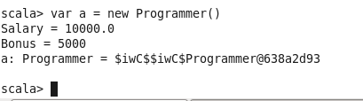

2)

