**Assignment 15.2**

**Problem Statement:**

Write a partial function to add three numbers in which one number is constant and two numbers can be passed as inputs and define another method which can take the partial function as input and squares the result.

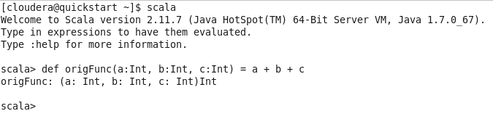

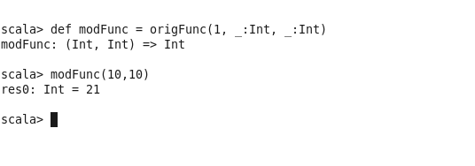

Now to get square as a result

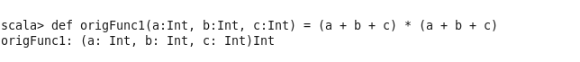

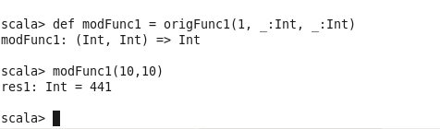

Here we are keeping 1 as our constant parameter and passing two arguments as int. The _ is used as a placeholder. In our partial function modFunc we are passing our two variable arguments.

Write a program to print the prices of 4 courses of Acadgild: Android-12999,Big DataDevelopment-17999,Machine Learning -17999,Spark-19999 using match and add a default condition if the user enters any other course.

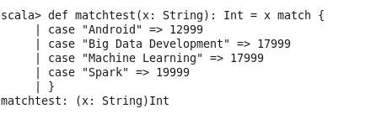

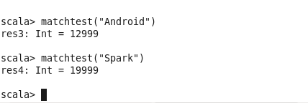

Here we are giving our input as a string and that is what is to be matched hence defined as string in our matchtest function. The value to be returned and matched is int hence the final function definition is def matchtest(x: String): Int = x match {

Test condition

}