**Assignment16.1**

**Problem Statement:**

Given a list of numbers - List[Int] (1, 2, 3, 4, 5, 6, 7, 8, 9, 10)

- find the sum of all numbers

- find the total elements in the list

- calculate the average of the numbers in the list

- find the sum of all the even numbers in the list

- find the total number of elements in the list divisible by both 5 and 3

Sum of all elements

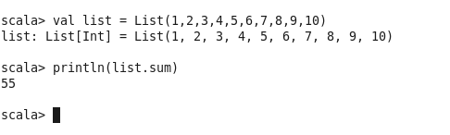

Total length of elements

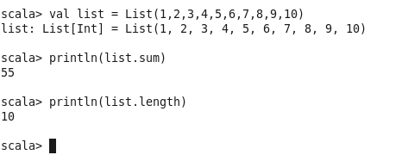

Average of the numbers in the list

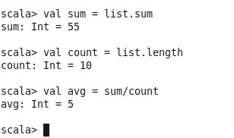

Sum of even numbers in list

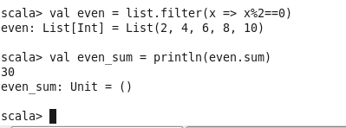

Elements in the list divisible by both 5 and 3

