**Assignment17.1**

**Problem Statement**

1. Write a program to read a text file and print the number of rows of data in the document.
2. Write a program to read a text file and print the number of words in the document.
3. We have a document where the word separator is -, instead of space. Write a spark code, to obtain the count of the total number of words present in the document.

Sample document :

This-is-my-first-assignment.

It-will-count-the-number-of-lines-in-this-document.

The-total-number-of-lines-is-3

Write a program to read a text file and print the number of rows of data in the document

The sample textfile is as follows

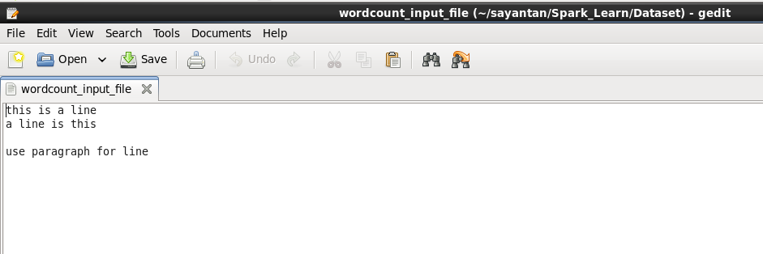

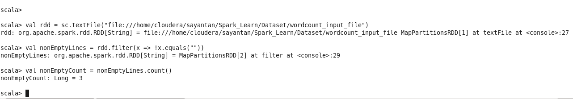

Hence we get the count of number of rows which is three.

2) Write a program to read a text file and print the number of words in the document.

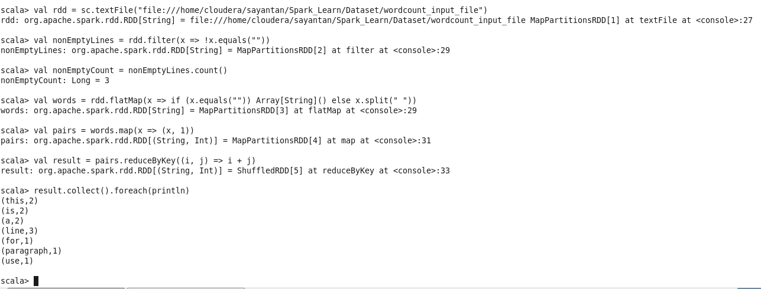

Hence we get the count of each word in our textfile.

3) We have a document where the word separator is -, instead of space. Write a spark code, to obtain the count of the total number of words present in the document.

Sample document :

This-is-my-first-assignment.

It-will-count-the-number-of-lines-in-this-document.

The-total-number-of-lines-is-3

