**Assignment18.3**

**Problem Statement**

1. **Considering age groups of < 20 , 20-35, 35 > ,Which age group spends the most amount of money travelling.**

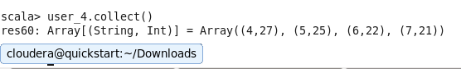

This is our user rdd filtered according to age,we have to join this with transport rdd

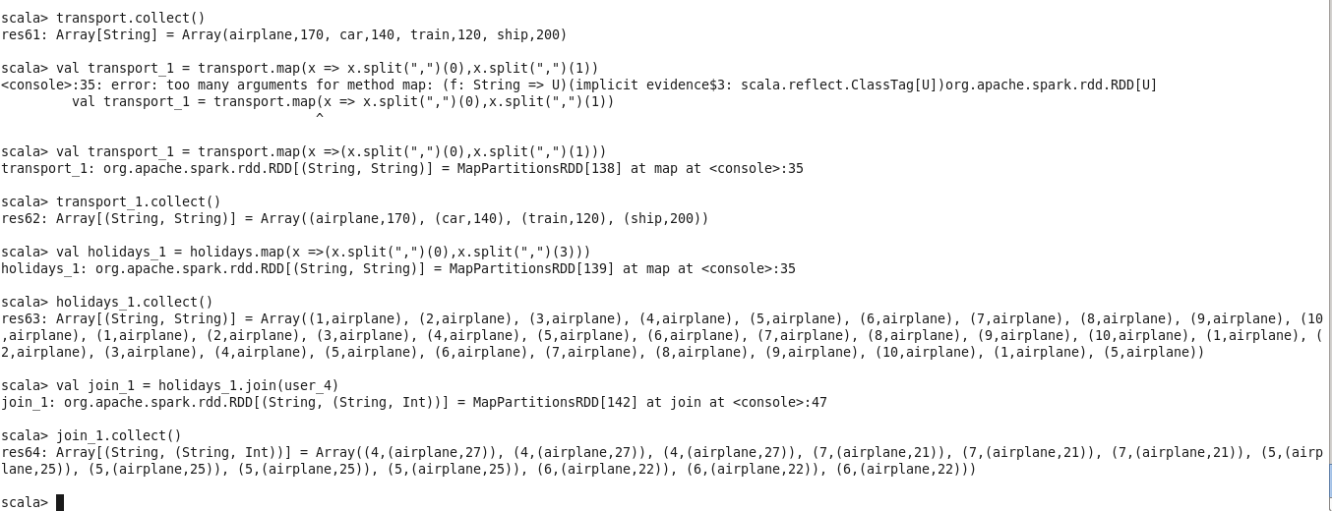

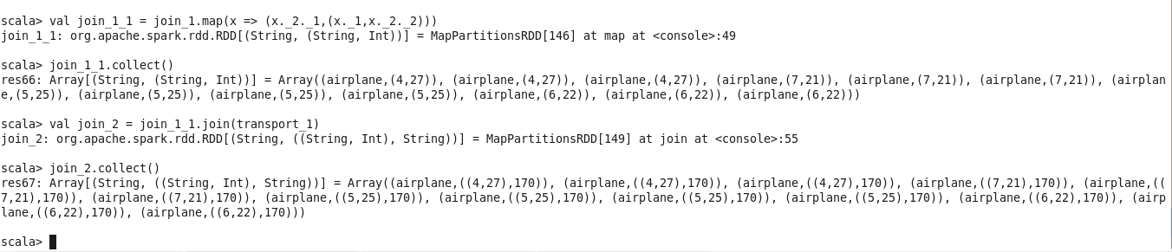

Now we will do our transformations on join_2 to reach our result

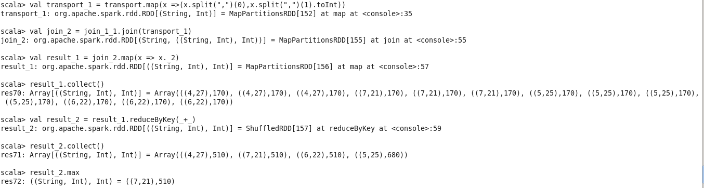

Hence we get the maximum value.

1. **What is the amount spent by each age-group, every year in travelling?**

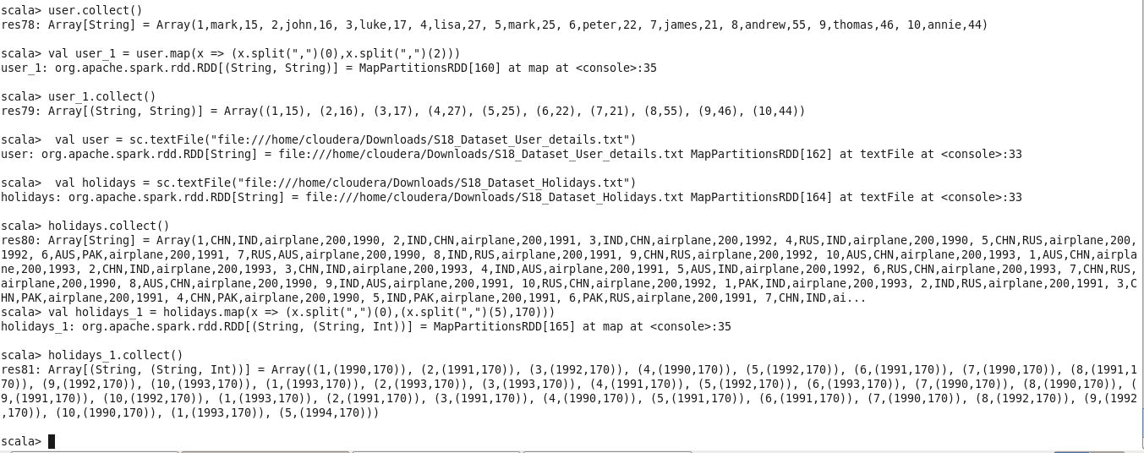

We have explicitly passes the value 170 because we know for airplane the cost per unit is 170 and both datasets are small.

We have to join holidays and user rdd to get the result

At the end we have to apply reduceByKey.

