**Assignment19.2**

**Problem Statement**

1.Change firstname, lastname columns into

Mr.first_two_letters_of_firstname<space>lastname

for example - michael, phelps becomes Mr.mi phelps

we have to first create a udf and register it so that we can call it during sql queries.

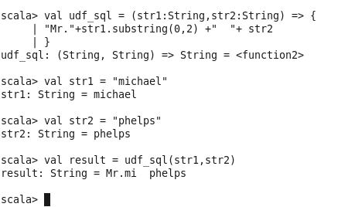

So we just created the function and tested it using an example argument Michael phelps.

Now we will register our function.



We can now use this function in spark sql

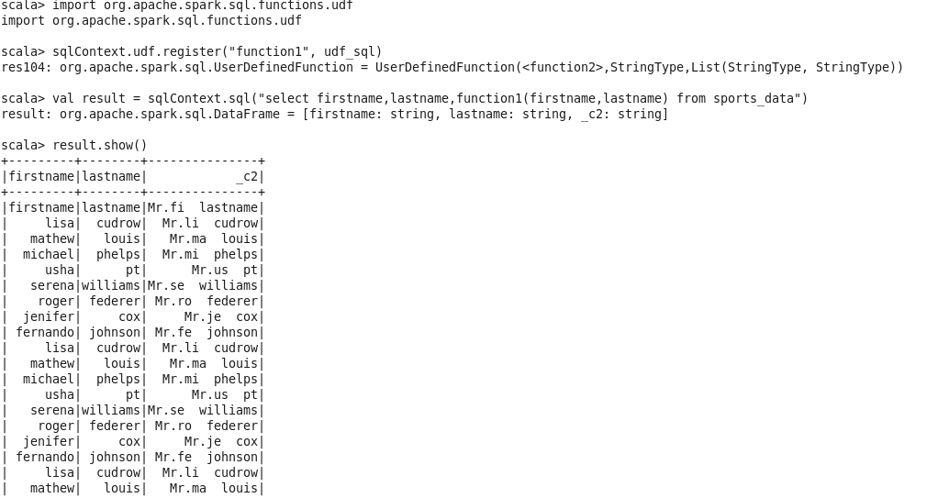

2)Add a new column called ranking using udfs on dataframe, where :gold medalist, with age >= 32 are ranked as pro,gold medalists, with age <= 31 are ranked amateur,silver medalist, with age >= 32 are ranked as expert,silver medalists, with age <= 31 are ranked rookie.

For this we shall define the function as follows:

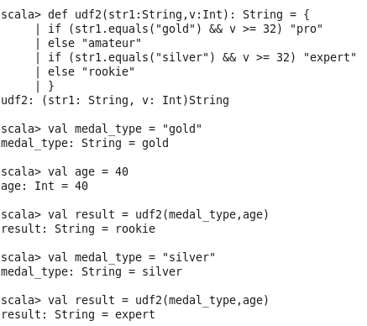

We will register this udf so as to use it with spark sql



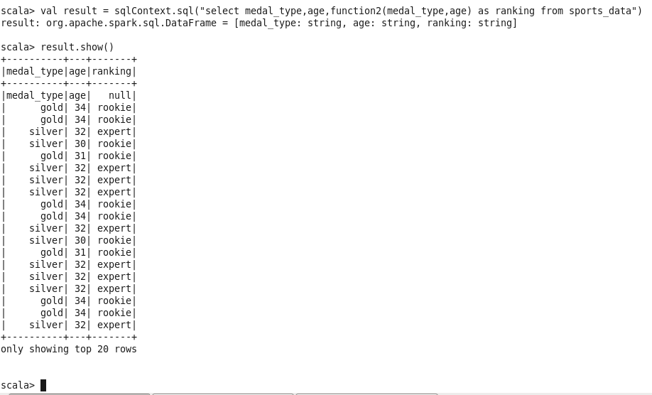

As we can see from the screenshot we ranked each sportsperson according to his age and medal