**Assignment19.1**

**Problem Statement**

**Using spark-sql, Find:**

**1. What are the total number of gold medal winners every year**

**2. How many silver medals have been won by USA in each sport**

We have to first load the data as rdd and create a schema for it using dataframe.

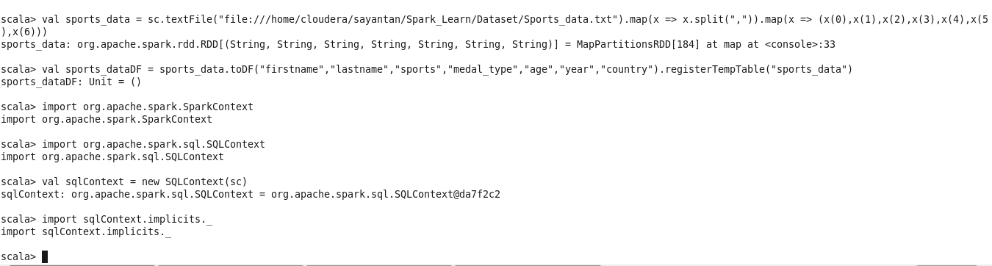

What are the total number of gold medal winners every year

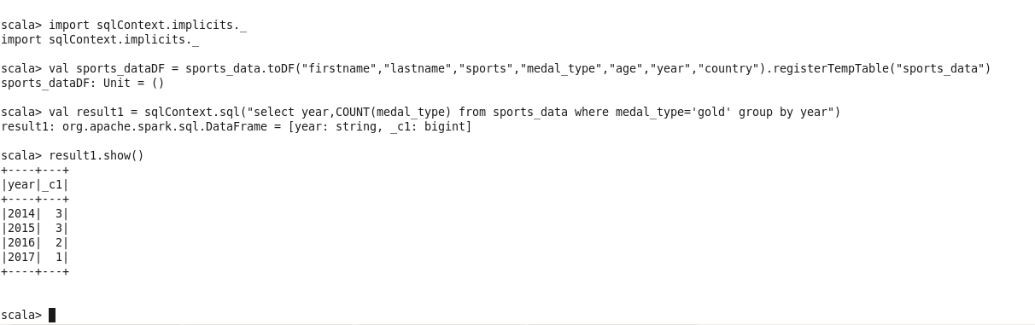

How many silver medals have been won by USA in each sport

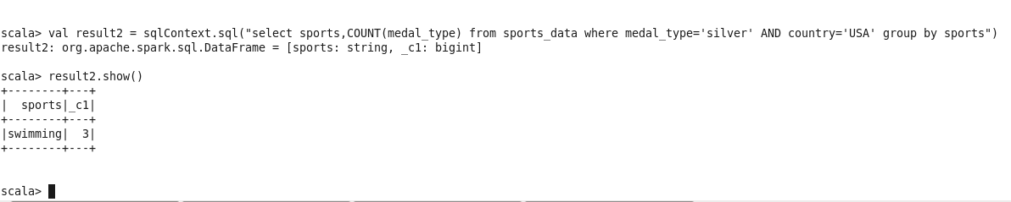

Hence by creating a sqlContext with object sc and running queries on the dataframe we arrive to both the results to the problem statements.