**Assignment19.3**

**Problem Statement**

**Create a dataframe with 1 to 100 and save as parquet file.**

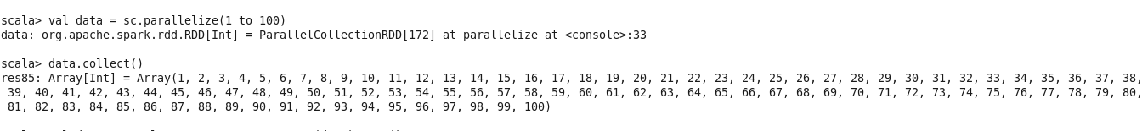

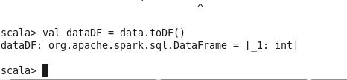

We created a rdd and created a dataframe using toDF function.

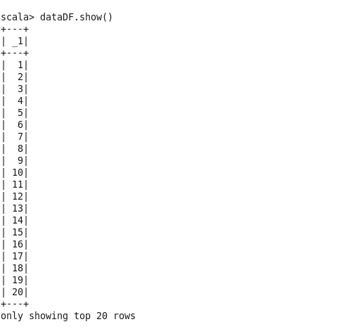

Now we will save the dataframe as parquet file and try to read it again

