**Assignment 1.2**

Explain the following Linux commands with example

1. **pwd –** This command is known as the print working directory. It is used to display the current directory in which the user is working.

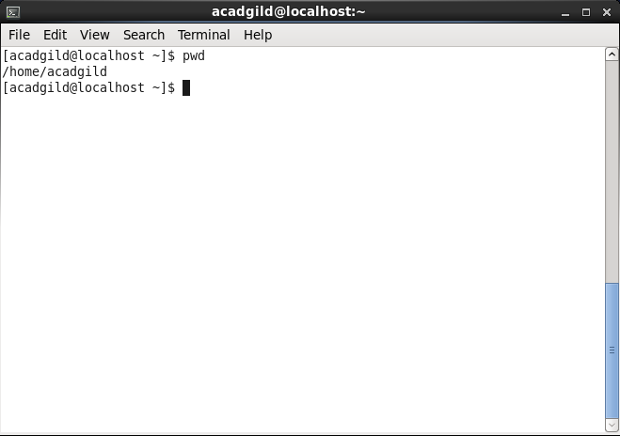

1. **vi –** This command is used to edit files using the screen oriented text editor. You can use the vi editor to edit an existing file or to create a new file from scratch. You can also use this editor to just read a text file.

**Commands-**

**vi filename** – creates a new file if it does not exit or opens an existing file.

**vi –R filename/view filename** – opens an existing file in the read only mode.

Eg. vi testfile

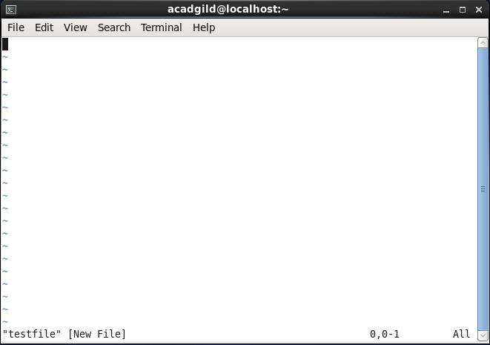

This creates a new file testfile if it doesn’t exist in the current working directory.

1. **touch** – touch creates a new file inside the working directory. It takes the filename as an argument and creates a new empty file in the directory. Here we will create new file called data.txt

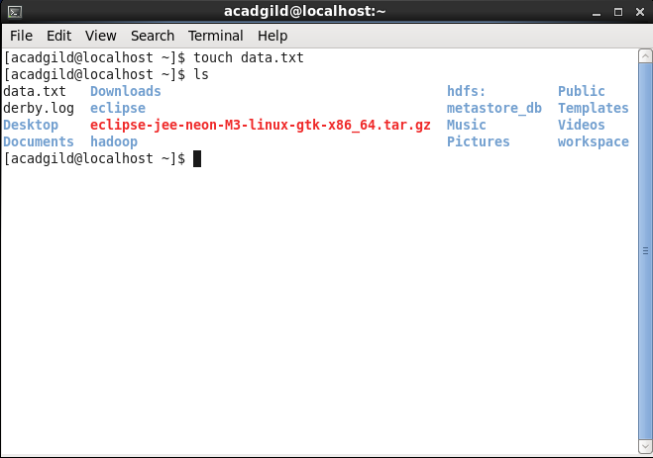

1. **mkdir** – mkdir takes a directory name as an argument and then creates a new directory inside the working directory. Here we will create a new directory called media inside /home/acadgild directory.

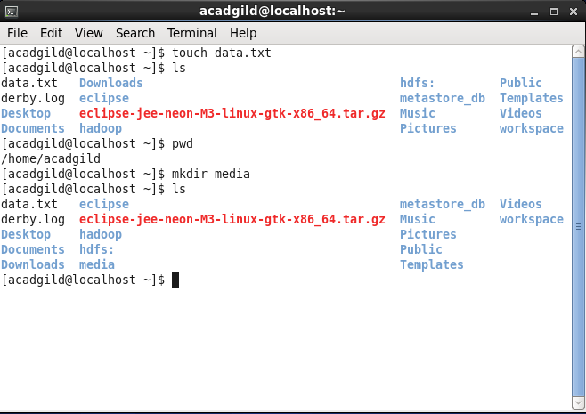

1. **rm**- rm command is used to delete files. Here we will delete the file data.txt which was created earlier.

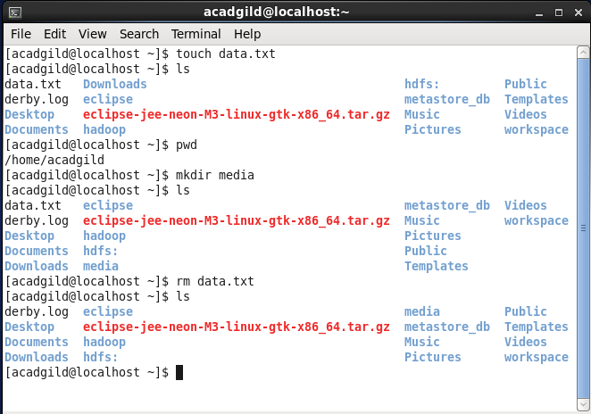

1. **ls –** Lists all files and directory in the current working directory.

**ls –a** – Lists all contents in the directory including hidden files.

**ls –l** – Lists all contents in the directory in a long format.

**ls –t -**  Orders files and directories by the time they were last modified.

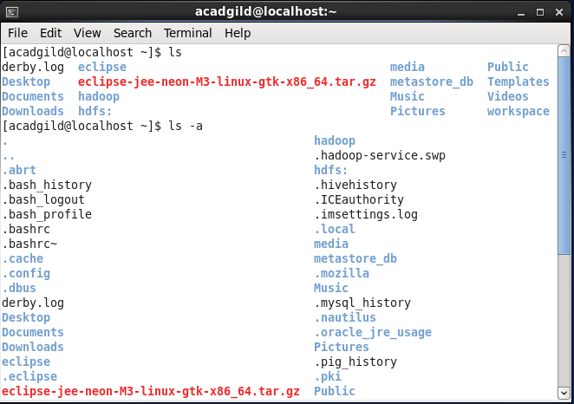

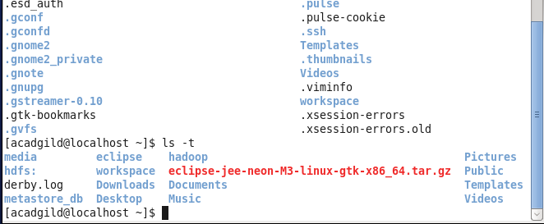

1. **echo -** echo is a fundamental command found in most operating systems that offer a command line. It is frequently used in scripts, batch files, and as part of individual commands, anywhere you may need to insert text. Here we will print hello world on console.

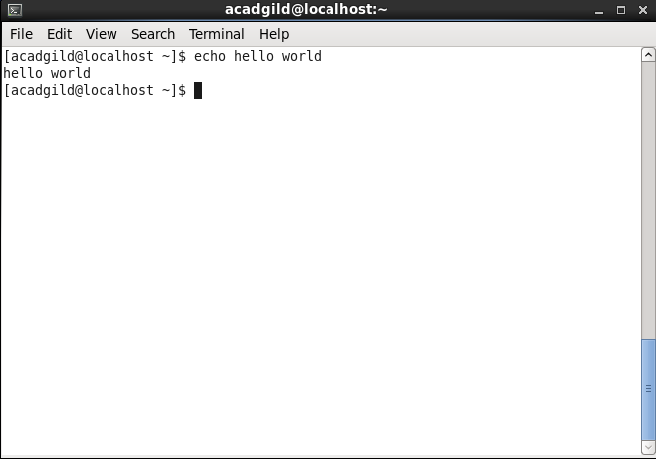

1. **cat-** cat command is used to concatenate contents of a file or used as standard input to standard output using >,<,>> or |. Here we will create two text files and redirect the contents of each.

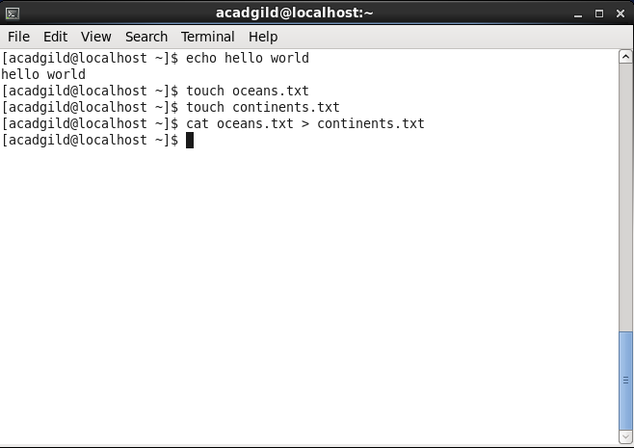

1. **who** – displays all the users who are currently logged on to the system. Displays the username, line and time of all currently logged in sessions.

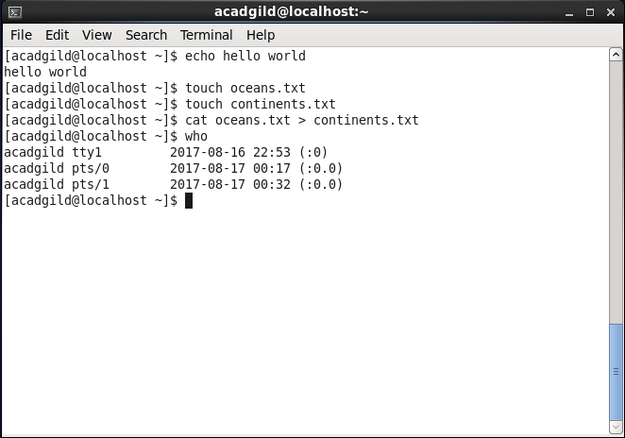

1. **cd**- cd takes the directory name as argument and switches into that directory.

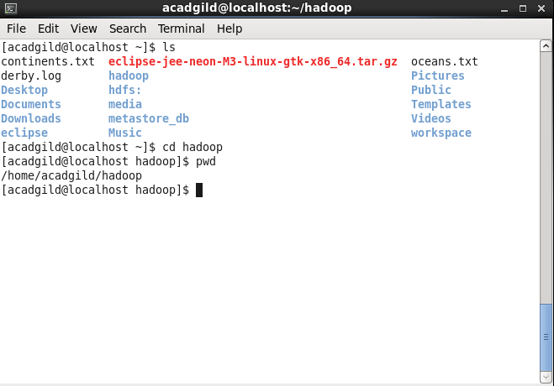

1. **date**- date command is to print out, or change the value of the system’s time and date information.

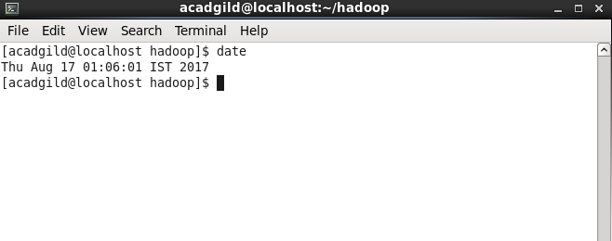

1. **cal-** It is used to display a conveniently formatted calender from the command line. If no options are used then by default cal command displays the current month at the command line.

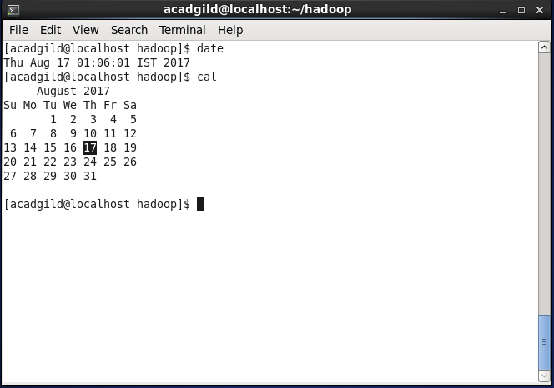

1. **mv-** It is used to move a file into a directory with the source file as the first argument and the destination directory as the second directory.

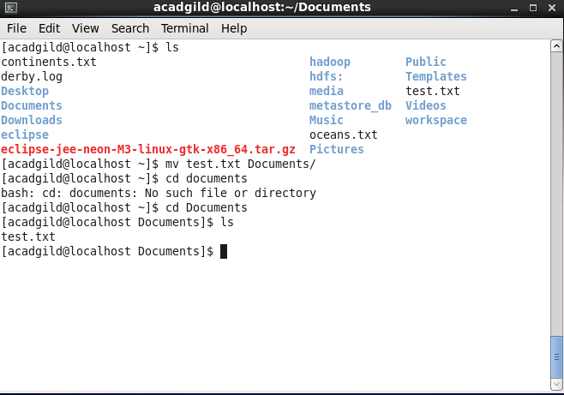

1. **cp-** This command is used to copy files or directories. 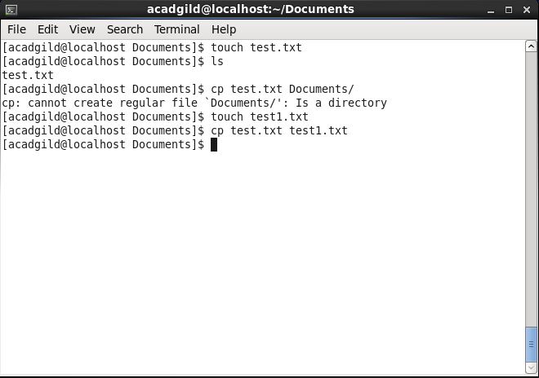
2. **which-** which returns the pathnames of the files which would be executed in the current environment when the filename has been given as a command. 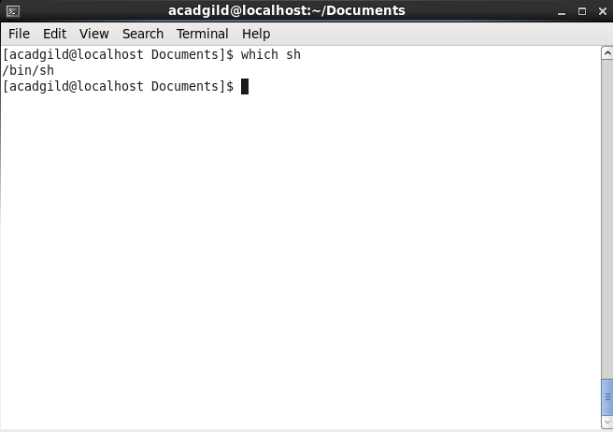

Locates the pathname of the file which would be run if the sh command were executed.