**Assignment20.1**

**Census data analysis**

**Due to the limitation of 22 elements for a map function, we are taking only 22 columns from the data set.**

**Here is the total dataset description**

State String,District String,Persons String,Males int,Females int,Growth_1991_2001 int,Rural int,Urban int,Scheduled_Caste_population int,Percentage_SC_to_total int,Number_of_households int,Household_size_per_household int,Sex_ratio_females_per_1000_males int ,Sex_ratio_0_6_years int,Scheduled_Tribe_population int,Percentage_to_total_population_ST int,Persons_literate int,Males_Literate int,Females_Literate int,Persons_literacy_rate int,Males_Literatacy_Rate int,Females_Literacy_Rate int,Total_Educated int,Data_without_level int,Below_Primary int,Primary int,Middle int,Matric_Higher_Secondary_Diploma int,Graduate_and_Above int,X0_4_years int,X5_14_years int,X15_59_years int,X60_years_and_above_Incl_ANS int,Total_workers int,Main_workers int,Marginal_workers int,Non_workers int,SC_1_Name String,SC_1_Population int,SC_2_Name String,SC_2_Population int,SC_3_Name String,SC_3_Population int,Religeon_1_Name String,Religeon_1_Population int,Religeon_2_Name String,Religeon_2_Population int,Religeon_3_Name String,Religeon_3_Population int,ST_1_Name String,ST_1_Population int,ST_2_Name String,ST_2_Population int,ST_3_Name String,ST_3_Population int,Imp_Town_1_Name String,Imp_Town_1_Population int,Imp_Town_2_Name String,Imp_Town_2_Population int,Imp_Town_3_Name String,Imp_Town_3_Population int,Total_Inhabited_Villages int,Drinking_water_facilities int,Safe_Drinking_water int,Electricity_Power_Supply int,Electricity_domestic int,Electricity_Agriculture int,Primary_school int,Middle_schools int,Secondary_Sr_Secondary_schools int,College int,Medical_facility int,Primary_Health_Centre int,Primary_Health_Sub_Centre int,Post_telegraph_and_telephone_facility int,Bus_services int,Paved_approach_road int,Mud_approach_road int,Permanent_House int,Semi_permanent_House int,Temporary_House int

**Here is what we are taking**

"State" ,"Persons","Males" ,"Females" ,"Growth_1991_2001" ,"Rural" ,"Urban" ,"Scheduled_Caste_population" ,"Percentage_SC_to_total" ,"Number_of_households" ,"Household_size_per_household" ,"Sex_ratio_females_per_1000_males " ,"Sex_ratio_0_6_years" ,"Scheduled_Tribe_population" ,"Percentage_to_total_population_ST" ,"Persons_literate" ,"Males_Literate" ,"Females_Literate" ,"Persons_literacy_rate" ,"Males_Literatacy_Rate" ,"Females_Literacy_Rate" ,"Total_Educated"

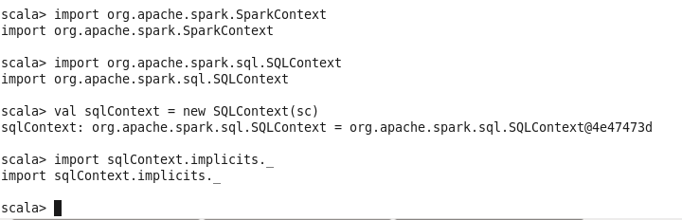

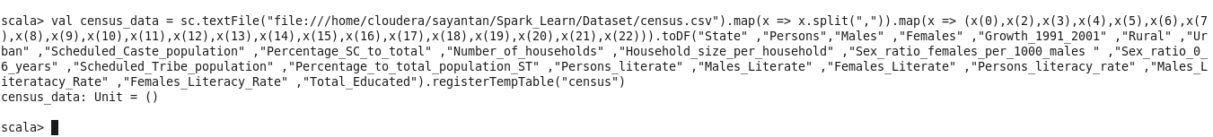

1. **Find out the state wise population and order by state**

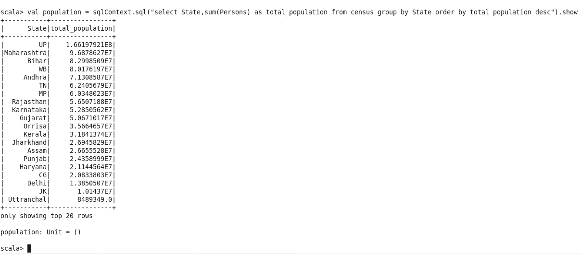

1. **Find out the Growth Rate of Each State Between 1991-2001**

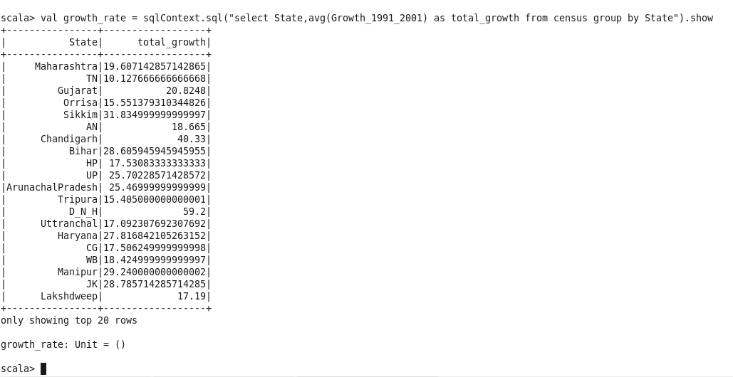

**3. Find the literacy rate of each state**

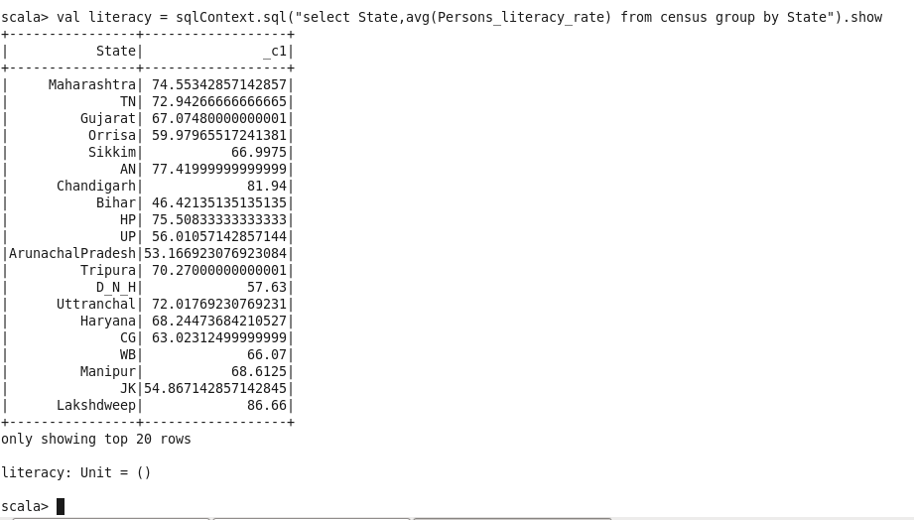

**4. Find out the States with More Female Population**

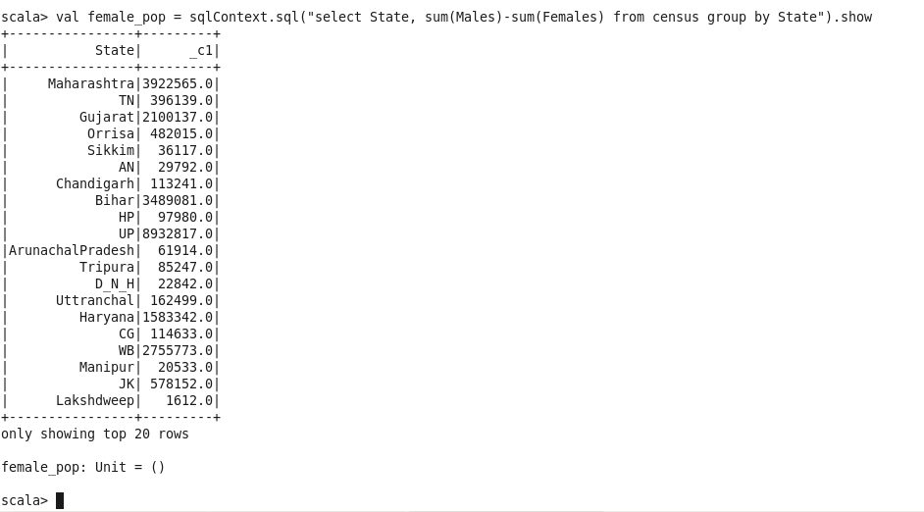

**5. Find out the Percentage of Population in Every State**

val percenet_pop = spark.sql("select state, (sum(persons) * 100.0) / SUM(sum(persons)) over() as percent_pop_by_state from census group by state").show

