**Assignment20.2**

**Sentiment analysis on demonetization**

We first have to create a sqlContext

Spark context is invoked at the time the shell starts.

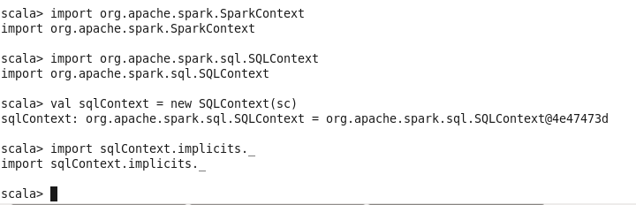

Now we have to load the csv dataset and assign a schema to it by toDF function.

After this we have to create a view or temporary table on which we can run our sql queries to reach the result.

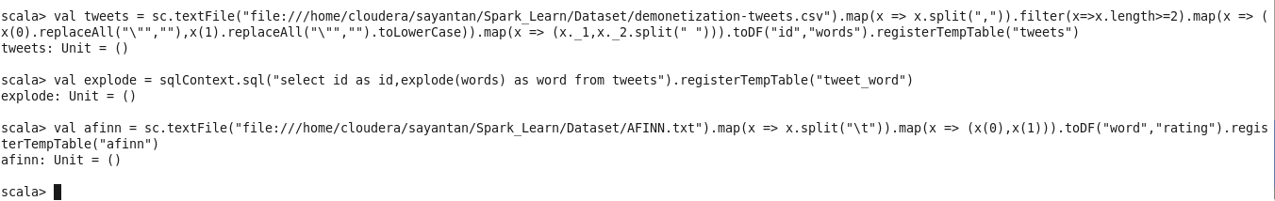

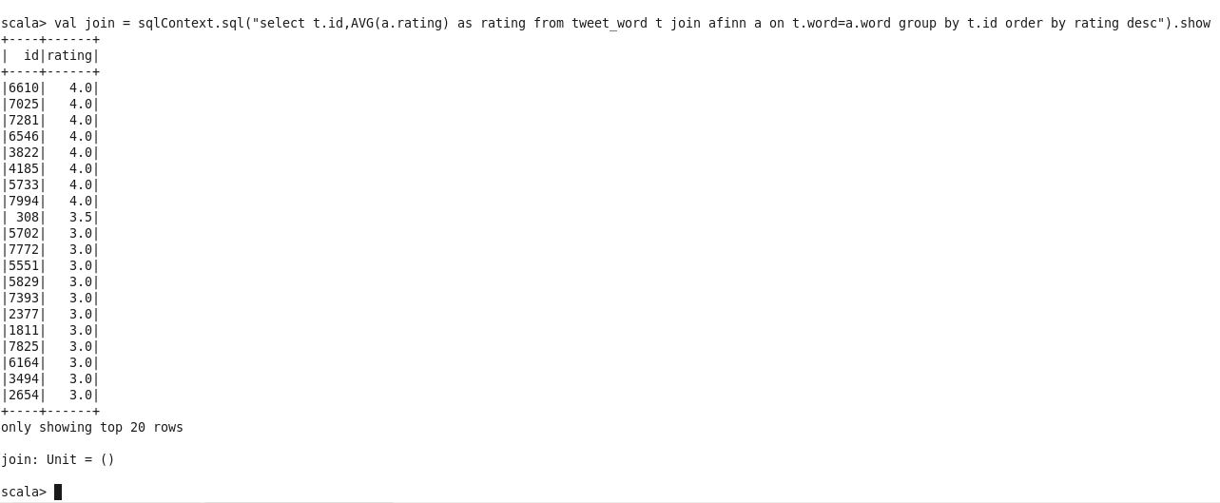

Hence we have found the rating for each id from the demonetization tweets.