**Assignment23.2**

**Aviation data analysis**

The U.S. Department of Transportation’s (DOT) Bureau of Transportation Statistics (BTS) tracks the on-time performance of domestic flights operated by large air carriers. Summary information on the number of on-time, delayed, canceled, and diverted flights appears in DOT’s monthly Air Travel Consumer Report, published about 30 days after the month’s end, as well as in summary tables posted on this website. Summary statistics and raw data are made available to the public at the time the Air Travel Consumer Report is released.

The dataset description is as follows

Name Description

1 Year 1987-2008

2 Month 1-12

3 DayofMonth 1-31

4 DayOfWeek 1 (Monday) - 7 (Sunday)

5 DepTime actual departure time (local, hhmm)

6 CRSDepTime scheduled departure time (local, hhmm)

7 ArrTime actual arrival time (local, hhmm)

8 CRSArrTime scheduled arrival time (local, hhmm)

9 UniqueCarrier unique carrier code

10 FlightNum flight number

11 TailNum plane tail number

12 ActualElapsedTime in minutes

13 CRSElapsedTime in minutes

14 AirTime in minutes

15 ArrDelay arrival delay, in minutes

16 DepDelay departure delay, in minutes

17 Origin origin IATA airport code

18 Dest destination IATA airport code

19 Distance in miles

20 TaxiIn taxi in time, in minutes

21 TaxiOut taxi out time in minutes

22 Cancelled was the flight cancelled?

23 CancellationCode reason for cancellation (A = carrier, B = weather, C = NAS, D = security)

24 Diverted 1 = yes, 0 = no

25 CarrierDelay in minutes

26 WeatherDelay in minutes

27 NASDelay in minutes

28 SecurityDelay in minutes

29 LateAircraftDelay in minutes

**Problem Statement 1**

**Find out the top 5 most visited destinations.**

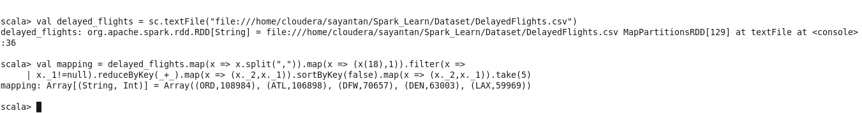

**Problem Statement 2**

**Which month has seen the most number of cancellations due to bad weather?**

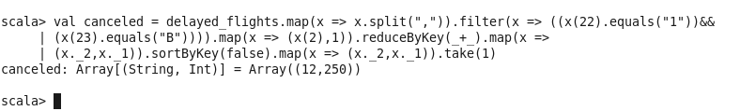

**Problem Statement 3**

**Top ten origins with the highest AVG departure delay**

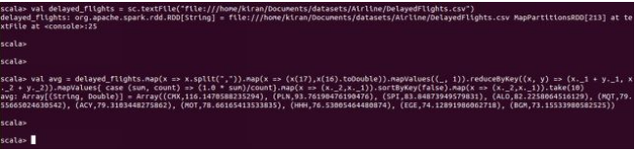

**Problem Statement 4**

**Which route (origin & destination) has seen the maximum diversion?**

