Assignment 3.3

5. Problem Statement

We have a dataset of sales of different TV sets across different locations.

Records look like:

Samsung|Optima|14|Madhya Pradesh|132401|14200

The fields are arranged like:

Company Name|Product Name|Size in inches|State|Pin Code|Price

There are some invalid records which contain 'NA' in either Company Name or Product Name.

2. Write a Map Reduce program to calculate the total units sold for each Company.

**Code:**

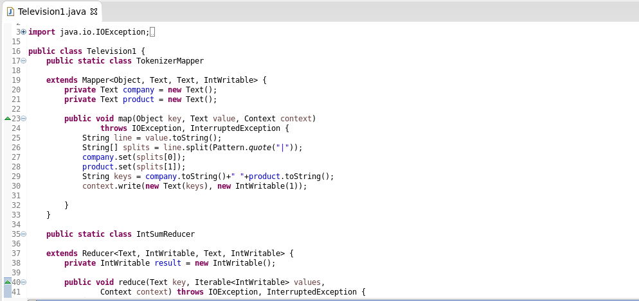

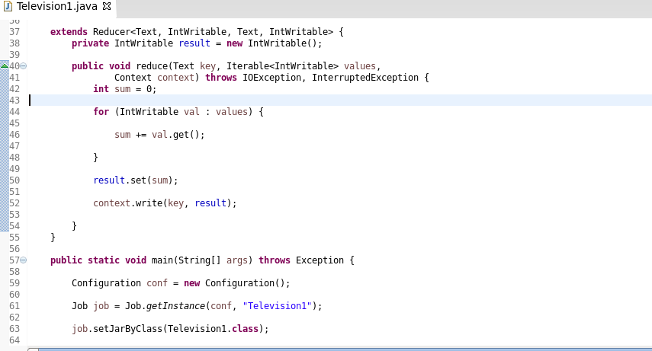

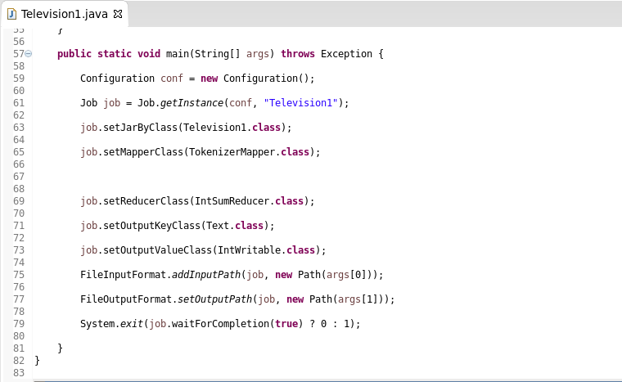

**Output:**

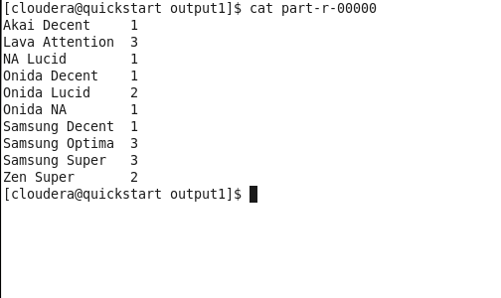

3. Write a Map Reduce program to calculate the total units sold in each state for Onida company.

**CODE:**

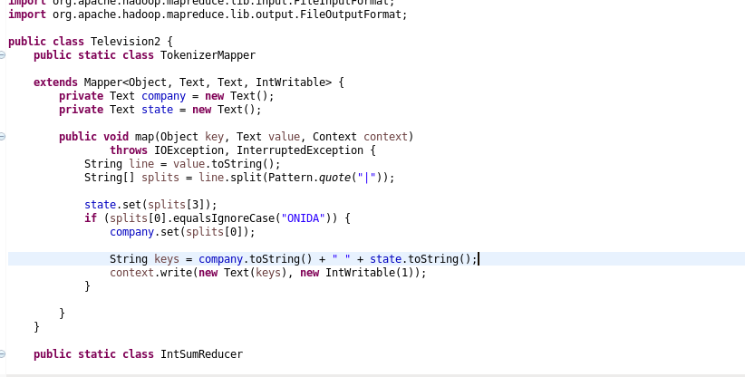

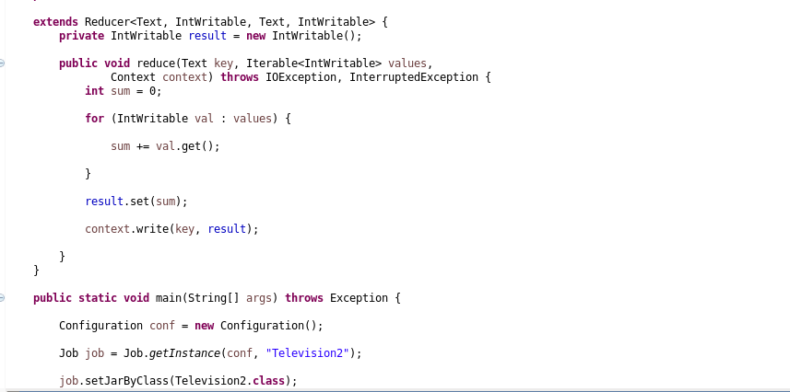

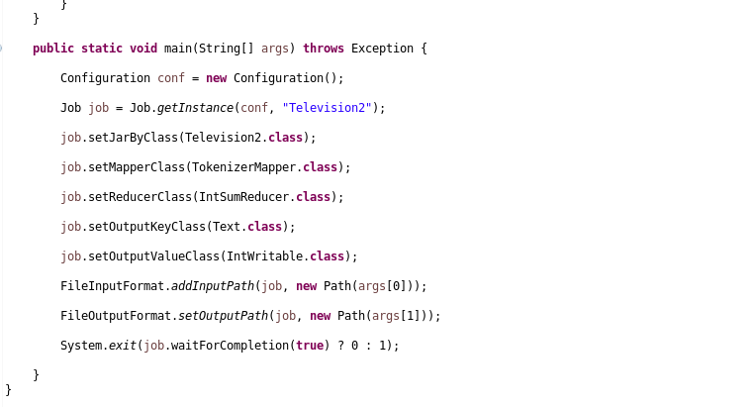

**OUTPUT:**

