**Assignment4.3**

Write a program to implement wordcount using pig

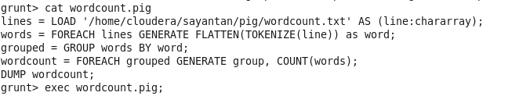

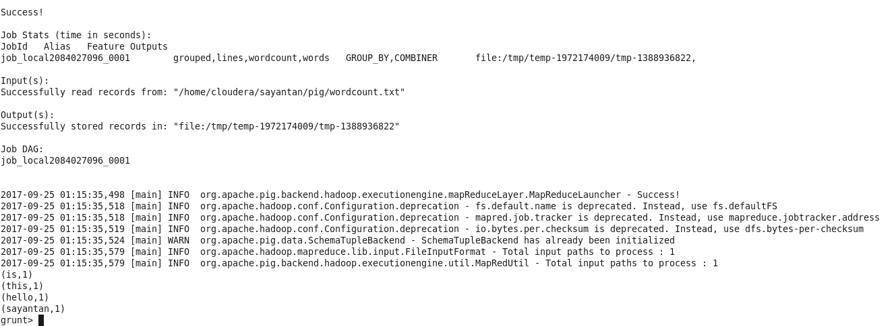

First created a wordcount.txt file in my pig directory using gedit. Then made a pig script file consisting all the pig commands for wordcount.

Next ran the script in local mode using exec wordcount.pig.

The pig commands for wordcount are:

lines = LOAD '/home/cloudera/sayantan/pig/wordcount.txt' AS (line:chararray);

words = FOREACH lines GENERATE FLATTEN(TOKENIZE(line)) as word;

grouped = GROUP words BY word;

wordcount = FOREACH grouped GENERATE group, COUNT(words);

DUMP wordcount;