**Assignment 5.1**

(a) Top 5 employees (employee id and employee name) with highest rating. (In case two

employees have same rating, employee with name coming first in dictionary should get

preference)

**Commands used as follows:**

Emp_details = LOAD ‘employee_details’ USING PigStorage(‘,’) AS (emp_id:int,emp_name:chararray,emp_salary:int,emp_rating:int);

Emp = FOREACH Emp_details GENERATE emp_id,emp_name,emp_rating;

EMP1 = ORDER Emp BY emp_name,emp_rating ASC;

dump EMP1;

Emp2 = LIMIT EMP1 5;

**OUTPUT:**

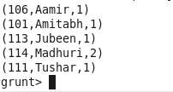

(b) Top 3 employees (employee id and employee name) with highest salary, whose employee id

is an odd number. (In case two employees have same salary, employee with name coming first

in dictionary should get preference)

**Commands used as follows:**

A1 = FOREACH emp_details GENERATE emp_id,emp_name,emp_salary;

A2 = FILTER A1 BY emp_id%2 !=0;

A3 = ORDER A2 BY emp_salary DESC;

A4 = LIMIT A3 3;

dump A4;

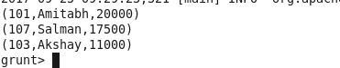

(c) Employee (employee id and employee name) with maximum expense (In case two

employees have same expense, employee with name coming first in dictionary should get

preference)

**Commands used are as follows:**

A = LOAD ‘employee_details.txt’ AS PigStorage(‘,’) AS (emp_id:int,emp_name:chararray,emp_salary:int,emp_rating:int);

B = LOAD ‘employee_expenses’ AS (emp_exp_id:int,emp_exp:int);

C = JOIN employee_details BY emp_id,employee_expenses BY emp_exp_id;

D = FOREACH C GENERATE emp_id,emp_name,emp_exp);

E = ORDER D BY emp_exp DESC;

dump E;

**OUTPUT:**

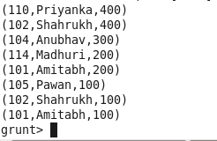

(d) List of employees (employee id and employee name) having entries in employee_expenses

file.

**Commands used as follows:**

A = LOAD ‘employee_details.txt’ AS PigStorage(‘,’) AS (emp_id:int,emp_name:chararray,emp_salary:int,emp_rating:int);

B = LOAD ‘employee_expenses’ AS (emp_exp_id:int,emp_exp:int);

C = JOIN employee_details BY emp_id,employee_expenses BY emp_exp_id;

D = FOREACH C GENERATE emp_id,emp_name,emp_exp;

**OUTPUT:**

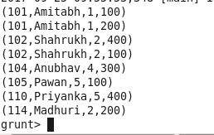

(e) List of employees (employee id and employee name) having no entry in employee_expenses

file.

**Commands used as follows:**

A = LOAD ‘employee_details.txt’ AS PigStorage(‘,’) AS (emp_id:int,emp_name:chararray,emp_salary:int,emp_rating:int);

B = LOAD ‘employee_expenses’ AS (emp_exp_id:int,emp_exp:int);

C = JOIN A BY emp_id,B BY emp_exp;

D = FOREACH C GENERATE emp_id,emp_name,emp_exp;

dump D;

**OUTPUT:**

