**Assignment 5.2**

**Aviation Data Analysis Using Apache Pig**

**Problem Statement 1:** **Find out the top 5 most visited destinations.**

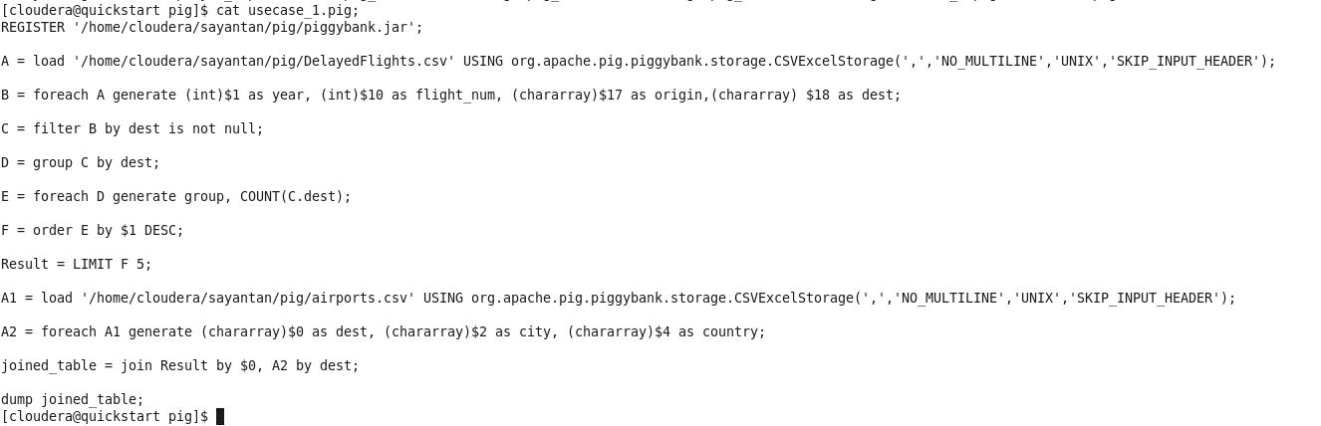

**Commands:**

**1) gedit usecase_1.pig;**

**2) exec usecase_1.pig;**

**OUTPUT:**

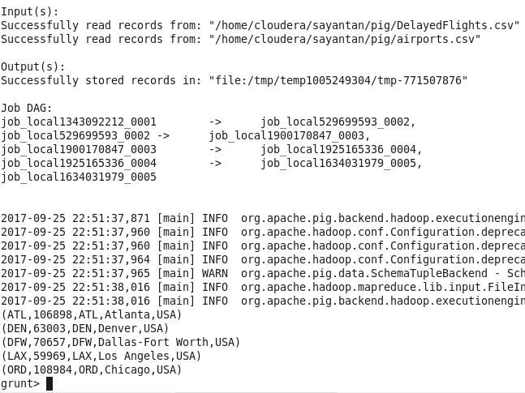

**Problem Statement 2: Which month has seen most number of cancellations due to bad weather?**

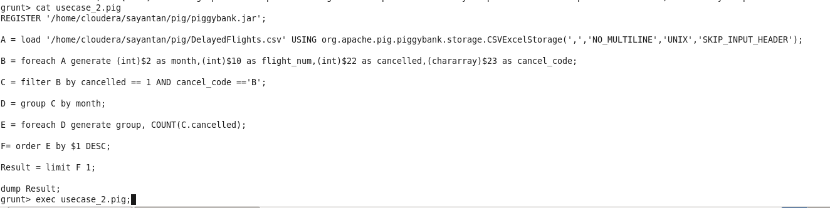

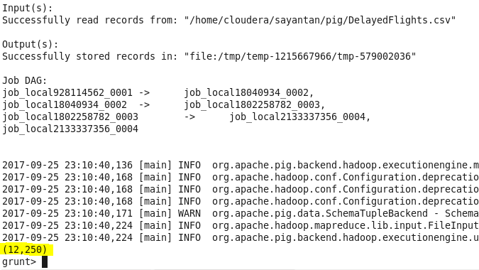

**Problem Statement 3: Top ten origins with the highest AVG departure delay.**

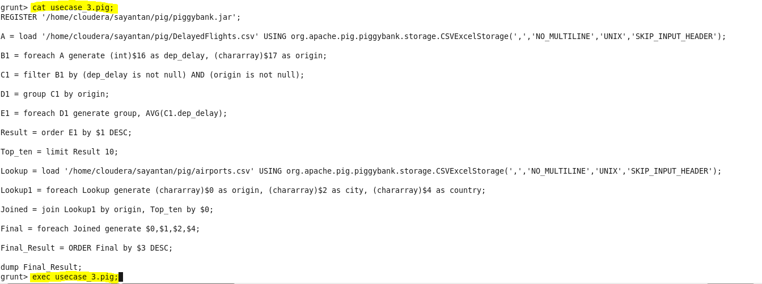

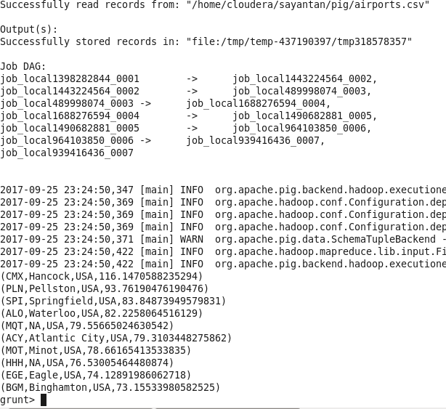

**Problem Statement 4: Which route(origin and destination) has seen the maximum diversion?**



