Assignment 6.2

Problem Statement

Fetch date and temperature from temperature_data where zip code is greater than 300000 and less than 399999.

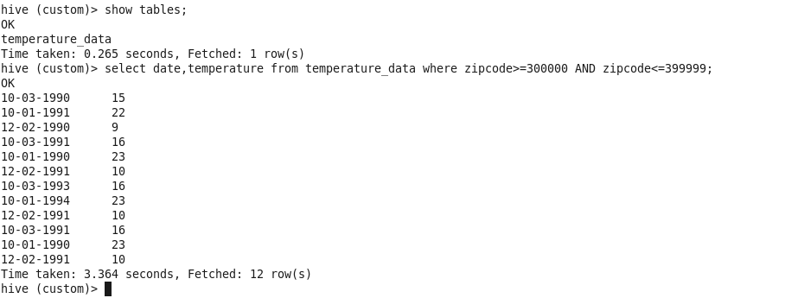

Calculate maximum temperature corresponding to every year from temperature_data table.

Command: select from_unixtime(unix_timestamp(date,'mm-dd-yyyy'),’yyyy’),max(temperature) from temperature_data group by date;

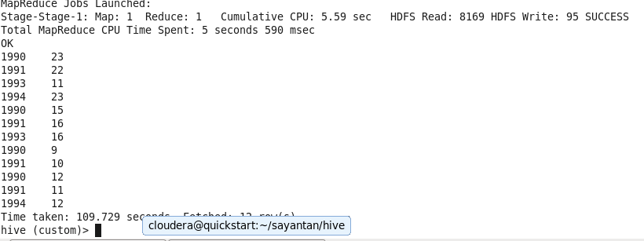

Calculate maximum temperature from temperature_data table corresponding to those years which have at least 2 entries in the table.



Create a view on the top of last query, name it temperature_data_vw.

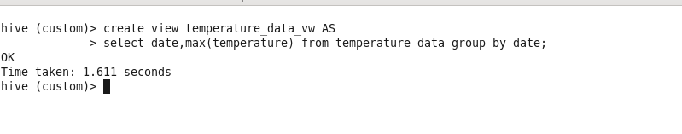

Export contents from temperature_data_vw to a file in local file system, such that each file is '|' delimited.

