**Assignment 7.2**

Problem Statement:

Write a Hive program to find the number of medals won by each country in swimming.

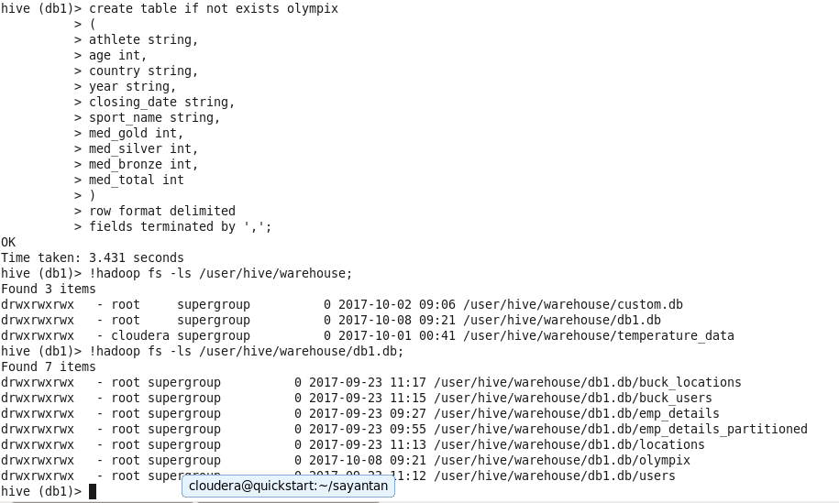

Command: select country,SUM(med_total) from olympix where sport_name=’Swimming’ group by country;

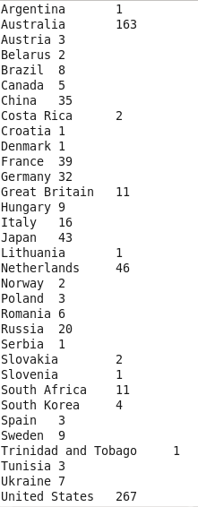

Write a Hive program to find the number of medals that India won year wise.

Command: select year,SUM(medal_total) from olympix where country=’India’ group by year;

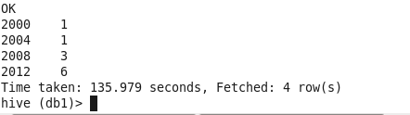

Write a Hive Program to find the total number of medals each country won.

Command: select country,SUM(med_total) from olympix group by country;

Afghanistan 2

Algeria 8

Argentina 141

Armenia 10

Australia 609

Austria 91

Azerbaijan 25

Bahamas 24

Bahrain 1

Barbados 1

Belarus 97

Belgium 18

Botswana 1

Brazil 221

Bulgaria 41

Cameroon 20

Canada 370

Chile 22

China 530

Chinese Taipei 20

Colombia 13

Costa Rica 2

Croatia 81

Cuba 188

Cyprus 1

Czech Republic 81

Denmark 89

Dominican Republic 5

Ecuador 1

Egypt 8

Eritrea 1

Estonia 18

Ethiopia 29

Finland 118

France 318

Gabon 1

Georgia 23

Germany 629

Great Britain 322

Greece 59

Grenada 1

Guatemala 1

Hong Kong 3

Hungary 145

Iceland 15

India 11

Indonesia 22

Iran 24

Ireland 9

Israel 4

Italy 331

Jamaica 80

Japan 282

Kazakhstan 42

Kenya 39

Kuwait 2

Kyrgyzstan 3

Latvia 17

Lithuania 30

Macedonia 1

Malaysia 3

Mauritius 1

Mexico 38

Moldova 5

Mongolia 10

Montenegro 14

Morocco 11

Mozambique 1

Netherlands 318

New Zealand 52

Nigeria 39

North Korea 21

Norway 192

Panama 1

Paraguay 17

Poland 80

Portugal 9

Puerto Rico 2

Qatar 3

Romania 123

Russia 768

Saudi Arabia 6

Serbia 31

Serbia and Montenegro 38

Singapore 7

Slovakia 35

Slovenia 25

South Africa 25

South Korea 308

Spain 205

Sri Lanka 1

Sudan 1

Sweden 181

Switzerland 93

Syria 1

Tajikistan 3

Thailand 18

Togo 1

Trinidad and Tobago 19

Tunisia 4

Turkey 28

Uganda 1

Ukraine 143

United Arab Emirates 1

United States 1312

Uruguay 1

Uzbekistan 19

Venezuela 4

Vietnam 2

Zimbabwe 7

Time taken: 127.627 seconds, Fetched: 111 row(s)

hive (db1)>

Write a Hive program to find the number of gold medals each country won.

Command: select country,SUM(med_gold) from olympix group by country;

Afghanistan 0

Algeria 2

Argentina 49

Armenia 0

Australia 163

Austria 36

Azerbaijan 6

Bahamas 11

Bahrain 0

Barbados 0

Belarus 17

Belgium 2

Botswana 0

Brazil 46

Bulgaria 8

Cameroon 20

Canada 168

Chile 3

China 234

Chinese Taipei 2

Colombia 2

Costa Rica 0

Croatia 35

Cuba 57

Cyprus 0

Czech Republic 14

Denmark 46

Dominican Republic 3

Ecuador 0

Egypt 1

Eritrea 0

Estonia 6

Ethiopia 13

Finland 11

France 108

Gabon 0

Georgia 6

Germany 223

Great Britain 124

Greece 12

Grenada 1

Guatemala 0

Hong Kong 0

Hungary 77

Iceland 0

India 1

Indonesia 5

Iran 10

Ireland 1

Israel 1

Italy 86

Jamaica 24

Japan 57

Kazakhstan 13

Kenya 11

Kuwait 0

Kyrgyzstan 0

Latvia 3

Lithuania 5

Macedonia 0

Malaysia 0

Mauritius 0

Mexico 19

Moldova 0

Mongolia 2

Montenegro 0

Morocco 2

Mozambique 1

Netherlands 101

New Zealand 18

Nigeria 6

North Korea 6

Norway 97

Panama 1

Paraguay 0

Poland 20

Portugal 1

Puerto Rico 0

Qatar 0

Romania 57

Russia 234

Saudi Arabia 0

Serbia 1

Serbia and Montenegro 11

Singapore 0

Slovakia 10

Slovenia 5

South Africa 10

South Korea 110

Spain 19

Sri Lanka 0

Sudan 0

Sweden 57

Switzerland 21

Syria 0

Tajikistan 0

Thailand 6

Togo 0

Trinidad and Tobago 1

Tunisia 2

Turkey 9

Uganda 1

Ukraine 31

United Arab Emirates 1

United States 552

Uruguay 0

Uzbekistan 5

Venezuela 1

Vietnam 0

Zimbabwe 2

Time taken: 139.976 seconds, Fetched: 111 row(s)

hive (db1)>