**Assignment 8.3**

**Transactions in Hive**

**Transactions in Hive**

Transactions in Hive are introduced in Hive 0.13, but they only partially fulfill the ACID properties like atomicity, consistency, durability, at the partition level. Here, Isolation can be provided by turning on one of the locking mechanisms available with zookeeper or in memory.

But in Hive 0.14, new API’s have been added to completely fulfill the ACID properties while performing any transaction.

Transactions are provided at the row-level in Hive 0.14. The different row-level transactions available in Hive 0.14 are as follows:

1. Insert
2. Delete
3. Update

There are numerous limitations with the present transactions available in Hive 0.14. ORC is the file format supported by Hive transaction. It is now essential to have ORC file format for performing transactions in Hive. The table needs to be bucketed in order to support transactions.

**Row-level Transactions Available in Hive 0.14**

Let’s perform some row-level transactions available in Hive 0.14. Before creating a Hive table that supports transactions, the transaction features present in Hive needs to be turned on, as by default they are turned off.

The below properties needs to be set appropriately in ***hive shell***, order-wise to work with transactions in Hive:

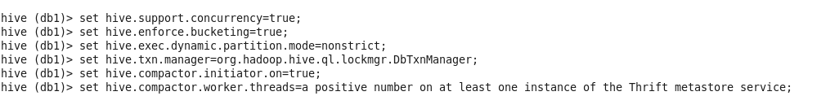



## Inserting Data into a Hive Table

INSERT INTO table college values(1,'nec','nlr'),(2,'vit','vlr'),(3,'srm','chen'),(4,'lpu','del'),(5,'stanford','uk'),(6,'JNTUA','atp'),(7,'cambridge','us');

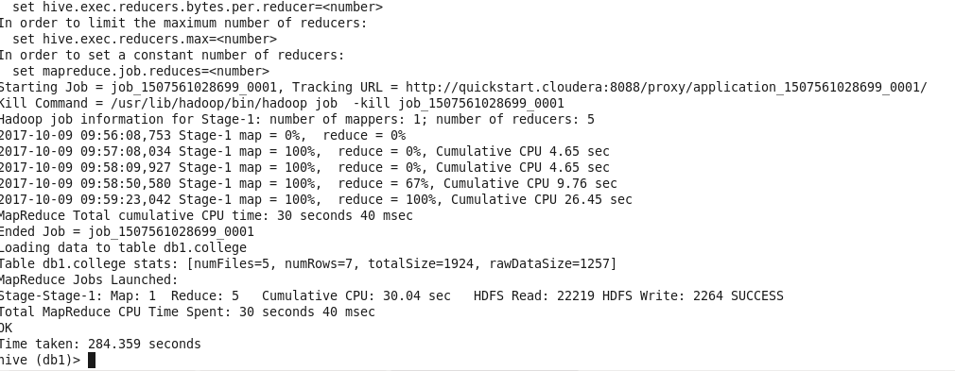

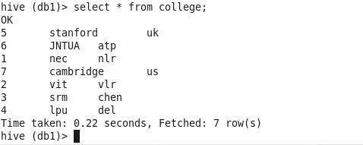

Now if we try to re-insert the same data again, it will be appended to the previous data as shown below:

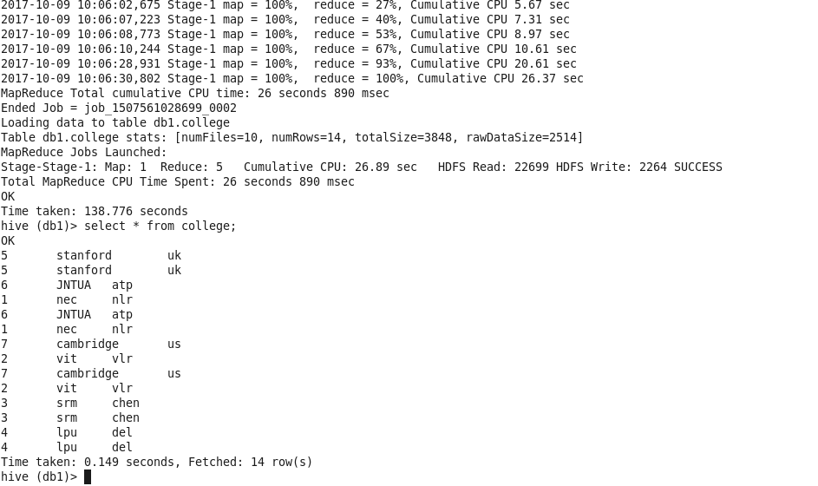

## Updating the Data in Hive Table

## 

## 

## 

## 

## 

## Deleting a Row from Hive Table

## 

## 

## 

## We have now successfully deleted a row from the Hive table.