**Assignment 8.2**

Problem Statement:

Write a hive UDF that implements functionality of string concat_ws(string SEP, array<string>).This UDF will accept two arguments, one string and one array of string.It will return a single string where all the elements of the array are separated by the SEP.

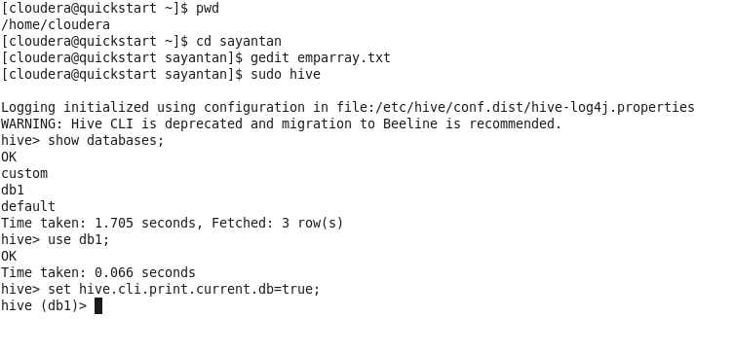

The dataset is as follows:

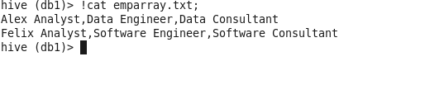

Now we have to create a table and load the contents

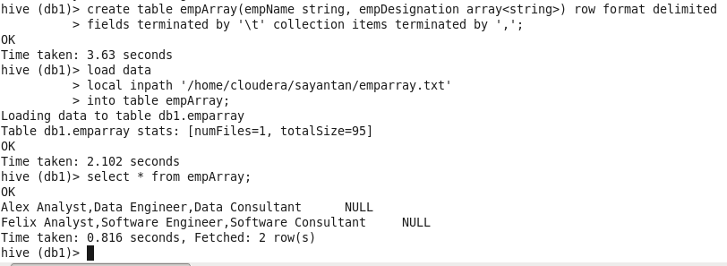

The next step is to add our jar file and create a temporary function

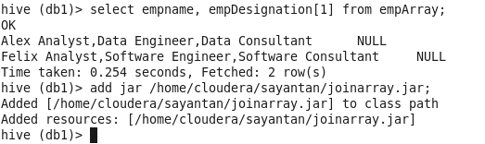

Creating a temporary function concat

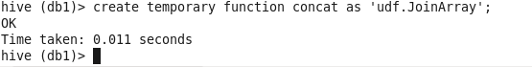

Now running our function in a query

