**Assignment9.2**

Problem 1:

Create an HBase table named 'clicks' with a column family 'hits' such that it should be able to store last 5 values of qualifiers inside 'hits' column family.

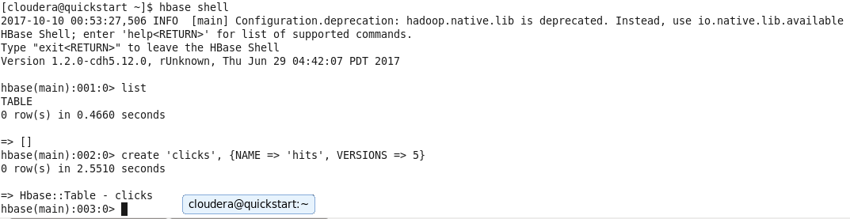

Hbase shell command is used to start the shell.

List command lists all the existing tables.

The create ‘tablename’,{NAME=>’column family name’,VERSIONS=>5}

Here clicks is the table qualifier and hits is the column family name.Versions specifies the number of versions it can hold.

Problem 2:

Add few records in the table and update some of them. Use IP Address as row-key. Scan the table to view if all the previous versions are getting displayed.

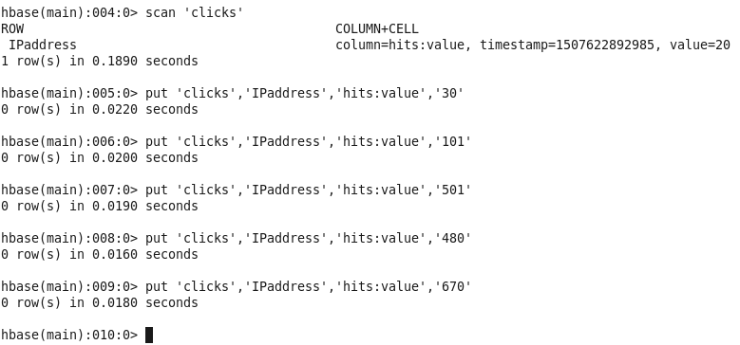

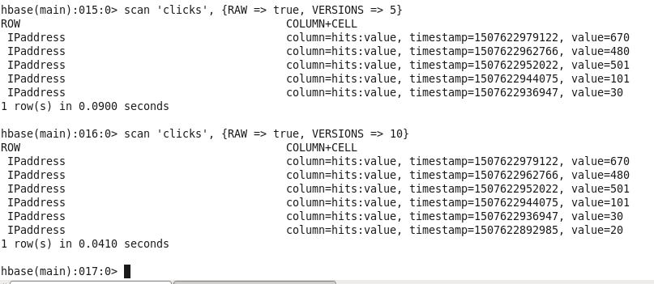

Hence the command scan ‘tablename’,{RAW=>true,VERSIONS=> }

Raw indicates it scan all the cells including delete markers and uncollected deleted cells.The output displays the last 5 versions as shown above in the screenshot.